Q1.

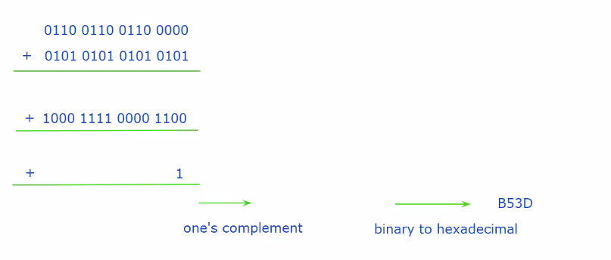

Q2.

False, 346 is sent by A but B may not receive the segment.

Q3a.

40 – 20(TCP header) = 20

Q3b.

330 350 **370**

Q3c.

330

Q4.

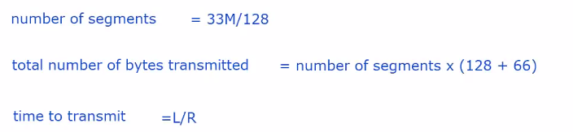

8 x 33 x 1024 x 1024 / 128 x (128 + 66) / (1 x 1000 x 1000 x 1000) = 0.4196s

OR

No. of package = floor(33x1024x1024/128) = 270336

T = ((128+66) x 270336) x 8 / 1e9 = 0.4196