Question1:

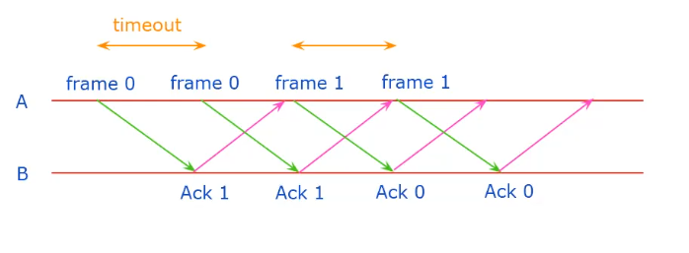

Question2:



Question3:

Question4: