**Quiz**

Question 1

Host A sends a packet of **WXYZ** **5604** bytes to host B via 2 routers. **WXYZ** are the first 4 digits of your student ID number (in decimal). **The distance between host A and the first router is 30 m**. **The distance between host B and the second router is 35 m**. **The distance between the two routers is 400 m.** **The propagation speed is 2 x 108 m/sec**.

The recommended transmission rates are: **3 Mbps between host A and the first router**, **200 Gbps between the 2 routers**, and **5 Mbps between the second router and host B**. Each router **spends 1 msec** to perform error detection.

1. At what time the last bit of the packet leaves host A?
2. At what time the last bit of the packet reaches the second router?
3. If there is no congestion in the network, calculate the total end-to-end transmission delay for host A to send the packet to host B.

[5 marks]

Question 2

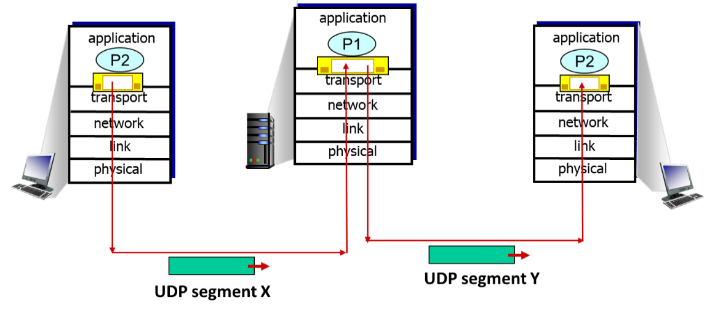

|  |  |
| --- | --- |
|  | 3009 |
|  |  |
| 2021 | **6680** |

|  |  |
| --- | --- |
|  | 3315 |
|  |  |
| 2602 | 5678 |
| **6680** | CDEF |

UDP segment X

UDP segment Y

**56046680**

**WXYZ** are the last 4 digits of your student ID number (in hexadecimal).

1. Determine all the unknown fields of UDP segment X. All numbers are in hexadecimal.
2. Similarly, determine all the unknown fields of UDP segment Y.

[5 marks]

Question 3

Host A sends a file of **51,300** bytes to Host B over a TCP connection. Assume the maximum segment size (MSS) is **144** bytes. The segment has no options field. The transport layer, network layer, and data-link layer add headers of a total size **of 66** bytes to each segment before the resulting packet is sent out over a **100 Mbps** link.

1. What is the size of the first packet?

(b) What is the size of the last packet?

(c) What is the sequence number (in 8 hexadecimal digits) of the last segment?

(d) Assume no congestion, calculate the time (in msec, round to 3 decimal places) required to transmit the file.

[5 marks]

**Submission:**

Answer the questions in a MS Word document file. Name the file with your student ID number, e.g. 12345678.docx. **One mark will be deducted for wrong file name.** Submit the file by e-mail at or before 8 pm. **Late submission will not be accepted.**