**EE3211 Modelling Techniques**

**Week 2 Assignment**

**Nutrition:**

Suppose that total carbohydrate intake in 12- to 14-yearold boys is normally distributed, with mean = 124 g/1000 cal and standard deviation = 20 g/1000 cal.

**Q1**. What percentage of boys in this age range have carbohydrate intake above 140 g/1000 cal? (1 mark)

**Q2**. What percentage of boys in this age range have carbohydrate intake below 90 g/1000 cal? (1 mark)

**Cardiovascular Disease:**

Serum cholesterol is an important risk factor for coronary disease. We can show that serum cholesterol is approximately normally distributed, with mean = 219 mg/dL and standard deviation = 50 mg/dL.

**Q3**. If the clinically desirable range for cholesterol is <200 mg/dL, what proportion of people have clinically desirable levels of cholesterol? (1 mark)

**Q4**. Some investigators believe that only cholesterol levels over 250 mg/dL indicate a high-enough risk for heart disease to warrant treatment. What proportion of the population does this group represent? (1 mark)

**Q5**. What proportion of the general population has borderline high-cholesterol levels—that is, > 200 but

< 250 mg/dL? (2 marks)

**Give random variable distribution (~X) and probability (Pr) are:**

|  |  |  |  |  |  |  |
| --- | --- | --- | --- | --- | --- | --- |
| X | -2 | -1 | 0 | 1 | 2 | 3 |
| Pr(X=Xi) | 1/12 | 3/12 | 4/12 | 1/12 | 2/12 | 1/12 |

**Q6**. What is the distribution and probability of Y = 0.5X ? (1 mark)

**Q7**. What is the distribution and probability of Z = X2 ? (1 mark)

**Q8**. Calculate the expected value and variance of X. (2 marks)

EE3211 Modelling Techniques

Week 2 Assignment

Name:

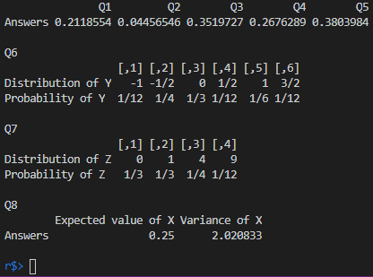

1. Z = (140 – 124) / 20 = 0.8

P(x>140) = 1 - P(x<140) = 0.212

1. Z = (90 – 124) / 20 = -1.7

P(x<90) = 0.0446

1. Z = (200 – 219) / 50 = -0.38

P(x<200) = 0.35197

1. Z = (250 – 219) / 50 = 0.62

P(x>250) = 1 - P(x<250) = 0.268

1. Z1 = -0.38, Z2 = 0.62

P(-0.38<x<0.62) = 1 - P(x<0.38) - P(x>0.62) = 1 - 0.35197 - 0.26763 = 0.3804

1. expected value = (-2x1/12) + (-1x3/12) + … + (3x1/12) = 0.25

variance = (-2-0.25) ^2 x 1/12 + (-1-0.25) ^2 x 3/12 + … + (3-0.25) ^2 x 1/12 = 2.021