EE3211 Assignment Week4

Pulmonary Disease

A 1980 study was conducted whose purpose was to compare the indoor air quality in offices where smoking was permitted with that in offices where smoking was not permitted [7]. Measurements were made of carbon monoxide (CO) at 1:20 p.m. in 40 work areas where smoking was permitted and in 40 work areas where smoking was not permitted. Where smoking was permitted, the mean CO level was 11.6 parts per million (ppm) and the standard deviation CO was 7.3 ppm. Where smoking was not permitted, the mean CO was 6.9 ppm and the standard deviation CO was 2.7 ppm.

**Q1.** Test for whether the standard deviation of CO is significantly different in the two types of working environments. (1 mark)

**Q2.** Test for whether or not the mean CO is significantly different in the two types of working environments. (2 marks)

**Q3.** Provide a 95% CI for the difference in mean CO between the smoking and nonsmoking working environments. (2 marks)

Ophthalmology

A camera has been developed to detect the presence of cataract more accurately. Using this camera, the gray level of each point (or pixel) in the lens of a human eye can be characterized into 256 gradations, where a gray level of 1 represents black and a gray level of 256 represents white. To test the camera, photographs were taken of 6 randomly selected normal eyes and 6 randomly selected cataractous eyes (the two groups consist of different people). The median gray level of each eye was computed over the 10,000+ pixels in the lens. The data are given in Table:

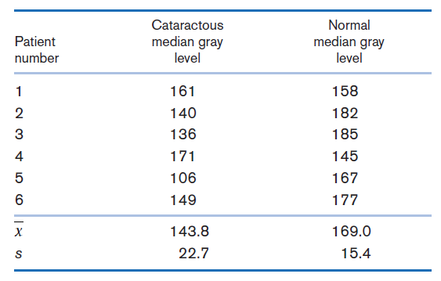

**Q4.** What statistical procedure can be used to test whether there is a significant difference in the median gray levels between cataractous and normal eyes? (1 mark)

**Q5.** Carry out the test procedure mentioned in Problem4, and report a p-value. (2 marks)

**Q6.** Provide a 99% CI for the mean difference in median gray levels between cataractous and normal eyes. (2 marks)

EE3211 Modelling Techniques

Week 2 Assignment

Name:

Q1.

Conclusion: The standard deviation of CO is significantly different from each other with p-value = 8.666198e-09 which is smaller than 0.05. It is concluded that the null hypothesis: σ12 = σ22 is rejected.

Q2.

Conclusion: The mean CO is significantly different from each other with p-value = 0.0003742124 which is smaller than 0.05. It is concluded that the null hypothesis: μ1 = μ2 is rejected.

Q3. The 95% CI is (2.227515, 7.172485)

Q4. Do a F test first to test the equality of variances, then do a T test.

Q5. The standard deviation is not significantly different from each other with p-value = 0.4144665 which is larger than 0.05. With a t test, the p-value is 0.04815642.

Q6. The 99% CI is (-10.29137, 60.69137)

