**EE3211 Modelling Techniques**

**Week 6 Assignment**

Greene and Touchstone conducted a study to relate birth weight and Estriol level in pregnant women as given in **Table-1**:

**Table: 1** Sample Data from Greene and Touchstone study relating birth weight and estriol.

|  |  |  |  |  |  |
| --- | --- | --- | --- | --- | --- |
| ***i*** | **Estriol (mg/24 hr) xi** | **Birth weight(g/100) yi** | ***i*** | **Estriol (mg/24 hr) xi** | **Birth weight(g/100) yi** |
| 1 | 7 | 25 | 6 | 17 | 32 |
| 2 | 9 | 25 | 7 | 25 | 32 |
| 3 | 9 | 25 | 8 | 27 | 34 |
| 4 | 12 | 27 | 9 | 15 | 34 |
| 5 | 14 | 27 | 10 | 15 | 34 |

Q1. Derive the estimated regression line for the data. (2 points)

Q2. What is the estimated average birth weight if a pregnant woman has an estriol level of 15 mg/24 hr? (2 points)

Q3. If low birth weight is defined as ≤2500 g, for what estriol level would the predicted birth weight be 2500 g? (2 points)

Q4. Fit a linear regression model based on the data using R. (2 points)

Q5.Test for the significance of the regression line derived for the birthweight−estriol data. (2 points)

EE3211 Modelling Techniques

Week 2 Assignment

Name:

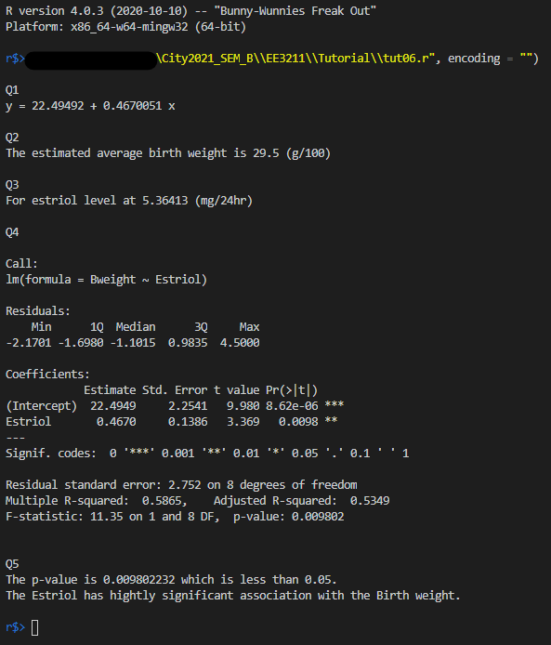

Q4. Plot

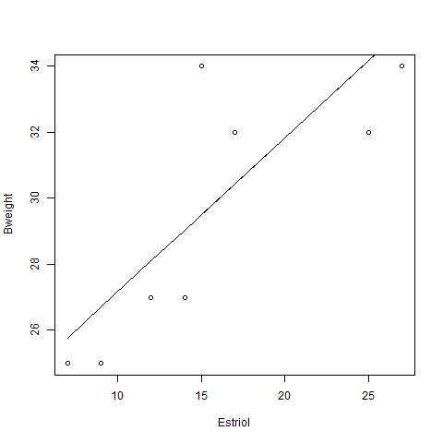

Code:

