**EE3211 Modelling Techniques**

**Week 8 Assignment**

A study was conducted concerning the effect of calcium supplementation on bone loss among postmenopausal women. Women were randomized to (1) estrogen cream and calcium placebo (n = 15), (2) placebo estrogen cream and 2000 mg/day of calcium (n = 15), or (3) placebo estrogen cream and calcium placebo (n = 13). Subjects were seen every 3 months for a 2-year period. The rate of bone loss was computed for each woman and expressed as a percentage of the initial bone mass. The results are shown in the table below.

# Table. Mean (±1 sd) slope of total-body bone mass (percentage per year) in the three treatment groups.

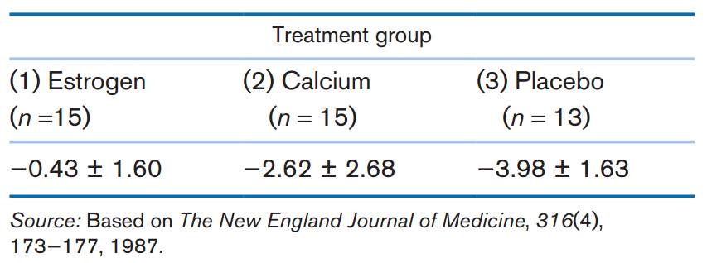

Q1. What test can be used to compare the mean rate of bone loss in the three groups? (1 point)

Q2. Implement the test in Q1, and report a *p*-value. (4 points)

Q3. Identify which pairs of groups are different from each other, using both *t* tests and the method of multiple comparisons. Report a *p*-value for each pair of treatment groups. (4 points)

Q4. Which methodology do you think is more appropriate in Q3? (1 points)

EE3211 Modelling Techniques

Week 8 Assignment

Name:

