4)

1. The gaussian low-pass filter was used to allow high frequencies detected to remove artifacts (short-term fluctuations) detected in the image which tries to saturate the white part at the center of the ring finger to become invisible to the eye but the edge values are still intact.

Then the gaussian high-pass filter is used to outline the edges in the image such as the bones, but since the white part at the center of the ring finger is still present very strongly in the image, due to the nature of the high-pass filter it will get highlighted and shown similarly to the other edges detected such as the bones.

In the sample image below to test the theory, I added a white square similar to the white part of the center of the ring finger in the question, and it showed a strong presence in the resulting image.

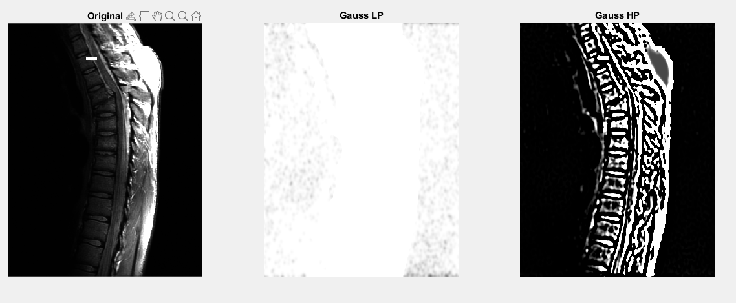

1. In theory, the presence of the white spot is strong as it has a larger coverage than the average artifact such as salt and pepper noises, no it shouldn’t matter if the process is reversed.

This is also put into practice in matlab to prove that the theory is correct.

