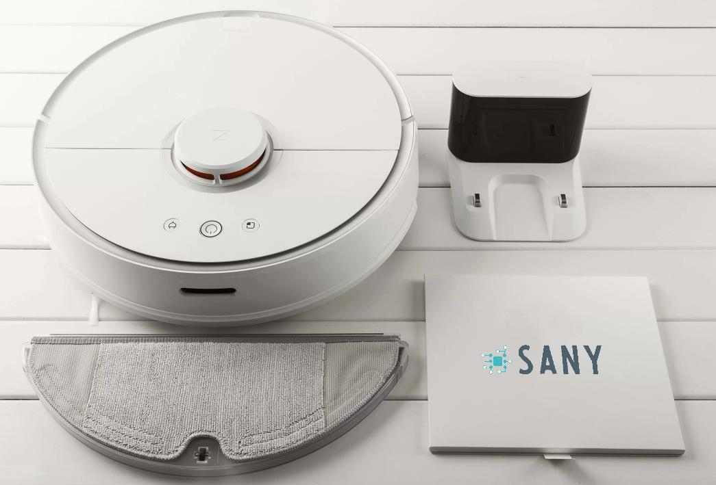

**Floor-cleaning Robots**

A Blueprint for Schneider

Prepared by Sany

Meeting time: 27/11/2020

Meeting Avenue: Zoom

Table of contents

**1.** **Project Background** 4

**1.1.** **Client Situation** 4

**1.2.** **Definition of the complication** 4

**1.3.** **Client’s Requirements** 4

**1.4.** **Proposed Solution** 5

2. Product Information 6

2.1. System function and layout design 6

2.2. Functions for users 6

2.3. Functions for maintenance 6

**3.** **Robot design** 7

**3.1.** **Software design** 7

**3.1.1.** **New Operating System (OS)** 7

**3.1.2.** **Pre-installed applications** 8

**3.1.3.** **Wireless firmware and applications updates** 9

**3.1.4.** **Compatibilization with Home assistance** 10

**3.2.** **Hardware design** 11

**3.2.1.** **Upgraded motors for the wheels and vacuuming** 11

**3.2.2.** **Flexible wheels** 11

**3.2.3.** **Sensors and camera for obstacle detection** 12

**3.2.4.** **Path calculation chips** 12

**3.2.5.** **New Components** 12

**3.2.6.** **Enlarged battery** 12

**6.** **Project duration and stages** 13

**6.1.** **Project Duration Table** 13

**6.2.** **Project Timeline** 13

Blank page:

***Things to don’t need to care about:***

1. ***The index***
2. ***The page numbers***

***They will update automatically. by Ligma***

Things Ligma has finished:

1. The front page
2. Section 3 (excluding 3.3)
3. Section 6
4. **Project Background**
   1. **Client Situation**

Schneider is a company that strives to satisfy technological consumerism in our modern society, specifically in the cleaning and work automation industry. But given the circumstances of today’s business model, searching for companies that could provide them with a good stock of technological advanced products for sale is as difficult as one can imagine, and this is one of the purposes of Schneider’s existence.

* 1. **Definition of the complication**

In today’s modern society, most of the people will belong in the working class and as such would have little to no time to spare for chores such as housework. Dealing with the same chores as well would require some amount of skill in order for the task to be satisfactorily done.

**1.2.1. Steep slopes**

Our vacuum cleaning robot currently unfortunately does not have legs so therefore slopey environments such as a house with stairsteps or random objects around everywhere would result in the robot getting in a mishap.

**1.2.2. Navigation problems**

The vacuum cleaning robots would also sometimes miss some spots and fail at reaching its starting point again.

* 1. **Client’s Requirements**

Since our company wants to sell a product that further improves the quality of life of modern society, specifically the working class, and increase sales, they have given the following requirements:

**1.3.1. Enhanced Robot Vision**

For this request, we would need the robot to have ‘eyes’ that can recognize ‘debris’ and such, that it would improve its navigation and develop its own mapping of the household.

**1.3.2. Surveillance System**

Since the product itself is a robot, our company would like it to be able to have remote control access to its ‘eyes’ (camera).

**1.3.3. Safe Operating System**

In order for this to be a product, it would need to be safe. For example, if the new vacuum cleaner robot declared a ‘pet’ to be a ‘debris’ that is to be removed, it would result in the harm of the pet.

**1.3.4. Better Travelling System**

The robot would need to be able to climb up stairs or navigate through steep terrain, and our current robot only has wheels which made it impossible with its horsepower as well to climb up steep slopes such as stairs.

**1.3.5. Other Quality of Life changes**

A longer battery life with quick recharge time would help avoid overcharging and damaging the battery, just like a phone. Having a better design such as having the robot look like a character from a famous franchise.

* 1. **Proposed Solution**

For the enhanced robot vision, surveillance, and safe operating system, the engineers have proposed to develop an AI (artificial intelligence) and install a camera onto the robot. For this to work, the robot would also have to be able to establish a network connection of sorts. The AI would need to be able to discern various debris, and what would be considered fragile or a living thing for the robot to not affect it.

Due to technological limitations, the team may have to resort to investing into a backend server for the AI to have enough processing power. This would then require the robot to be connected to our server, and in the same way would enable customers to be able to remote control the robot and use the surveillance system from its cameras. Of course, the engineers would have to ensure our servers are secure enough to prevent unauthorized access and information leakage.

In order for the robot to have a better navigation system, the engineers have proposed for the robot’s wheels to be replaced with up-liftable wheels. These wheels would enable it to traverse steep slopes with ease.

As for the battery, we could just increase our previous product’s battery size with quick charge as it is already using the best technology (lithium ion battery). And the design, I have already gotten the licensing required for legal use and commissioned several reputable online artists for the robot’s ‘colourful’ design.

1. Product Information
   1. System function and layout design
   2. Functions for users
   3. Functions for maintenance
2. **Robot design**
   1. **Software design**
      1. **New Operating System (OS)**

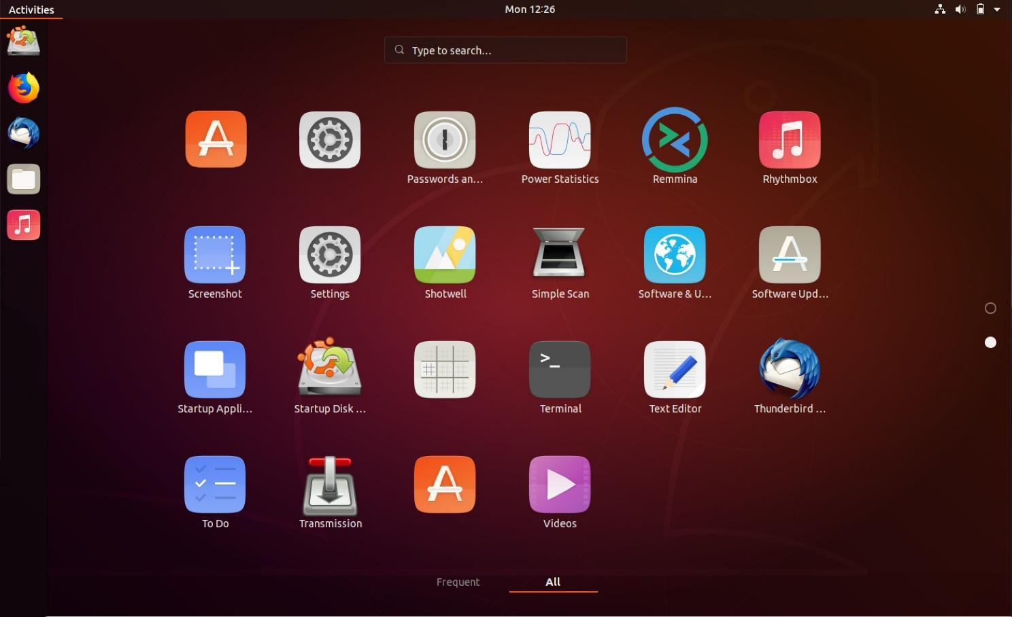

**Fig x:** Screenshot of the new Operating System

The new OS (Fig x) can provide the users a cleaner interface when interacting with the robot. It is a Unix based OS which adopted the Graphical User Interface (GUI) which is also used by many OS, such as Windows, MacOS, Android and IOS. Thus, users could be more convenient when using our OS as it can show the functions of the cleaning robots with icons, users could operate the robot in a familiar way. As it is a light-weight OS, so it does not require heavy hardware resources to operate and run programs.

* + 1. **Pre-installed applications**

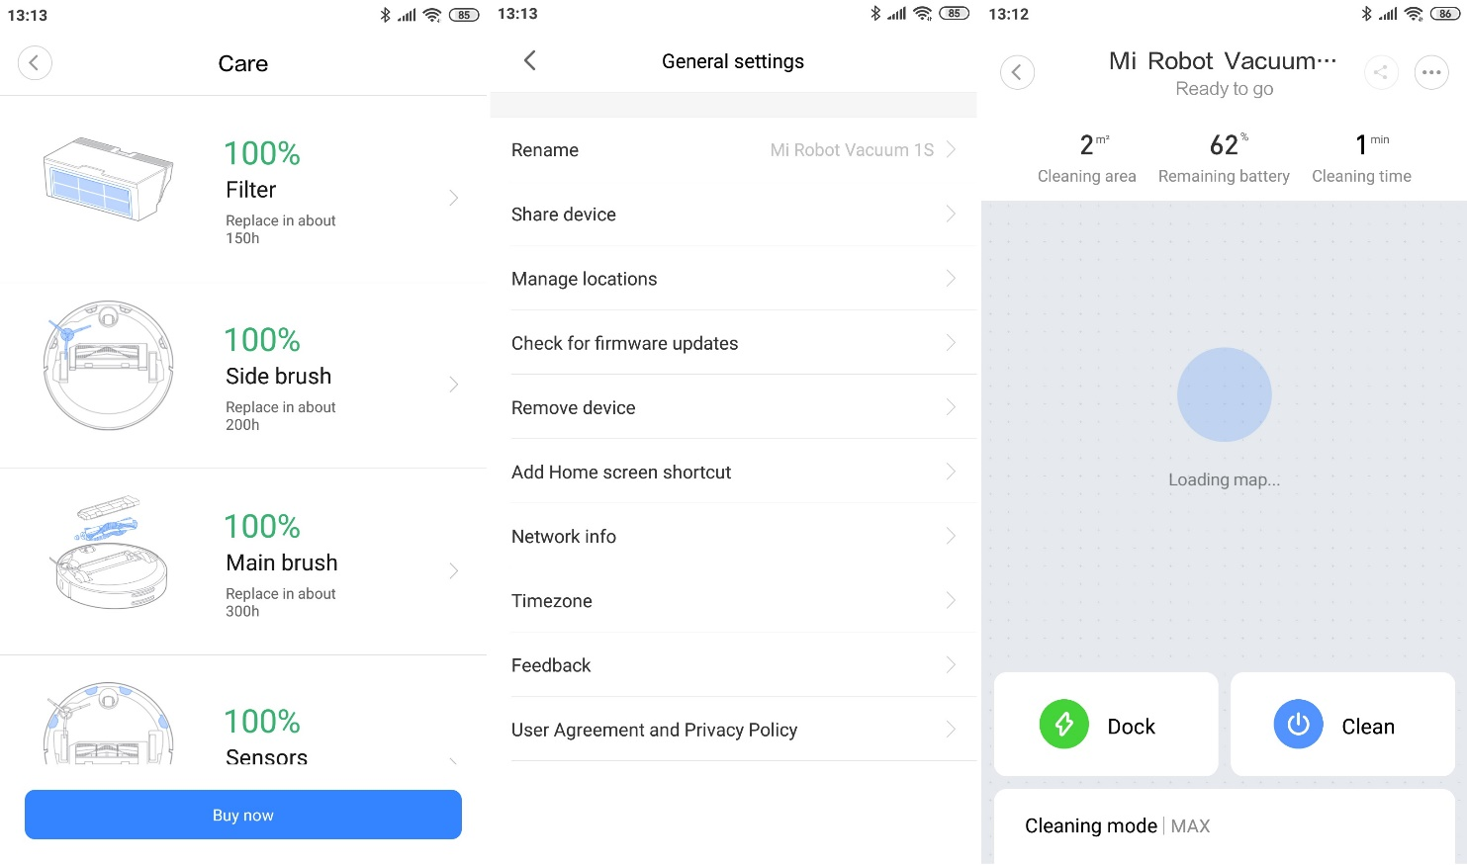

**Fig x:** Screenshot of the Cleaning Master

There will be some pre-installed applications (Fig x) for example, Cleaning Master   
(C.M.) is an application which lets the users have full control over the floor cleaning robot. With the minimalistic interface design, the user can check the states of the robot such as the battery status, filter status, nozzle status and more. Users can also change the settings of the robots via this application such as redefine the cleaning path and cleaning priority of robot, rename the robots, connecting the robot to their home assistance. With the music player pre-installed, users can play music with this robot if they want. With the Camera Capture (CC) application pre-installed, users can have real-time control access to the robot's camera.

* + 1. **Wireless firmware and applications updates**

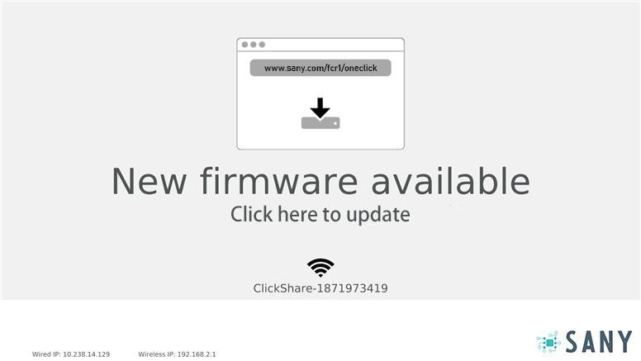

**Fig x:** Screenshot of the firmware update application

The wireless firmware application (Fig x), makes firmware update so much easier. Traditionally, when a robot needs to update its firmware, that will require the user to connect the robot to their computer via a physical wire which causes so many inconveniences. With this new feature, users can update firmware and all pre-installed applications with just one click when the robot is connected to the network via Wi-Fi and no cable is needed.

* + 1. **Compatibilization with Home assistance**

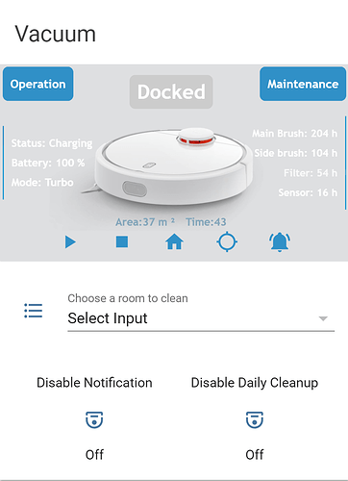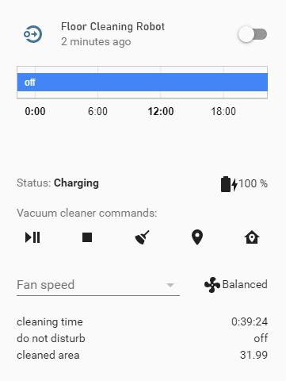

**Fig x:** Screenshot of controlling the robot via Google Assistance

Users can set the cleaning time configuration and scheduling, the cleaning speed, the cleaning path, the cleaning priorities and other features all with their smartphone via our application for smartphones. Users can pause and unpause the robot or even set up a “Don’t Disturb Mode” and “Quiet Mode” by this method. As the demand of controlling smart devices via home assistance is increasing. We decided to add the ability of using home assistance to control the floor cleaning robot. So, users can control the robot by their voice, for example by using Google Assistant (Fig x), “Hey Google, clean the kitchen and bathroom but not the bedroom at 1 p.m.” The robot currently supports Google Assistant, Apple Siri and Amazon Alexa.

* 1. **Hardware design**
     1. **Upgraded motors for the wheels and vacuuming**

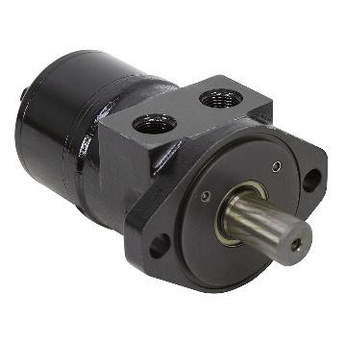

**Fig x:** High Torque High Speed motor



**Fig x:** Pulse-Width Modulation motor

We decided to upgrade to motors to a High Torque High Speed motor (HTHS motor) for the wheels and a Pulse-Width Modulation motor (PWM motor) for the. With the HTHS motor, the robots are able to navigate through steep terrain while maintaining its speed, thus have a better travelling system. With the PWM motor the robots are toggle to vacuum motor speed. Thus, it can reduce the noise level, when users enable “Quiet mode”, and the robots will slow down its wheels speed and vacuum motor speed in order to produce less noise.

* + 1. **Flexible wheels**

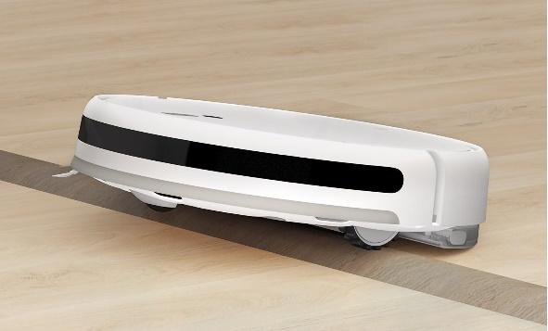

**Fig x:** Demonstration for new wheels design

In order to overcome tough terrains like uneven floors, small stairs and ramps, or small obstacles like socks, wires and cables, the wheels are up-liftable. For example, when ramps are detected, the back wheels will be lifted up in order to navigate through the ramps. A 360-degree-movable wheels design is also introduced, the wheels can turn at any angle, thus the robot can have more precise turns to have a better travelling system.

* + 1. **Sensors and camera for obstacle detection**

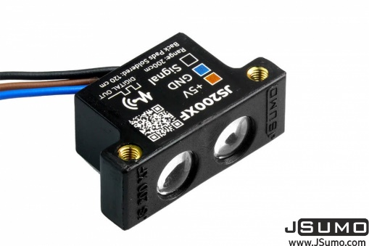

**Fig x:** Infrared sensor

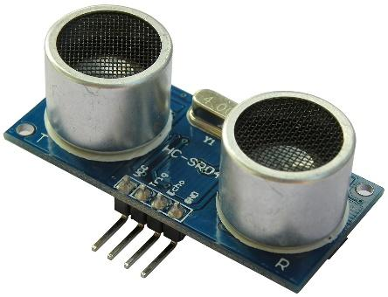

**Fig x:** Ultrasound sensor

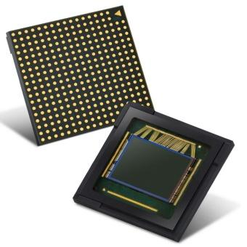

**Fig x: C**amera sensors

As for detecting obstacles, Infrared sensor (Fig x), Ultrasound sensor (Fig x), camera and camera sensors (Fig x) are introduced. These sensors can help the robots to identify obstacles detected by its size, density, distance and temperature. The robots can also recognize fragile or living creatures from obstacles by using the sensor and calculating, to avoid hitting or hurting animals or pets.

* + 1. **Path calculation chips**

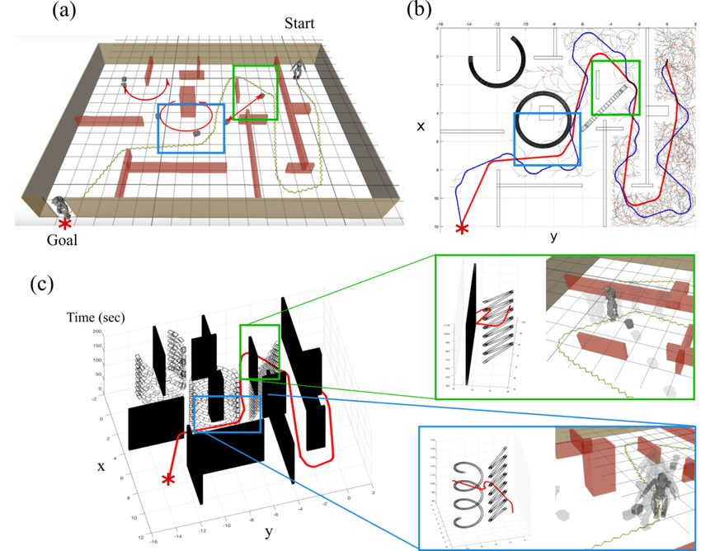

**Fig x:** Path calculation model

With an additional chip for real-time path calculating (Fig x), the robot can calculate its cleaning path automatically. The robots will receive the data collected from the chips and sensor, then those data will be decomposed by the mapping chips and sent to our server to calculate the best fit path which fits the requirement of the user. After that, the robot will receive the package from our server and load the path into its mapping chips and the robot will follow the path calculated by our server. By this method, a high efficiency cleaning path is generated, with avoiding dangers such as falling edges and stairs, also particular spots like corners and edges of the walls will not be missed anymore, and most importantly, the robot can back to its charging position and charge automatically.

* + 1. **New Components**

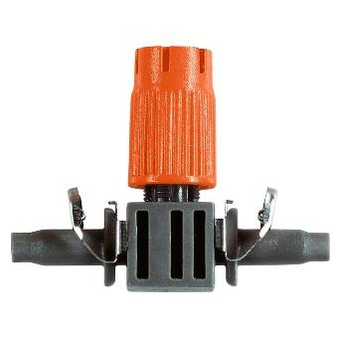

**Fig x:** Rear nozzle



**Fig x:** Bacterial killing UV light

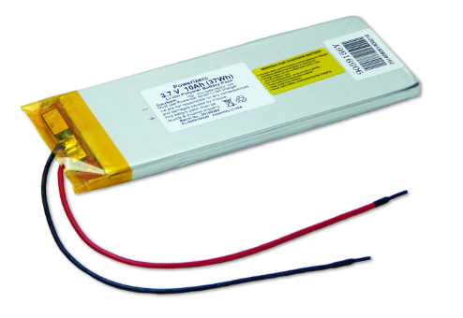

**Fig x:** Lithium-ion battery

This new nozzle (Fig x) is installed on the rear of the robot, corners and edges can be cleaned more easily. As this design of nozzle is smaller in size compared to front and back nozzles, it is aimed to clean the edges and corners of the walls. Bacterial killing UV light is introduced, as this feature is so useful during the quarantine period. The UV light is pointed toward the floor in order to sterilize the floor.

* + 1. **Enlarged battery**

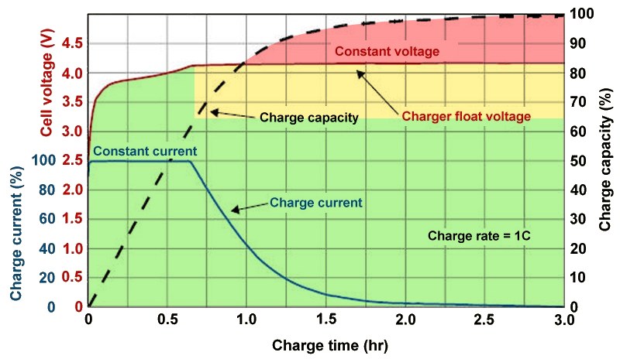

**Fig x:** Charing time vs Charging capacity

Lithium-ion battery (Li-ion battery) (Fig x) as it is already the best batteries technology. We successfully increased the volume of the battery while maintaining the battery size. The battery life is extended, as the cycle and frequency of charging is now deceased. The battery can be used for at least 5 cycles of cleaning on average before it needs to recharge. We also introduced the Quick Charge (QC) technology to the robot, and it is now only requiring 30 minutes to charge from 10% to 80%. The user can use the product more frequently instead of waiting for the robot to charge up.

* 1. Backend server
     1. Train the pathing model with cloud server
        1. Build a map of the house after scan house
        2. To calculate an effective cleaning path with the map
           1. Order and path can be adjusted by user
           2. e.g. which room to be cleaned
        3. To calculate the path for auto-return to its initial position
           1. Thus, it can charge automatically

1. Beta testing (Tim)

1. Cost and deliverables
   1. Cost
   2. After Sales Service
2. **Project duration and stages**
   1. **Project Duration Table**

|  |  |  |  |  |
| --- | --- | --- | --- | --- |
| **Project Duration 12 months (start from 25/11/2019)** | | | | |
| Phase | Work summary | Duration (Days) | Start Date | Finish Date |
| 1 | Preparatory Stage | 35 | 25/11/2019 | 30/12/2019 |
| 2 | Identification of Requirements | 29 | 30/12/2019 | 28/1/2020 |
| 3 | Research on Existed Product | 34 | 28/1/2020 | 2/3/2020 |
| 4 | Meeting with Clients Firm | 15 | 2/3/2020 | 17/3/2020 |
| 5 | Product Design | 69 | 17/3/2020 | 25/5/2020 |
| 6 | Software and  Server End Design | 55 | 25/5/2020 | 19/7/2020 |
| 7 | Prototype  Marking | 28 | 19/7/2020 | 16/8/2020 |
| 8 | Internal Product Testing | 15 | 16/8/2020 | 31/8/2020 |
| 9 | Deploy Samples  to the Clients Firm | 7 | 31/8/2020 | 7/9/2020 |
| 10 | Feedback From  Clients Firm | 38 | 7/9/2020 | 15/10/2020 |
| 11 | Product Deployment | 40 | 15/10/2020 | 24/11/2020 |

**Table x**: Project duration table of the project

* 1. **Project Timeline**

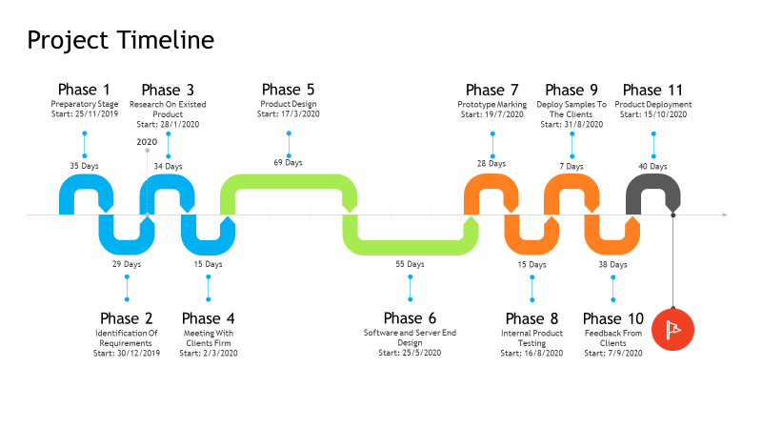

**Fig x**: Project timeline of the project

1. About us (Ryan)