2. 1. 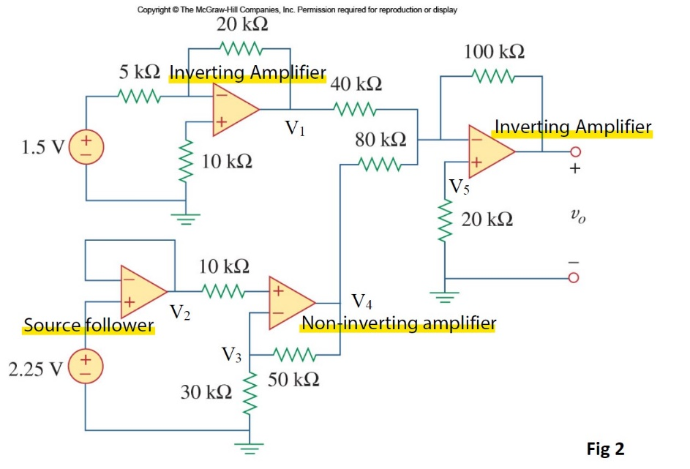







**It is a bandpass filter**

$$\frac{V_{o}}{V_{i}}=-\frac{R_{f}}{R_{i}}\left(\frac{1}{1+jωC_{1}R}\right)\left(\frac{jωC_{2}R}{1+jωC_{2}R}\right)$$

$$=-\frac{R_{f}}{R_{i}}\left(\frac{1}{1+\frac{jω}{ω_{1}}}\right)\left(\frac{\frac{jω}{ω_{2}}}{1+\frac{jω}{ω_{2}}}\right)$$

$$ω_{o}=\sqrt{ω_{1}ω_{2}} \\ \frac{V_{o}}{V_{i}}=-\frac{R_{f}}{R_{i}}\left(\frac{1}{1+\frac{j\sqrt{ω_{1}ω_{2}}}{ω_{1}}}\right)\left(\frac{\frac{j\sqrt{ω_{1}ω_{2}}}{ω_{2}}}{1+\frac{j\sqrt{ω_{1}ω_{2}}}{ω_{2}}}\right) \\ =-\frac{R_{f}}{R_{i}}\left(\frac{1}{1+j\sqrt{\frac{ω_{2}}{ω_{1}}}}\right)\left(\frac{j\sqrt{\frac{ω_{1}}{ω_{2}}}}{1+j\sqrt{\frac{ω_{1}}{ω_{2}}}}\right) \\ =-\frac{R_{f}}{R_{i}}\left(\frac{j\sqrt{\frac{ω_{1}}{ω_{2}}}}{1+j\sqrt{\frac{ω_{2}}{ω_{1}}}+j\sqrt{\frac{ω_{1}}{ω_{2}}}+j\sqrt{\frac{ω_{2}}{ω_{1}}}j\sqrt{\frac{ω_{1}}{ω_{2}}}}\right) \\ =-\frac{R_{f}}{R_{i}}\left(\frac{\sqrt{\frac{ω_{1}}{ω_{2}}}}{\sqrt{\frac{ω_{2}}{ω_{1}}}+\sqrt{\frac{ω_{1}}{ω_{2}}}}\right) \\ =-\frac{R_{f}}{R_{i}}\left(\frac{\sqrt{\frac{ω_{1}}{ω_{2}}}\left(\sqrt{\frac{ω_{2}}{ω_{1}}}-\sqrt{\frac{ω_{1}}{ω_{2}}}\right)}{\frac{ω_{2}}{ω_{1}}-\frac{ω_{1}}{ω_{2}}}\right) \\ =-\frac{R_{f}}{R_{i}}\left(\frac{ω_{1}ω_{2}-{ω_{1}}^{2}}{{ω_{2}}^{2}-{ω_{1}}^{2}}\right) \\ =-\frac{R_{f}}{R_{i}}\left(\frac{ω_{1}}{ω_{2}+ω_{1}}\right) \\ =-\frac{R_{f}}{R_{i}}\left(\frac{\frac{1}{{RC}_{1}}}{\frac{1}{{RC}_{2}}+\frac{1}{{RC}_{1}}}\right) \\ =-\frac{R_{f}}{R_{i}}\left(\frac{1}{\frac{C_{1}}{C_{2}}+1}\right) \\ =-\frac{R_{f}}{R_{i}}\left(\frac{C_{2}}{C_{1}+C_{2}}\right) \\ \left|\frac{V_{o}}{V_{i}}\right|=\left|-\frac{R_{f}}{R_{i}}\left(\frac{C_{2}}{C_{1}+C_{2}}\right)\right| \\ =\frac{R_{f}}{R_{i}}\left(\frac{C_{2}}{C_{1}+C_{2}}\right)$$