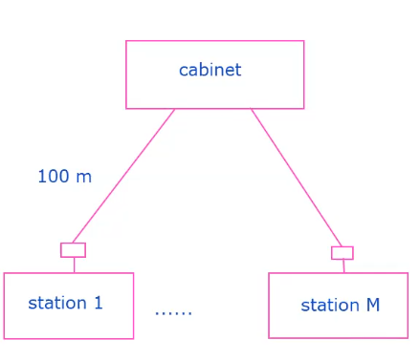

Question 1a: $$ρ_{max}=λ\frac{L}{R} \\ 1=λ\left(\frac{1250×8}{25×{10}^{6}}\right) \\ λ=2500{frames}/{sec}$$

Question 1b:

$$τ^{'}=τ+\frac{Mb}{R} \\ =\frac{M×2×100}{2×{10}^{8}}+\frac{M×8}{25×{10}^{6}} \\ =1.32×{10}^{-6}M$$

$$a^{'}=\frac{τ^{'}R}{L} \\ ρ_{max}=\frac{1}{1+\frac{a^{'}}{M}}=\frac{1}{1+\frac{τ^{'}R}{LM}} \\ λ=\frac{ρ_{max}R}{L}=\frac{1}{L/R+{τ^{'}}/M}$$

Direct calculation:

$$λ=\frac{1}{L/R+{τ^{'}}/M} \\ =\frac{1}{\frac{1250×8}{25×{10}^{6}}+\frac{1.32×{10}^{-6}M}{M}} \\ =2492{frames}/{sec}$$

Question 3a:

|  |  |
| --- | --- |
| ARP table in 111.111.111.110 | |
| IP address | MAC address |
| 111.111.111.111 | 74-29-9C-E8-FF-55 |
| 111.111.111.112 | CC-49-DE-D0-AB-7D |

|  |  |
| --- | --- |
| ARP table in 222.222.222.220 | |
| IP address | MAC address |
| 222.222.222.221 | 88-B2-2F-54-1A-0F |
| 222.222.222.222 | 49-BD-D2-C7-56-2A |

Question 3b:

|  |  |
| --- | --- |
| Source IP address | 222.222.222.222 |
| Destination IP address | 111.111.111.111 |
| Source MAC address | 49-BD-D2-C7-56-2A |
| Destination MAC address | 1A-23-F9-CD-06-9B |