Q3

a

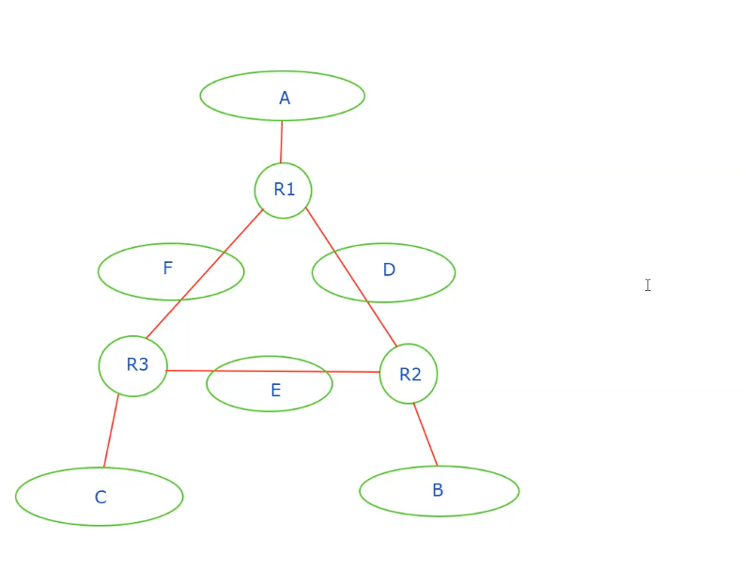

A: 256 address

214.97.255/24

B: 120

214.97.254.0/25 – 214.97.254.0/29

(7 bits for 128 address, 3 bits for give out 8 address away)

C: 128

214.97.254.128/25

D: 2

214.97.254.0/31

E: 2

214.97.254.2/31

F: 4

214.97.254.4/30

b

convert address into binary, delete 32-n bit at the end.