2) a)

Running the given code for Phead produces a plot that shows the outcomes generated from using the command “binornd” which is a binomial distribution function. Which means that the plot is showing a binomial distribution plot with the y axis as the computed probability based on the number of experiments with the given probability of success and x axis as the number of trials.

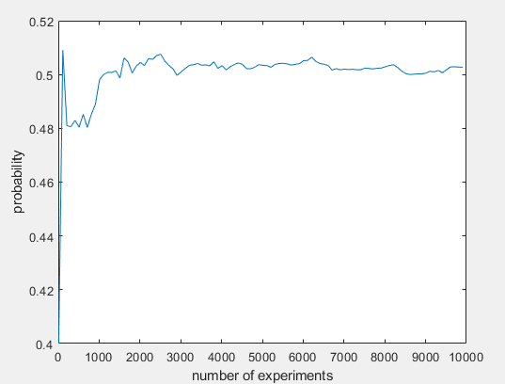

b)

Since in the program, the probability to flip heads is the probability of success, we input 0.4 as the probability of success in line 7 where we are generating the results of success using binornd.

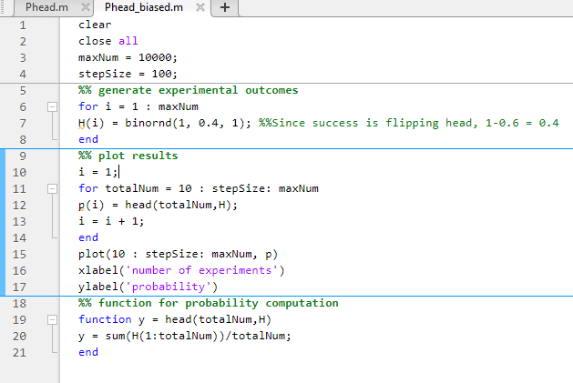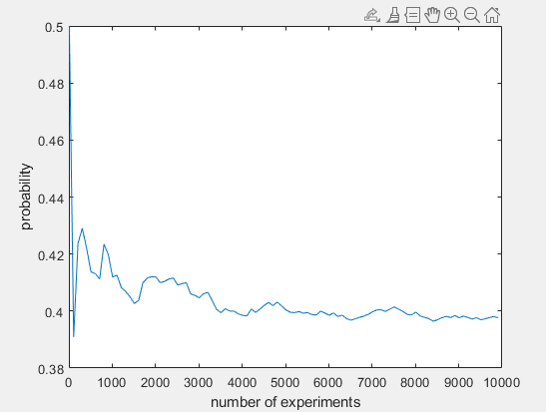

3) a) 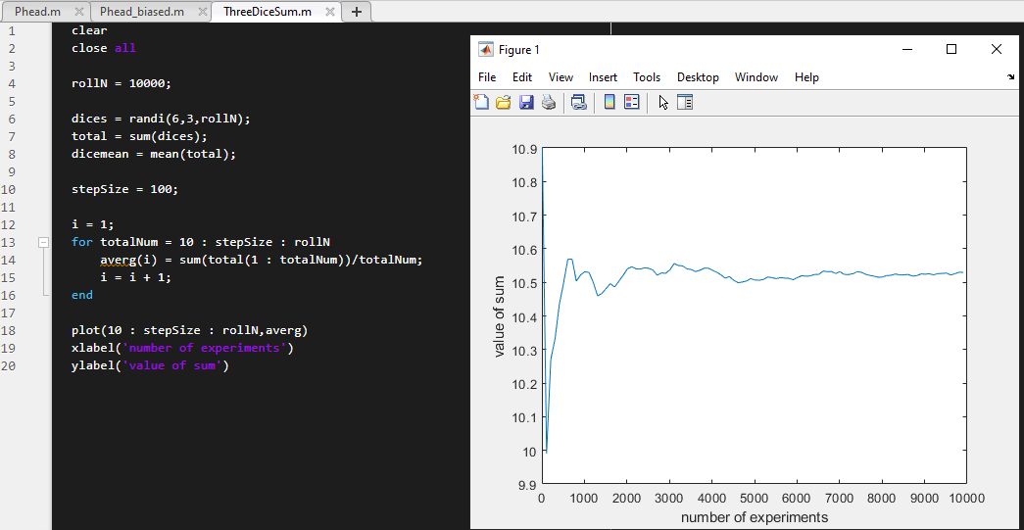

The computed results slowly hovered around the 10.5 ranges, so yes the results do align with the expected value of the outcome.

b)

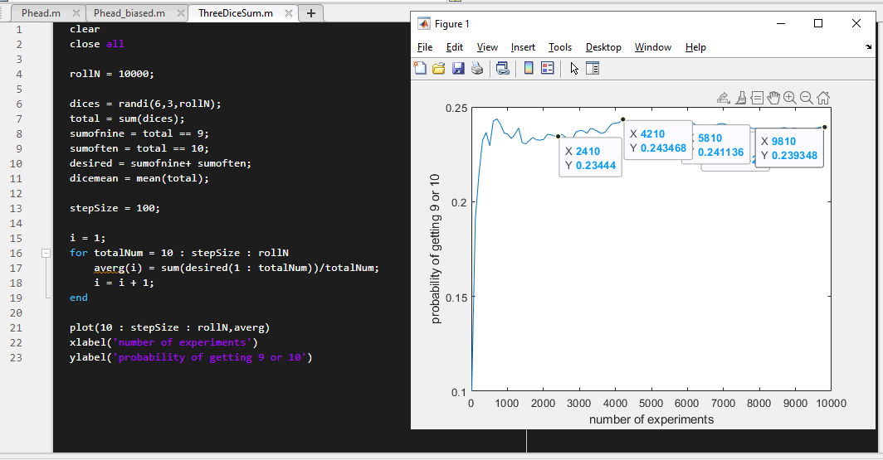

3 = 1 + 1 + 1

4 = 1 + 1 + 2

5 = 1 + 1 + 3 = 2 + 2 + 1

6 = 1 + 1 + 4 = 1 + 2 + 3 = 2 + 2 + 2

7 = 1 + 1 + 5 = 2 + 2 + 3 = 3 + 3 + 1 = 1 + 2 + 4

8 = 1 + 1 + 6 = 2 + 3 + 3 = 4 + 3 + 1 = 1 + 2 + 5 = 2 + 2 + 4

9 = 6 + 2 + 1 = 4 + 3 + 2 = 3 + 3 + 3 = 2 + 2 + 5 = 1 + 3 + 5 = 1 + 4 + 4

10 = 6 + 3 + 1 = 6 + 2 + 2 = 5 + 3 + 2 = 4 + 4 + 2 = 4 + 3 + 3 = 1 + 4 + 5

11 = 6 + 4 + 1 = 1 + 5 + 5 = 5 + 4 + 2 = 3 + 3 + 5 = 4 + 3 + 4 = 6 + 3 + 2

12 = 6 + 5 + 1 = 4 + 3 + 5 = 4 + 4 + 4 = 5 + 2 + 5 = 6 + 4 + 2 = 6 + 3 + 3

13 = 6 + 6 + 1 = 5 + 4 + 4 = 3 + 4 + 6 = 6 + 5 + 2 = 5 + 5 + 3

14 = 6 + 6 + 2 = 5 + 5 + 4 = 4 + 4 + 6 = 6 + 5 + 3

15 = 6 + 6 + 3 = 6 + 5 + 4 = 5 + 5 + 5

16 = 6 + 6 + 4 = 5 + 5 + 6

17 = 6 + 6 + 5

18 = 6 + 6 + 6

Using the sample space,

$$P\left(Sum of 9 or 10\right)=\frac{25}{216}+\frac{27}{216}=24.07\%$$

And in the screenshot we can see that the computed experimental probability is slowly moving towards the theoretical probability.

c)

For reconstructing part A)

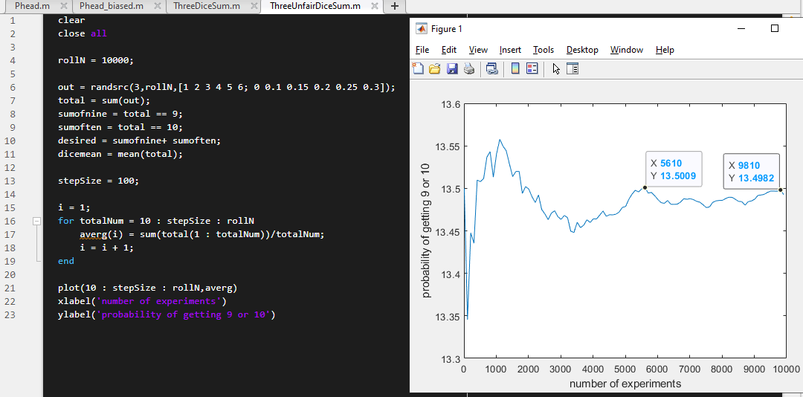

With the new given probabilities to roll the numbers, we have a new expected value for the sum of the three dices.

$$E\left(X=Sum of 3 unfair dice\right)=0*1+0.1*2+0.15*3+0.2*4+0.25*5+0.3*0.6 \\ E\left(X\right)=4.5$$

$$E\left(3X\right)=3E\left(X\right)=13.5$$

Seeing as the plot is getting closer to the expected value, the computation done by the code seems to be close to accurate given the number of experiments is higher.

For reconstructing part B)

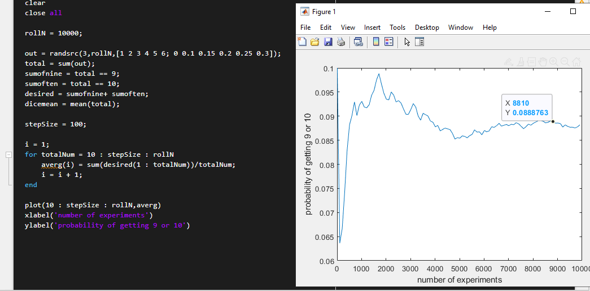

$$P\left(Sum of 9 or 10\right)= 0.0887$$

Seeing as it got closer to the theoretical probability, we can assume the computation is done right.

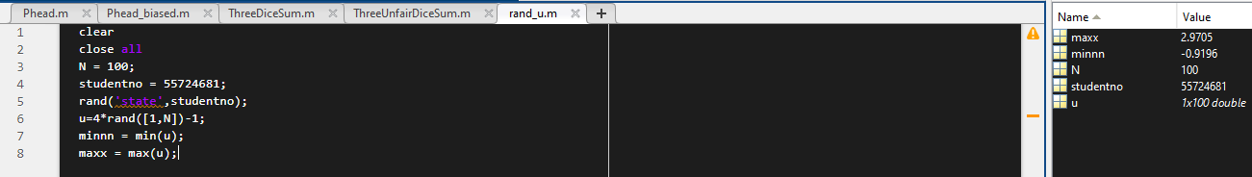4) a)

The minimum value would be -0.9196 and maximum value would be 2.9705.

b) 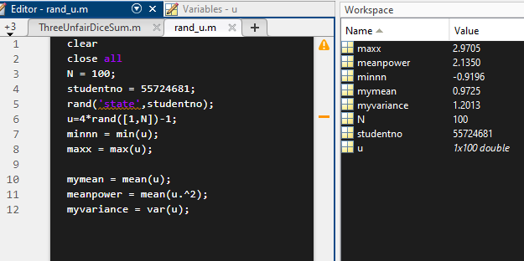

From the computed values above, the mean is 0.9725, meanpower is 2.1350, and variance is 1.2013.

c)

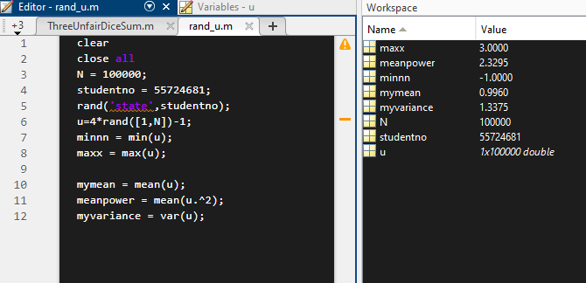

From the computed values above, the mean is 0.9960, meanpower is 2.3295, and variance is 1.3375.

d)

With a higher N, the computed values are getting more accurate as runnning N with a value of 100000000, the mean results in a value of 1 and variance results to 1/3.

e) & f)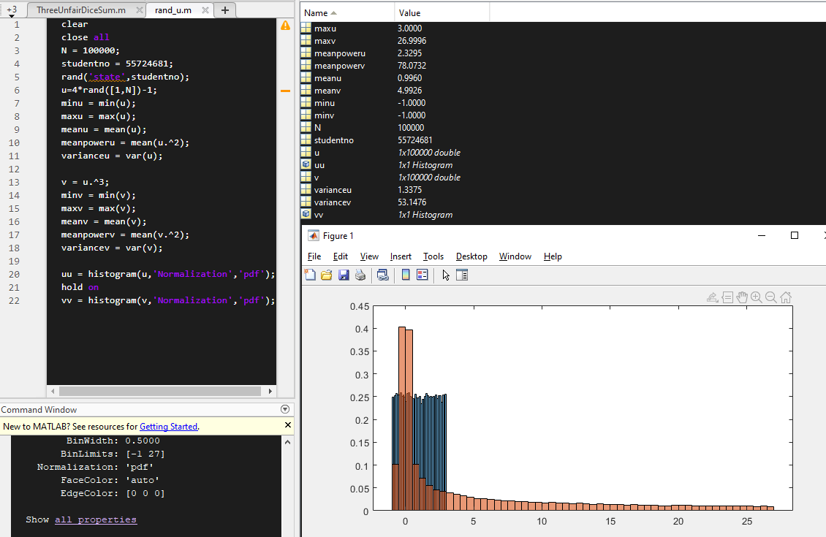

The plot in the diagram is showing the orange values as values of V and blue values as values of U.

Because $V=U^{3}$, we can see that the variance dramatically increased by nearly 53 fold, the mean by 5 fold, and mean power nearly increased by mean of u to the power of 5.

5) a)

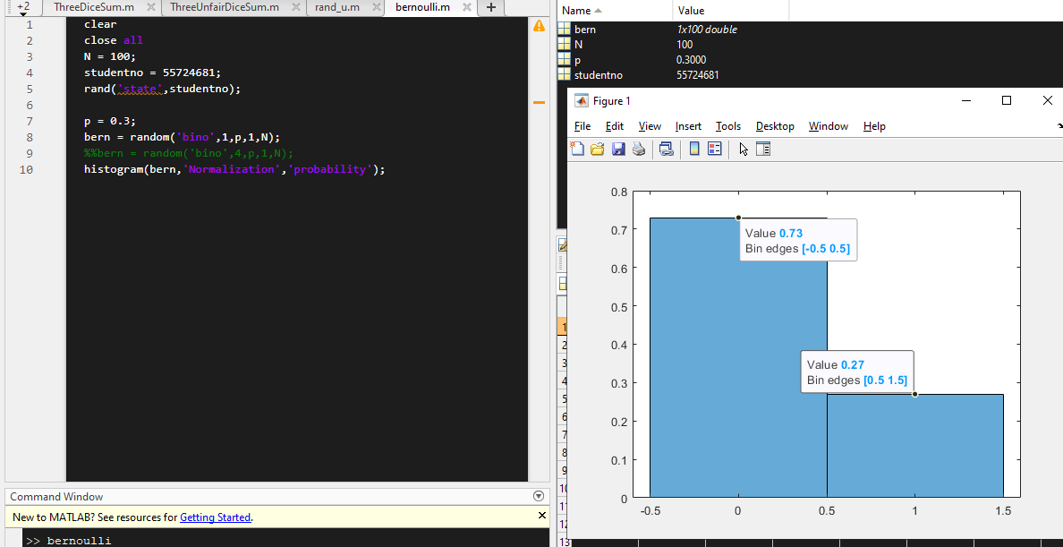

b)

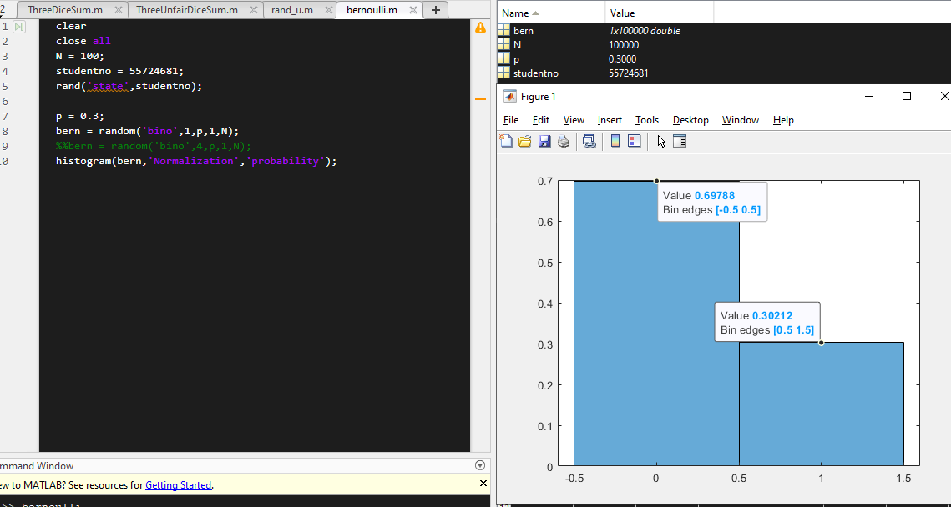

We can see that the values are getting closer to the theoretical values where 0.7 is the rate of getting 0 and 0.3 is the rate of getting 1, while in the previous one with lesser trials we get values deviating more from the theoretical values.

c) 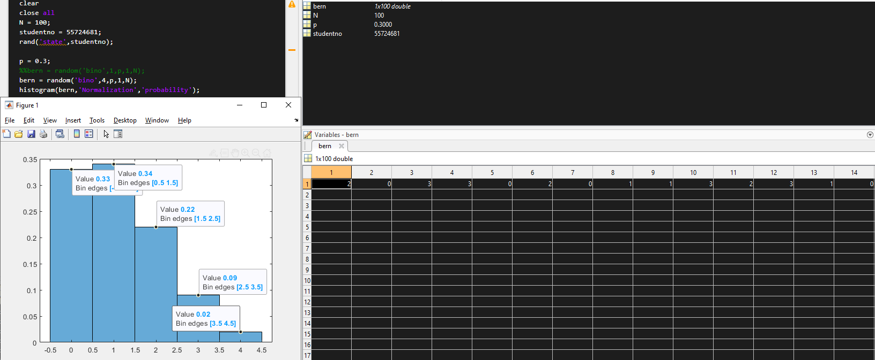

The bernoulli random variables was then converted to a binomial random variables are generated with possible values ranging from 0 to 4 given that n = 4, and the pmf graph seen also is telling of the change as it has similar shape to that of a typical binomial pmf shown below.

