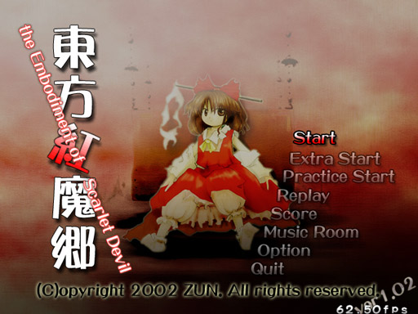
The Embodiment
of Scarlet Devil

A critique on EoSD's influence as part of the Touhou series.

TS320 Summer 2014

By Samuel Navarrete (V00744358)
The Embodiment of Scarlet Devil

We've all had hopes and dreams when we were young, specially us imaginative gamers. Video games have always been the source of much of my motivation, even now as an adult. This motivation is what ultimately moved me to pursue a major as a software developer, from when I wanted to make a game and learnt Flash/ActionScript to now studying computer science in a foreign country. While my goals have changed, that inspiration was the spark from my childhood that fired up those ideas worthy of my obsession. Those same hopes and dreams that led Japanese game developer Zun (Ota Jun'ya) to single-handed create an influential series of video games known as The Touhou Project.
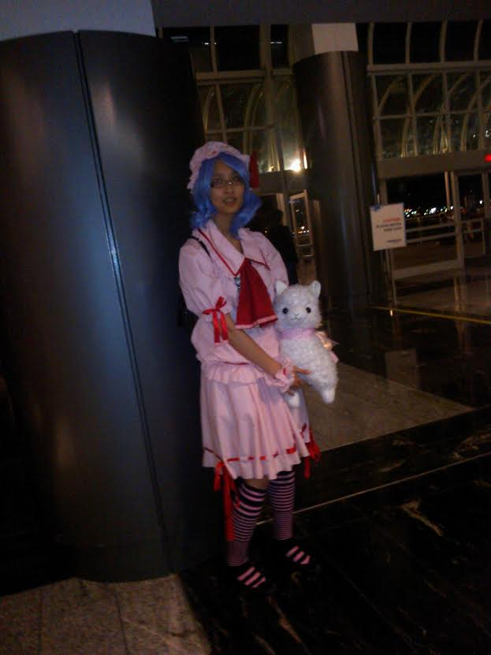Photo of a Touhou fan (dressed as Remilia Scarlet) that I took in Vancouver
Games from the series, migrated from PC98 to PC in 2002 starting from Touhou 6: The Embodiment of Scarlet Devil or EoSD, are now responsible for a huge fandom in Japan that involves everything from incredible amounts of fan art, to cosplay and Touhou-related conventions like Reitaisai. All this was possible for a single game developer who established the ultimate social connection that any true game developer wishes to achieve: making a game without regards of other people's opinions, a game made absolutely for your own enjoyment, the embodiment of a childhood dream, and is still positively praised into becoming an immortal symbol. Think about games like Super Mario Bros., powerful enough to affect the audience's feelings such that they will ever be remembered.

The Embodiment of Scarlet Devil is a bullet hell shooter game designed to challenge the player more so than many other types of games. That is no different than any other game of the bullet hell genre. However, something that makes a game have a personal link with the audience is memorable characters, one of the things that make the Embodiment of Scarlet Devil so “catchy.” An interest phenomena that occurs with the Touhou franchise is that a part of its fans do not play the game much but absolutely adore many of the characters. Characters in EoSD (in accordance with the overall atmosphere of the Touhou series) are portrayed in a Japanese art and cultural style but some of the characters are western-style witches and vampires. The main character is a shrine-maiden, straight out of Japanese tradition, known as Reimu Hakurei. Other characters include the western-style witch known as Marissa, and the villain Scarlet family composed of a landlady vampire named Remilia, her maid Sakuya and her sister Flandre. These characters are all done with a cute artstyle and unique attitudes. The Embodiment of Scarlet Devil's universe takes place in a land known as Gensokyo, somewhat translated from Japanese to “Land of illusions” or “Land of Fantasy.”^{[1]} Touhou has a complex background story (often aided by fanworks that sometimes make it into canon) but focusing only on EoSD, the story is quite simple; a red mist has appeared and Reimu (or Marissa, depending on whom you choose) must investigate the unusual event through projectile-filled battles and silly discussions. The six available story levels progressively increase in difficulty making the later stages of the game harder and seemingly impossible on the higher difficulties. The easiest difficulty however, is easy enough for any player to enjoy through.
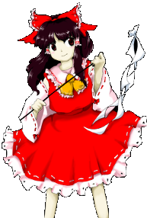Reimu, main character in EoSD

EoSD is a simple game in the sense that the player moves, shoots, and focuses. Focusing is done by holding a certain key to slow the player down in order to accurately dodge or concentrate damage. The game is far from easy, however. You lose a life if a bullet touches your weak spot, and those lives are scarce. There are four available difficulties and only the easiest one is doable by those who haven't been previously exposed to games of the genre. This daunting factor aided the popularity of the genre; for example, Flandre, one of the hardest bosses in EoSD, requires some quite “theatrical” maneuvers in order to beat, making the game quite a spectacle to watch. Most people not familiar with the genre just rule it out as impossible to do and praise the players as being good enough to be able to “stand in the rain and not get wet.” Other gamers will look at it as a challenge and proceed to learn until they make it. This challenge and sense of progress and accomplishment is what makes a game like EoSD worth a try, it's the breathtaking challenging moments of the game that make you forget everything else and experience the game for what it is supposed to be. All in combination with the heavily instrumental soundtrack and visually-perplexing gameplay are what makes up the whole EoSD multimedia experience. While the art quality was somewhat lacking in the earlier games like EoSD, the music and level design have stayed superb all throughout the series, and EoSD might very well be one of my favourite soundtracks of all time. The music in EoSD (as with all the other games of the Touhou Series) has been the target of fans for remixes and such, many of these have millions of views on YouTube.
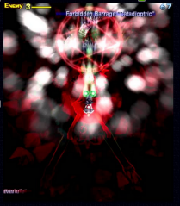Gamplay from EoSD

Touhou 6: The Embodiment of Scarlet Devil is a good place to start for anyone who'd like a feel for an independently-produced game that remains faithful to the developer's purpose and taste. Zun created Touhou because he was not satisfied with other games and wanted to make something that he liked himself. By creating a game for personal enjoyment, a challenging game uncommon of this generation that also manages to reflect aspects of his culture, he has achieved much of my praise. Although this is something that we also see on the western culture through games like Braid and Fez, I believe Zun's story is a good vibe for any artist to hear and influence from. Knowing that the entirety of the game was executed by one only developer is quite an inspiring tale for anyone afraid to express their feelings because of fear of being rejected.

References:
[1] http://touhou.wikia.com/wiki/Gensokyo

Canon: material accepted as part of the story in an individual fictional universe. It is often used as the basis for works of fan fiction. From Wikipedia.

