通达信系统指标公式

并非闲人编辑整理

2016年4月

目 录
目录 2
第一章 技术指标公式 1
第一节 大势型 1
第二节 超买超卖型 3
第三节 趋势型 9
第四节 能量型 14
第五节 成交量型 16
第六节 均线型 19
第七节 图表型 22
第八节 路径型 23
第九节 停损型 25
第十节 策略型 25
第十一节 神系 28
第十二节 龙系 30
第十三节 鬼系 32
第十四节 其他系 32
第十五节 特色型 37
第二章 条件选股公式 44
第一节 指标条件选股 44
第二节 基本面选股 49
第三节 即时盘中选股 50
第四节 走势特征选股 51
第五节 形态特征选股 57
第三章 专家系统公式 62
第四章 五彩K线公式 66

通达信系统指标公式

技术指标公式

大势型

ABI 绝对广量指标
ABI:100*ABS(ADVANCE-DECLINE)/(ADVANCE+DECLINE);
MAABI:EMA(ABI,M);
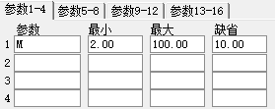

ADL 腾落指标
ADL:SUM(ADVANCE-DECLINE,0);
MAADL:MA(ADL,M);
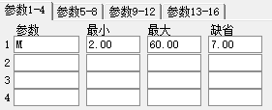

ADR 涨跌比率
ADR:SUM(ADVANCE,N)/SUM(DECLINE,N);
MAADR:MA(ADR,M);
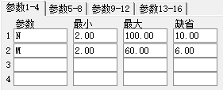

ARMS 阿姆氏指标
ARMS:EMA(ADVANCE/DECLINE,N);
MAARMS:MA(ARMS,M);
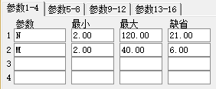

BTI 广量冲力指标
BTI:EMA(100*ADVANCE/(ADVANCE+DECLINE),N);
MABTI:MA(BTI,M);
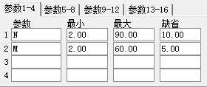

MCL 麦克连指标
DIF:=ADVANCE-DECLINE;
EMA1:=EMA(DIF,N1);
EMA2:=EMA(DIF,N2);
MCL:EMA1-EMA2;
MAMCL1:EMA1;
MAMCL2:EMA2;
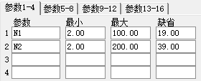

MSI 麦氏综合指标（加密）

OBOS 超买超卖指标
OBOS:EMA(ADVANCE-DECLINE,N);
MAOBOS:MA(OBOS,M);
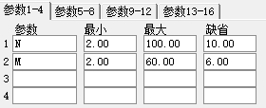

STIX 指数平滑广量
TBR:100*ADVANCE/(ADVANCE+DECLINE);
MATBR:EMA(TBR,M);
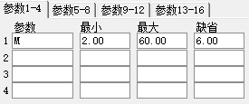

超买超卖型

CCI 商品路径指标
TYP:=(HIGH+LOW+CLOSE)/3;
CCI:(TYP-MA(TYP,N))/(0.015*AVEDEV(TYP,N));
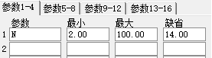

KDJ 随机指标KDJ
RSV:=(CLOSE-LLV(LOW,N))/(HHV(HIGH,N)-LLV(LOW,N))*100;
K:SMA(RSV,M1,1);
D:SMA(K,M2,1);
J:3*K-2*D;
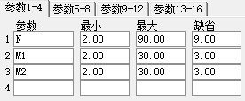

MFI 资金流量指标
TYP := (HIGH + LOW + CLOSE)/3;
V1:=SUM(IF(TYP>REF(TYP,1),TYP*VOL,0),N)/SUM(IF(TYP<REF(TYP,1),TYP*VOL,0),N);
MFI:100-(100/(1+V1));
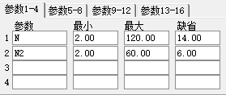

MTM 动量线
MTM:CLOSE-REF(CLOSE,N);
MTMMA:MA(MTM,M);
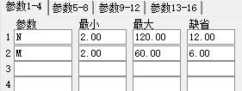

OSC 变动速率线
OSC:100*(CLOSE-MA(CLOSE,N));
MAOSC:EXPMEMA(OSC,M);
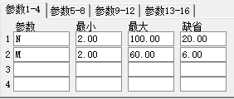

RSI 相对强弱指标
LC:=REF(CLOSE,1);
RSI1:SMA(MAX(CLOSE-LC,0),N1,1)/SMA(ABS(CLOSE-LC),N1,1)*100;
RSI2:SMA(MAX(CLOSE-LC,0),N2,1)/SMA(ABS(CLOSE-LC),N2,1)*100;
RSI3:SMA(MAX(CLOSE-LC,0),N3,1)/SMA(ABS(CLOSE-LC),N3,1)*100;
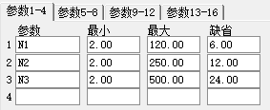

MARSI 相对强弱平均线
DIF:=CLOSE-REF(CLOSE,1);
VU:=IF(DIF>=0,DIF,0);
VD:=IF(DIF<0,-DIF,0);
MAU1:=MEMA(VU,M1);
MAD1:=MEMA(VD,M1);
MAU2:=MEMA(VU,M2);
MAD2:=MEMA(VD,M2);
RSI10:MA(100*MAU1/(MAU1+MAD1),M1);
RSI6:MA(100*MAU2/(MAU2+MAD2),M2);
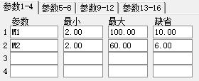

KD 随机指标KD
RSV:=(CLOSE-LLV(LOW,N))/(HHV(HIGH,N)-LLV(LOW,N))*100;
K:SMA(RSV,M1,1);
D:SMA(K,M2,1);
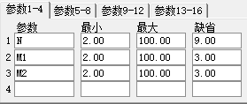

SKDJ 慢速随机指标
LOWV:=LLV(LOW,N);
HIGHV:=HHV(HIGH,N);
RSV:=EMA((CLOSE-LOWV)/(HIGHV-LOWV)*100,M);
K:EMA(RSV,M);
D:MA(K,M);
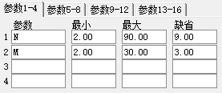

UDL 引力线
UDL:(MA(CLOSE,N1)+MA(CLOSE,N2)+MA(CLOSE,N3)+MA(CLOSE,N4))/4;
MAUDL:MA(UDL,M);
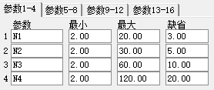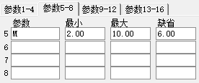

WR 威廉指标
WR1:100*(HHV(HIGH,N)-CLOSE)/(HHV(HIGH,N)-LLV(LOW,N));
WR2:100*(HHV(HIGH,N1)-CLOSE)/(HHV(HIGH,N1)-LLV(LOW,N1));
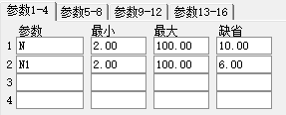

LWR 慢速威廉指标
RSV:= (HHV(HIGH,N)-CLOSE)/(HHV(HIGH,N)-LLV(LOW,N))*100;
LWR1:SMA(RSV,M1,1);
LWR2:SMA(LWR1,M2,1);
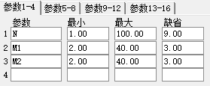

BIAS-QL 乖离率-传统版
BIAS :(CLOSE-MA(CLOSE,N))/MA(CLOSE,N)*100;
BIASMA :MA(BIAS,M);
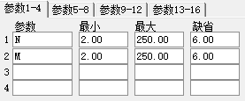

BIAS 乖离率
BIAS1 :(CLOSE-MA(CLOSE,N1))/MA(CLOSE,N1)*100;
BIAS2 :(CLOSE-MA(CLOSE,N2))/MA(CLOSE,N2)*100;
BIAS3 :(CLOSE-MA(CLOSE,N3))/MA(CLOSE,N3)*100;
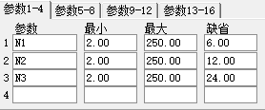

BIAS36 三六乖离
BIAS36:MA(CLOSE,3)-MA(CLOSE,6);
BIAS612:MA(CLOSE,6)-MA(CLOSE,12);
MABIAS:MA(BIAS36,M);
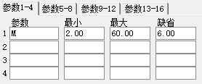

ACCER 幅度涨速
ACCER:SLOPE(CLOSE,N)/CLOSE;
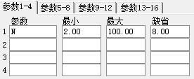

CYD 承接因子
CYDS:WINNER(CLOSE)/(VOL/CAPITAL);
CYDN:WINNER(CLOSE)/MA(VOL/CAPITAL,N);
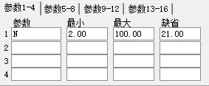

CYF 市场能量
CYF:100-100/(1+EMA(HSL,N));
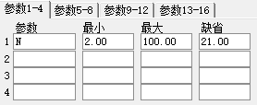

FSL 分水岭
SWL:(EMA(CLOSE,5)*7+EMA(CLOSE,10)*3)/10;
SWS:DMA(EMA(CLOSE,12),MAX(1,100*(SUM(VOL,5)/(3*CAPITAL))));

ADTM 动态买卖气指标
DTM:=IF(OPEN<=REF(OPEN,1),0,MAX((HIGH-OPEN),(OPEN-REF(OPEN,1))));
DBM:=IF(OPEN>=REF(OPEN,1),0,MAX((OPEN-LOW),(OPEN-REF(OPEN,1))));
STM:=SUM(DTM,N);
SBM:=SUM(DBM,N);
ADTM:IF(STM>SBM,(STM-SBM)/STM,IF(STM=SBM,0,(STM-SBM)/SBM));
MAADTM:MA(ADTM,M);
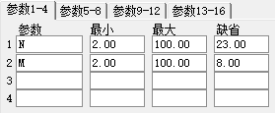

ATR 真实波幅
MTR:MAX(MAX((HIGH-LOW),ABS(REF(CLOSE,1)-HIGH)),ABS(REF(CLOSE,1)-LOW));
ATR:MA(MTR,N);
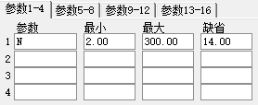

DKX多空线
MID:=(3*CLOSE+LOW+OPEN+HIGH)/6;
DKX:(20*MID+19*REF(MID,1)+18*REF(MID,2)+17*REF(MID,3)+
16*REF(MID,4)+15*REF(MID,5)+14*REF(MID,6)+
13*REF(MID,7)+12*REF(MID,8)+11*REF(MID,9)+
10*REF(MID,10)+9*REF(MID,11)+8*REF(MID,12)+
7*REF(MID,13)+6*REF(MID,14)+5*REF(MID,15)+
4*REF(MID,16)+3*REF(MID,17)+2*REF(MID,18)+REF(MID,20))/210;
MADKX:MA(DKX,M);
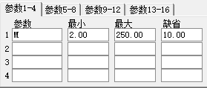

TAPI 加权指数成交值（需下载日线）
TAPI:AMOUNT/INDEXC;
MATAIP:MA(TAPI,M);
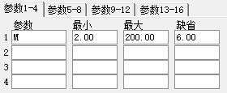

趋势型

ASI 振动升降指标（加密）

CHO 佳庆指标
MID:=SUM(VOL*(2*CLOSE-HIGH-LOW)/(HIGH+LOW),0);
CHO:MA(MID,N1)-MA(MID,N2);
MACHO:MA(CHO,M);
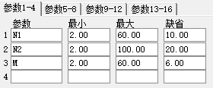

DMA 平均差
DIF:MA(CLOSE,N1)-MA(CLOSE,N2);
DIFMA:MA(DIF,M);
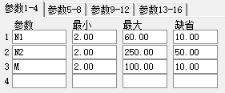

DMI 趋向指标
MTR:=EXPMEMA(MAX(MAX(HIGH-LOW,ABS(HIGH-REF(CLOSE,1))),ABS(REF(CLOSE,1)-LOW)),N);
HD :=HIGH-REF(HIGH,1);
LD :=REF(LOW,1)-LOW;
DMP:=EXPMEMA(IF(HD>0&&HD>LD,HD,0),N);
DMM:=EXPMEMA(IF(LD>0&&LD>HD,LD,0),N);
PDI: DMP*100/MTR;
MDI: DMM*100/MTR;
ADX: EXPMEMA(ABS(MDI-PDI)/(MDI+PDI)*100,MM);
ADXR:EXPMEMA(ADX,MM);
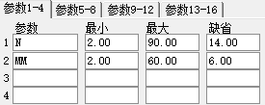

DPO 区间震荡线
DPO:CLOSE-REF(MA(CLOSE,N),N/2+1);
MADPO:MA(DPO,M);
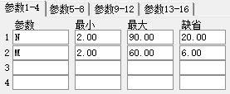

EMV 简易波动指标
VOLUME:=MA(VOL,N)/VOL;
MID:=100*(HIGH+LOW-REF(HIGH+LOW,1))/(HIGH+LOW);
EMV:MA(MID*VOLUME*(HIGH-LOW)/MA(HIGH-LOW,N),N);
MAEMV:MA(EMV,M);
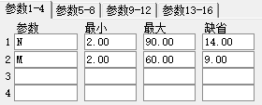

MACD 平滑异同平均
DIF:EMA(CLOSE,SHORT)-EMA(CLOSE,LONG);
DEA:EMA(DIF,MID);
MACD:(DIF-DEA)*2,COLORSTICK;
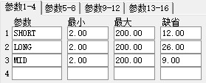

VMACD 量平滑异同平均
DIF:EMA(VOL,SHORT)-EMA(VOL,LONG);
DEA:EMA(DIF,MID);
MACD:DIF-DEA,COLORSTICK;
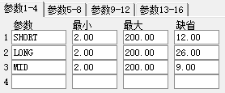

QACD 快速异同平均
DIF:EMA(CLOSE,N1)-EMA(CLOSE,N2);
MACD:EMA(DIF,M);
DDIF:DIF-MACD;
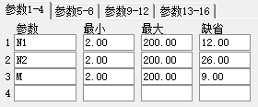

TRIX 三重指数平均线
MTR:=EMA(EMA(EMA(CLOSE,N),N),N);
TRIX:(MTR-REF(MTR,1))/REF(MTR,1)*100;
MATRIX:MA(TRIX,M) ;
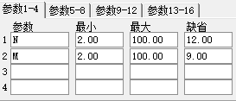

UOS 终极指标
TH:=MAX(HIGH,REF(CLOSE,1));
TL:=MIN(LOW,REF(CLOSE,1));
ACC1:=SUM(CLOSE-TL,N1)/SUM(TH-TL,N1);
ACC2:=SUM(CLOSE-TL,N2)/SUM(TH-TL,N2);
ACC3:=SUM(CLOSE-TL,N3)/SUM(TH-TL,N3);
UOS:(ACC1*N2*N3+ACC2*N1*N3+ACC3*N1*N2)*100/(N1*N2+N1*N3+N2*N3);
MAUOS:EXPMEMA(UOS,M);
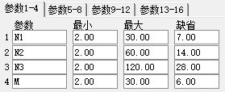

VPT 量价曲线
VPT:SUM(VOL*(CLOSE-REF(CLOSE,1))/REF(CLOSE,1),N);
MAVPT:MA(VPT,M);
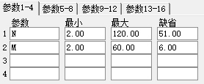

WVAD 威廉变异离散量
WVAD:SUM((CLOSE-OPEN)/(HIGH-LOW)*VOL,N)/10000;
MAWVAD:MA(WVAD,M);
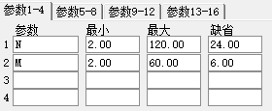

PAV 筹码引力（加密）

DBQR 对比强弱
ZS:(INDEXC-REF(INDEXC,N))/REF(INDEXC,N);
GG:(CLOSE-REF(CLOSE,N))/REF(CLOSE,N);
MADBQR1:MA(GG,M1);
MADBQR2:MA(GG,M2);
MADBQR3:MA(GG,M3);
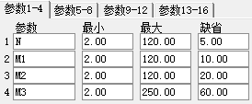

JS 加速线
JS:100*(CLOSE-REF(CLOSE,N))/(N*REF(CLOSE,N));
MAJS1:MA(JS,M1);
MAJS2:MA(JS,M2);
MAJS3:MA(JS,M3);
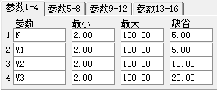

PAVE 强筹码引力（加密）

CYE 市场趋势
MAL:=MA(CLOSE,5);
MAS:=MA(MA(CLOSE,20),5);
CYEL:(MAL-REF(MAL,1))/REF(MAL,1)*100;
CYES:(MAS-REF(MAS,1))/REF(MAS,1)*100;

QR 强弱
个股: (CLOSE-REF(CLOSE,N))/REF(CLOSE,N)*100;
大盘: (INDEXC-REF(INDEXC,N))/REF(INDEXC,N)*100;
强弱值:EMA(个股-大盘,2),COLORSTICK;
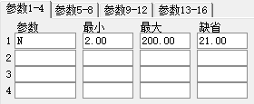

GDX 鬼道线
AA:=ABS((2*CLOSE+HIGH+LOW)/4-MA(CLOSE,N))/MA(CLOSE,N);
JAX:DMA(CLOSE,AA);
压力线:(1+M/100)*JAX;
支撑线:(1-M/100)*JAX;
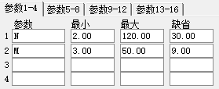

JLHB 绝路航标
VAR1:=(CLOSE-LLV(LOW,60))/(HHV(HIGH,60)-LLV(LOW,60))*80;
B:SMA(VAR1,N,1);
VAR2:SMA(B,M,1);
绝路航标:IF(CROSS(B,VAR2) AND B<40,50,0);
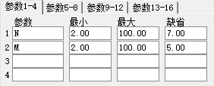

第四节 能量型

BRAR 情绪指标
BR:SUM(MAX(0,HIGH-REF(CLOSE,1)),N)/SUM(MAX(0,REF(CLOSE,1)-LOW),N)*100;
AR:SUM(HIGH-OPEN,N)/SUM(OPEN-LOW,N)*100;
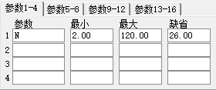

CR 带状能量线
MID:=REF(HIGH+LOW,1)/2;
CR:SUM(MAX(0,HIGH-MID),N)/SUM(MAX(0,MID-LOW),N)*100;
MA1:REF(MA(CR,M1),M1/2.5+1);
MA2:REF(MA(CR,M2),M2/2.5+1);
MA3:REF(MA(CR,M3),M3/2.5+1);
MA4:REF(MA(CR,M4),M4/2.5+1);
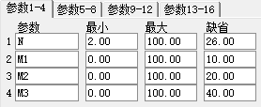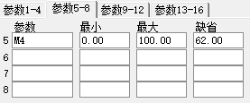

MASS 梅斯线
MASS:SUM(MA(HIGH-LOW,N1)/MA(MA(HIGH-LOW,N1),N1),N2);
MAMASS:MA(MASS,M);
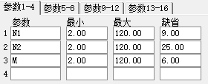

PSY 心理线
PSY:COUNT(CLOSE>REF(CLOSE,1),N)/N*100;
PSYMA:MA(PSY,M);
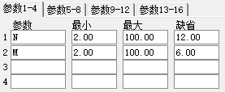

VR 成交量变异率
TH:=SUM(IF(CLOSE>REF(CLOSE,1),VOL,0),N);
TL:=SUM(IF(CLOSE<REF(CLOSE,1),VOL,0),N);
TQ:=SUM(IF(CLOSE=REF(CLOSE,1),VOL,0),N);
VR:100*(TH*2+TQ)/(TL*2+TQ);
MAVR:MA(VR,M);
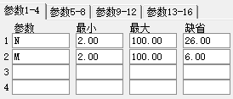

WAD 威廉多空力度线
MIDA:=CLOSE-MIN(REF(CLOSE,1),LOW);
MIDB:=IF(CLOSE<REF(CLOSE,1),CLOSE-MAX(REF(CLOSE,1),HIGH),0);
WAD:SUM(IF(CLOSE>REF(CLOSE,1),MIDA,MIDB),0);
MAWAD:MA(WAD,M);
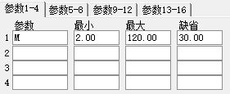

PCNT 幅度比
PCNT:(CLOSE-REF(CLOSE,1))/CLOSE*100;
MAPCNT:EXPMEMA(PCNT,M);
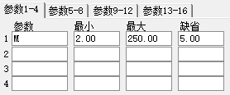

CYR 市场强弱
DIVE:=0.01*EMA(AMOUNT,N)/EMA(VOL,N);
CYR:(DIVE/REF(DIVE,1)-1)*100;
MACYR:MA(CYR,M);
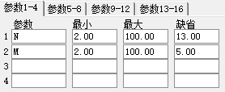

NVI 负成交量（加密）

PVI 正成交量（加密）

第五节 成交量型

AMO 成交金额
AMO:AMOUNT,VOLSTICK;
MAAMO1:MA(AMO,M1);
MAAMO2:MA(AMO,M2);
MAAMO3:MA(AMO,M3);
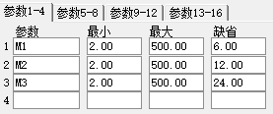

OBV 累积能量线
VA:=IF(CLOSE>REF(CLOSE,1),VOL,-VOL);
OBV:SUM(IF(CLOSE=REF(CLOSE,1),0,VA),0);
MAOBV:MA(OBV,M);
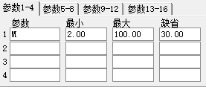

VOL 成交量
VOLUME:VOL,VOLSTICK;
MAVOL1:MA(VOLUME,M1);
MAVOL2:MA(VOLUME,M2);
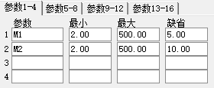

VOL-TDX 成交量（盘中虚拟）
TOTAL:=IF(PERIOD=1,5,IF(PERIOD=2,15,IF(PERIOD=3,30,IF(PERIOD=4,60,IF(PERIOD=5,TOTALFZNUM,1)))));
MTIME:=MOD(FROMOPEN,TOTAL);
CTIME:=IF(MTIME<0.5,TOTAL,MTIME);
VVOL:IF((CURRBARSCOUNT=1 AND DYNAINFO(8)>1),VOL*TOTAL/CTIME,DRAWNULL),NODRAW;
STICKLINE((CURRBARSCOUNT=1 AND DYNAINFO(8)>1),VVOL,0,-1,-1),COLOR00C0C0;
VOLUME:VOL,VOLSTICK;
MAVOL1:MA(VOLUME,M1);
MAVOL2:MA(VOLUME,M2);
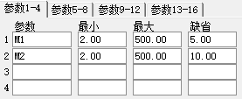

CCL 持仓量（适用于期货）
持仓量:VOLINSTK;
MACCL:MA(持仓量,M);
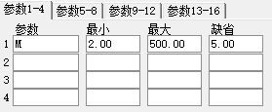

SHORTVOL 抛空量（适用于港股）
抛空量:HKSHORTVOL,VOLSTICK;
MACCL:MA(抛空量,M);
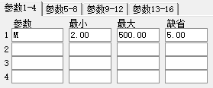

VRSI 相对强弱量
LC:=REF(VOL,1);
RSI1:SMA(MAX(VOL-LC,0),N1,1)/SMA(ABS(VOL-LC),N1,1)*100;
RSI2:SMA(MAX(VOL-LC,0),N2,1)/SMA(ABS(VOL-LC),N2,1)*100;
RSI3:SMA(MAX(VOL-LC,0),N3,1)/SMA(ABS(VOL-LC),N3,1)*100;
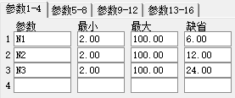

HSL 换手线
HSL:100*VOL/(FINANCE(7)/100);
MAHSL:MA(HSL,N);
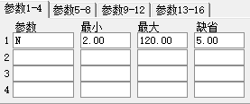

HSCOL 换手柱
HSCOL:100*VOL/(FINANCE(7)/100),VOLSTICK;
MAHSL:MA(HSCOL,N);
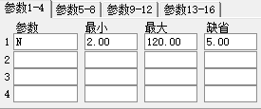

DBQRV 对比强弱量
ZS:(INDEXV-REF(INDEXV,N))/REF(INDEXV,N);
GG:(VOL-REF(VOL,N))/REF(VOL,N);

DBLB 对比量比
GG:=VOL/SUM(REF(VOL,1),N);
ZS:=INDEXV/SUM(REF(INDEXV,1),N);
DBLB:GG/ZS;
MADBLB:MA(DBLB,M);
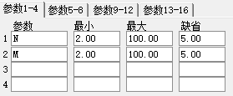

第六节 均线型

MA 均线
MA1:MA(CLOSE,M1);
MA2:MA(CLOSE,M2);
MA3:MA(CLOSE,M3);
MA4:MA(CLOSE,M4);
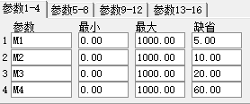

MA2 均线
MA1:MA(CLOSE,M1);
MA2:MA(CLOSE,M2);
MA3:MA(CLOSE,M3);
MA4:MA(CLOSE,M4);
MA5:MA(CLOSE,M5);
MA6:MA(CLOSE,M6);
MA7:MA(CLOSE,M7);
MA8:MA(CLOSE,M8);
MA9:MA(CLOSE,M9);
MA10:MA(CLOSE,M10);
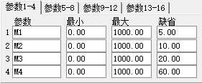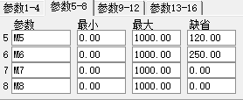

ACD 升降线
LC:=REF(CLOSE,1);
DIF:=CLOSE-IF(CLOSE>LC,MIN(LOW,LC),MAX(HIGH,LC));
ACD:SUM(IF(CLOSE=LC,0,DIF),0);
MAACD:EXPMEMA(ACD,M);
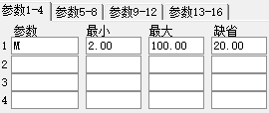

BBI 多空指标
BBI:(MA(CLOSE,M1)+MA(CLOSE,M2)+MA(CLOSE,M3)+MA(CLOSE,M4))/4;
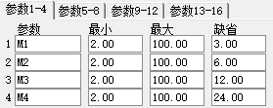

EXPMA 指数平均线
EXP1:EMA(CLOSE,M1);
EXP2:EMA(CLOSE,M2);
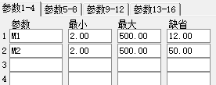

EXPMA-S 指数平均线-副图
EXP1:EMA(CLOSE,M1);
EXP2:EMA(CLOSE,M2);

HMA 高价平均线
HMA1:MA(HIGH,M1);
HMA2:MA(HIGH,M2);
HMA3:MA(HIGH,M3);
HMA4:MA(HIGH,M4);
HMA5:MA(HIGH,M5);
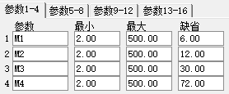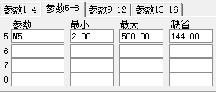

LMA 低价平均线
LMA1:MA(LOW,M1);
LMA2:MA(LOW,M2);
LMA3:MA(LOW,M3);
LMA4:MA(LOW,M4);
LMA5:MA(LOW,M5);
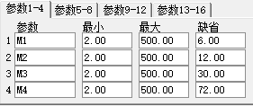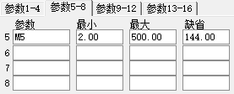

VMA 变异平均线
VV:=(HIGH+OPEN+LOW+CLOSE)/4;
VMA1:MA(VV,M1);
VMA2:MA(VV,M2);
VMA3:MA(VV,M3);
VMA4:MA(VV,M4);
VMA5:MA(VV,M5);

AMA 成本价均线
AMOV:=VOL*(OPEN+CLOSE)/2;
AMV1:SUM(AMOV,M1)/SUM(VOL,M1);
AMV2:SUM(AMOV,M2)/SUM(VOL,M2);
AMV3:SUM(AMOV,M3)/SUM(VOL,M3);
AMV4:SUM(AMOV,M4)/SUM(VOL,M4);
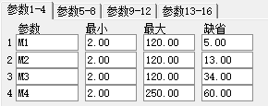

MCST 市场成本

BBIBOLL 多空布林线
CV:=CLOSE;
BBIBOLL:(MA(CV,3)+MA(CV,6)+MA(CV,12)+MA(CV,24))/4;
UPR:BBIBOLL+M*STD(BBIBOLL,N);
DWN:BBIBOLL-M*STD(BBIBOLL,N);
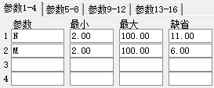

第七节 图表型

ZXNH 直线拟合（加密）

ZX 重心线
AV:0.01*AMOUNT/VOL;

PUCU 逆时钟曲线
PU:MA(CLOSE,N);
CU:MA(VOL,N);
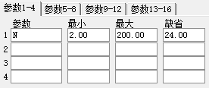

第八节 路径型

BOLL-M 布林线-主图叠加

BOLL 布林线
BOLL:MA(CLOSE,N);
UB:BOLL+2*STD(CLOSE,N);
LB:BOLL-2*STD(CLOSE,N);
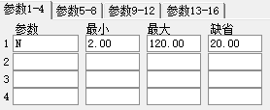

PXB 瀑布线
PBX1:(EMA(CLOSE,M1)+MA(CLOSE,M1*2)+MA(CLOSE,M1*4))/3;
PBX2:(EMA(CLOSE,M2)+MA(CLOSE,M2*2)+MA(CLOSE,M2*4))/3;
PBX3:(EMA(CLOSE,M3)+MA(CLOSE,M3*2)+MA(CLOSE,M3*4))/3;
PBX4:(EMA(CLOSE,M4)+MA(CLOSE,M4*2)+MA(CLOSE,M4*4))/3;
PBX5:(EMA(CLOSE,M5)+MA(CLOSE,M5*2)+MA(CLOSE,M5*4))/3;
PBX6:(EMA(CLOSE,M6)+MA(CLOSE,M6*2)+MA(CLOSE,M6*4))/3;
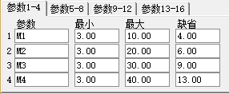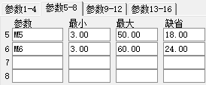

EXE 轨道线
UPPER:(1+M1/100)*MA(CLOSE,N);
LOWER:(1-M2/100)*MA(CLOSE,N);
ENE:(UPPER+LOWER)/2;
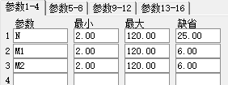

MIKE 麦克支撑压力
HLC:=REF(MA((HIGH+LOW+CLOSE)/3,N),1);
HV:=EMA(HHV(HIGH,N),3);
LV:=EMA(LLV(LOW,N),3);
STOR:EMA(2*HV-LV,3);
MIDR:EMA(HLC+HV-LV,3);
WEKR:EMA(HLC*2-LV,3);
WEKS:EMA(HLC*2-HV,3);
MIDS:EMA(HLC-HV+LV,3);
STOS:EMA(2*LV-HV,3);
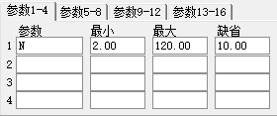

SSRP 筹码峰（加密）

XS 薛斯通道（加密）

XS2 薛斯通道Ⅱ
AA:=MA((2*CLOSE+HIGH+LOW)/4,5);
通道1:AA*N/100;
通道2:AA*(200-N)/100;
CC:=ABS((2*CLOSE+HIGH+LOW)/4-MA(CLOSE,20))/MA(CLOSE,20);
DD:=DMA(CLOSE,CC);
通道3:(1+M/100)*DD;
通道4:(1-M/100)*DD;
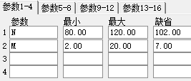

第九节 停损型

SAR 抛物线指标（加密）

TDXWAVE 通达信趋势浪（加密）

VTY 价格变异率（加密）

第十节 策略型

MA策略 MA交易策略
{该模型为示范模型,仅用于说明算法语法,用户需根据自己交易经验修改后再实际应用}
{变量赋值}
MA1:=MA(CLOSE,SHORT);
MA2:=MA(CLOSE,LONG);
{交易条件}
平空开多:=CROSS(MA1,MA2);
平多开空:=CROSS(MA2,MA1);
{交易系统}
BUYSHORT_BUY(平空开多,LOW);
SELL_SELLSHORT(平多开空,HIGH);
{交易信号过滤}
AUTOFILTER;
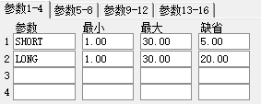

MACD策略 MACD交易策略
{该模型为示范模型,仅用于说明算法语法,用户需根据自己交易经验修改后再实际应用}
DIFF:=EMA(CLOSE,SHORT)-EMA(CLOSE,LONG);
DEA:=EMA(DIFF,MID);
MACD:=2*(DIFF-DEA);
平空开多:=CROSS(MACD,0);
平多开空:=CROSS(0,MACD);
BUYSHORT_BUY(平空开多,LOW);
SELL_SELLSHORT(平多开空,HIGH);
AUTOFILTER;
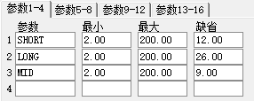

KDJ策略 KDJ交易策略
{该模型为示范模型,仅用于说明算法语法,用户需根据自己交易经验修改后再实际应用}
RSV:=(CLOSE-LLV(LOW,N))/(HHV(HIGH,N)-LLV(LOW,N))*100;
K:=SMA(RSV,M1,1);
D:=SMA(K,M1,1);
J:=3*K-2*D;
平空开多:=CROSS(J,0);
平多开空:=CROSS(100,J);
BUYSHORT_BUY(平空开多,LOW);
SELL_SELLSHORT(平多开空,HIGH);
AUTOFILTER;
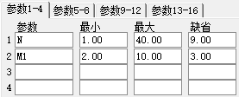

肯特纳 肯特纳通道交易策略
{该模型为示范模型,仅用于说明算法语法,用户需根据自己交易经验修改后再实际应用}
MA1:=REF(MA((HIGH+LOW+CLOSE)/3,AVGLENGTH),1);
UPPERBAND:=MA1+REF(MA(TR,ATRLENGTH),1);
LOWERBAND:=MA1-REF(MA(TR,ATRLENGTH),1);
开多条件:=MA1>REF(MA1,1) AND HIGH>=UPPERBAND;
平多条件:=LOW<=MA1;
开空条件:=MA1<REF(MA1,1) AND LOW<=LOWERBAND;
平空条件:=HIGH>=MA1;
GL1:=NOT(开多条件=1 AND 平多条件=1);
GL2:=NOT(开空条件=1 AND 平空条件=1);
SELL(平多条件,HIGH);
BUYSHORT(平空条件,LOW);
BUY(开多条件 AND GL1,LOW);
SELLSHORT(开空条件 AND GL2,HIGH);
AUTOFILTER;
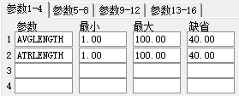

唐奇安 唐奇安通道交易策略
{该模型为示范模型,仅用于说明算法语法,用户需根据自己交易经验修改后再实际应用}
周期高点:=REF(HHV(H,X1),1);
周期低点:=REF(LLV(L,X2),1);
平空开多:=HIGH>=周期高点;
平多开空:=LOW<=周期低点;
BUYSHORT_BUY(平空开多,LOW);
SELL_SELLSHORT(平多开空,HIGH);
AUTOFILTER;
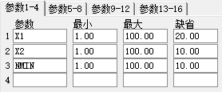

日内突破 日内突破交易策略
{该模型为示范模型,仅用于说明算法语法,用户需根据自己交易经验修改后再实际应用}
{变量赋值}
NBAR:=BARSLAST(DATE<>REF(DATE,1))+1;
HHN:REF(HHV(H,N),1);
LLN:REF(LLV(L,N),1);
MID:(HHN+LLN)/2;
T1:=TIME>900 AND TIME <1455;{根据品种的交易时间和选择的周期做相应调整}
T2:=TIME>=1455;{根据品种的交易时间和选择的周期做相应调整}
{交易条件}
开多条件:=H>HHN AND (HHN-MID)/MID<M/1000 AND NBAR>=30 AND T1;
开空条件:=L<LLN AND (MID-LLN)/MID<M/1000 AND NBAR>=30 AND T1;
{交易系统}
BUY(开多条件,LOW);
SELLSHORT(开空条件,HIGH);
SELL(T2,HIGH);
BUYSHORT(T2,LOW);
AUTOFILTER;
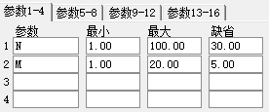

HANS123 日内HANS交易策略
{该模型为示范模型,仅用于说明算法语法,用户需根据自己交易经验修改后再实际应用}
{变量赋值}
N:=BARSLAST(DATE<>REF(DATE,1))+1;
HHH:=VALUEWHEN(TIME<=900+NMIN1,HHV(H,N));
LLL:=VALUEWHEN(TIME<=900+NMIN1,LLV(L,N));
上轨:HHH+M*MINDIFF;
下轨:LLL-M*MINDIFF;
{交易条件}
开多条件:=C>上轨;
开空条件:=C<下轨;
交易时间:=TIME>900+NMIN1 AND TIME<1450;
平仓时间:=TIME>=1500-NMIN2;
{交易系统}
BUY(开多条件 AND 交易时间,LOW);
SELLSHORT(开空条件 AND 交易时间,HIGH);
SELL(平仓时间,HIGH);
BUYSHORT(平仓时间,LOW);
AUTOFILTER;
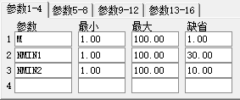

第十一节 神系

SG-XDT 心电图（需下载日线）
QR:CLOSE/INDEXC*1000;
MQR1:MA(QR,5);
MQR2:MA(QR,10);
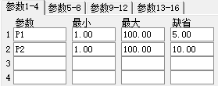

SG-NDB 脑电波
HH:=IF(C/REF(C,1)>1.093 AND L>REF(H,1),2*C-REF(C,1)-H,2*C-H-L);
V1:=BARSCOUNT(C);
V2:=2*REF(C,V1)-REF(H,V1)-REF(L,V1);
DK:SUM(HH,0)+V2;
MDK5:MA(DK,P1);
MDK10:MA(DK,P2);
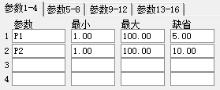

SG-SMX 生命线（需下载日线）
H1:=HHV(HIGH,N);
L1:=LLV(LOW,N);
H2:=HHV(INDEXH,N);
L2:=LLV(INDEXL,N);
ZY:=CLOSE/INDEXC*2000;
ZY1:EMA(ZY,3);
ZY2:EMA(ZY,17);
ZY3:EMA(ZY,34);
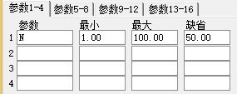

SG-LB 量比（需下载日线）
ZY2:=VOL/INDEXV*1000;
量比:ZY2;
MA5:MA(ZY2,5);
MA10:MA(ZY2,10);

SG-PF 强势股评分（需下载日线）
ZY1:=CLOSE/INDEXC*1000;
A1:=IF(ZY1>HHV(ZY1,3),10,0);
A2:=IF(ZY1>HHV(ZY1,5),15,0);
A3:=IF(ZY1>HHV(ZY1,10),20,0);
A4:=IF(ZY1>HHV(ZY1,2),10,0);
A5:=COUNT(ZY1>REF(ZY1,1) ,9)*5;
强势股评分:A1+A2+A3+A4+A5;

第十二节 龙系

RAD 威力雷达
SM:=(OPEN+HIGH+CLOSE+LOW)/4;
SMID:=MA(SM,D);
IM:=(INDEXO+INDEXH+INDEXL+INDEXC)/4;
IMID:=MA(IM,D);
SI1:=(SMID-REF(SMID,1))/SMID;
II:=(IMID-REF(IMID,1))/IMID;
RADER1:SUM((SI1-II)*2,S)*1000;
RADERMA:SMA(RADER1,M,1);
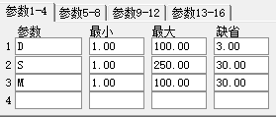

LON 龙系长线
LC := REF(CLOSE,1);
VID := SUM(VOL,2)/(((HHV(HIGH,2)-LLV(LOW,2)))*100);
RC := (CLOSE-LC)*VID;
LONG := SUM(RC,0);
DIFF := SMA(LONG,10,1);
DEA := SMA(LONG,20,1);
LON : DIFF-DEA;
LONMA : MA(LON,10);
LONT : LON, COLORSTICK;
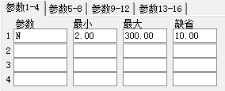

SHT 龙系短线
VAR1:=MA((VOL-REF(VOL,1))/REF(VOL,1),5);
VAR2:=(CLOSE-MA(CLOSE,24))/MA(CLOSE,24)*100;
MY: VAR2*(1+VAR1);
SHT: MY, COLORSTICK;
SHTMA: MA(SHT,N);
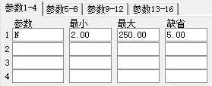

ZLJC 主力进出
VAR1:=(CLOSE+LOW+HIGH)/3;
VAR2:=SUM(((VAR1-REF(LOW,1))-(HIGH-VAR1))*VOL/100000/(HIGH-LOW),0);
VAR3:=EMA(VAR2,1);
JCS:VAR3;
JCM:MA(VAR3,12);
JCL:MA(VAR3,26);

ZLMM 主力买卖
LC :=REF(CLOSE,1);
RSI2:=SMA(MAX(CLOSE-LC,0),12,1)/SMA(ABS(CLOSE-LC),12,1)*100;
RSI3:=SMA(MAX(CLOSE-LC,0),18,1)/SMA(ABS(CLOSE-LC),18,1)*100;
MMS:MA(3*RSI2-2*SMA(MAX(CLOSE-LC,0),16,1)/SMA(ABS(CLOSE-LC),16,1)*100,3);
MMM:EMA(MMS,8);
MML:MA(3*RSI3-2*SMA(MAX(CLOSE-LC,0),12,1)/SMA(ABS(CLOSE-LC),12,1)*100,5);

SLZT 神龙在天
白龙: MA(CLOSE,125);
黄龙: 白龙+2*STD(CLOSE,170);
紫龙: 白龙-2*STD(CLOSE,145);
青龙: SAR(125,1,7), LINESTICK;
VAR2:=HHV(HIGH,70);
VAR3:=HHV(HIGH,20);
红龙: VAR2*0.83;
蓝龙: VAR3*0.91;

ADVOL 龙系离散量
A:=SUM(((CLOSE-LOW)-(HIGH-CLOSE))*VOL/10000/(HIGH-LOW),0);
ADVOL:A;
MA1:MA(A,30);
MA2:MA(MA1,100);

第十三节 鬼系

CYC 成本均线
JJJ:=IF(DYNAINFO(8)>0.01,0.01*DYNAINFO(10)/DYNAINFO(8),DYNAINFO(3));
DDD:=(DYNAINFO(5)<0.01 || DYNAINFO(6)<0.01);
JJJT:=IF(DDD,1,(JJJ<(DYNAINFO(5)+0.01) && JJJ>(DYNAINFO(6)-0.01)));
CYC1:IF(JJJT,0.01*EMA(AMOUNT,P1)/EMA(VOL,P1),EMA((HIGH+LOW+CLOSE)/3,P1));
CYC2:IF(JJJT,0.01*EMA(AMOUNT,P2)/EMA(VOL,P2),EMA((HIGH+LOW+CLOSE)/3,P2));
CYC3:IF(JJJT,0.01*EMA(AMOUNT,P3)/EMA(VOL,P3),EMA((HIGH+LOW+CLOSE)/3,P3));
CYC∞:IF(JJJT,DMA(AMOUNT/(100*VOL),100*VOL/FINANCE(7)),EMA((HIGH+LOW+CLOSE)/3,120));
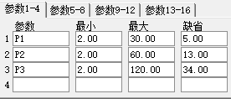

CYS 市场盈亏
CYC13:=0.01*EMA(AMOUNT,13)/EMA(VOL,13);
CYS:(CLOSE-CYC13)/CYC13*100;

CYQKL 博弈K线长度
KL:100*(WINNER(CLOSE)-WINNER(OPEN));

CYW 主力控盘
VAR1:=CLOSE-LOW;
VAR2:=HIGH-LOW;
VAR3:=CLOSE-HIGH;
VAR4:=IF(HIGH>LOW,(VAR1/VAR2+VAR3/VAR2)*VOL,0);
CYW: SUM(VAR4,10)/10000, COLORSTICK;

第十四节 其他系

XT 箱体
【箱顶】:PEAK(CLOSE,N,1)*0.98;
【箱底】:TROUGH(CLOSE,N,1)*1.02;
【箱高】:100*(【箱顶】-【箱底】)/【箱底】,NODRAW;
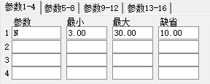

JAX 济安线
AA:=ABS((2*CLOSE+HIGH+LOW)/4-MA(CLOSE,N))/MA(CLOSE,N);
济安线:DMA((2*CLOSE+LOW+HIGH)/4,AA),LINETHICK3,COLORMAGENTA;
CC:=(CLOSE/济安线);
MA1:=MA(CC*(2*CLOSE+HIGH+LOW)/4,3);
MAAA:=((MA1-济安线)/济安线)/3;
TMP:=MA1-MAAA*MA1;
J:IF(TMP<=济安线,济安线,DRAWNULL),LINETHICK3,COLORCYAN;
A:TMP,LINETHICK2,COLORYELLOW;
X:IF(TMP<=济安线,TMP,DRAWNULL),LINETHICK2,COLORGREEN;
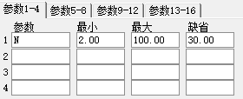

CJDX 超级短线
VAR1:=(2*CLOSE+HIGH+LOW)/4;
VAR2:=EMA(EMA(EMA(VAR1,4),4),4);
J: (VAR2-REF(VAR2,1))/REF(VAR2,1)*100, COLORSTICK;
D: MA(J,3);
K: MA(J,1);

ZJTJ 庄家抬轿
VAR1:=EMA(EMA(CLOSE,9),9);
控盘:=(VAR1-REF(VAR1,1))/REF(VAR1,1)*1000;
STICKLINE(控盘<0,控盘,0,1,0),COLORWHITE;
A10:=CROSS(控盘,0);
无庄控盘:IF(控盘<0,控盘,0),COLORWHITE,NODRAW;
开始控盘:IF(A10,5,0),LINETHICK1,COLORYELLOW;
STICKLINE(控盘>REF(控盘,1) AND 控盘>0,控盘,0,1,0),COLORRED;
有庄控盘:IF(控盘>REF(控盘,1) AND 控盘>0,控盘,0),COLORRED,NODRAW;
VAR2:=100*WINNER(CLOSE*0.95);
STICKLINE(VAR2>50 AND COST(85)<CLOSE AND 控盘>0,控盘,0,1,0),COLORFF00FF;
高度控盘:IF(VAR2>50 AND COST(85)<CLOSE AND 控盘>0,控盘,0),COLORFF00FF,NODRAW;
STICKLINE(控盘<REF(控盘,1) AND 控盘>0,控盘,0,1,0),COLOR00FF00;
主力出货:IF(控盘<REF(控盘,1) AND 控盘>0,控盘,0),COLOR00FF00,NODRAW;

ZBCD 准备抄底
VAR1:=AMOUNT/VOL/7;
VAR2:=(3*HIGH+LOW+OPEN+2*CLOSE)/7;
VAR3:=SUM(AMOUNT,N)/VAR1/7;
VAR4:=DMA(VAR2,VOL/VAR3);
抄底:(CLOSE-VAR4)/VAR4*100,COLORLIMAGENTA;
DRAWICON(CROSS(-7.0,抄底),抄底,1);
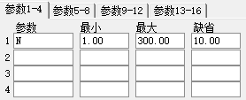

BDZX 波段之星
VAR2:=(HIGH+LOW+CLOSE*2)/4;
VAR3:=EMA(VAR2,21);
VAR4:=STD(VAR2,21);
VAR5:=((VAR2-VAR3)/VAR4*100+200)/4;
VAR6:=(EMA(VAR5,5)-25)*1.56;
AK: EMA(VAR6,2)*1.22;
AD1: EMA(AK,2);
AJ: 3*AK-2*AD1;
AA:100;
BB:0;
CC:80;
买进: IF(CROSS(AK,AD1),58,20);
卖出: IF(CROSS(AD1,AK),58,20);

LHXJ 猎狐先觉
VAR1:=(CLOSE*2+HIGH+LOW)/4;
VAR2:=EMA(VAR1,13)-EMA(VAR1,34);
VAR3:=EMA(VAR2,5);
主力弃盘: (-2)*(VAR2-VAR3)*3.8;
主力控盘: 2*(VAR2-VAR3)*3.8;

LYJH 猎鹰歼狐
VAR1:=(HHV(HIGH,36)-CLOSE)/(HHV(HIGH,36)-LLV(LOW,36))*100;
机构做空能量线: SMA(VAR1,2,1);
VAR2:=(CLOSE-LLV(LOW,9))/(HHV(HIGH,9)-LLV(LOW,9))*100;
机构做多能量线: SMA(VAR2,5,1)-8;
LH: M;
LH1: M1;

JFZN 飓风智能中线
VAR2:=SUM(IF(CLOSE>OPEN,VOL,0),N)/SUM(VOL,N)*100;
VAR3:=100-SUM(IF(CLOSE>OPEN,VOL,0),N)/SUM(VOL,N)*100;
多头力量: VAR2;
空头力量: VAR3;
多空平衡: 50;
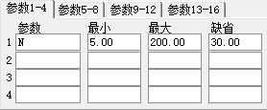

CYHT 财运亨通
VAR1:=(2*CLOSE+HIGH+LOW+OPEN)/5;
高抛: 80;
VAR2:=LLV(LOW,34);
VAR3:=HHV(HIGH,34);
SK: EMA((VAR1-VAR2)/(VAR3-VAR2)*100,13);
SD: EMA(SK,3);
低吸: 20;
强弱分界: 50;
VAR4:=IF(CROSS(SK,SD),40,22);
VAR5:=IF(CROSS(SD,SK),60,78);
卖出: VAR5;
买进: VAR4;

SCR 筹码集中度
A:=P1+(100-P1)/2;
B:=(100-P1)/2;
CC:=COST(A);
DD:=COST(B);
SCR:(CC-DD)/(CC+DD)*100/2;
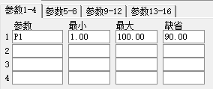

ASR 浮筹比例
ASR:(WINNER(C*1.1)-WINNER(C*0.9))/WINNER(HHV(H,0))*100;

BSQJ 买卖区间
买线:=EMA(C,2);
卖线:=EMA(SLOPE(C,21)*20+C,42);
STICKLINE(买线>=卖线,REFDATE(HHV(H,0),DATE),REFDATE(LLV(L,0),DATE),6,0),COLOR001050;
STICKLINE(买线<卖线,REFDATE(HHV(H,0),DATE),REFDATE(LLV(L,0),DATE),6,0),COLOR404050;
DRAWKLINE(H,O,L,C);
指导:=EMA((EMA(CLOSE,4)+EMA(CLOSE,6)+EMA(CLOSE,12)+EMA(CLOSE,24))/4,2);
界:=MA(CLOSE,27);
B买:IF(CROSS(指导,界) OR CROSS(买线,卖线),C,DRAWNULL),COLORMAGENTA,NODRAW;
持仓:IF(买线>=卖线,C,DRAWNULL),COLORRED,NODRAW;
S卖:IF(CROSS(界,指导) OR CROSS(卖线,买线),C,DRAWNULL),COLORLIGRAY,NODRAW;
空仓:IF(买线<卖线,C,DRAWNULL),COLORGREEN,NODRAW;
DRAWICON(CROSS(买线,卖线),L,1);
DRAWICON(CROSS(卖线,买线),H,2);

ZJL 折价率 用于排序
折价率:IF(FINANCE(34)>0.001,(FINANCE(34)-CLOSE)*100.0/FINANCE(34),0);

CDP-STD 逆势操作
CH:=REF(H,1);
CL:=REF(L,1);
CC:=REF(C,1);
CDP:(CH+CL+CC)/3;
AH:CDP+CH-CL;
NH:CDP+CDP-CL;
NL:CDP+CDP-CH;
AL:CDP-CH+CL;

TBP-STD 趋势平衡点
APX:=(H+L+C)/3;
TR0:=MAX(H-L,MAX(ABS(H-REF(C,1)),ABS(L-REF(C,1))));
MF0:=C-REF(C,2);
MF1:=REF(MF0,1);
MF2:=REF(MF0,2);
DIRECT1:=BARSLAST(MF0>MF1 AND MF0>MF2);
DIRECT2:=BARSLAST(MF0<MF1 AND MF0<MF2);
DIRECT0:=IF(DIRECT1<DIRECT2,100,-100);
TBP:REF(REF(C,1)+IF(DIRECT0>50,MIN(MF0,MF1),MAX(MF0,MF1)),1);
多头获利:REF(IF(DIRECT0>50,APX*2-L,DRAWNULL),1),NODRAW;
多头停损:REF(IF(DIRECT0>50,APX-TR0,DRAWNULL),1),NODRAW;
空头回补:REF(IF(DIRECT0<-50,APX*2-H,DRAWNULL),1),NODRAW;
空头停损:REF(IF(DIRECT0<-50,APX+TR0,DRAWNULL),1),NODRAW;

SC 三叉（加密）

NDB 脑电波（加密）

JYJL 交易参考均量
单位时间总量: SUM(VOL,N)*100,NODRAW;
单位时间内均量: 单位时间总量/(N/M);
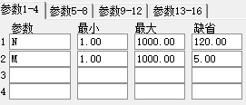

JSJG 参考结算价（适用于金融期货）
FIRST:=IF(PERIOD=0,HOUR=14 AND MINUTE=16,DRAWNULL);
TOTAL:=IF(PERIOD=0,60,0);
MAMIN:=BARSLAST(FIRST)+1;
COUNTFLAG:=(PERIOD=0 AND ( (HOUR=14 AND MINUTE>=16) OR HOUR=15 ));
逼近结算价格:IF(COUNTFLAG,SUM(C*V,MAMIN)/SUM(V,MAMIN),DRAWNULL);
LASTP:=C;
LASTM:=MAMIN;
LASTV:=MA(V,MAMIN);
参考结算价格:IF(COUNTFLAG,(SUM(C*V,MAMIN)+
LASTP*LASTV*(TOTAL-LASTM))/(LASTV*TOTAL),DRAWNULL);

VOLATILITY 波动率
SQRT(250)*STD(C/REF(C,1)-1,N);

第十五节 特色型

CPBS 操盘BS点
BU:=CROSS(HIGH,SAR(3,1,20));
SEL:=CROSS(SAR(3,1,20),LOW);
DRAWTEXT(BU,LOW,'B'),COLORYELLOW,LINETHICK2;
DRAWTEXT(SEL,1.01*HIGH,'S'),COLORGREEN,LINETHICK2;

CYX 撑压线
Z1:=STRCAT(HYBLOCK,' ');
Z2:=STRCAT(Z1,DYBLOCK);
Z3:=STRCAT(Z2,' ');
DRAWTEXT_FIX(ISLASTBAR,0,0,0,STRCAT(Z3,GNBLOCK)),COLOR00C0C0;
A1:=REF(H,N)=HHV(H,2*N+1);
B1:=FILTER(A1,N);
C1:=BACKSET(B1,N+1);
D1:=FILTER(C1,N);
A2:=REF(L,N)=LLV(L,2*N+1);
B2:=FILTER(A2,N);
C2:=BACKSET(B2,N+1);
D2:=FILTER(C2,N);
E1:=(REF(LLV(L,2*N),1)+REF(HHV(H,2*N),1))/2;
E2:=(H+L)/2;
H1:=(D1 AND NOT(D2 AND E1>=E2)) OR ISLASTBAR OR BARSCOUNT(C)=1;
L1:=(D2 AND NOT(D1 AND E1<E2));
H2:=D1 AND NOT(D2 AND E1>=E2);
X1:=REF(BARSLAST(H1),1)+1;
F1:=BACKSET(H1 AND COUNT(L1,X1)>0,LLVBARS(IF(L1,L,10000),X1));
G1:=F1>REF(F1,1);
I1:=BACKSET(G1,2);
LD:=I1>REF(I1,1);
L2:=LD OR ISLASTBAR OR BARSCOUNT(C)=1;
X2:=REF(BARSLAST(L2),1)+1;
F2:=BACKSET(L2 AND COUNT(H2,X2)>0,HHVBARS(IF(H2,H,0),X2));
G2:=F2>REF(F2,1);
I2:=BACKSET(G2,2);
HD:=I2>REF(I2,1);
R1:=BACKSET(ISLASTBAR,BARSLAST(HD)+1);
S1:=R1>REF(R1,1);
T1:=BACKSET(ISLASTBAR,BARSLAST(LD)+1);
U1:=T1>REF(T1,1);
R2:=BACKSET(S1,REF(BARSLAST(HD),1)+2);
S2:=R2>REF(R2,1);
T2:=BACKSET(U1,REF(BARSLAST(LD),1)+2);
U2:=T2>REF(T2,1);
NOTEXT1:DRAWLINE(S2,H,S1,H,1),LINETHICK2,COLORRED;
NOTEXT2:DRAWLINE(U2,L,U1,L,1),LINETHICK2,COLORGREEN;
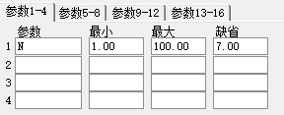

WAVE 波浪分析
ZIG(3,因子);
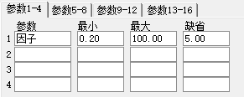

SKSD 时空隧道
STICKLINE(CURRBARSCOUNT<=N,H,L,-1,0),COLORBLACK;
DRAWTEXT_FIX(ISLASTBAR,0,0,0,STRCAT(CON2STR(N,0),'周期前K线 选中主图后按ALT+T键调节回退的周期')),COLORLIMAGENTA;
NOTEXT1:IF(CURRBARSCOUNT>=N+1,MA(C,M),DRAWNULL),COLORWHITE;
NOTEXT2:IF(CURRBARSCOUNT<=N,MA(C,M),DRAWNULL),COLORBLACK;
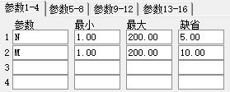

XLPL 吸拉派落（加密）

GSTQ 股市天气（加密）

AROON 阿隆指标
上轨:(N-HHVBARS(H,N))/N*100,COLORRED;
下轨:(N-LLVBARS(H,N))/N*100,COLORGREEN;
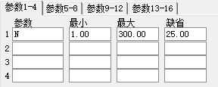

CFJT 财富阶梯
突破:=REF(EMA(C,14),1);
A1X:=(EMA(C,10)-突破)/突破*100;
多方:=IF(A1X>=0,REF(EMA(C,10),BARSLAST(CROSS(A1X,0))+1),DRAWNULL);
空方:=IF(A1X<0,REF(EMA(C,10),BARSLAST(CROSS(0,A1X))+1),DRAWNULL);
STICKLINE(A1X>=0,多方,突破,10,0),COLOR000099;
STICKLINE(A1X<0,空方,突破,10,0),COLOR00CC66;

TJCJL 太极成交量
总手:VOL,NODRAW;
DRAWTEXT_FIX(ISLASTBAR,0,0,0,'说明: 红色柱为吸货量,绿色为出货量,黄色为天量,蓝色为地量'),COLORGRAY;
ZZ:=IF(REF(C,1)>REF(O,1) AND O>REF(C,1)*1.014 AND C<O*1.02,1,3);
V5:=MA(V,5);
V12:=MA(V,12);
V34:=MA(V,34);
C6:=MA(C,6);
STICKLINE(VOL,0,VOL,1,0),COLORLIGRAY;
STICKLINE(CROSS(C,C6) AND V>V5*1.2 AND V>V12*1.2 AND ZZ>2 AND C>H*0.975,0,VOL,1,0),COLORRED;
STICKLINE(CROSS(C6,C) AND V>V5*1.2 AND V>V12*1.2,0,VOL,1,0),COLORGREEN;
STICKLINE(VOL>MA(VOL,5)*2 AND V>V34*3 AND C<REF(C,1)*1.05,0,VOL,1,0),COLORYELLOW;
STICKLINE(VOL<MA(VOL,5)/2 AND V<V12/2,0,VOL,1,0),COLORBLUE;
STICKLINE(VOL>MA(VOL,5)*2 AND V>V34*3 AND C<REF(C,1)*1.05 AND CROSS(C,C6) AND V>V5*1.2 AND V>V12*1.2 AND ZZ>2 AND C>H*0.975,VOL*0.5,0,1,0),COLORRED;
STICKLINE(VOL>MA(VOL,5)*2 AND V>V34*3 AND C<REF(C,1)*1.05 AND CROSS(C6,C) AND V>V5*1.2 AND V>V12*1.2,VOL*0.5,0,1,0),COLORRED;

ZJFZ 追击反转
VAR2:=REF(LOW,1);
VAR3:=SMA(ABS(LOW-VAR2),3,1)/SMA(MAX(LOW-VAR2,0),3,1)*100;
VAR4:=EMA(VAR3*10,3);
VAR5:=LLV(LOW,13);
VAR6:=HHV(VAR4,13);
VAR7:=EMA(IF(LOW<=VAR5,(VAR4+VAR6*2)/2,0),3)/618;
VAR8:=IF(VAR7>500,500,VAR7);
STICKLINE(VAR8>-120,0,VAR8,3,1),COLORGRAY;
STICKLINE(VAR8>1 AND "KDJ.J">REF("KDJ.J",1) AND REF("KDJ.J",1)<REF("KDJ.J",2),0,VAR8,3,0),COLORRED;
STICKLINE(VAR8>0.1 AND VAR8<1 AND "KDJ.J">REF("KDJ.J",1) AND REF("KDJ.J",1)<REF("KDJ.J",2),0,VAR8,3,0),COLOR00FFFF;

ZSDB 指数对比
A:=REF(INDEXC,1);
指数涨幅:IF(A>0,(INDEXC-A)*100/A,0),NODRAW;
HYDB:DRAWKLINE(INDEXH,INDEXO,INDEXL,INDEXC);

HYDB 行业对比
A:=REF(HY_INDEXC,1);
行业涨幅:IF(A>0,(HY_INDEXC-A)*100/A,0),NODRAW;
DRAWTEXT_FIX(ISLASTBAR,0,0,0,HYBLOCK),COLOR00C0C0;
HYDB:DRAWKLINE(HY_INDEXH,HY_INDEXO,HY_INDEXL,HY_INDEXC);

FKX 反K线
DRAWKLINE(-LOW, -OPEN, -HIGH, -CLOSE);

ZJLX 资金流向
超B:=L2_AMO(0,2)/10000.0;
大B:=L2_AMO(1,2)/10000.0;
中B:=L2_AMO(2,2)/10000.0;
小B:=L2_AMO(3,2)/10000.0;
超S:=L2_AMO(0,3)/10000.0;
大S:=L2_AMO(1,3)/10000.0;
中S:=L2_AMO(2,3)/10000.0;
小S:=L2_AMO(3,3)/10000.0;
资金流向:(超B+大B+中B+小B)-(超S+大S+中S+小S),NODRAW;
STICKLINE(资金流向>0,0,资金流向,2,0),COLORRED;
STICKLINE(资金流向<0,0,资金流向,2,0),COLORCYAN;
近5日流向:SUM(资金流向,5),NODRAW;
近10日流向:SUM(资金流向,10),NODRAW;

ZJQDL 资金驱动力
超B:=L2_AMO(0,2)/10000.0;
大B:=L2_AMO(1,2)/10000.0;
中B:=L2_AMO(2,2)/10000.0;
小B:=L2_AMO(3,2)/10000.0;
超S:=L2_AMO(0,3)/10000.0;
大S:=L2_AMO(1,3)/10000.0;
中S:=L2_AMO(2,3)/10000.0;
小S:=L2_AMO(3,3)/10000.0;
净流入:(超B+大B+中B+小B)-(超S+大S+中S+小S);
大宗净流入:(超B+大B)-(超S+大S);

ZJBY 资金博弈
超B:=L2_AMO(0,2)/10000.0;
大B:=L2_AMO(1,2)/10000.0;
中B:=L2_AMO(2,2)/10000.0;
小B:=L2_AMO(3,2)/10000.0;
超S:=-L2_AMO(0,3)/10000.0;
大S:=-L2_AMO(1,3)/10000.0;
中S:=-L2_AMO(2,3)/10000.0;
小S:=-L2_AMO(3,3)/10000.0;
净流入:(超B+大B+中B+小B)+(超S+大S+中S+小S),NODRAW;
超大单:(超B)+(超S);
大单:(大B)+(大S);
中单:(中B)+(中S);
小单:(小B)+(小S);

DDX 大单动向
大单动向:(LARGEINTRDVOL-LARGEOUTTRDVOL)*10000/FINANCE(7),NODRAW;
NOTEXT1:MA(大单动向,N)*3;
STICKLINE(大单动向>0,0,大单动向,2,0),COLORRED;
STICKLINE(大单动向<0,0,大单动向,2,0),COLORCYAN;

DDY 涨跌动因
涨跌动因:IF(TRADENUM>0,(TRADEOUTNUM-TRADEINNUM)*100/TRADENUM,0),NODRAW;
NOTEXT1:MA(涨跌动因,N)*3;
STICKLINE(涨跌动因>0,0,涨跌动因,2,0),COLORRED;
STICKLINE(涨跌动因<0,0,涨跌动因,2,0),COLORCYAN;

DDZ 大单差分
大单差分:IF(TRADENUM>0,
(LARGETRDINNUM-LARGETRDOUTNUM)/TRADENUM*100,0),NODRAW;
DDZ1:=大单差分*7;
DDZ2:=大单差分*3;
DRAWBAND(DDZ1,RGB(255,32,32),DDZ2,RGB(0,224,224));

DDF 大单频率
大单频率:IF(TRADENUM>0,LARGETRDINNUM*100/TRADENUM,0),NODRAW;
NOTEXT1:MA(大单频率,N)*2;
STICKLINE(1,0,大单频率,2,0);
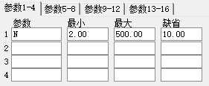

SUPL 主力集散线
主力集散线:SUM((LARGEINTRDVOL-LARGEOUTTRDVOL)*10000/FINANCE(7),0),LINETHICK2;
MA1:MA(主力集散线,N),COLORBROWN;
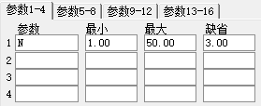

SUPV 主力净买量
主力净买量:(LARGEINTRDVOL-LARGEOUTTRDVOL);
主力买量:LARGEINTRDVOL,COLORRED,NODRAW;
主力卖量:LARGEOUTTRDVOL,COLORGREEN,NODRAW;
STICKLINE(1,0,IF(主力买量>0,VOL,0),2,0),COLORBROWN;
STICKLINE(1,0,IF(主力卖量>0,-VOL,0),2,0),COLORBROWN;
STICKLINE(1,0,主力买量,2,0),COLORRED;
STICKLINE(1,0,(-1*主力卖量),2,0),COLORGREEN;

SUPH 主力活跃度
TMP:=LARGEINTRDVOL-LARGEOUTTRDVOL;
主力活跃度:(LARGEINTRDVOL+LARGEOUTTRDVOL)*10000/(2*FINANCE(7)),NODRAW;
STICKLINE(TMP>0,0,主力活跃度,2,0),COLORLIRED;
STICKLINE(TMP<0,0,主力活跃度,2,0),COLORLIGREEN;

SUPAMO 主力资金线
主力资金线:(L2_AMO(0,0)+L2_AMO(1,0)-L2_AMO(0,1)-L2_AMO(1,1))/10000.0,LINETHICK2;

DDE排序 DDE用于排序
DDX:(LARGEINTRDVOL-LARGEOUTTRDVOL)*10000/FINANCE(7);
DDY:IF(TRADENUM>0,(TRADEOUTNUM-TRADEINNUM)*100/TRADENUM,0);
DDZ:IF(TRADENUM>0,(LARGETRDINNUM-LARGETRDOUTNUM)/TRADENUM*100,0);

SUP排序SUP用于排序
SUPL:SUM((LARGEINTRDVOL-LARGEOUTTRDVOL)*10000/FINANCE(7),0);
SUPV:(LARGEINTRDVOL-LARGEOUTTRDVOL);
SUPH:(LARGEINTRDVOL+LARGEOUTTRDVOL)*10000/(2*FINANCE(7));
SUPAMO:(L2_AMO(0,0)+L2_AMO(1,0)-L2_AMO(0,1)-L2_AMO(1,1))/10000.0;

DDE力度 DDE力度用于排序
主力买力度:LARGEINTRDVOL*100/VOL;
主力卖力度:LARGEOUTTRDVOL*100/VOL;

条件选股公式

指标条件选股

BIAS买入 乖离率买入条件选股
(CLOSE-MA(CLOSE,N))/MA(CLOSE,N)*100+LL<0;
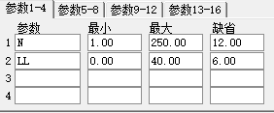

KD买入 KD买入条件选股
RSV:=(CLOSE-LLV(LOW,N))/(HHV(HIGH,N)-LLV(LOW,N))*100;
K:=SMA(RSV,M1,1);
D:=SMA(K,M2,1);
KD:CROSS(K,D)&&K<20;
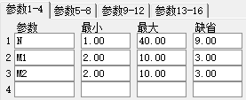

W&R买入 威廉指标买入条件选股
CROSS(LL,WR(N,N));
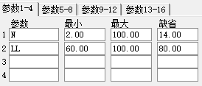

MTM买入 MTM买入条件选股
IMTM:CROSS(MTM(N,N),0);
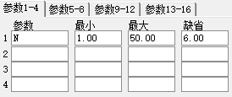

KDJ买入 KDJ买入条件选股
RSV:=(CLOSE-LLV(LOW,N1))/(HHV(HIGH,N1)-LLV(LOW,N1))*100;
K:=SMA(RSV,N2,1);
D:=SMA(K,N3,1);
J:=3*K-2*D;
CROSS(J,0);
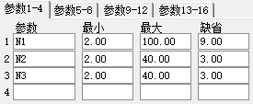

BIAS卖出 乖离率卖出条件选股
100*(CLOSE-MA(CLOSE,N))/MA(CLOSE,N)>M;
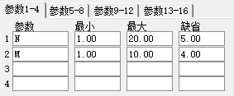

BOLL买入 布林带买入条件选股
MID := MA(CLOSE,N);
UPPER:= MID+S*STD(CLOSE,N);
LOWER:= MID-S*STD(CLOSE,N);
CROSS(CLOSE,LOWER);
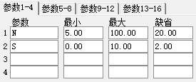

BOLL卖出 布林带卖出条件选股
MID := MA(CLOSE,N);
UPPER:= MID+PP*STD(CLOSE,N);
LOWER:= MID-PP*STD(CLOSE,N);
CROSS(UPPER,CLOSE);
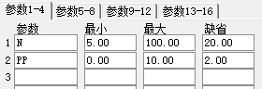

KD卖出 KD卖出条件选股
RSV:= (CLOSE-LLV(LOW,N))/(HHV(HIGH,N)-LLV(LOW,N))*100;
K:=SMA(RSV,N1,1);
D:=SMA(K,N2,1);
CROSS(D,K) AND D>N3;
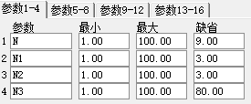

KDJ卖出 KDJ卖出条件选股
RSV:=(CLOSE-LLV(LOW,N1))/(HHV(HIGH,N1)-LLV(LOW,N1))*100;
K:=SMA(RSV,N2,1);
D:=SMA(K,N3,1);
J:=3*K-2*D;
CROSS(100,J);
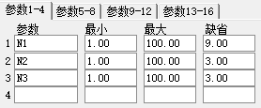

MA买入 均线买入条件选股
CROSS(MA(CLOSE,SHORT),MA(CLOSE,LONG));
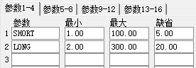

MA卖出 均线卖出条件选股
RSV:=(CLOSE-LLV(LOW,N1))/(HHV(HIGH,N1)-LLV(LOW,N1))*100;
K:=SMA(RSV,N2,1);
D:=SMA(K,N3,1); J:=3*K-2*D;
CROSS(100,J);
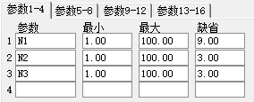

MACD买入 MACD买入点条件选股
DIFF := EMA(CLOSE,SHORT) - EMA(CLOSE,LONG);
DEA := EMA(DIFF,M);
CROSS(DIFF,DEA);
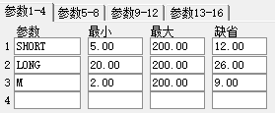

MACD卖出 MACD卖出条件选股
DIFF := EMA(CLOSE,SHORT) - EMA(CLOSE,LONG);
DEA := EMA(DIFF,M);
CROSS(DEA ,DIFF);
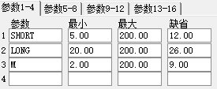+

MTM卖出 MTM卖出条件选股
CROSS(0,MA(CLOSE-REF(CLOSE,N),N1));
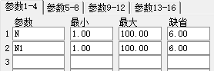

RSI买入 RSI买入条件选股
LC:= REF(CLOSE,1);
RSI1:=SMA(MAX(CLOSE-LC,0),N,1)/SMA(ABS(CLOSE-LC),N,1)*100;
CROSS(RSI1,LL);
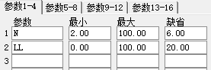

RSI卖出 RSI卖出条件选股
LC := REF(CLOSE,1);
RSI1:=SMA(MAX(CLOSE-LC,0),N,1)/SMA(ABS(CLOSE-LC),N,1)*100;
CROSS(LL,RSI1);
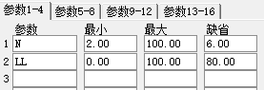

SAR买入 抛物转向买入条件选股
SARTURN(N,STEP,MAXP)=1;
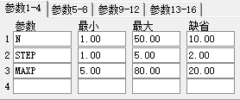

SAR卖出 抛物转向卖出条件选股
SARTURN(N,STEP,MAXP)=-1;
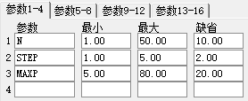

W&R卖出 威廉指标卖出条件选股
WR:=100*(HHV(HIGH,N)-CLOSE)/(HHV(HIGH,N)-LLV(LOW,N));
CROSS(M,WR);
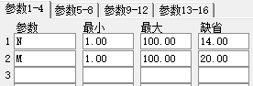

PRD 穿透率（大于）
PR:(WINNER(CLOSE)-REF(WINNER(CLOSE),1))>P1*VOL/CAPITAL;
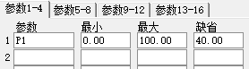

PRX 穿透率（小于）
PR:(WINNER(CLOSE)-REF(WINNER(CLOSE),1))<P1*VOL/CAPITAL;
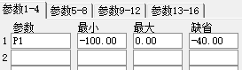

ASRD 浮筹比例（大于）
ASR:100*(WINNER(CLOSE*1.1)-WINNER(CLOSE*0.9))>P1*WINNER(HHV(HIGH,0));
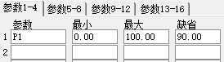

ASRX 浮筹比例（小于）
ASR:100*(WINNER(CLOSE*1.1)-WINNER(CLOSE*0.9))<P1*WINNER(HHV(HIGH,0));
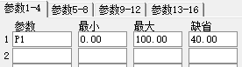

基本面选股

A001 低动态市盈率选股
DYNAINFO(39)>0 AND DYNAINFO(39)<=N;
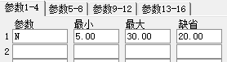

A003 主营业务利润率选股
FINANCE(20)>0 && FINANCE(23)/FINANCE(20)>N/100;
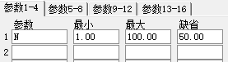

A004 市净率选股
FINANCE(34)>0 AND CLOSE/FINANCE(34)<N;
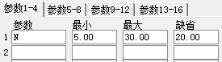

A005 次新股选股
FINANCE(42)<N;
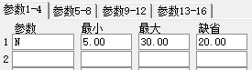

A006 PEG 选股
PE:=DYNAINFO(39);
EPSRATE:=FINANCE(43);
PE>0 && PE<50 && EPSRATE>0 && PE/EPSRATE<1;

A011 可能的指标股或标的股
AAA:=BARSLASTCOUNT(FINANCE(7)*CLOSE>市值*10000*10000)>=天数;
BBB:=(10000*(SUM(VOL,天数2))/FINANCE(7))>换手;
CCC:=(FINANCE(7)>股本*10000*10000);
AAA&&BBB&&CCC;
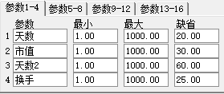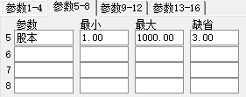

即时盘中选股

B003 内外盘选股（上涨）
(DYNAINFO(23)>DYNAINFO(22)) AND (DYNAINFO(7)>DYNAINFO(3));

B004 内外盘选股（下跌）
(DYNAINFO(22)>DYNAINFO(23)) AND (DYNAINFO(7)<DYNAINFO(3));

B005 盘中活跃低价股
DYNAINFO(7)<价格
AND DYNAINFO(14)>(最低涨幅/100)
AND DYNAINFO(14)<0.2
AND DYNAINFO(17)>量比
AND (SELLVOL/BUYVOL)<内外比;
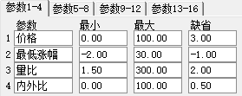

B006 盘中分时出现金叉
DYNAINFO(7)>MAX(DYNAINFO(11)+0.01,DYNAINFO(11)*1.001) AND DYNAINFO(25)<DYNAINFO(11);

走势特征选股

UPN 连涨数天
UP3:UPNDAY(CLOSE,N);
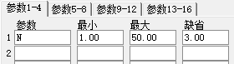

DOWNN 连跌数天
DOWN3:DOWNNDAY(CLOSE,N);
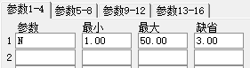

C101 N日内创新高
HHV(HIGH,N)=HHV(HIGH,0) AND BARSCOUNT(CLOSE)>=N;
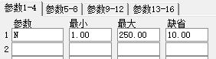

C102 N日内创新低
LLV(LOW,N)=LLV(LOW,0) AND BARSCOUNT(CLOSE)>=N;
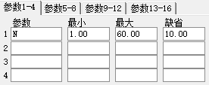

C103 N日内阴线多于阳线
COUNT(OPEN>CLOSE,M)/M >= N/100;
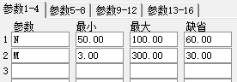

C104 N日内阳线多于阴线
COUNT(OPEN<CLOSE,M)/M >= N/100;
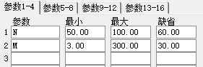

C105 N日内上涨多于下跌
COUNT(CLOSE>REF(CLOSE,1),M)/M >= N/100;
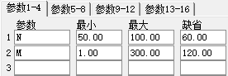

C106 N日内下跌多于上涨
COUNT(CLOSE<REF(CLOSE,1),M)/M >= N/100;
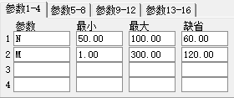

C107 连续N天收阳线
EVERY(CLOSE>OPEN,N);
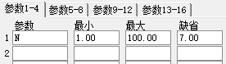

C108 连续N天收阴线
EVERY(OPEN>CLOSE,N);
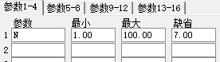

C109 首次创新高
BARSSINCE(CLOSE>HHV(IF(BARSCOUNT(CLOSE)=1,HIGH,0),0))+1=1;

C110 单日放量
A1:=MA(VOL,5);
A2:=REF(A1,1);
VOL/A2>N AND 100*VOL/CAPITAL>M;
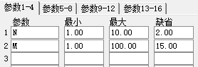

C111 阶段缩量
100*SUM(VOL,N)/CAPITAL<=M;
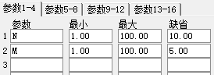

C112 阶段放量
100*SUM(VOL,N)/CAPITAL>=M;
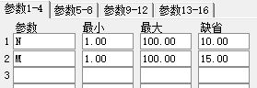

C113 持续放量
EVERY(VOL>=REF(VOL,1),M);
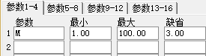

C114 持续缩量
COUNT(VOL<=REF(VOL,1),M)=M;
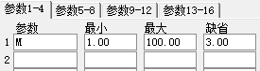

C115 间隔放量
A:=MA(VOL,5);
BARSCOUNT(CLOSE)>=N AND HHV(A,N)<N1*LLV(A,N)
AND COUNT(VOL>N2*A,N)>N3;
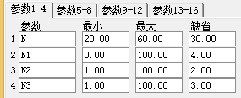

C116 放量上攻
A:= (CLOSE-REF(CLOSE,1))/REF(CLOSE,1)>=(N/100);
100*SUM(VOL,N1)/CAPITAL>=N2
AND COUNT(VOL>REF(VOL,1),N3)=N3 AND COUNT(A,N3)=N3;
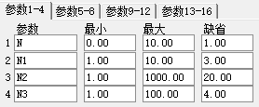

C117 温和放量上攻
A1:=CLOSE/REF(CLOSE,1);
A2:=A1>1 AND A1<1.03;
{股价小幅上扬}
B1:=VOL/REF(VOL,1);
B2:=B1>1 AND B1<2;
C1:=100*MA(VOL,N)/CAPITAL<5;
{成交量小幅上扬}
COUNT(A2 AND B2,N)/N>0.6 AND C1;
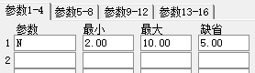

C118 突然放量
VOL>REF(HHV(VOL,N),1)*M;
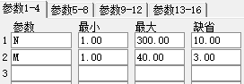

C119 平台整理
COUNT(CLOSE>0,0)>N &&
(HHV(CLOSE,N)-LLV(CLOSE,N))/LLV(CLOSE,N)<=(N1/100);+
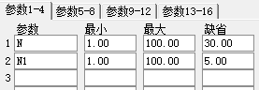

C123 突破长期盘整
REF(((HHV(HIGH,N)-LLV(LOW,N))/LLV(LOW,N)),1)<=(N1/100)
&& CLOSE>=REF(HHV(HIGH,N),1) && BARSCOUNT(CLOSE)>N;
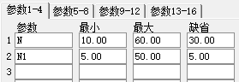

C124 阶段强于大盘
A:=SUM(IF(CURRBARSCOUNT=N,INDEXC,0),0);
B:=SUM(IF(CURRBARSCOUNT=N1,INDEXC,0),0);
E:=SUM(IF(CURRBARSCOUNT=N,CLOSE,0),0);
F:=SUM(IF(CURRBARSCOUNT=N1,CLOSE,0),0);
((F-E)/E)>(((B-A)/A)+0.01);
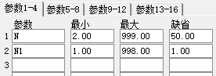

C125 阶段弱于大盘
A:=SUM(IF(CURRBARSCOUNT=N,INDEXC,0),0);
B:=SUM(IF(CURRBARSCOUNT=N1,INDEXC,0),0);
E:=SUM(IF(CURRBARSCOUNT=N,CLOSE,0),0);
F:=SUM(IF(CURRBARSCOUNT=N1,CLOSE,0),0);
((F-E)/E)<(((B-A)/A)-0.01);
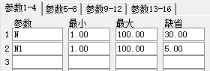

C126 大盘同步选股
COUNT((CLOSE>OPEN && INDEXC>INDEXO) || (CLOSE<OPEN && INDEXC<INDEXO),N)/N>M/100;
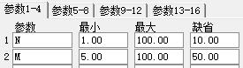

C127 N日内强势股
GG:=(CLOSE-REF(OPEN,N))/REF(OPEN,N);
DP:=(INDEXC-REF(INDEXO,N))/REF(INDEXO,N);
QSG:GG/DP>=M;
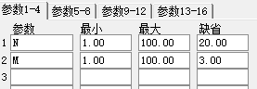

C128 N天内出现以涨停收盘
ZT:=(CLOSE>=ZTPRICE(REF(CLOSE,1),0.1)); { 以涨停收盘 }
ZTO:EXIST(ZT,N); { N天存在以涨停收盘 };
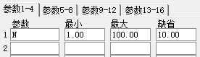

C129 N天内出现涨停
EZT:=(HIGH>=ZTPRICE(REF(CLOSE,1),0.1)); { 出现过涨停 }
EZTO:EXIST(EZT,N); { N天内存在过涨停 };
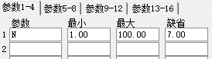

C130 N天内经常涨停
ZTTJ:=(CLOSE>=ZTPRICE(REF(CLOSE,1),0.1));
COUNT(ZTTJ,N)>=涨停天数;
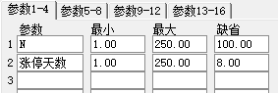

C131 下跌多日再放量上涨
A1:=REF(CLOSE,5)>REF(CLOSE,4);
A2:=REF(CLOSE,4)>REF(CLOSE,3);
A3:=REF(CLOSE,3)>REF(CLOSE,2);
A4:=REF(CLOSE,2)>REF(CLOSE,1);
A5:=CLOSE>REF(HIGH,1) AND V>REF(V,1);
RET:A1 AND A2 AND A3 AND A4 AND A5;

C132 跳空高开或低开
A:= (O>REF(H,1) AND (O-REF(C,1))/REF(C,1)*100>N);
B:= (O<REF(L,1) AND (O-REF(C,1))/REF(C,1)*100<N);
IF(N>0,A,B);
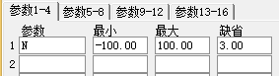

C1228 N天内出现6个点收盘
ZT:=CLOSE>REF(CLOSE,1)*1.065; { 以涨停收盘 }
ZTO:EXIST(ZT,N); { N天存在以涨停收盘 };
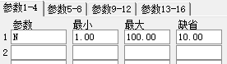

形态特征选股

MSTAR 早晨之星
STAR:REF(CLOSE,2)/REF(OPEN,2)<0.95&&
REF(OPEN,1)<REF(CLOSE,2)&&
ABS(REF(OPEN,1)-REF(CLOSE,1))/REF(CLOSE,1)<0.03&&
CLOSE/OPEN>1.05&&CLOSE>REF(CLOSE,2);

SWORD 剑
AA:=VOL>REF(VOL,1)||VOL>CAPITAL;
BB:=OPEN>=(REF(HIGH,1))&&REF(HIGH,1)>(REF(HIGH,2)*1.06);
CC:=CLOSE>(REF(CLOSE,1))-(REF(CLOSE,1)*0.01);
DD:=CLOSE<(HIGH*0.965) && HIGH>(OPEN*1.05);
EE:=LOW<OPEN && LOW<CLOSE && HIGH>(REF(CLOSE,1)*1.06);
FF:=(HIGH-(MAX(OPEN,CLOSE)))/2>(MIN(OPEN,CLOSE))-LOW;
GG:=(ABS(OPEN-CLOSE))/2<(MIN(OPEN,CLOSE)-LOW);
STAR:AA&&BB&&CC&&DD&&EE&&FF&&GG;

TLFZ 天量法则
STAR:CLOSE>OPEN&&HHV(CLOSE,50)=CLOSE&&DYNAINFO(37)>0.1&&
DYNAINFO(13)<0.14;

GREEN4 四串阴
STAR:EVERY(CLOSE<OPEN,4);

CSFR 出水芙蓉
AAA:=CLOSE>OPEN;
BBB:=AAA&&CLOSE>MA(CLOSE,S)&&CLOSE>MA(CLOSE,M)&&CLOSE>MA(CLOSE,N);
CCC:=BBB&&OPEN<MA(CLOSE,M)&&OPEN<MA(CLOSE,N);
CSFR:CCC&&(CLOSE-OPEN)>0.0618*CLOSE;
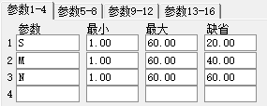

NHIGH 近日创历史新高
HHV(HIGH,N)=HHV(HIGH,0);
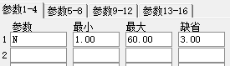

NLOW 近日创历史新低
LLV(LOW,N)=LLV(LOW,0);
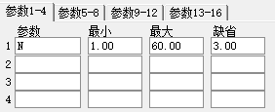

XRDS 旭日东升
BUY1:=LAST(CLOSE<MA(CLOSE,N),0,5);
BUY:CLOSE>MA(CLOSE,N)&&VOL>MA(VOL,5)*2&&BUY1;
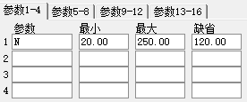

QTDS 蜻蜓点水
BUY1:=LAST(CLOSE>MA(CLOSE,N),0,5);
BUY2:=EXIST(CLOSE<MA(CLOSE,N),5);
BUY:CLOSE>MA(CLOSE,N)&&BUY1&&BUY2;
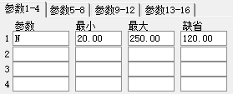

DTPL 均线多头排列
A1:=MA(CLOSE,N);
A2:=MA(CLOSE,N1);
A3:=MA(CLOSE,N2);
A4:=MA(CLOSE,N3);
CLOSE>A1 AND A1>A2 AND A2>A3 AND A3>A4 AND CLOSE>OPEN;
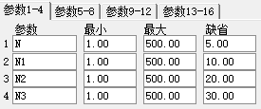

KTPL 均线空头排列
A1:=MA(CLOSE,N);
A2:=MA(CLOSE,N1);
A3:=MA(CLOSE,N2);
A4:=MA(CLOSE,N3);
CLOSE<A1 AND A1<A2 AND A2<A3 AND A3<A4 AND CLOSE<OPEN;
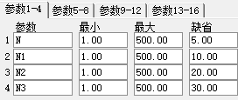

QSZL 强势整理
A1:=ABS(CLOSE-OPEN)/OPEN<0.015;
A2:=COUNT(A1,M)=M;
A3:=REF(OPEN,M)<REF(CLOSE,M) AND
REF(CLOSE,M)/REF(CLOSE,M+1)>1+N/100;
A2 AND A3;
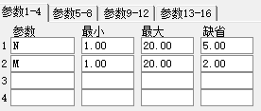

W-103 高开大阴线
OPEN/REF(CLOSE,1)>=1+M/100 && CLOSE/OPEN<=1-N/100;
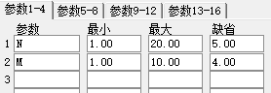

W-104 低开大阳线
OPEN/REF(CLOSE,1)>=1+M/100 && CLOSE/OPEN<=1-N/100;
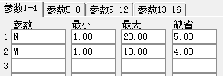

W-105 跳空缺口选择
HIGH<(REF(LOW,1)-0.001) || LOW>(REF(HIGH,1)+0.001);

SP 低点搜寻+
W:=MA((LLV(LOW,45)-CLOSE)/(HHV(HIGH,45)-LLV(LOW,45))*100,N);
CROSS(-5,W);
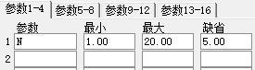

TP 突破
M1:=MA(C,N1);{短期参数：5}
M2:=MA(C,N2);{中期参数：10}
M3:=MA(C,N3);{长期参数：30}
{以下计算交叉点距今的天数}
D1:=BARSLAST(CROSS(M1,M2));{短上穿中}
D2:=BARSLAST(CROSS(M1,M3));{短上穿长}
D3:=BARSLAST(CROSS(M2,M3));{中上穿长}
T1:=CROSS(M2,M3);{今天中线上穿长线}
T2:=D1>=D2 AND D2>=D3;{交叉按指定的先后出现}
T3:=COUNT(CROSS(M2,M1) OR CROSS(M3,M2) OR CROSS(M3,M1),D1)=0;{中间无夹杂其它交叉}
T4:=REF(M1<M3 AND M2<M3,D1+1);{短上穿中前一天短、中线在长线之下}
JT:T1 AND T2 AND T3 AND T4;{价托确定};
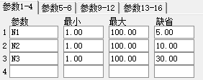

专家系统公式

BIAS 乖离率专家系统
BIAS:=(CLOSE-MA(CLOSE,N))/MA(CLOSE,N)*100;
ENTERLONG:CROSS(-LL,BIAS);
EXITLONG:CROSS(BIAS,LH);
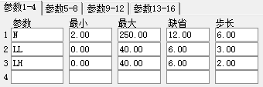

CCI CCI专家系统
INDEX:=CCI(N);
ENTERLONG:CROSS(INDEX,-100);
EXITLONG:CROSS(100,INDEX);
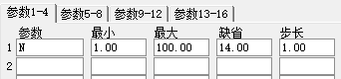

DMI 趋向专家系统
MTR:=SUM(MAX(MAX(HIGH-LOW,ABS(HIGH-REF(CLOSE,1))),ABS(LOW-REF(CLOSE,1))),N);
HD :=HIGH-REF(HIGH,1);
LD :=REF(LOW,1)-LOW;
PDM:=SUM(IF(HD>0&&HD>LD,HD,0),N);
MDM:=SUM(IF(LD>0&&LD>HD,LD,0),N);
PDI:=PDM*100/MTR;
MDI:=MDM*100/MTR;
ENTERLONG:CROSS(PDI,MDI);
EXITLONG:CROSS(MDI,PDI);
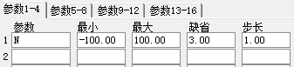

KD KD指标专家系统
WRSV:=(CLOSE-LLV(LOW,N))/(HHV(HIGH,N)-LLV(LOW,N))*100;
WK:=SMA(WRSV,M1,1);
D:=SMA(WK,M2,1);
ENTERLONG:CROSS(WK,D)&&WK<20;
EXITLONG:CROSS(D,WK)&&WK>80;
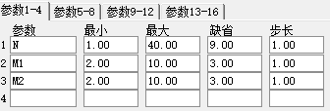

BOLL 布林带专家系统
MID :=MA(CLOSE,N);
UPPER:=MID+2*STD(CLOSE,N);
LOWER:=MID-2*STD(CLOSE,N);
ENTERLONG:CROSS(CLOSE,LOWER);
EXITLONG:CROSS(CLOSE,UPPER);
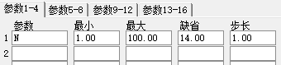

KDJ KDJ专家系统
RSV:=(CLOSE-LLV(LOW,N))/(HHV(HIGH,N)-LLV(LOW,N))*100;
K:=SMA(RSV,M1,1);
D:=SMA(K,M1,1);
J:=3*K-2*D;
ENTERLONG:CROSS(J,0);
EXITLONG:CROSS(100,J);
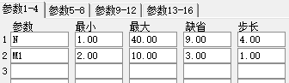

MA 均线专家系统
ENTERLONG:CROSS(MA(CLOSE,SHORT),MA(CLOSE,LONG));
EXITLONG:CROSS(MA(CLOSE,LONG),MA(CLOSE,SHORT));
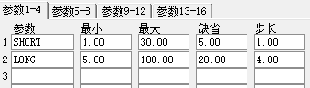

MACD MACD专家系统
DIFF:=EMA(CLOSE,SHORT) - EMA(CLOSE,LONG);
DEA := EMA(DIFF,M);
MACD := 2*(DIFF-DEA);
ENTERLONG:CROSS(MACD,0);
EXITLONG:CROSS(0,MACD);
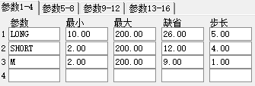

MTM 动力指标专家系统
WMTM:=MTM;
ENTERLONG:CROSS(WMTM,0);
EXITLONG:CROSS(0,WMTM);

PSY PSY心理线专家系统
MYPSY:=PSY(N,1);
ENTERLONG:CROSS(LL,MYPSY);
EXITLONG:CROSS(MYPSY,LH);
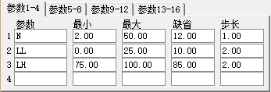

ROC 变动速率专家系统
WROC:=ROC(N,M);
ENTERLONG:CROSS(WROC,0);
EXITLONG:CROSS(0,WROC);
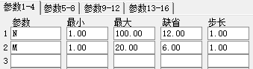

RSI 相对强弱专家系统
LC:=REF(CLOSE,1);
WRSI:=SMA(MAX(CLOSE-LC,0),N,1)/SMA(ABS(CLOSE-LC),N,1)*100;
ENTERLONG:CROSS(WRSI,LL);
EXITLONG:CROSS(LH,WRSI);
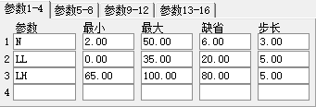

VR VR容量比率专家系统
WVR := SUM((IF(CLOSE>OPEN,VOL,0)+IF(CLOSE=OPEN,VOL/2,0)),N)/
SUM((IF(CLOSE<OPEN,VOL,0)+IF(CLOSE=OPEN,VOL/2,0)),N)*100;
ENTERLONG:CROSS(LL,WVR);
EXITLONG:CROSS(WVR,LH);
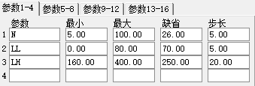

DPSJ 大盘随机专家系统
RSV:=(INDEXC-LLV(INDEXL,N1))/(HHV(INDEXH,N1)-LLV(INDEXL,N1))*100;
K:=SMA(RSV,N2,1);
ENTERLONG: CROSS(K,20);
EXITLONG: (CROSS(HSL,5) OR CROSS(K,80));
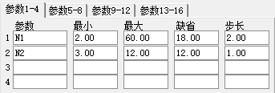

第四章 五彩K线公式

KSTAR1 十字星
KSTAR:CLOSE=OPEN&&HIGH>LOW;

KSTAR2 早晨之星
KSTAR:(REF(CLOSE,2)/REF(OPEN,2)<0.95)&&
(REF(OPEN,1) < REF(CLOSE,2))&&
(ABS(REF(OPEN,1)-REF(CLOSE,1))/REF(CLOSE,1)<0.03) &&
CLOSE/OPEN>1.05 && CLOSE>REF(CLOSE,2);

KSTAR3 黄昏之星
KSTAR:REF(CLOSE,2)/REF(OPEN,2)>1.05&&
REF(OPEN,1)>REF(CLOSE,2)&&
ABS(REF(OPEN,1)-REF(CLOSE,1))/REF(CLOSE,1)<0.03&&
CLOSE/OPEN<0.95&&CLOSE<REF(CLOSE,2);

SHI1 长十字
KSTAR:CLOSE=OPEN&&HIGH/LOW>1.03;

K134 垂死十字
KSTAR:CLOSE=OPEN&&CLOSE=LOW&&CLOSE<HIGH;

K140 早晨十字星
KSTAR:REF(CLOSE,2)/REF(OPEN,2)<0.95&&
REF(OPEN,1)<REF(CLOSE,2)&&
REF(OPEN,1)=REF(CLOSE,1)&&
CLOSE/OPEN>1.05&&CLOSE>REF(CLOSE,2);

K150 黄昏十字星
KSTAR:REF(CLOSE,2)/REF(OPEN,2)>1.05&&
REF(OPEN,1)>REF(CLOSE,2)&&
REF(OPEN,1)=REF(CLOSE,1)&&
CLOSE/OPEN<0.95&&CLOSE<REF(CLOSE,2);

K160 射击之星
KSTAR:MIN(OPEN,CLOSE)=LOW&&
HIGH-LOW>3*(MAX(OPEN,CLOSE)-LOW)&&
CLOSE>MA(CLOSE,5);

K165 倒转锤头
KSTAR:MIN(OPEN,CLOSE)=LOW&&
HIGH-LOW>3*(MAX(OPEN,CLOSE)-LOW)&&
CLOSE<MA(CLOSE,5);

K170 锤头
OUT:HIGH=MAX(OPEN,CLOSE)&&
HIGH-LOW>3*(HIGH-MIN(OPEN,CLOSE))&&
CLOSE<MA(CLOSE,5);

K180 吊颈
OUT:HIGH=MAX(OPEN,CLOSE)&&
HIGH-LOW>3*(HIGH-MIN(OPEN,CLOSE))&&
CLOSE>MA(CLOSE,5);

K190 穿头破脚
OUT:(REF(CLOSE,1)/REF(OPEN,1)>1.03&&
CLOSE/OPEN<0.96&&
CLOSE<REF(OPEN,1)&&OPEN>REF(CLOSE,1))||
(REF(CLOSE,1)/REF(OPEN,1)<0.97&&
CLOSE/OPEN>1.04&&
CLOSE>REF(OPEN,1)&&OPEN<REF(CLOSE,1));

K220 身怀六甲
KSTAR:ABS(REF(CLOSE,1)-REF(OPEN,1))/REF(CLOSE,1)>0.04&&
ABS(CLOSE-OPEN)/CLOSE<0.005&&
MAX(CLOSE,OPEN)<MAX(REF(CLOSE,1),REF(OPEN,1))&&
MIN(CLOSE,OPEN)>MIN(REF(CLOSE,1),REF(OPEN,1));

K300 三个白武士
KSTAR:UPNDAY(CLOSE,3)&&NDAY(CLOSE,OPEN,3);

K310 三只乌鸦
KSTAR:DOWNNDAY(CLOSE,3)&&NDAY(OPEN,CLOSE,3);

K380 光头阳线
KSTAR:HIGH=CLOSE&&HIGH>LOW;

K390 光脚阴线
KSTAR:LOW=CLOSE&&HIGH>LOW;

KWORD 剑
AA:=VOL>REF(VOL,1)||VOL>(CAPITAL*0.1);
BB:=OPEN>=(REF(HIGH,1))&&REF(HIGH,1)>(REF(HIGH,2)*1.06);
CC:=CLOSE>(REF(CLOSE,1))-(REF(CLOSE,1)*0.01);
DD:=CLOSE<(HIGH*0.965) && HIGH>(OPEN*1.05);
EE:=LOW<OPEN && LOW<CLOSE&&HIGH>(REF(CLOSE,1)*1.06);
FF:=(HIGH-(MAX(OPEN,CLOSE)))/2>(MIN(OPEN,CLOSE))-LOW;
GG:=(ABS(OPEN-CLOSE))/2<(MIN(OPEN,CLOSE)-LOW);
SWORDO:AA&&BB&&CC&&DD&&EE&&FF&&GG;

CSFR 出水芙蓉
A:=CLOSE>OPEN;
B:=A&&CLOSE>MA(CLOSE,S)&&CLOSE>MA(CLOSE,M)&&CLOSE>MA(CLOSE,LL);
CC:=B&&OPEN<MA(CLOSE,M)&&OPEN<MA(CLOSE,LL);
CSFRO:CC&&(CLOSE-OPEN)>0.0618*CLOSE;

WYGD 乌云盖顶
BACKSET( REF(CLOSE,1)/REF(OPEN,1)>1.03
AND CLOSE/OPEN<0.97
AND OPEN>REF(CLOSE,1)
AND CLOSE<REF(CLOSE,1), 3);

SGCX 曙光初现
BACKSET( REF(CLOSE,1)/REF(OPEN,1)<0.97
AND CLOSE/OPEN>1.03
AND OPEN<REF(CLOSE,1)
AND CLOSE>REF(CLOSE,1), 3);

SZTAI 十字胎
BACKSET( ABS(REF(CLOSE,1)-REF(OPEN,1))/REF(CLOSE,1) > 0.04 AND
CLOSE=OPEN AND CLOSE < MAX(REF(CLOSE,1),REF(OPEN,1)) AND
CLOSE > MIN(REF(CLOSE,1),REF(OPEN,1)), 2);

PINGDING 平顶
BACKSET(ABS(HIGH-REF(HIGH,1))/HIGH<0.001,2);

PINGDI 平底
BACKSET((ABS(LOW-REF(LOW,1))/LOW<0.001 AND
ABS(REF(LOW,1)-REF(LOW,2))/REF(LOW,1)<=0.001),2);

DAYANGZHU 大阳烛
CLOSE/OPEN>1.05 AND HIGH/LOW < CLOSE/OPEN+0.018;

DAYINZHU 大阴烛
OPEN/CLOSE > 1.05 AND HIGH/LOW < OPEN/CLOSE+0.018;

HYFG 好友反攻
BACKSET( (REF(CLOSE,1)<REF(OPEN,1) AND
CLOSE>OPEN AND ABS(CLOSE-REF(CLOSE,1))/CLOSE<0.002),2);

TKQK 跳空缺口
BACKSET( HIGH<REF(LOW,1) OR LOW>REF(HIGH,1),2);

SFWY 双飞乌鸦
BACKSET( REF(CLOSE,1)<REF(OPEN,1) AND CLOSE<OPEN AND CLOSE/OPEN<0.98,1);

SSSBQ 上升三部曲
BACKSET(
REF(CLOSE,4)/REF(OPEN,4)>1.03 AND
REF(CLOSE,3)<REF(OPEN,3) AND
REF(CLOSE,2)<REF(OPEN,2) AND
REF(CLOSE,1)<REF(OPEN,1) AND
REF(LOW,4)<REF(LOW,3) AND
REF(LOW,4)<REF(LOW,2) AND
REF(LOW,4)<REF(LOW,1) AND
REF(HIGH,4)>REF(HIGH,3) AND
REF(HIGH,4)>REF(HIGH,2) AND
REF(HIGH,4)>REF(HIGH,1) AND
CLOSE/OPEN>1.03 AND
CLOSE>REF(CLOSE,4), 5);

XDSBQ 下跌三部曲
BACKSET(
REF(CLOSE,4)/REF(OPEN,4)<0.97 AND
REF(CLOSE,3)>REF(OPEN,3) AND
REF(CLOSE,2)>REF(OPEN,2) AND
REF(CLOSE,1)>REF(OPEN,1) AND
REF(LOW,4)<REF(LOW,3) AND
REF(LOW,4)<REF(LOW,2) AND
REF(LOW,4)<REF(LOW,1) AND
REF(HIGH,4)>REF(HIGH,3) AND
REF(HIGH,4)>REF(HIGH,2) AND
REF(HIGH,4)>REF(HIGH,1) AND
CLOSE/OPEN<0.97 AND
CLOSE<REF(CLOSE,4), 5);

CHXY 长下影
(MIN(CLOSE,OPEN)-LOW)/(HIGH-LOW)>0.667;

CHSY 长上影
(HIGH-MAX(CLOSE,OPEN))/(HIGH-LOW)>0.667,COLORBLUE;

FENLI 分离
BACKSET( OPEN=REF(OPEN,1) AND
(CLOSE-OPEN)*(REF(CLOSE,1)-REF(OPEN,1))<0,2);

NXSD 牛熊时段（加密）

（注：专业文档是经验性极强的领域，无法思考和涵盖全面，素材和资料部分来自网络，供参考。可复制、编制，期待你的好评与关注）

