1.2

|  |  |  |
| --- | --- | --- |
| U/V | Strom/mA | Wiederstand/Ohm |
| 0,1 | 4,898 | 2020 |
| 0,2 | 8,090 | 1210 |
| 0,5 | 12,770 | 742,7 |
| 1,0 | 17,589 | 510,5 |
| 2,0 | 25,599 | 311,5 |
| 5,0 | 43,64 | 113,6 |
| 10,0 | 65,16 | 0 |

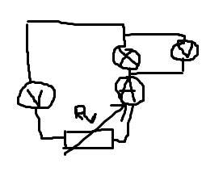

2.2

a) R10 = 1001,6 Ohm (9x100Ohm(+-0,02%) + 10x10Ohm(+-0,05%)+1x1Ohm(+-0,1%)+6x0,1(+-0,5%)

c)

Messung

deltaR = 1000-R1 (evtl R10-R1)

|  |  |  |
| --- | --- | --- |
| R1/Ohm | deltaR/R10 v | Uab/V |
| 500 | ~-0,499 | -1,0021 |
| 750 | ~-0,250 | -0,4305 |
| 1000 | 0 | -2,09mv |
| 1250 | ~0,250 | 0,3317 |
| 1500 | ~0,499 | 0,5986 |
| 1750 | ~0,749 | 0,8165 |
| 2000 | ~0,998 | 0,9996 |