# Alex Lugo

## Missing Data Assignment

library(tidyverse)

## -- Attaching packages -------------------------------------------------------------------------------- tidyverse 1.3.0 --

## v ggplot2 3.2.1 v purrr 0.3.3  
## v tibble 2.1.3 v dplyr 0.8.3  
## v tidyr 1.0.2 v stringr 1.4.0  
## v readr 1.3.1 v forcats 0.4.0

## -- Conflicts ----------------------------------------------------------------------------------- tidyverse_conflicts() --  
## x dplyr::filter() masks stats::filter()  
## x dplyr::lag() masks stats::lag()

library(VIM)

## Loading required package: colorspace

## Loading required package: grid

## Loading required package: data.table

##   
## Attaching package: 'data.table'

## The following objects are masked from 'package:dplyr':  
##   
## between, first, last

## The following object is masked from 'package:purrr':  
##   
## transpose

## VIM is ready to use.   
## Since version 4.0.0 the GUI is in its own package VIMGUI.  
##   
## Please use the package to use the new (and old) GUI.

## Suggestions and bug-reports can be submitted at: https://github.com/alexkowa/VIM/issues

##   
## Attaching package: 'VIM'

## The following object is masked from 'package:datasets':  
##   
## sleep

library(mice)

## Loading required package: lattice

## Registered S3 methods overwritten by 'lme4':  
## method from  
## cooks.distance.influence.merMod car   
## influence.merMod car   
## dfbeta.influence.merMod car   
## dfbetas.influence.merMod car

##   
## Attaching package: 'mice'

## The following object is masked from 'package:tidyr':  
##   
## complete

## The following objects are masked from 'package:base':  
##   
## cbind, rbind

grades = read_csv("class-grades.csv")

## Parsed with column specification:  
## cols(  
## Prefix = col_double(),  
## Assignment = col_double(),  
## Tutorial = col_double(),  
## Midterm = col_double(),  
## TakeHome = col_double(),  
## Final = col_double()  
## )

**TASK 1** There are 11 “NA” observations. 1 in “Tutorial” vaariable, 3 in “Midterm” variable, 3 in “TakeHome” variable, and 4 in “Final” variable.

summary(grades)

## Prefix Assignment Tutorial Midterm   
## Min. :4.000 Min. : 28.14 Min. : 34.09 Min. : 28.12   
## 1st Qu.:7.000 1st Qu.: 80.88 1st Qu.: 83.93 1st Qu.: 52.50   
## Median :8.000 Median : 89.94 Median : 93.37 Median : 69.38   
## Mean :7.313 Mean : 85.49 Mean : 89.79 Mean : 67.70   
## 3rd Qu.:8.000 3rd Qu.: 95.00 3rd Qu.:100.56 3rd Qu.: 81.56   
## Max. :8.000 Max. :100.83 Max. :112.58 Max. :110.00   
## NA's :1 NA's :3   
## TakeHome Final   
## Min. : 16.91 Min. : 28.06   
## 1st Qu.: 69.91 1st Qu.: 52.91   
## Median : 88.42 Median : 66.11   
## Mean : 81.12 Mean : 68.23   
## 3rd Qu.: 99.07 3rd Qu.: 83.61   
## Max. :108.89 Max. :108.89   
## NA's :3 NA's :4

**TASK 2** There does not seem to be systematic missingness. Beside one student missing the “TakeHome” and “Midterm”, all other “NA” observations seem to be at random.

grades$Tutorial[grades$Tutorial == ""] = NA  
grades$Midterm[grades$Midterm == ""] = NA  
grades$TakeHome[grades$TakeHome == ""] = NA  
grades$Final[grades$Final == ""] = NA  
vim_plot = aggr(grades, numbers = TRUE, prop = c(TRUE, FALSE), cex.axis = .8)

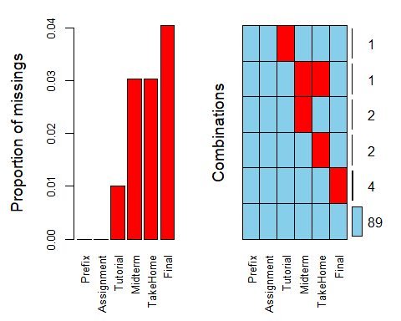

**TASK 3** There are 89 rows left after row-wise deletion of “NA’s”.

grades_rowdel = grades %>% drop_na(Tutorial, Midterm, TakeHome, Final)  
str(grades_rowdel)

## Classes 'tbl_df', 'tbl' and 'data.frame': 89 obs. of 6 variables:  
## $ Prefix : num 5 8 8 7 8 7 8 8 7 7 ...  
## $ Assignment: num 57.1 95 83.7 81.2 91.3 ...  
## $ Tutorial : num 34.1 105.5 83.2 96.1 93.6 ...  
## $ Midterm : num 64.4 67.5 30 49.4 95 ...  
## $ TakeHome : num 51.5 99.1 63.1 105.9 107.4 ...  
## $ Final : num 52.5 68.3 48.9 80.6 73.9 ...

**TASK 4** There are 2 columns left after column-wise deletion.

grades_coldel = grades %>% select(-Tutorial, -Midterm, -TakeHome, -Final)  
str(grades_coldel)

## Classes 'spec_tbl_df', 'tbl_df', 'tbl' and 'data.frame': 99 obs. of 2 variables:  
## $ Prefix : num 5 8 8 7 8 7 8 7 8 7 ...  
## $ Assignment: num 57.1 95 83.7 81.2 91.3 ...  
## - attr(*, "spec")=  
## .. cols(  
## .. Prefix = col_double(),  
## .. Assignment = col_double(),  
## .. Tutorial = col_double(),  
## .. Midterm = col_double(),  
## .. TakeHome = col_double(),  
## .. Final = col_double()  
## .. )

**TASK 5** The approach in Task 3(row-wise deletion) is more preferable for this dataset because the purpose is to predict student grades and this keeps all the variables we want to analyze. Task 4(column-wise deletion), removed all the grades for 4 different assignments that we would no longer be able to predict.

**TASK 6**

grades_imp = mice(grades, m=1, method = "pmm", seed = 12345)

##   
## iter imp variable  
## 1 1 Tutorial Midterm TakeHome Final  
## 2 1 Tutorial Midterm TakeHome Final  
## 3 1 Tutorial Midterm TakeHome Final  
## 4 1 Tutorial Midterm TakeHome Final  
## 5 1 Tutorial Midterm TakeHome Final

summary(grades_imp)

## Class: mids  
## Number of multiple imputations: 1   
## Imputation methods:  
## Prefix Assignment Tutorial Midterm TakeHome Final   
## "" "" "pmm" "pmm" "pmm" "pmm"   
## PredictorMatrix:  
## Prefix Assignment Tutorial Midterm TakeHome Final  
## Prefix 0 1 1 1 1 1  
## Assignment 1 0 1 1 1 1  
## Tutorial 1 1 0 1 1 1  
## Midterm 1 1 1 0 1 1  
## TakeHome 1 1 1 1 0 1  
## Final 1 1 1 1 1 0

densityplot(grades_imp)

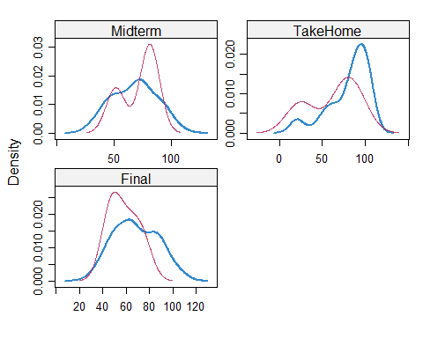

grades_complete = complete(grades_imp)   
summary(grades_complete)

## Prefix Assignment Tutorial Midterm   
## Min. :4.000 Min. : 28.14 Min. : 34.09 Min. : 28.12   
## 1st Qu.:7.000 1st Qu.: 80.88 1st Qu.: 84.69 1st Qu.: 52.50   
## Median :8.000 Median : 89.94 Median : 93.10 Median : 69.38   
## Mean :7.313 Mean : 85.49 Mean : 89.76 Mean : 67.80   
## 3rd Qu.:8.000 3rd Qu.: 95.00 3rd Qu.:100.55 3rd Qu.: 81.88   
## Max. :8.000 Max. :100.83 Max. :112.58 Max. :110.00   
## TakeHome Final   
## Min. : 16.91 Min. : 28.06   
## 1st Qu.: 67.96 1st Qu.: 52.09   
## Median : 87.96 Median : 65.56   
## Mean : 80.54 Mean : 67.81   
## 3rd Qu.: 98.42 3rd Qu.: 83.19   
## Max. :108.89 Max. :108.89

**TASK 7** If you work with missing data, you could potentially run into some errors when trying to do statistical analysis of your data. Running some statistical functions could come back with an error instead of the calculations you were looking for. A situation in which imputation may not be advisable to help with missingness is when the missing data should not be a numerical variable or if the data has a lot of randomness and imputating could provide an unrealistic value.