ALEX LUNDIN TELEPHONE (469) 394-5175
Design Engineer EMAIL alexander.m.lundin@gmail.com
Wattstopper, Legrand
2240 Campbell Creek Blvd
Plano TX, 75074

SCREENSHOTS

Regression Test Suite

https://autode.sk/2sByZYq

I learned about regression tests at the University of Texas at Dallas. However, AutoLISP is the language I currently work in, and it does not have an automated testing suite. So, I built my own.

  - Continuous integration and delivery
  - Automatically runs regression tests, to ensure the LISP build is successful
  - I embedded 1 failure, to show how tests appear, for either scenario, pass or fail
  - Passes and fails are separated cleanly
  - Helps in reporting on test coverage
  - Ensures a standard for all releases of my LISP code
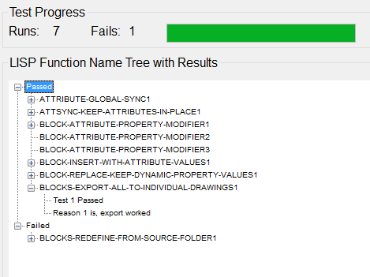

Control bar, built with open dcl

https://autode.sk/2SWDVCJ

This adds to the usability of my source code, from the User side, being able to see all commands, in one place.

  - Provide easy access to entire LISP glossary
  - Reads LISP source code, and displays user information in the text box, about the command
  - 8 tabs
  - 18 buttons, that dynamically change on tab selection
