|  |  |
| --- | --- |
| **Homework 3** | **ER Diagram and database schema** |
| **Due Sun, Sep 30 at 11:30 pm** | **Objectives:** To be able to create database schema using a tool |

**CS 4347: Database Systems Alex Lundin aml140830**

**4.17** - Consider the BANK ER schema of Figure , and suppose that it is necessary to keep track of different types of ACCOUNTS (SAVINGS_ACCTS, CHECKING_ACCTS,

...) and LOANS (CAR_LOANS, HOME_LOANS, ...). Suppose that it is also desirable to keep track of each account's TRANSACTIONs (deposits, withdrawals, checks, ...) and each loan's PAYMENTs; both of these include the amount, date, time, ... Modify the BANK schema, using ER and EER concepts of specialization and generalization. State any assumptions you make about the additional requirements.

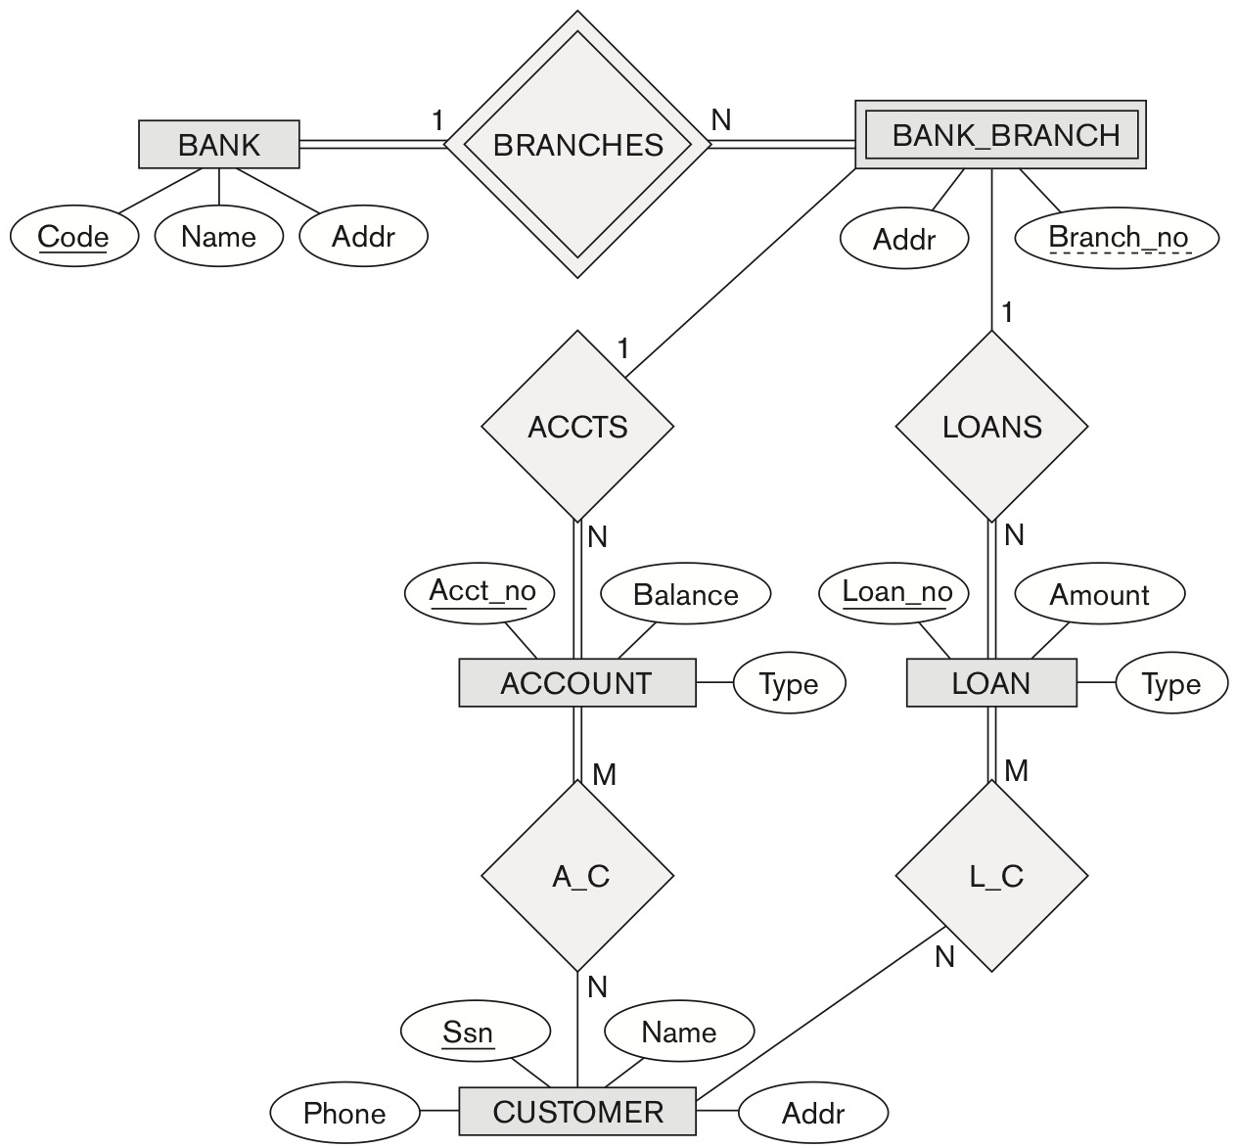

**Assumptions:**

**Answer:**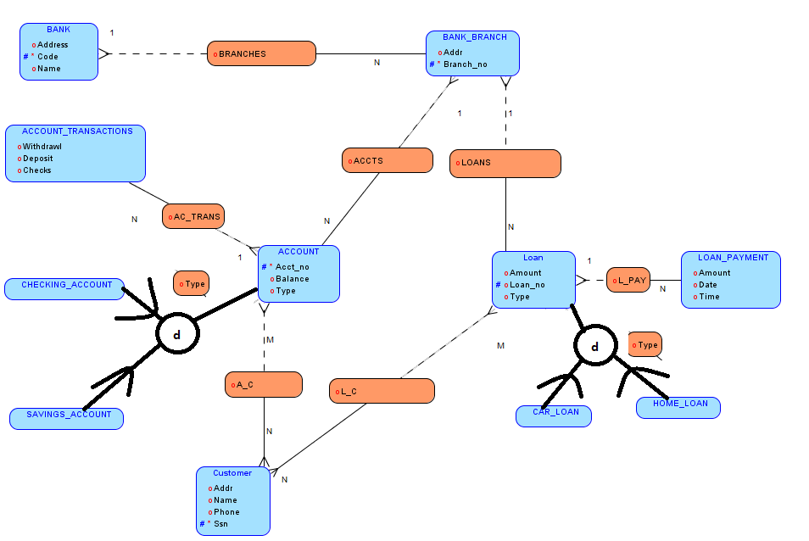

**5.11** - Suppose each of the following Update operations is applied directly to the database of Figure 5.6. Discuss *all* integrity constraints violated by each operation, if any, and the different ways of enforcing these constraints:

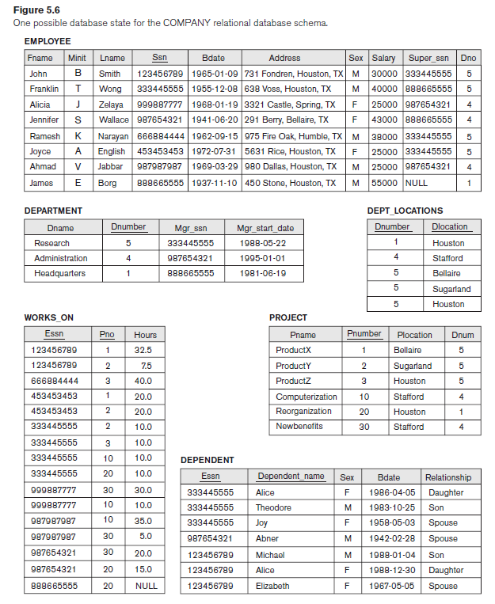

(a) Insert < 'Robert', 'F', 'Scott', '943775543', '21-JUN-42', '2365 Newcastle Rd,

Bellaire, TX', M, 58000, '888665555', 1 > into EMPLOYEE.

**No violations**

(b) Insert < 'ProductA', 4, 'Bellaire', 2 > into PROJECT.

**Violations**

**Referential Integrity**

**Bellaire maps to dnumber 4, so the reference is wrong**

(c) Insert < 'Production', 4, '943775543', '01-OCT-88' > into DEPARTMENT.

**Violations**

**Primary Key Uniqueness**

**Dnumber 4 is already in use**

**Referential Integrity**

**SSN 943775543 is not in the employee table**

(d) Insert < '677678989', null, '40.0' > into WORKS_ON.

**Violations**

**Referential Integrity**

**SSN 677678989 is not in the employee table**

**Entity Integrity**

**PNO is a primary key and cannot be null**

(e) Insert < '453453453', 'John', M, '12-DEC-60', 'SPOUSE' > into DEPENDENT.

**Violations**

**Referential Integrity**

**Super_SSN 453453453 is not in the employee table**

(f) Delete the WORKS_ON tuples with ESSN= '333445555'.

**No violations**

(g) Delete the EMPLOYEE tuple with SSN= '987654321'.

**Referential Integrity**

**SSN 453453453 is part of the DEPARTMENT, and WORKS_ON table**

(h) Delete the PROJECT tuple with PNAME= 'ProductX'.

**Referential Integrity**

**SSN 453453453 is part of the WORKS_ON table**

(i) Modify the MGRSSN and MGRSTARTDATE of the DEPARTMENT tuple with DNUMBER=5 to '123456789' and '01-OCT-88', respectively.

**No violations**

(j) Modify the SUPERSSN attribute of the EMPLOYEE tuple with SSN= '999887777' to

'943775543'.

**No violations**

(k) Modify the HOURS attribute of the WORKS_ON tuple with ESSN= '999887777' and

PNO= 10 to '5.0'.

**No violations**

**6.5** - Consider the database shown in Figure 1.2, whose schema is shown in Figure 2.1.

1. What are the referential integrity constraints that should hold on the schema?

**EMPLOYEE Table**

1 (PK) Ssn must contain all references for DEPARTMENT Table Mgr_SSN

WORKS_ON Table Essn and DEPENDENT Table Essn

2 (FK) Super_ssn must refer to an existing Ssn in the EMPLOYEE Table

3 (FK) Dno must refer to an existing Dnumber in the DEPARTMENT Table

**DEPARTMENT Table**

1 (PK) Dnumber must contain all references for EMPLOYEE Table Dno, Dept_Locations Table Dnumber and PROJECT Table Dnum

**DEPT_LOCATIONS Table**

1 (FK) Dnumber must refer to an existing Dnumber in the DEPARTMENT Table

**PROJECT Table**

1 (PK) Pnumber must contain all references for WORKS_ON Table Pno

2 (FK) Dnum must refer to an existing Dnumber in the DEPARTMENT Table

**WORKS_ON Table**

1 (FK) Pno must refer to an existing Pnumber in the PROJECT Table

2 (FK) Essn must refer to an existing Ssn in the EMPLOYEE Table

**DEPENDENT Table**

1 (FK) Essn must refer to an existing Ssn in the EMPLOYEE Table

1. Write appropriate SQL DDL statements to define the database.

CREATE TABLE EMPLOYEES

(Fname VARCHAR(15) NOT NULL,

Minit CHAR,

Lname VARCHAR(15) NOT NULL,

Ssn CHAR(9) NOT NULL,

Bdate DATE,

Address VARCHAR(60),

Sex CHAR,

Salary DECIMAL(10,2),

Super_ssn CHAR(9),

Dno INT NOT NULL,

PRIMARY KEY(Ssn));

CREATE TABLE DEPARTMENT

(Dname VARCHAR(15) NOT NULL,

Dnumber INT NOT NULL,

Mgr_ssn CHAR(9) NOT NULL,

Mgr_start_date DATE,

PRIMARY KEY(Dnumber),

UNIQUE(Dname),

FOREIGN KEY(Mgr_ssn) REFERENCES EMPLOYEES(Ssn));

CREATE TABLE DEPT_LOCATIONS

(Dnumber INT NOT NULL,

Dlocation VARCHAR(15) NOT NULL,

PRIMARY KEY(Dnumber, Dlocation),

FOREIGN KEY(Dnumber) REFERENCES DEPARTMENT(Dnumber));

CREATE TABLE PROJECT

(Pname VARCHAR(15) NOT NULL,

Pnumber INT NOT NULL,

Plocation VARCHAR(15),

Dnum INT NOT NULL,

PRIMARY KEY(Pnumber),

UNIQUE(Pname),

FOREIGN KEY(Dnum) REFERENCES DEPARTMENT(Dnumber));

CREATE TABLE WORKS_ON

(Essn CHAR(9) NOT NULL,

Pno INT NOT NULL,

Hours DECIMAL(3,1) NOT NULL,

PRIMARY KEY(Essn, Pno),

FOREIGN KEY(Essn) REFERENCES EMPLOYEES(Ssn),

FOREIGN KEY(Pno) REFERENCES PROJECT(Pnumber));

CREATE TABLE DEPENDENT

(Essn CHAR(9) NOT NULL,

Dependent_name VARCHAR(15) NOT NULL,

Sex CHAR,

Bdate DATE,

Relationship VARCHAR(8),

PRIMARY KEY(Essn, Dependent_name),

FOREIGN KEY(Essn) REFERENCES EMPLOYEES(Ssn));

­­