**CS 4347: Database Systems  
Homework 2**

**Alex Lundin**

**aml140830**

Question 1

3.16-Consider the following set of requirements for a UNIVERSITY database that is used to keep track of students' transcripts. This is similar but not identical to the database shown in Figure 1.2:

(a) The university keeps track of each student's name, student number, social security number, current address and phone, permanent address and phone, birthdate, sex, class (freshman, sophomore, ..., graduate), major department, minor department (if any), and degree program (B.A., B.S., ..., Ph.D.). Some user applications need to refer to the city, state, and zip of the student's permanent address, and to the student's last name. Both social security number and student number have unique values for each student.

(b) Each department is described by a name, department code, office number, office phone, and college. Both name and code have unique values for each department.

(c) Each course has a course name, description, course number, number of semester hours, level, and offering department. The value of course number is unique for each course.

(d) Each section has an instructor, semester, year, course, and section number. The section number distinguishes different sections of the same course that are taught during the same semester/year; its values are 1, 2, 3, ..., up to the number of sections taught during each semester.

(e) A grade report has a student, section, letter grade, and numeric grade (0, 1, 2, 3, 4 for F, D, C, B, A, respectively).

Design an ER schema for this application and draw an ER diagram for that schema. Specify key attributes of each entity type and structural constraints on each relationship type. Note any unspecified requirements and make appropriate assumptions to make the specification complete.

Answer:

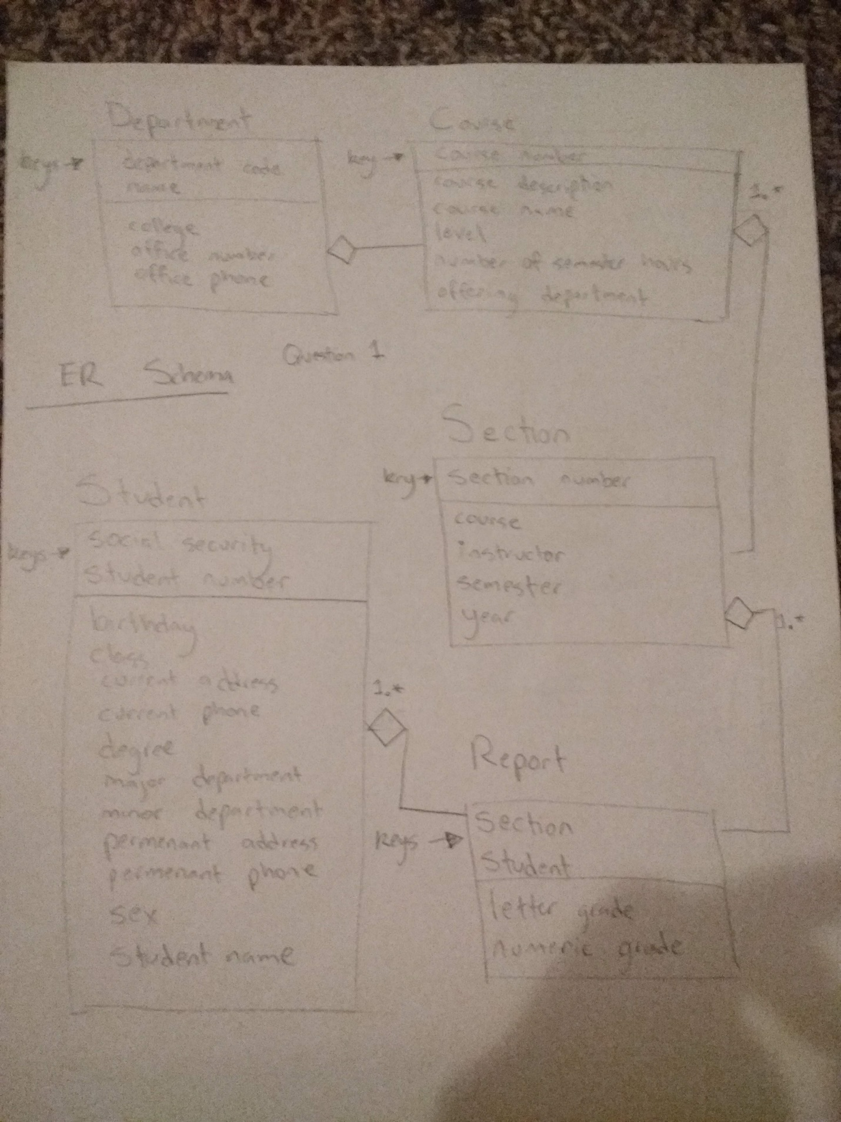

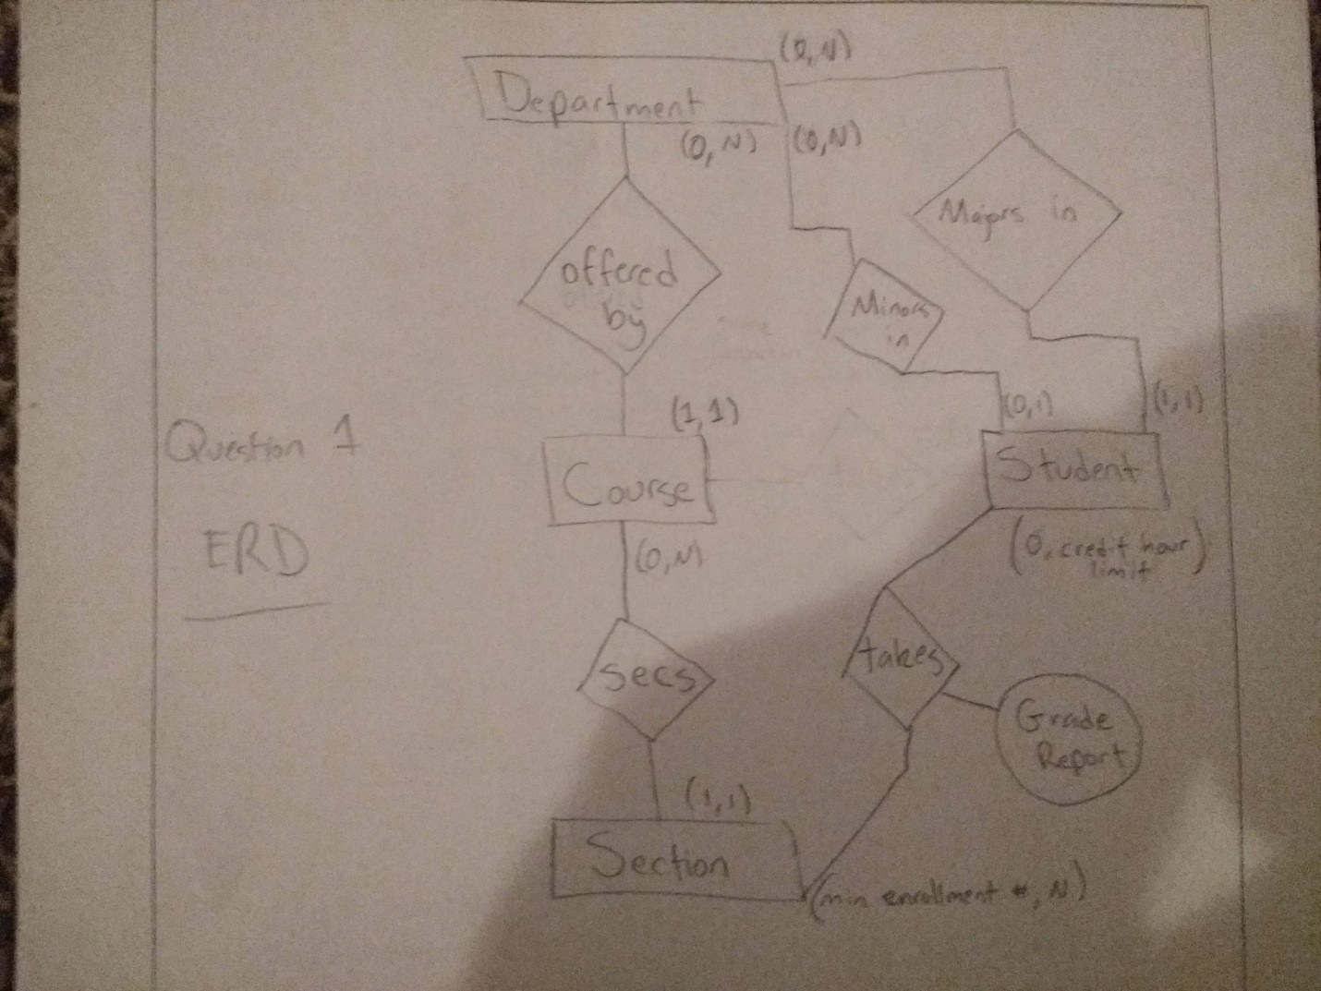

Question 2

3.17-Composite and multi-valued attributes can be nested to any number of levels. Suppose we want to design an attribute for a STUDENT entity type to keep track of previous college education. Such an attribute will have one entry for each college previously attended, and this entry is composed of: college name, start and end dates, degree entries (degrees awarded at that college, if any), and transcript entries (courses completed at that college, if any). Each degree entry is formed of degree name and the month and year it was awarded, and each transcript entry is formed of a course name, semester, year, and grade.

Design an attribute to hold this information.

Answer:

