|  |  |
| --- | --- |
| **Homework 3** | **ER Diagram and database schema** |
| **Due Sun, Sep 30 at 11:30 pm** | **Objectives:** To be able to create database schema using a tool |

**CS 4347: Database Systems Alex Lundin aml140830**

**4.17** - Consider the BANK ER schema of Figure , and suppose that it is necessary to keep track of different types of ACCOUNTS (SAVINGS_ACCTS, CHECKING_ACCTS,

...) and LOANS (CAR_LOANS, HOME_LOANS, ...). Suppose that it is also desirable to keep track of each account's TRANSACTIONs (deposits, withdrawals, checks, ...) and each loan's PAYMENTs; both of these include the amount, date, time, ... Modify the BANK schema, using ER and EER concepts of specialization and generalization. State any assumptions you make about the additional requirements.

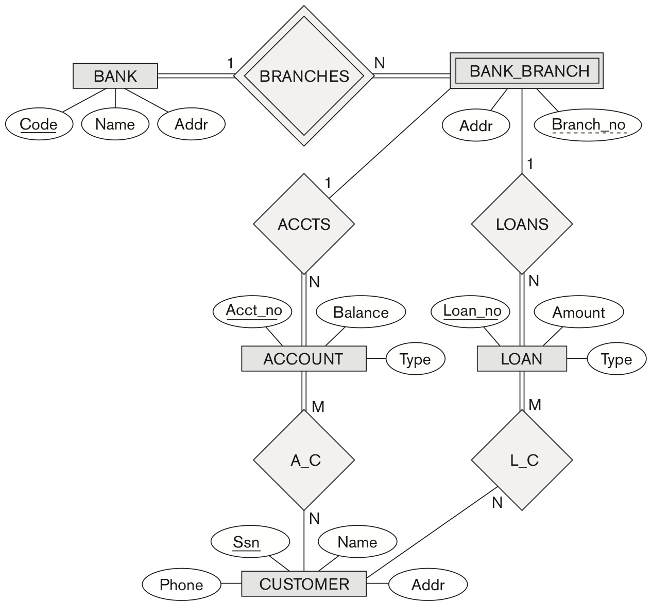

**Assumptions:**

I’m assuming we want to adhere to the best practice of keeping the database as simple as possible. So, the first requirements about keeping track of the ACCOUNTS and LOANS types are already in the tables. I’m not adding another relationship for this requirement.

**Answer:**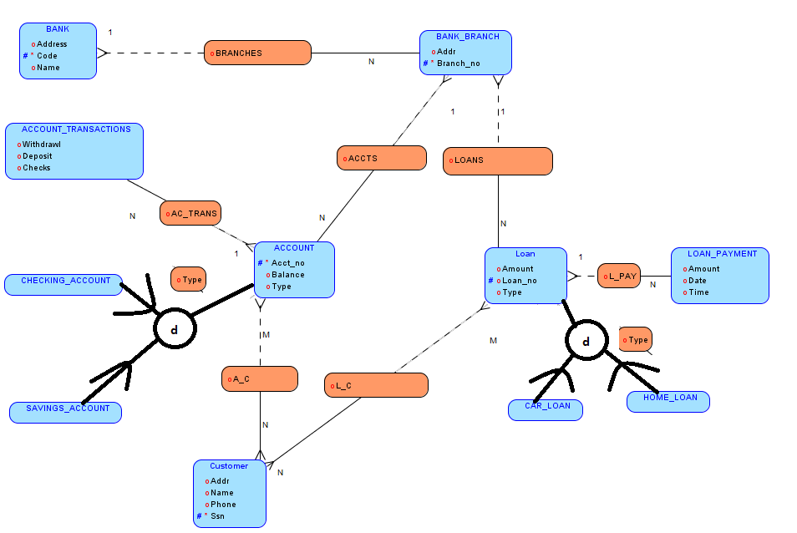

**5.11** - Suppose each of the following Update operations is applied directly to the database of Figure 5.6. Discuss *all* integrity constraints violated by each operation, if any, and the different ways of enforcing these constraints:

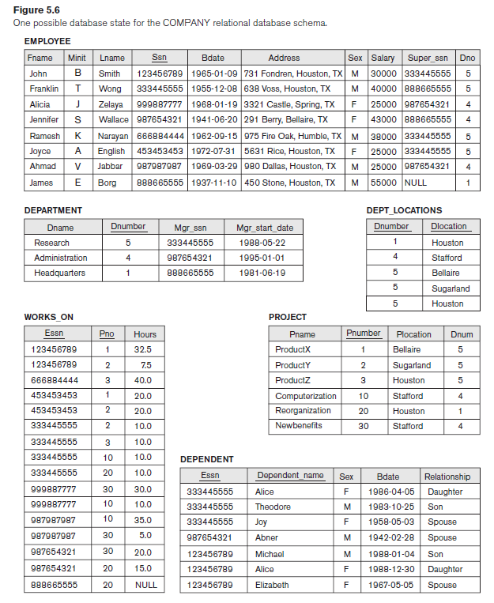

(a) Insert < 'Robert', 'F', 'Scott', '943775543', '21-JUN-42', '2365 Newcastle Rd,

Bellaire, TX', M, 58000, '888665555', 1 > into EMPLOYEE.

**No violations**

(b) Insert < 'ProductA', 4, 'Bellaire', 2 > into PROJECT.

**Violations**

**Referential Integrity**

**Bellaire maps to dnumber 4, so the reference is wrong**

(c) Insert < 'Production', 4, '943775543', '01-OCT-88' > into DEPARTMENT.

**Violations**

**Primary Key Uniqueness**

**Dnumber 4 is already in use**

**Referential Integrity**

SSN 943775543 is not in the employee table

(d) Insert < '677678989', null, '40.0' > into WORKS_ON.

**Violations**

**Referential Integrity**

**SSN 677678989 is not in the employee table**

**Null constraint**

**PNO is a primary key and can not be null**

(e) Insert < '453453453', 'John', M, '12-DEC-60', 'SPOUSE' > into DEPENDENT.

**Violations**

**Referential Integrity**

Super_SSN 453453453 is not in the employee table

(f) Delete the WORKS_ON tuples with ESSN= '333445555'.

(g) Delete the EMPLOYEE tuple with SSN= '987654321'.

(h) Delete the PROJECT tuple with PNAME= 'ProductX'.

(i) Modify the MGRSSN and MGRSTARTDATE of the DEPARTMENT tuple with DNUMBER=5 to '123456789' and '01-OCT-88', respectively.

(j) Modify the SUPERSSN attribute of the EMPLOYEE tuple with SSN= '999887777' to

'943775543'.

(k) Modify the HOURS attribute of the WORKS_ON tuple with ESSN= '999887777' and

PNO= 10 to '5.0'.

**6.5** - Consider the database shown in Figure 1.2, whose schema is shown in Figure 2.1.

1. What are the referential integrity constraints that should hold on the schema?
2. Write appropriate SQL DDL statements to define the database.

­­