**Alex Lundin**

**AML140830**

**Question 1**

**Go to the architecture of your favorite open source system. On the site, look for**

**the architectural documentation for that system. What is there? What is missing?**

**How would this affect your ability to contribute code to this project? (Chapter 18,**

**question 1)**

This is my favorite open source project.

<https://sourceforge.net/projects/opendcl/>

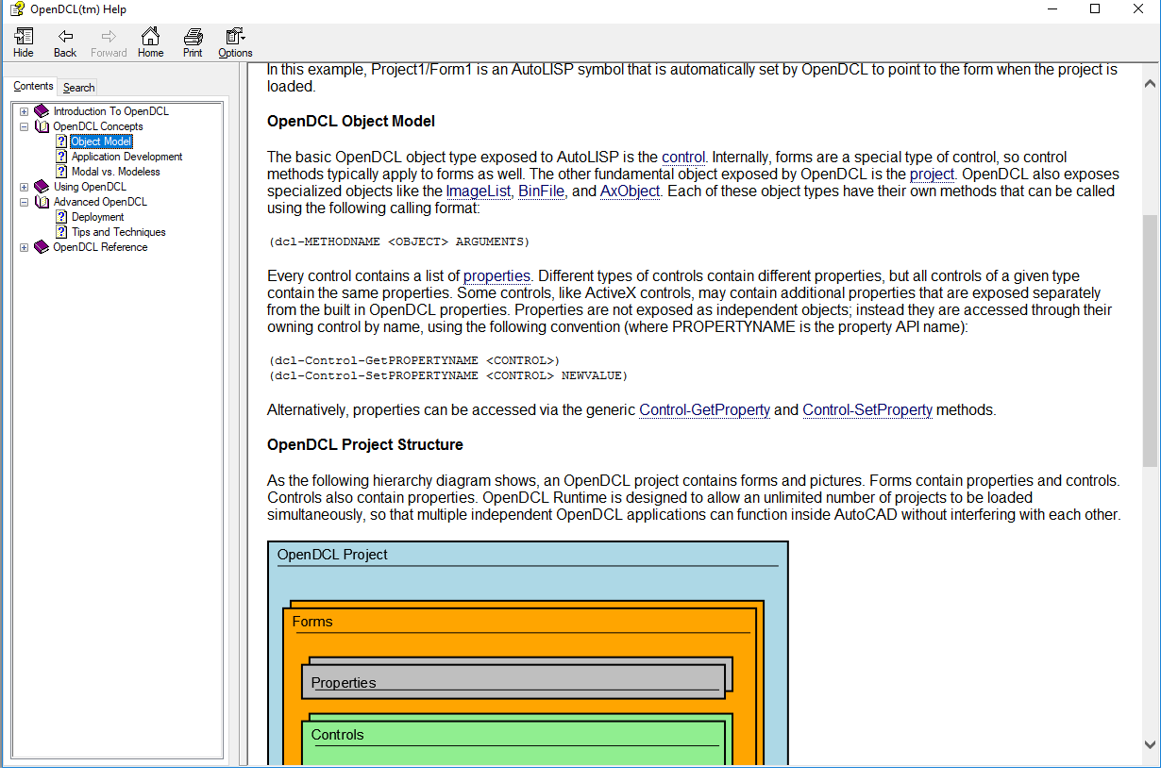

The do a great job documenting their object model, so end users can build with the architecture provided. OpenDCL provides everything a developer needs to leverage the existing architecture. They would need to include lower level documentation if they wanted end users to assist in bug fixes. I have no idea where to begin with fixing anything that is inside their compiled program. The documents they provide are great for using the product they provide to build more tools. However the documents do not describe how to edit the product itself.

In contrast, this is my favorite paid program.

AutoCAD by Autodesk

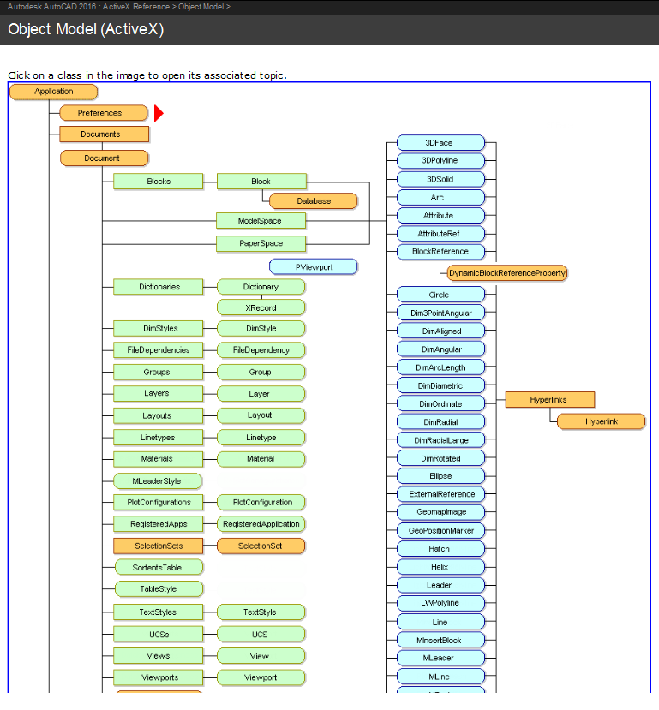

There is a plethora of architectural documents that make it easy for me to understand the object model and this makes customizing the product much less time consuming. Architectural documents are a must have for anyone who wants to encourage end users to build onto their Architecture. Same thing as OPENDCL, AutoCAD does not describe how to edit the end product.

**Question 2**

**Banks are justifiably cautious about security. Sketch the documentation you would**

**need for an automatic teller machine (ATM) in order to reason about its security**

**architecture. (Chapter 18, question 2)**

**Question 3**

**What is ATAM and what are some of its benefits? List the various steps involved**

**in this process.**

**Question 4**

**A sender wishes to send a sensitive document (e.g. a legal contract) to a receiver.**

**How can the receiver be certain of who created and sent the document?**

**Question 5**

**Can a firewall protect a private network against hackers trying to exploit critical**

**information? Draw and describe how this can be achieved.**