**Assignment 05 – Due on 10/25/18, 1.00pm**

# Question 1[: https://www.rathishkumar.in/2016/04/understanding-mysql-architecture.html](:%20https:/www.rathishkumar.in/2016/04/understanding-mysql-architecture.html)

Go to the architecture of your favorite open source system. On the site, look for the architectural documentation for that system. What is there? What is missing? How would this affect your ability to contribute code to this project? (Chapter 18, question 1)

**MySQL is at its core, a client-server architecture. The database server is ‘server’ and all of the applications that interface with the database servers are ‘clients’. The site describes factors such as:**

* **Application Layer** 
  + **Connection Handling**
  + **Authentication**
  + **Security**
* **MySQLServer Layer**
  + **MySQL services and utilities.**
  + **SQL Interface.**
  + **SQL Parser.**
  + **Optimizer.**
  + **Caches & buffers.**
* **Storage Engine Layer**

**The site excludes too much technical details but still provides a nice overview and helps in understanding the entirety of the system and how it acts. The client-server architecture is depicted nicely in a way that would help me contribute code to the project in an organized and relevant manner. A diagram from the site is shown below.**

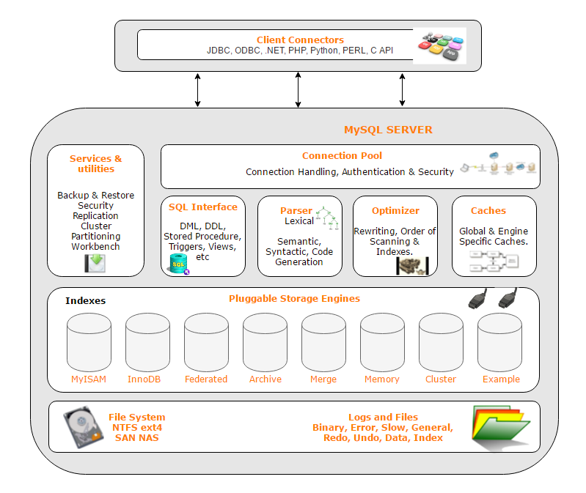

# Question 2

Banks are justifiably cautious about security. Sketch the documentation you would need for an automatic teller machine (ATM) in order to reason about its security architecture. (Chapter 18, question 2)

**The documentation needed in order to realize the security aspects of the architecture may include using document views such as the “C&C” view or “4+1” view. This view should show the components that have security/safety roles or responsibilities.**

**In the example of an ATM, the logical software behind the system should be designed defensively but not overtly such that it impedes usability. The documentation should also show contextual information such as how the ATM would be physically protected. Another aspect the document should describe is the behavior of the security. How the security protocols will handle user interaction with these elements and how it would respond to threats or vulnerabilities.**

# Question 3

What is ATAM and what are some of its benefits? List the various steps involved in this process.

**ATAM is the Architecture Tradeoff Analysis method. The purpose of this method is to evaluate the effect of decisions regarding quality attributes. It does not predict the overall quality but does help identify risks.**

**Some benefits of ATAM include:**

* Clarified quality attribute requirements
* Improved architecture documentation
* Documented basis for architectural decisions
* Identified risks early in the life-cycle
* Etc.

**Steps include:**

1. Present the ATAM
2. Present Business Drivers
3. Present current Architecture
4. Identify Architectural Approaches
5. Generate Utility Tree/Scenarios
6. Analyze the approaches
7. Brainstorm and Prioritzie
8. Analyze approaches again
9. Present Results

# Question 4

A sender wishes to send a sensitive document (e.g. a legal contract) to a receiver. How can the receiver be certain of who created and sent the document?

**Do not open the documents without first verifying with the sender if they sent the document. The sender and receiver should then go through and validate if the document is the correct one. (The receiver should hopefully know to expect this document in this case). Furthermore, having the receiver provide a secure address location to the sender can help assure that the document has not been tampered with by anyone else before the receiver gets the item.**

# Question 5: <https://searchsecurity.techtarget.com/definition/DMZ>

Can a firewall protect a private network against hackers trying to exploit critical information? Draw and describe how this can be achieved.

**A firewall can protect a private network, but it is still subject to exploitation by hackers. However, it can be protected by using 2 layers of firewalls. One protects the machines from the outside world and one that protects the private network from the outside world. We discussed this in class, and it was known as a DMZ network architecture.**

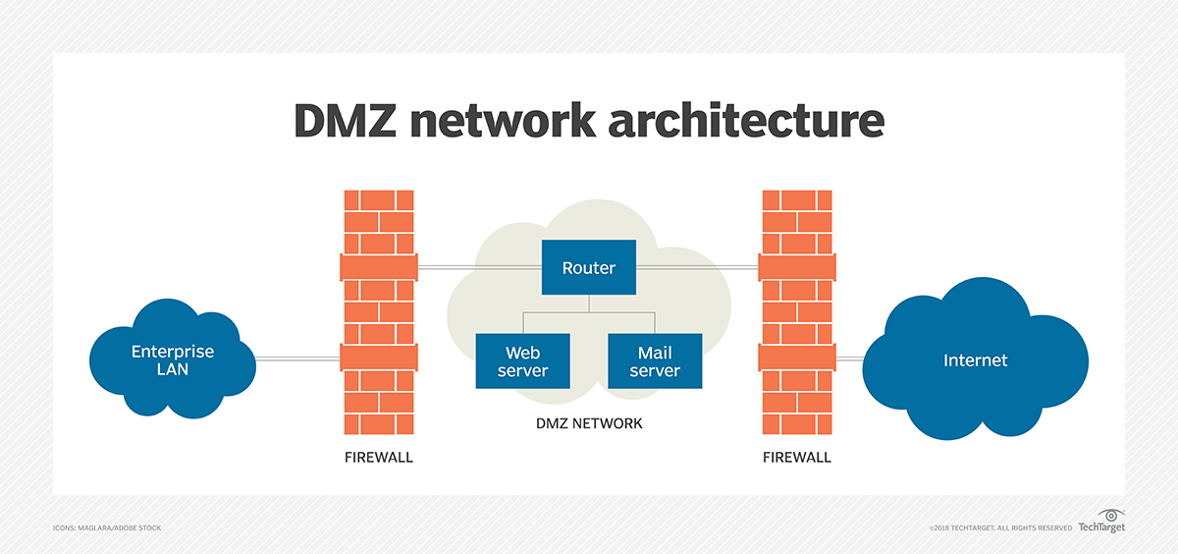

**This allows an enterprise to access necessary public internet services in a secure way. Through this architecture, internal and sensitive resources in the enterprises will be safe. Furthermore, if you want further internal security, you can split the enterprise into sensitive/critical data and user level/enterprise resources. You can reinforce these separate networks with internal firewalls of their own. This way, someone from within the enterprise cannot access the critical network.**