**Alex Lundin**

**AML140830**

***Question 1***

What is architecture reconstruction? Briefly describe the various reconstruction

activities and draw a diagram.

Architecture reconstruction is when an architect decides to rebuild the structures that created a system from the residual pieces. Reconstruction applies to products that already made at least one complete pass through the design and build phases. The architect will use artifacts from the initial architecture, if they exist, and the architect will employ several strategies to overcome lacking documentation. Such strategies include: involving anyone with knowledge of the system in the reconstruction, reading header files, reading source code and decompiling machine code from the existing system.

*Activities:*

1. Raw view extraction
2. Database construction
3. View fusion and manipulation
4. Architecture analysis

*Diagram:*

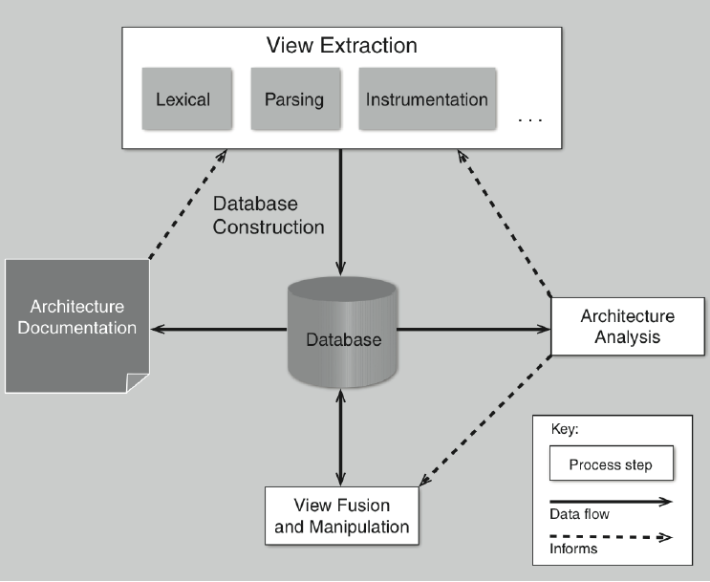

[1, slide 37]

***Question 2***

Provide the context, problem, and a real-world scenario for architecture

reconstruction (different from class example).

Context:

A team designed, developed and deployed a system for an Android phone application. The original architecture documents are incomplete, and half the original developers still work for the company. Today, the business goals shifted, and the company would like to market to iOS customers as well as Android.

Problem:

Our manager would like a cost estimate of reusing the existing architecture when porting between Android and iOS development frameworks.

Scenario:

Reconstruction would be necessary to evaluate the cost analysis of porting the system to iOS.

***Question 3***

You oversee the football stadium at a Big Ten school and oversee security.

Answer the following questions with a security mindset:

i) What assets do you need to protect?

Personal information of everyone involved

Students

Faculty

Staff

ii) What threats will you defend against?

External

Cracking

Hacking

Malware

Internal

Sabotage

iii) What countermeasures can you justify, in terms of costs and benefits?

Accounts

Two step account verification

Strong passwords

Expiring passwords every 2 months

***Question 4***

Listen/Watch the following webinar from SEI and submit a half page single spaced

summary in your own words about the webinar.

<https://resources.sei.cmu.edu/library/asset-view.cfm?assetid=18914>

The video starts off describing a systems evolution in terms of business goals. A system is designed to serve the goals, and as the system develops, the business goals are met, hopefully. And then the organization becomes more successful. Then the system starts over.

As the video continues, the process adds the concept of architecture into the process of building the system. The host states the it is more successful to have the architecture stem from business goals. Another interesting point is that the architecture should satisfy the business goals without even implementing the design.

After the architecture is created and it meets the business goals, then the architecture can drive the systems design through the implementation phase. The check on system implementation is conformance to architecture.

During the process of architecture design, evaluations are done. Will the designed system have properties that make the organization successful? Two definitions that must be included are, the metrics that make an organization successful and throughout knowledge of a systems properties.

During quality attribute evaluation every concept that makes an architecture good in terms of business success has drawbacks or side effects. The architect has to be aware of them and include these in the documentation. These could be items such as what data structures are in place, and the time it would take to change them.

Another interesting point is risk evaluation. No company in the world has enough time or money to build a non-trivial system that is perfect. The only systems that are possible are ones that are good enough. A risk becomes prevalent when system properties do not satisfy quality attributes. Or when the approaches for a certain scenario jeopardizes other scenarios.

References

[1] Dr. Pushpa Kumar, Lectures 17-18 Architecture Reconstruction, Topic: "Module8”, SE-4352.001, Software Engineering, University of Texas at Dallas, ECSS, 10/16/2018

[2] Dr. Pushpa Kumar, Lectures 19-20 Security, Topic: "Module9”, SE-4352.001, Software Engineering, University of Texas at Dallas, ECSS, 10/23/2018

[3] Dr. Pushpa Kumar, Lectures 21-22, Topic: "Module10” Software Product Lines”, SE-4352.001, Software Engineering, University of Texas at Dallas, ECSS, 10/30/2018