<https://compas.cs.stonybrook.edu/~nhonarmand/courses/fa17/cse306/schedule.html>

^ class almost exactly like ours, better slides

# Exam 2 Review Sheet

Table of Contents

Exam 2 Review Sheet 1

11-Locks 2

12-Concurrency 2

13-Semaphores 2

14- Concurrency Bugs 2

Notes from Review Day 2

## 11-Locks

Summary:

Threads share: code, data files

Threads have: unique registers, unique stack

## 12-Concurrency

Summary:

## 

## 13-Semaphores

Summary:

This slide deck focuses on how to achieve concurrency between multiple threads using wait and post functions in a new structure called semaphore. The semaphore is a structure that contains an integer value representing the semaphores internal state. The user CAN initialize the semaphore with any valid value. After initialization, the user CAN NOT directly edit the integer state variable. The user CAN ONLY call SEM_WAIT to decrement and SEM_POST to increment.

## 

## 14- Concurrency Bugs

Summary:

20-Raid

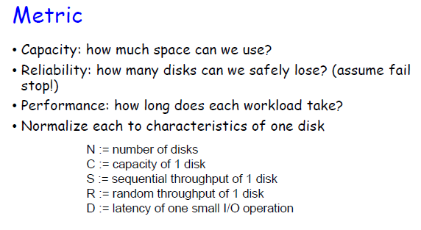

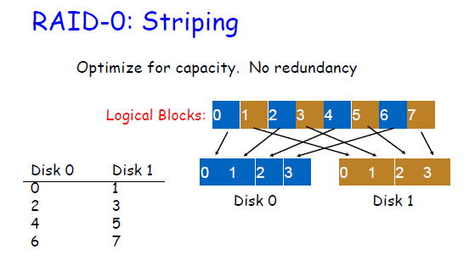

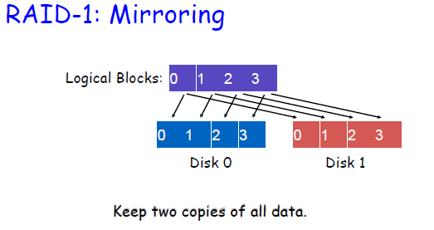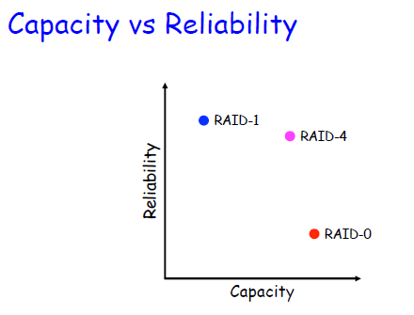

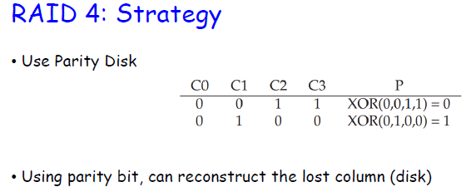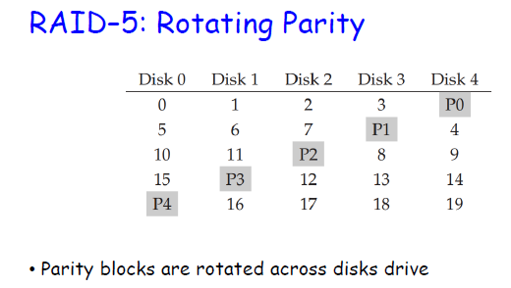

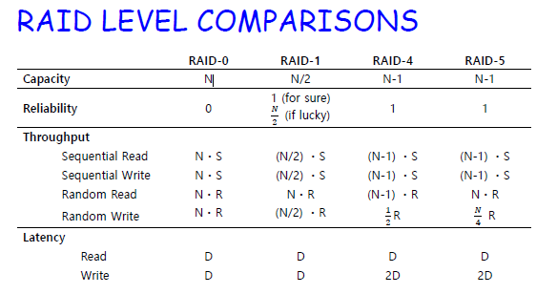

## Notes from Review Day

Exam2 Review

Big picture