By
Rahul Kotian
Pratyush Chandra.M
Deepak V Shenoy
Siddharth Phadkar

Table of Contents
Table of Contents 2
1. Introduction 3
2. Abstract 3
2.1 Requirement Sources: 4
3. System Overview: 4
3.1 Purpose: 4
3.2 Scope: 4
4. Product overview: 4
4.1 Definitions: 5
5. Team Architecture: 5
5.1 Stakeholders: 5
5.2 Team Responsibilities: 6
6. Enterprise Requirements 7
6.1 Enterprise Functional Requirements: 7
6.2 Conflicts: 7
6.3 Conflict Resolution: 7
6.4 Enterprise Non-Functional Requirements: 8
Preliminary Understanding: 9
Enterprise Requirements 9
7. System Functional Requirements: 10
8. System Non- Functional Requirements: 12
9. Issues: 15
10. Improved Enterprise Requirements: 18
Enterprise Requirements 18
11. System Functional Requirements (Improved Understanding): 19
12. System Non-Functional Requirements (Improved Understanding): 20
12.1 System Non-Functional Requirements: 21
13. Use-Case Diagram: 22
14. Sequence Diagram: 23
15. Activity Diagram: 24
16. Screenshots: 25
17. References: 30

1. Introduction

This document describes the Enterprise, functional, non-functional requirements for the Synergy Soft Distributed Meeting Scheduler product that is planned for product development in the near future.

The purpose of the document is to gather all the Requirements needed for the product from the users or stake holders to define the Vision Statement and goals for the new product and to list all the functional and non functional requirements for the success of the product.

2. Abstract

Scheduling Meetings was done manually once upon a time when offices were not automated. This was a tough and time consuming job as every thing was done manually (e.g. typing agendas, writing meetings etc)
With the advent of computer technologies and flatter hierarchies the task of scheduling meetings has become a must to all of the company CEO’s and all the higher executives to maintain a Meeting Scheduler Software. In bringing any group of people together, there are so many factors to take into account. It could be that there's a certain pecking order, and some people have to work around more important people's schedules. Or, some people can best be contacted by phone, some by e-mail, or some through a third party such as a secretary or administrative assistant. Decisions about where the meeting is held are important as well, and very political. For some meetings, a simple announcement will do. For others, participants will need to be polled for their availability and then confirmed later.

So with all these factors in mind our company has decided to come up with a basic model at this phase to design an Online Meeting Scheduler which automates all the above process and makes things easier. Many Software vendors are eagerly waiting for this product to come into the market.

With in the last few months our company has spent all its time in gathering some initial requirements from the customers. As it is well known to every one in the software industry these requirements are vague and not clear but the Synergy soft will slowly categorize all these requirements by identifying its prime customers and gathering the requirements from them (What they want?)

Requirements Elicitation is a never ending process and the Requirements team will take care of this stuff. Even though the basic version of Meeting Scheduler is developed the Requirements team keeps on eliciting the requirements for further enhancement of the system.
All the informal requirements gathered are converted into formal requirements using UML tools to complete the entire development process successfully. Apart from that Synergy Soft Inc is looking to our company’s expertise to deliver a detailed requirements document with precise and as conceptual as possible that satiates the real needs of customers of the real world.

2.1 Requirement Sources:

- Existing ‘Meeting Scheduler’ softwares
- Internet
- Interviews
- Personal Experiences

3. System Overview:

3.1 Purpose:

The purpose of this RE elicitation document is to provide a proper documentation for the SDMS system with all the possible requirements for the success of the system. In general this team will provide the basic functions of the system and the team’s project plan and its initiatives. This document will also talk about the functional requirements as well as non-functional requirements that help in improving the performance of the system

3.2 Scope:

As discussed above this document discusses about the functional requirements, non- functional requirements, Stake Holders, Team Architecture and scope of the project. This document also provides the basic prototype of the system. The architecture and detailed design are not discussed in this document as the scope limits this document to initial Enterprise Requirements, System functional requirements, and non –functional requirements.

4. Product overview:

Synergy Distributed Meeting Scheduler is a meeting scheduler which can be used by any organization of university to organize meetings effectively and determine the available resources and also will help in scheduling meetings from virtual places. One person will be initiating the meeting and the rest of the team will respond to it and meeting is scheduled accordingly .One admin will be taking care of all the user profiles and maintains the database of the meetings held and its agendas and their outputs.
This product is a combination of simple jsps where the user can access from any where in the world with internet connection. It has a very easy user interface and can be accessed with ease and is cheap comparative to the rest of the existing software in the market.

4.1 Definitions:

Agenda: The main topic which is to be discussed in the meeting.

Date Range: A time interval prescribed by the Meeting Initiator.

Duration: The time interval for which the meeting is going to take place.

Meeting Initiator: Person who initiates the meeting.

Important Participant: Participant whose presence is necessary for the meeting to take place.

Strong Date Conflict: Conflict which arises when no date can be found within the date range and outside the exclusion set given by participants.

Representative: One who initiates a meeting on behalf of someone.

5. Team Architecture:

5.1 Stakeholders:
"Stakeholders" are persons who have any interest whatsoever in the software project. (E.g. developers, project leads, architects, patrons, customers, consultants and various user groups).Stakeholders can be defined as people who are directly or indirectly affected by the system’s existence .This will include everyone from the developers who built the system to the end users who use the system, the Testing team, the Requirement Engineers.
We have divided the stakeholders into the following categories:
- End users.
- Meeting Participants.
- Meeting schedulers/initiators.
- Requirement engineers.
- Developers responsible for the system development and maintenance.
- Network support group.
- Potential customers of the organizations who will use the system.
- Domain expert.
We reviewed the documents provided by SynergySoft and discussed the various issues in detail. We conducted researches and went through various sources to get the accurate information. We also reused some of the previous work which was done by earlier teams which has helped us in understanding the requirements much better.
We divided the team into four categories, representing User World, Subject World, System World, and Developer World.

Team Member | Role Played
Pratyush Chandra | Developer World
Rahul Kotian | Subject World
Deepak Shenoy | User World
Siddharth Phadkar | System World

5.2 Team Responsibilities:

The “Developer World “representative’s role is to provide inputs regarding the feasibility of the project and inclusion of the various standards and best practices for software development.

The “Subject World” representative’s role is to provide inputs for the various operations included in scheduling a meeting such as organizing contacts and coordinating the various communications.

The “User World” representative ‘s role is to provide inputs from the user’s perspective ,what is that the user needs in the system , the look and feel of the system ,the interface of the system, the usability issues of the proposed software.

The “System World” representative’s role is to represent the requirements of the software product to be developed.

6. Enterprise Requirements

6.1 Enterprise Functional Requirements:
Meetings are arranged in the following manner:
The Meeting Initiator initiates a meeting by asking all potential meeting attendees for their information regarding dates on which they cannot attend the meeting as well as the dates on which they would prefer to meet. An initiator can be one of the participants or some representative, such as a secretary.
The Meeting Initiator shall provide the date range, the meeting locations, the agenda for the meeting and also determine who all are the potential attendees. The Meeting Initiator shall decide which participants are ‘important’ and which of them are ‘active’.
The Initiator shall ask the Active participants to state any special requirements of equipments and the important participants to state the location preferences.
After all the participants have given their input the meeting date shall be decided .This date shall be in the date range and not in any of the exclusion sets stated by the participants.
The Meeting Room shall be chosen based on the preference of the important participant.
The Meeting Room shall have the required equipments as stated by the participants.
The Meeting Room shall be available on the meeting date.

6.2 Conflicts:
A strong Date Conflict arises when no date can be found which is in the preferred set of most participants.
A weak date conflict occurs when dates can be found within the date range and outside all exclusion sets, but no date can be found at the intersection of all preference sets.

6.3 Conflict Resolution:
Conflict shall be resolved by Meeting Initiator extending the date range.
Conflict shall be resolved by participants removing dates from their exclusion set.
Conflict shall be resolved by some participants withdrawing from the meeting.
Conflict shall be resolved by some participants adding date to their preference set.

6.4 Enterprise Non-Functional Requirements:
Conflict Resolution shall be done quickly.
Conflict Resolution shall be done with minimum interactions.
Negotiations for meeting rooms shall be kept minimal.
A new round of negotiations may be required when no such room can be found.

Preliminary Understanding:

Enterprise Requirements

Meeting Initiator
Date
Range
Legend:

Means X depends on Y
Y
X

Potential Meeting Attendees
Exclusion
Sets
Preference Sets
Meeting Date & Location
Special
Equipment requirement
Active
Participants ?????
Preference of Location
Important
Participants

7. System Functional Requirements:

- Here are some of the functional requirements that are noted and recorded for further development of the system.

- The meeting scheduler shall schedule the meeting given the date, time range, topic or agenda and place where the meeting is to be conducted.

- The meeting scheduler shall be able to monitor the meetings held at virtual places

- The meeting scheduler shall be able to reschedule the meeting with dates and time changed

- The meeting scheduler shall cancel the meetings if required or due to the absence of important participants

- The meeting scheduler shall reschedule the meeting to resolve conflict

- The meeting scheduler shall be accessed from the web

- The meeting scheduler should have a user friendly interface to the meeting initiator by providing all the available options such as date range, active participants and important participants, time range and also an option to choose the resources

- The meeting scheduler shall suggest a meeting place for available dates.

- The meeting scheduler shall have a registration page for all the users to get registered

- The user profiles in the meeting scheduler can be only changed by the administrator who is responsible for the system

- The meeting scheduler shall inform all the users of the system once the meeting is initiated by the meeting initiator

System Functional Requirements:

SDMS

Monitor Meetings????
Plan Meetings
Replan Meetings

Modify Preference Set/exclusion set
External Constraint
Accommodate Important Meeting
Cancel Meeting
Change Date& Location
Manage Concurrency
Support Conflict Resolution
Policies by Client
Manage Interactions
Updates
Support Negotiations
8. System Non- Functional Requirements:

Any software that is designed with some purpose and intention should be fast, consistent and reliable

Here are some of the non-functional requirements that improves the quality of the software

1. Performance:

- Elapsed time between determination of meeting and communication of this information should be minimal

- Lower Bound should be fixed between the determination of meeting date and actual meeting

2. User friendliness:

The System being designed should be user friendly to every one that means that the user should be able to access the system or use the system with out any difficulty

3. Robustness:

The system should be accurately monitored, especially when it is held in a virtual place. Hence, nomad city will be taken into consideration. The intended system should considerably reduce the amount of overhead usually incurred in organizing meetings where potential attendees are distributed over many different places and communicate with each other

4. Security

Private users or unauthorized users should not be able to access the system .Proper Authentication and validation of user should be done .The system should provide as much decentralized requests as possible

5. Reliability

The system should be reliable. The system should act as human who conducts or schedules meetings with out any flaws .Every one should be able to blindly believe the system for its accuracy .It should be well automated

6. Flexibility
Rescheduling of meetings should be done automatically. Also, the system should be flexible enough to accommodate evolving data (e.g. the sets of concerned participants may be varying; the address at which a participant can be reached may be varying, etc.).

7. Extensibility

The system should be able to handle explicit dependencies between meeting date and meeting location

System Non-Functional Requirements

Monitor Meetings
Plan Meetings
Replan Meetings
Manage concurrency
Support conflict
resolution

Manage Interactions

Accommodate decentralized meetings

Reduce overhead

Reduce overhead

Convenient date and locations

Dynamic

Manage physical
constraints

Flexible

Minimal

Usable???

Customizable???

Improved Performance???

9. Issues:

The team initially had some meetings and brain storming sessions for the whole process to come into action .While discussing in the meetings the team members had some issues regarding the project (issues are those statements which can be ambiguous or some kind of conflict that comes in the normal flow of events and disturbs the system) Each issue is recorded, numbered and properly documented for further references

In general these issues are resolved with the help of senior management and some senior consultants.

Issue 1: Role of Administrator

Description: The initial requirements specification has administrator but we could not
Properly identify the role of administrator and his involvement with the sytem.

Then we had 2 options

Option 1: To give meeting initiator the role of administrator
Problem: Then there can be many administrators for the system which does not make any
Sense

Option 2: To give Administrator the following roles

- Handling user profiles
- Maintains the database
- Keeps track of all the meetings that were held in a particular year with their outputs and agendas
Contact: Pratyush Chandra (Developer World)
Rahul Kotian(Subject World)
Issue 2: Is Meeting Initiator an active participant

After vigorous discussion we came up with an answer yes since a person to a particular domain of that issue can only initiate the meeting to solve it or for some other purposes
So the entire team came up with an answer yes

Contact: User world representative ( Deepak V Shenoy)

Issue 3: Issues regarding the date range
Description: Should the meeting initiator only resort to expanding the date range when there is no possible date when all the important participants can attend, or should this be considered for every participant?
Solution: Extend date range when a larger amount of participants can’t attend then the ones who can attend, regardless of how important they are.
Contact: Siddharth Phadkar (System world representative )
Issue 4: A meeting should be accurately monitored, especially when it is held in a virtual place.

Description: What does ‘monitoring’ mean?

Solution: Here Monitoring will include the various events taken place till the meeting is scheduled and conveying the various events to the concerned people.

Contact: Pratyush Chandra (Developer World)
Rahul Kotian(Subject World)

Issue 5: The meeting initiator will ask all potential meeting attendees…

Description: Who decides who the potential meeting attendees are?

Resolution: The Meeting Initiator will decide this.

Contact: Rahul Kotian(Subject World)

Issue 6: To make them confident about the reliability of the communications.

Description: How to make them confident about the reliability?

Resolution: The System will have to send timely and accurate updates about the various events in the scheduling of meetings.

Contact: Pratyush Chandra (Developer World)
Siddharth Phadkar (System world representative)

Issue 7: ‘Make participants aware of what is going on’ and ‘Keep participants informed about schedules and changes’.

Description: Redundant requirement statements.

Resolution. Retaining only one of the statements: Keep participants informed about schedules and changes’.
Contact: Siddharth Phadkar (System world representative)

Issue 8: “The intended system should considerably reduce the amount of overhead usually incurred in organizing meetings…..”

Description: How to reduce the overhead?

Resolution: The system will be using the email system which the user uses and not have email service of its own.

Contact: Pratyush Chandra (Developer World).

10. Improved Enterprise Requirements:

Enterprise Requirements

Meeting Initiator

Potential Meeting Attendees
Exclusion
Sets
Preference Sets
Meeting Date & Location
Date
Range
Legend:

Means X depends on Y
Y
X
Special
Equipment requirement
Active
Participants
Preference of Location
Important
Participants

11. System Functional Requirements (Improved Understanding):

SDMS

Monitor Meetings
Plan Meetings
Replan Meetings

Modify Preference Set/exclusion set
External Constraint
Accommodate Important Meeting
Cancel Meeting
Change Date& Location
Manage Concurrency
Support Conflict Resolution
Policies by Client
Manage Interactions
Updates
Support Negotiations
12. System Non-Functional Requirements (Improved Understanding):

Monitor Meetings
Plan Meetings
Replan Meetings
Manage concurrency
Support conflict
resolution

Manage Interactions

Accommodate decentralized meetings

Reduce overhead

Reduce overhead

Convenient date and locations

Dynamic

Manage physical constraints

Flexible

Minimal

12.1 System Non-Functional Requirements:

Usable
Customizable
Flexible
Extensible
Improved Performance
SDMS

13. Use-Case Diagram:
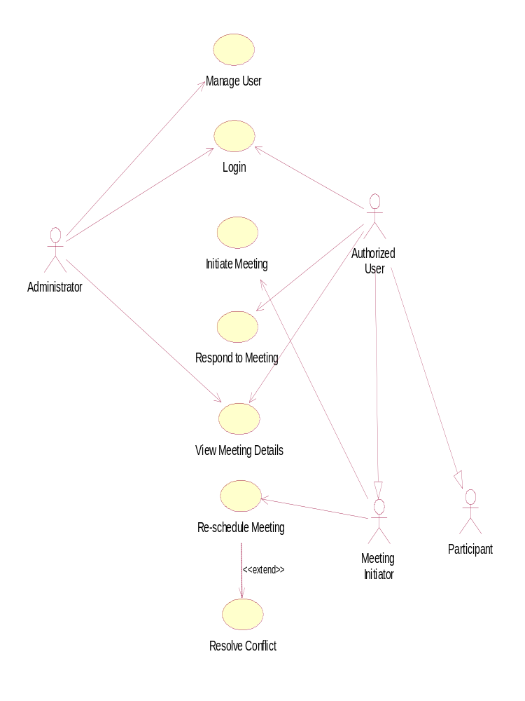

14. Sequence Diagram:

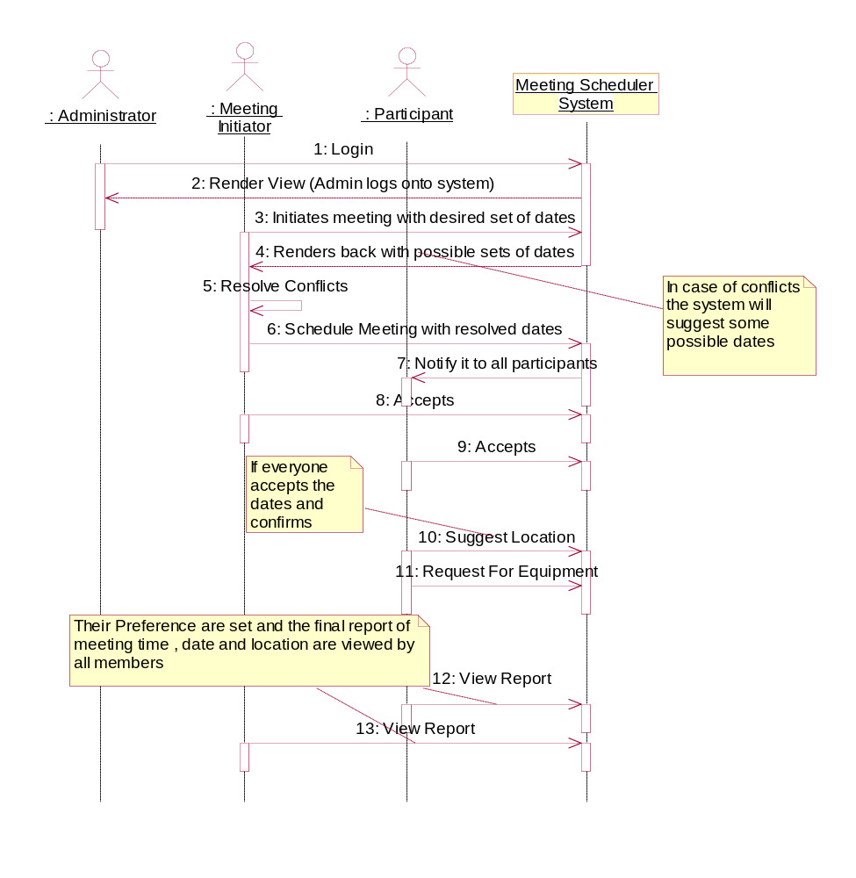

15. Activity Diagram:
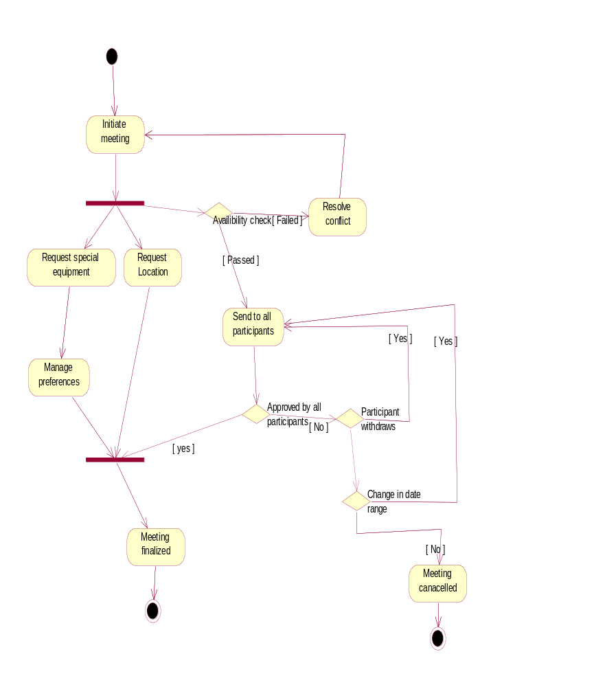
16. Screenshots:
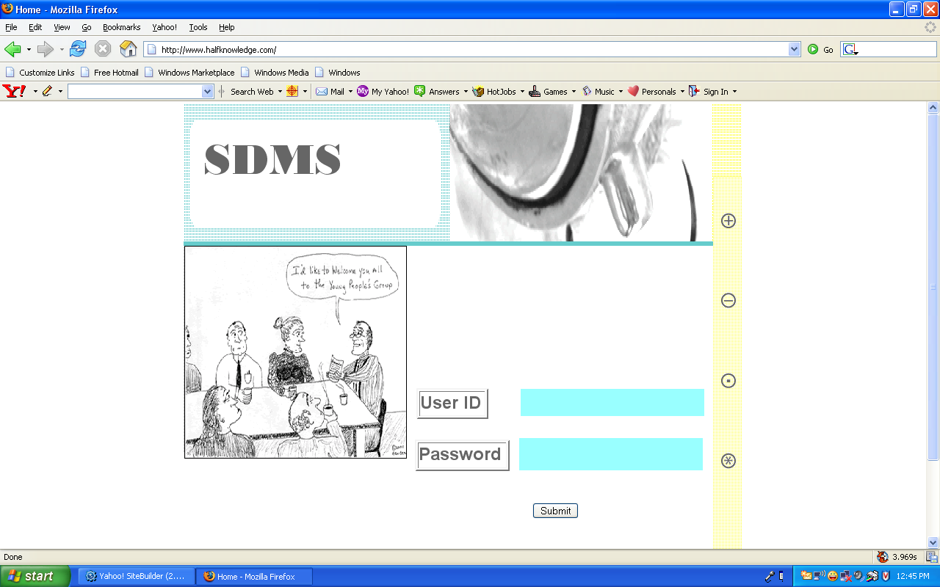

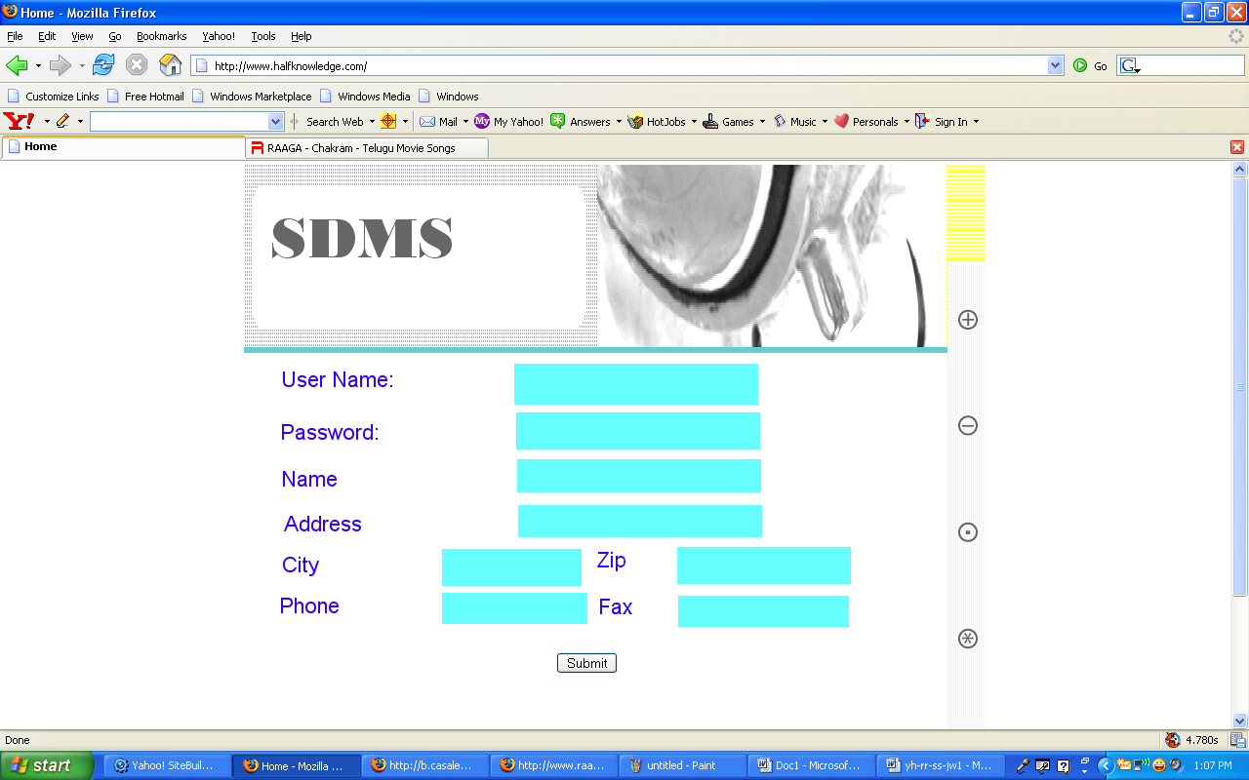

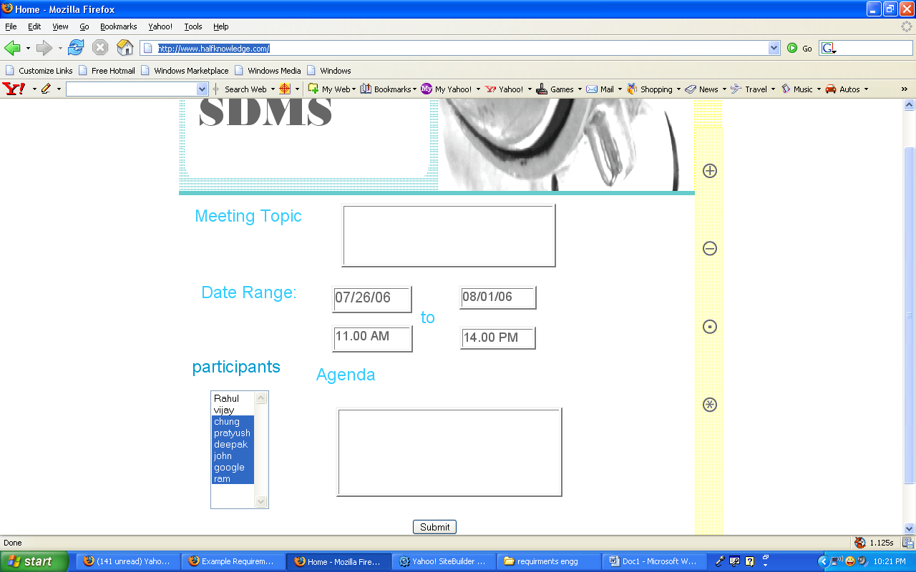

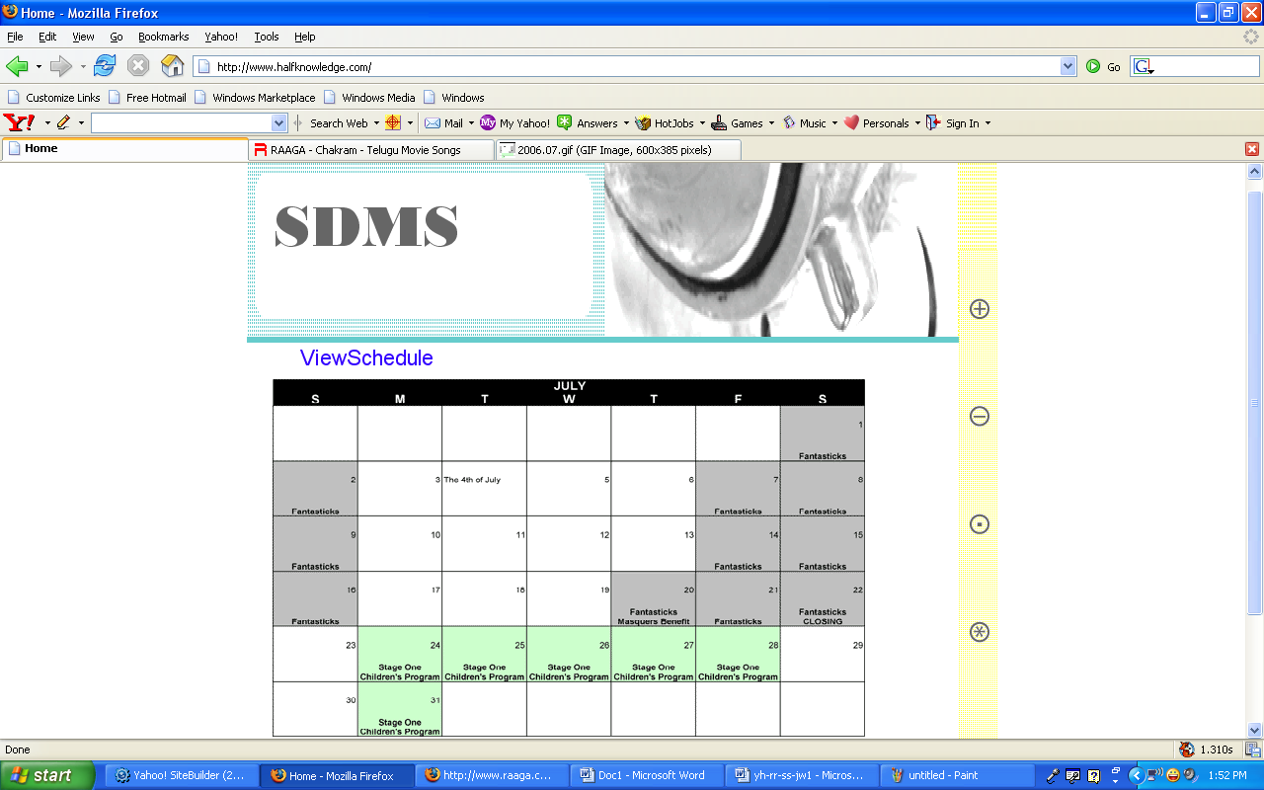

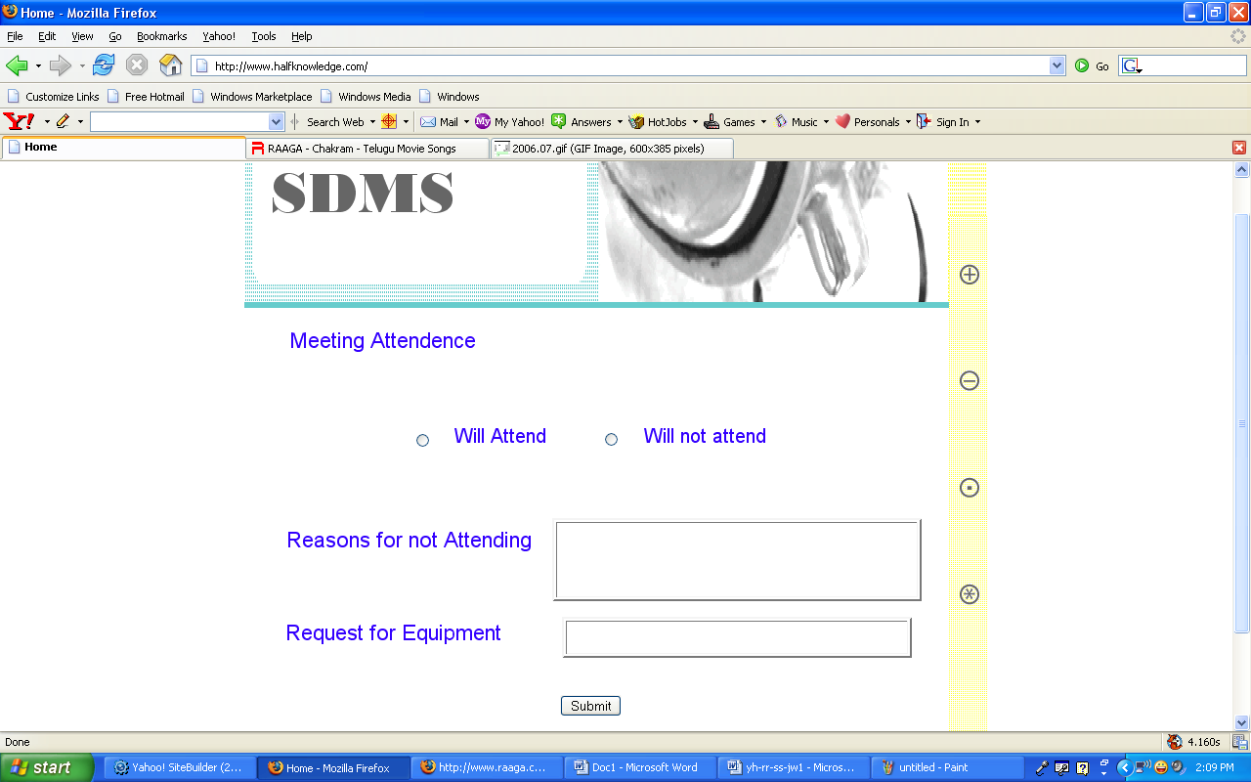

17. References:

- Presentation 1 Summer 2006
- Presentation 2 Summer 2006

