SDMSTM Synergy Distributed Meeting Scheduler

REQUIREMENTS ELICITATION
Initial Understanding
Phase1

CS 6361 Requirements Engineering
Professor Lawrence Chung
Summer 2006

Yogita Devarajan
Jeffrey Koch
Geetanjali Sharma

June 21, 2006

Table of Contents

Table of Contents 2
Introduction: 4
SDMSTM System Overview: 6
Purpose 6
Scope 6
Product Overview 6
Team Architecture 8
Problem Analysis Step 8
Product Description Step 9
SEMI-FORMAL REQUIRMENTS DESCRIPTION: 10
ENTERPRISE REQUIRMENTS: 10
Enterprise Functional Requirements Description: 12
Enterprise Non-Functional Objectives 13
System Functional Requirements 14
System Functional Requirements Description 14
System Non-Functional Requirements 16
System Non-Functional Requirements Description 16
3. Issues Discussed in the Meetings 18
A) Incompleteness 18
B) Ambiguous: 19
C) Misclassified: 21
D) Missing: 21
E) Redundancy 22
4. Improved Understanding:: 23
Enterprise Functional Requirements: 23
Definitions: Enterprise Requirements 23
Enterprise Functional Requirements 24
Enterprise Non-Functional Requirements 25
System Functional Requirements: 25
Draft Screen Shots 27

Introduction:
Scheduling meetings is one of the most common tasks in the modern workplace. In earlier days, the time-consuming tasks of scheduling meetings, typing up agendas, and taking minutes was the domain of the office secretary. With the advent of computer technologies and flatter hierarchies, the task of setting up meetings is a chore for all but the highest of executives, and even they get there hand in it from time-to-time.
As companies continue to grow, they tend to seek for better software that will help them improve their current scheduling system and increase productivity within their organization. These scheduling systems range from scheduling courses and flights, room assignments at hospitals and hotels, scheduling national and international meetings, logistics, job scheduling in production systems, as well as command and control systems. Other scheduling systems include allocating transmission lines, buffers and routers in computer networks, and maybe used for other types of scheduling specific to the organization.
Scheduling a meeting really is not as simple as it looks, even with scheduling software. A lot of judgment is involved, and there's a real sense of propriety required. In bringing any group of people together, there are so many factors to take into account. It could be that there's a certain pecking order, and some people have to work around more important people's schedules. Or, some people can best be contacted by phone, some by e-mail, or some through a third party such as a secretary or administrative assistant. Decisions about where the meeting is held are important as well, and very political. For some meetings, a simple announcement will do. For others, participants will need to be polled for their availability and then confirmed later.
With the growing popularity of scheduling systems, SynergySoft, Inc. aims to provide such a product, which would outperform any such system that is currently available in the highly competitive market. SynergySoft, Inc. is proposing an innovative approach to a new product called SDMSTM or Synergy Distributed Meeting Scheduler, in which this product is intended for supporting people to schedule their meetings. Many software vendors are eager to offer such a system, especially one with a powerful vantage point (e.g. Microsoft, IBM-Lotus, etc.).
Within the last few months, SynergySoft, Inc. has gathered some initial requirements from potential customers. However, the company is well aware that they have not clearly characterized what their customers really want, not to mention who their real customers might be. Consequently, the requirements definition is only preliminary, sketch, imprecise, incomplete and possibly inconsistent.

Furthermore, SynergySoft, Inc. is also aware that getting the right requirements the first time will be the barometer to successfully completing the entire development effort, reducing production time, and to keeping up its well-established reputation and ultimately to satisfying their workforce and customers. In essence, SynergySoft, Inc. is looking to our company’s expertise to deliver a detailed requirements description, which precisely, concisely and conceptually as possible to capture real customer’s real needs or wants.

SDMSTM System Overview:

Purpose
The purpose of this Requirements Elicitation document is to provide a brief introduction to the SDMSTM system and to identify the critical requirements essential to the project’s success. This document is intended for the use of providing an abstract overview of the SDMSTM system and is only used to provide a general overview of the entire project. However, the architectural and detail design is outside the scope of this document, but will be covered in the Software Requirements Specification document.
In general, this document will be used to organize our team’s project plan and deliverables. This document explains our team architecture, our team’s initial understanding of the user needs. It will assist our team in understanding the system specifications and analyze the critical aspects of our project. Then again, this document is the initial phase of understanding the user wants and needs. It will allow the project management and development group to grasp the high level details delivered to the end user. This document will briefly discuss the stakeholders involved in the development, the sources of the requirements, provide an informal preliminary requirements description, and address any issues encountered while transforming the requirements.

Scope
This document is intended for providing an abstract overview of SDMSTM system and general overview of the entire project. The Enterprise Functional and Non-Functional requirements, Stake Holders, Team Architecture, System Functional and Non-Functional Requirements are the scope of this document. This document is also intended to provide a proto-type of the SDMSTM system. However, the Software Architectural Design and Detailed Design of SDMSTM system are beyond the scope of this initial Requirements Elicitation Document and will be described in Software Architectural Design and Detail Design Document in the future phases of this project

Product Overview
The SDMSTM system is a web-based meeting scheduler system used within an organization to efficiently schedule meetings and determine the available resources necessary for the meeting to be initiated. The purpose of this system is to support the organization in scheduling meetings by determining each meeting’s request, date and location. The SDMSTM system will monitor meetings, plan meetings under constraints expressed by the participants, reschedule meetings based on constraints, support conflict resolutions, and manage all the interactions among participants. It also has the ability to concurrently handle several meeting requests at a time.
Conveniently, the SDMSTM system can be accessed from any computer with Internet access. This allows the user to schedule meetings at any particular time of the day. From its easy to use interface to its simple installation, this system can be used by any organization of any size. Then again, with its low cost and maintenance appeal, the system is a sure success.

Team Architecture
During our initial meetings, we reviewed the documents provided by Synergysoft: the initial requirement summary and reports from other consulting firms who had conducted prior research on behalf of Synergysoft. With Synergysoft's permission, we were able to reuse much of the work from earlier teams; this significantly aided our ability to meet the condensed schedule.
For our next meeting, we interviewed Dr. Laurence Cheng of Synergysoft to clarify ambiguities in the requirement summary.
Our team then divided into three categories, representing people in the Customer World, Management World and Consultant World. Primary functions and roles played by each team member are:

First Delivery

Team Member | Role Played | Primary Functions Performed
Yogita | Customer World:  End-user/Buyer | - Initial Requirement Analysis
Anjali | Consultant World:  Programmer,  Consultant | - Requirement Issues
Jeff | Management World:  Project Manager  Product Manager | - Process

Second Delivery
The overall work is made up of two major activities: Problem Analysis and product description.

Problem Analysis Step
- Domain analysis and study
- End user interviews regarding their meeting scheduling needs
- Identification of possible solutions and their constraints
- Selection of trade-offs between constraints
- Selection of preferred solution given constraints
During the domain analysis and study phase, the team relied on observations in office environments, media reports on meeting management, and research of existing meeting scheduling systems.

Product Description Step
- Organize ideas
- Document RS
- Resolve conflicting views
- Extract issues

SEMI-FORMAL REQUIRMENTS DESCRIPTION:

ENTERPRISE REQUIRMENTS:

Stakeholders
System stakeholders are people or organizations who will be affected by the system and who have a direct or indirect influence on the system requirements. Stakeholders are categorized as end-users, managers and others involved in the organizational processes influenced by the system, engineers responsible for system development and maintenance, customers of the organization who will use the system to provide a service, external bodies such as regulators, domain experts, and so on. They will each have different goals, and will try to satisfy their own without recourse to others.
The stakeholders involved in the development of this project include the Project Management Team and the Requirement Engineers (Operations group) at Synergy, Inc, and the End Users.
The Project Management Team and the Requirement Engineers shall be the initial contact for the requirements for the system. The Operations group will include everyone from development, network support, and those supporting the system. By understanding the usability from the operations group, our team will be able to implement the non-functional requirements for this system.
This project is extended to potential users such as schools, businesses, organizations, government offices and any users interested in using a low cost, maintenance free, user friendly and efficient scheduling system requiring very little technical skills. Requirements obtained from this group will be analyzed through surveys and testimonials observed during the requirements phase.
To further our understanding of the necessary requirements of this system that will appeal to the competitive market, our team will conduct a brainstorming session with the operations group at SynergySoft, Inc. This will help our team gather user requirements that will be implemented into the SDMSTM system.
In addition to the brainstorming session, there will be a survey system, which will be conducted to gather more information about the wants and needs of the current market. These survey results will also be discussed to identify the needs of a common customer and will be addressed during the requirements specification phase.
ENTERPRISE FUNCTIONAL REQUIRMENTS:
Dependency Graph of Enterprise Functional Requirements:

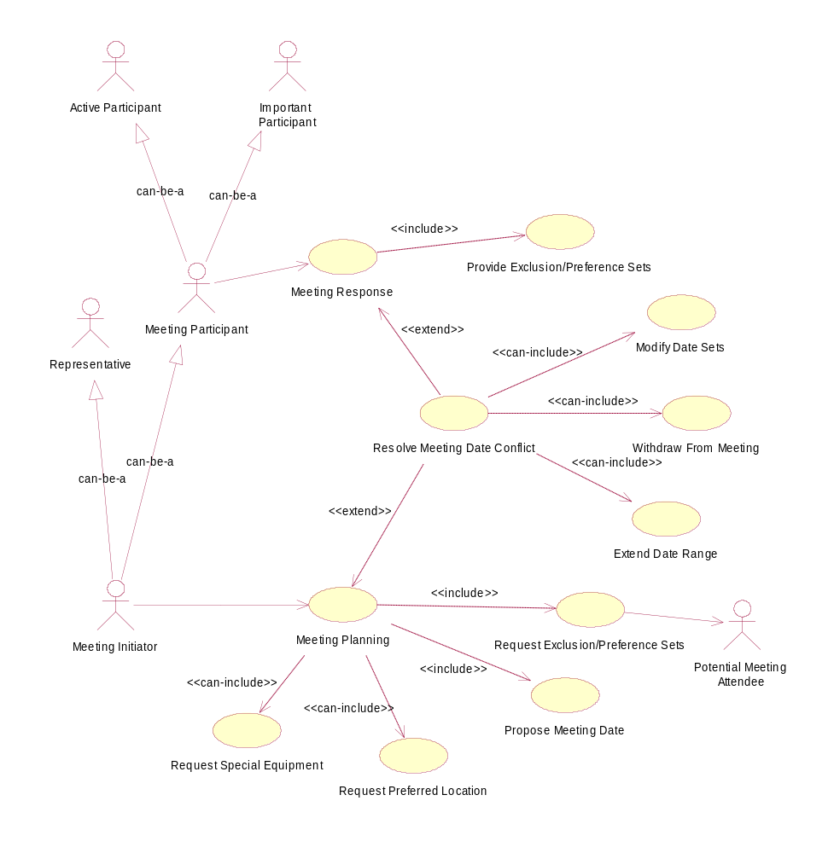

Enterprise Functional Requirements Description:
To determine a meeting date and location.

Meeting Initiation
- The meeting initiator issues a meeting request by inviting all potential meeting attendees for a meeting based on the participant’s agenda. An initiator can be one of the participants or some representative, such as a secretary.
- The system automatically fills in the submission date. The initiator fills in the other fields, including the date range, meeting locations, meeting type, and all potential meeting attendants. The initiator also indicates attendees’ importance levels.
- The initiator notifies the potential attendants to input their data. Active participants should fill in the equipment they need. If an attendee is designated an important participant, he is required to fill in his preferred locations. The exclusive sets and preference sets should be contained in the date range.
- If there are not any meeting conflicts, continue.
- After all participants input their data; the initiator asks the system to make a meeting schedule based on the given information. When making a schedule, the system should consider the proposed meeting date, the stated date range and none of the exclusive set, and find a meeting room available at the selected meeting date.

Meeting Room Description
- Meeting room shall belong to one of the locations preferred by as many important participants as possible.
- The preferred meeting room shall be available at the selected meeting date.
- Meeting room shall meet the equipment requirements.
- If participants are geographically dispersed, virtual meeting rooms shall be included like teleconferencing through notebook computers, pc etc.
- Participants shall have the ability to negotiate for rooms. Negotiations should be kept minimal, but a new round of negotiations may be required when no such room can be found.
Meeting Conflicts
- A date conflict occurs when a strong date conflict occurs when no data can be found within the date range and outside all exclusion sets.
- A weak date conflict occurs when dates can be found within the date range and outside all exclusion sets, but no date can be found at the intersection of all preference sets.

Meeting Conflict Resolution
- If a strong conflict occurs while generating a meeting, the system shall notify the initiator and ask to
  - notify a participant to remove a date from his exclusive set,
  - propose a participant with low importance level to extend the date set or withdraw from the meeting,
  - propose a participant with high importance level to extend a date range
  - Propose the initiator to cancel the meeting.
  - Each conflict resolution should be done as soon as possible and with no more interactions than is really needed.
If none of the proposed locations can meet the equipment requirements while making a meeting schedule, the system should inform the initiator. The initiator can propose other locations or cancel the meeting.
In the first case, the initiator first inputs some new locations and then restarts a new round of meeting scheduling.
In the second case, the initiator cancels the meeting, and all participants should be informed of the cancellation.

Enterprise Non-Functional Objectives
- Negotiations for meeting rooms shall be kept minimal, but a new round of negotiations may be required when no such room can be found.
- All conflicts shall be resolved within minimum round of interactions between initiator and participants.
- Any physical changes to the meeting room and its equipments shall be kept up-to-date.
- If any physical changes to the meeting room and its equipments shall occur after a scheduled meeting and before the meeting date, the initiator shall be notified promptly.
- All participants shall not need to be using the system; in that case, the non-user participant shall receive a plain email message.

System Functional Requirements
Monitor Meetings
Application Domain
Plan Meetings
Reschedule meetings
Modify Exclusion Set
Modify Location
Participant Constraints
Modify Preference Set
Cancel a Meeting
External Constraints
Support Conflict
Resolution
Check Resolution
Policies
Manage Participant
Interactions
Get Replies
From Participants
Communicate Requests
Support Negotiation
and Conflict Resolution
Inform Participants
about schedule and
changes
Up-to-date Information
about Planning Process

Dependency Graph for System Functional

System Functional Requirements Description
- The system shall monitor meetings especially when they are held in a distributed manner. (i.e. Participants can be in several different locations whether they are physical or virtual, and communicate through different means).
- When planning meetings, the system shall take into account all constraints that are expressed by the meeting participants.
  - Every constraint expressed by a participant shall be added to a preference or exclusion set that is within the date range specified by the meeting initiator.
    - Each date that the meeting participant can attend shall be added to the preference set.
    - Each date that the meeting participant cannot attend shall be added to the exclusion set.
- In the event that a user changes their constraints, the SDMS shall reschedule a meeting to accommodate this change.
  - The user’s preference set, exclusion set, and preferred location shall be modified before a meeting date/location is proposed by the meeting initiator.
  - External constraints shall be considered after a meeting date and location have been proposed. For example, if a high priority meeting needs to be accommodated, a lower priority meeting may be changed or cancelled.
- Conflict resolution shall be supported according to resolution policies stated by the client.
- All required interactions between meeting participants for organization of the meeting shall be managed
  - There shall be a means of communicating requests
  - Replies shall be received from all participants whether or not they react promptly
  - The processes of negotiation and conflict resolution shall be supported
  - Participants shall be aware of the events occurring during the planning process
  - All participants shall be informed of their schedules and changes
  - There shall be a means of making each participant confident in the reliability of the communications

System Non-Functional Requirements

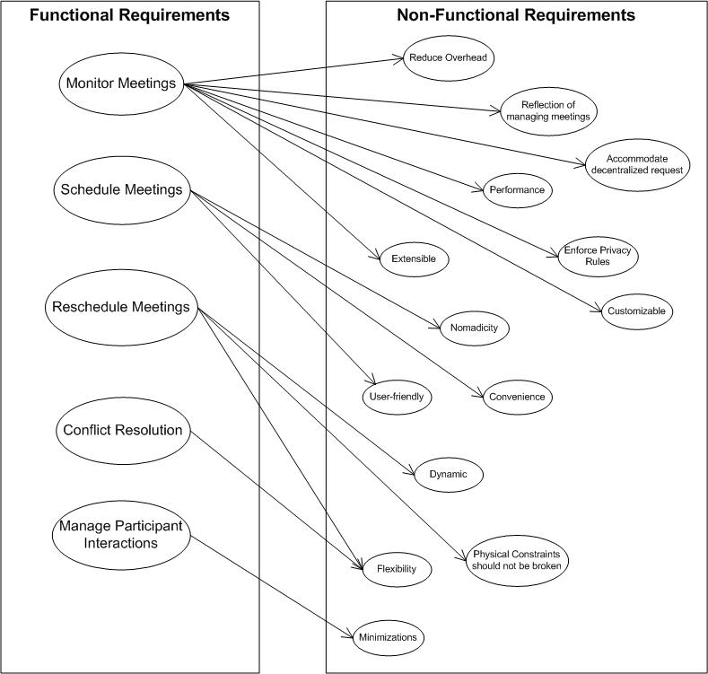

System Non-Functional Requirements Description
- User friendliness
The system should be usable by non-experts, where the user can learn to operate easily.
- Performance
The elapsed time between the submission of a request and the computation time should be minimal.
  - Elapsed time between determination of meeting and communication of this information should be minimal (i.e.) Ensure that the application or component does not make a user wonder whether or not it has received the user’s request.
  - Lower bound should be fixed between determination of meeting date and actual meeting.
- Robustness
The system should be accurately monitored, especially when it is held in a virtual place. Hence, nomadicity will be taken into consideration. The intended system should considerably reduce the amount of overhead usually incurred in organizing meetings where potential attendees are distributed over many different places and communicate with each other (e.g. via Internet).
- Extensibility
The system should be able to handle explicit priorities among dates in preference sets. It also has the ability to handle explicit dependencies between meeting date and meeting location. Then again, it manages participation through delegation, in which a participant may ask another person to represent him/her at the meeting. There may also be variations in date formats, address formats, interface language, partial reuse in other contexts, such as helping establish course schedule, etc.
- Security
Privacy rules should be enforced a non-privileged participant should not be aware of constraints stated by other participants. The system should accommodate as much decentralized requests as possible. Therefore, any authorized user should be able to request a meeting independently of his/her whereabouts.
- Reliability
The system should reflect as closely as possible to the way meetings are typically managed. Then again, physical constraints should not be broken (e.g. a person may not be at two different places at the same time, a meeting room may not be allocated to more than one meeting at the same time, etc.). Also, the meeting date and location should be convenient as possible, and is available as early as possible to all potential participants.
- Customizable
The system shall be customizable to two modes (1) Private (2) Professional meetings –Characterized by different restrictions on the time period that may be allocated (e.g. meeting during office hours, private activities during leisure time).
- Flexibility
Rescheduling of a meeting should be done dynamically and with as much flexibility as possible. Also, the system should be flexible enough to accommodate evolving data (e.g. the sets of concerned participants may be varying, the address at which a participant can be reached may be varying, etc.).

3. Issues Discussed in the Meetings

A) Incompleteness

- “The system extensibility can be enhanced additionally by allowing a participant to attend only part of the meeting”.

Problem

The requirement stated is incomplete. It does not explain how a person just attending a part of the meeting would improve system extensibility.

Option 1: Introduce a new criteria asking the participant what part of the meeting he/she would be able to attend.

Option 2: Consider the requirement to be incomplete and would not enhance the system and just drop the requirement.

Solution: Option 2

Reason: Choosing option 1 would lead to more inconsistencies such as if the meeting is attended by only two participants and if they choose to attend different parts of the meeting would be useless. So the requirement is not required and can be proved that it could not enhance the extensibility of system.

2. “It [meeting room] should ideally belong to one of the locations preferred by as many important participants as possible. ”

Problem: The term important participant is not defined else where. There is no concept of a participant being important and other being less important.

Option 1: Choose the locations manually at the time of scheduling the meeting.

Option 2: Always keep a list of preferred locations in the user details. The system shall extract them and display the relevant ones and let the user to choose multiple locations from it.

Solution: Option 2

Reason: Will drastically reduce the work given to the user and also enhance the system performance as the process of choosing the location is automated and the chance of hitting a common location and time quickly is increased.

- “ The amount of interaction among participants should be kept minimal”

Problem: The system non-functional requirement specifies ‘The amount of interaction among participants must be kept minimal’, but the term ‘minimal’ is a very relative term.
Option 1 – Set a value that indicates the minimum.
Option 2 – Let the meeting initiator decide this minimum based on the importance of the meeting.
Option 3- Add a calendar function that allows the meeting initiator to view all participants calendars .This eliminates the interactions involved in collecting preference and exclusion sets.
Solution: - option 2
Reason – If a value is specified for the minimum, it reduces the confusion. It also makes the system more efficient.

B) Ambiguous:

1.” A meeting should be accurately monitored, especially when it is held in a virtual place. Here, nomadicity will then be important to consider.”

2U_

Problem
This system non-functional requirement is ambiguous in the sense saying that the meeting scheduler software should also monitor meetings that are held in a virtual place. The term ‘Virtual Place’ is not defined else where.

Option 1: Add a new requirement concerning monitoring and consider coming up with requirements for a separate module for monitoring meetings also.

Option 2: Just consider this requirement as ambiguous and beyond the scope of the software and hence drop it.

Option 3: Allow location information to be entered manually and allow enough space for teleconferencing phone number, pin and server id etc.

Solution: Option 3

Reason: To keep the software and its purpose simple.

2. Difference between potential meeting attendees and participants

Problem: The meeting initiator starts the meeting arrangement by requesting information from the potential meeting attendees. From this point forward all communication is done between the meeting initiator and participants. There appears to be some overlap between these two entity sets. However, there is no distinction is made between the two groups.
Option 1: No change. Add requirement that potential attendees "become" participants when they respond to the initial request of the meeting initiator.
Option 2: Remove the potential attendee entity set. Refer to all person initially requested as participants. One is no longer a participant when he withdraws from the meeting.
Solution: Option 2
Reason: Removes possible areas of ambiguity and confusion.
- Clarification of criteria for expanding date range. “
Problem: Should the meeting initiator only resort to expanding the date range when there is no possible date when all the important participants can attend, or should this be considered for every participant?
Option 1: Only extend date range only when all important participants can’t attend because having to consider everyone may cause significant delays in resolving conflicts.
Option 2: Extend date range when a larger amount of participants can’t attend then the ones who can attend, regardless of how important they are.
Solution: Option 2
Reason: It is easy and worth to extend date only if there are majority of participants who cannot attend the meeting on desired date.

C) Misclassified:

1 “To make them confident about the reliability of the communications”

Problem: The requirement “There shall be a means of making each participant confident in the reliability of the communications” should be classified as a non-functional requirement. Confidence of reliability is a usability issue which is non-functional.

Option 1: Move this to non-functional requirements

Solution: Option 1
Reason: Confidence of reliability is definitely a non-functional requirement

- “Physical constraints should not be broken.”

Problem: The following requirement “Physical constraints shall not be broken. For example, a person can only be in one place at any time, and a meeting room can only accommodate a single meeting at any given time” should be classified as a functional requirement. This requirement describes the possible outputs from a set of inputs and is, therefore, a functional requirement. In addition, I recommend moving “The system shall reflect as closely as possibly the way meetings are typically managed” to “Usability” and removing “Practicality”.

Option 1: The statement concerning physical constraints will be considered a functional requirement

Solution: Option 1
Reason: Checking to make sure physical constraints are not broken is functional, and
the system reflecting the way meetings are typically managed is definitely a usability issue.

D) Missing:

- “Missing Login and Logout requirements”

Problem: There is no system functional requirement in text or in the dependency graph that describes logging into the system or out of the system. Is the system open to everyone or should each user have a login ID and password?

Option 1: Assume that the user has logged in upon managing or monitoring meetings
Option 2: Specify that the login process takes place in the system requirements, and create a new item in the dependency graph that represents login having taken place

Solution: Option 2
Reason: User login is a crucial part of the system that determines what the user can and can’t do.

- The system dosen’t specify how many participants at the most can be there in a meeting.

Problem: It is necessary to know the number of participants to book a meeting room
or to arrange a net meeting.

Option 1: Specify the maximum number and the minimum no for a meeting to take place.

Option 2: Assume the number of participants.

Solution : Option 1

Reason: Specifying the number of participants will make it easier to organize and plan the meeting .

E) Redundancy
1 “ Make participants aware of what is going on’ and ‘Keep participants informed about schedules and changes. “
Problem : The functional requirements specify that the scheduling software must ‘Make participants aware of what is going on’ and ‘Keep participants informed about schedules and changes’.
Option 1 – Delete the second statement.
Option 2 – Provide a common way of solving both these issues.
Solution – Option 2
Reason – This is because, the use of a meeting status web page helps all th e meeting attendees know about the status of the meeting just by viewing one web page.

4. Improved Understanding::

Enterprise Functional Requirements:
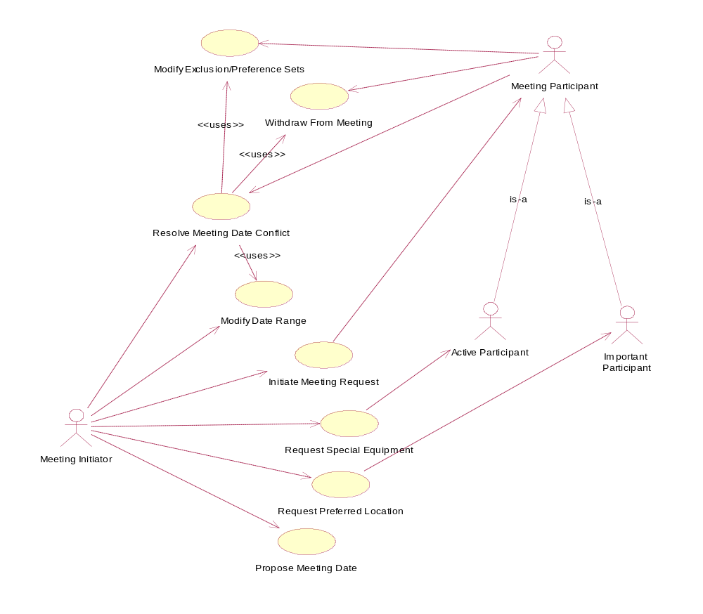

Definitions: Enterprise Requirements
This section defines terms used to specify the enterprise requirements.

Exclusion set: a set of dates on which participants cannot attend the meeting

Preference set: a set of dates on which participants would prefer the meeting to take place

Date range: a time interval established by the meeting initiator during which he would like the meeting to occur

Active participant: a participant who will play a major role in the meeting and is responsible for specifying equipment requirements; is identified by the meeting initiator

Important participant: a participant who is necessary to the purpose of the meeting and is given the privilege of requesting a meeting location preference; is identified by the meeting initiator

Strong date conflict: a conflict when scheduling the meeting date that occurs when no date can be found within the date range and outside all exclusion sets

Representative: a person who initiates a meeting on behalf of someone else (i.e. secretary)

Enterprise Functional Requirements
This section defines the functional requirements for meeting arrangement in the application domain.
- A meeting initiator shall start arranging a meeting by send the following information to all meeting participants:
  - Date range
  - Request for exclusion set
  - Request for preference set.
- Exclusion and preference sets should be contained in the date range.
- The meeting initiator should ask active participants to provide any special equipment requirements on the meeting location.
- The meeting initiator should ask important participants to state meeting location preferences.
- A meeting date shall be defined by a pair (calendar date, time period).
- The proposed meeting date shall belong to the date range and to none of the exclusion sets when no strong conflict occurs.
- Date conflict resolution tasks should include one or more of the following actions:
  - the meeting initiator should extend the date range;
  - some participants should remove dates from their exclusion sets;
  - some participants should withdraw from the meeting;
  - some participants should add new dates to their preference set.
- A meeting location shall be a physical location or virtual location.
- A meeting location shall be available at the selected meeting date.
- A meeting location should meet the special equipment requirements.
- The meeting initiator should be a meeting participant or a representative.
- A meeting date proposal should be made as soon as all preference and exclusion sets have been received by the meeting initiator or the maximum number of reminders has been sent to participants.
- The proposed meeting date shall belong to as many preferences sets as possible.
- A meeting location should be one of the locations preferred by as many important participants as possible.

Enterprise Non-Functional Requirements
This section defines the non-functional requirements for meeting arrangement in the application domain.
- The proposed meeting date shall belong to as many preferences sets as possible.
- Conflict resolution should be completed as quickly as possible.
- Conflict resolution should be completed with a minimal number of necessary interactions.

System Functional Requirements:
- Concurrency shall be maintained as the system shall have the ability to handle several meeting requests in parallel.
- The system shall support date and room conflict resolution.
- The system shall come up with visual aids for interest such as posters, diagrams, etc as proposed by the initiator.
- The system shall post a large agenda up front for the meeting participant’s referral.
- The system shall sent messages in plain text format rather than larger and slower HTML messages.
- The system shall provide the users the ability to propose multiple times, suggest new times, confirm times, change times, send automatic reminders etc.
- The system shall provide the user to schedule customized recurring meetings - daily, weekly, bi-weekly, monthly, etc.
- The system shall be accessed from the Web.
- The system shall provide the user the facility to view the availability and schedules of teams or groups of people from a single window.
- The system shall adjust automatically to any of the 319 time zones around the world
- The system shall set standard banners to display on a daily, weekly or monthly basis
- The system shall maintain a list of contacts to be used by the users.
- The system shall provide printouts of schedules in Calendar format.

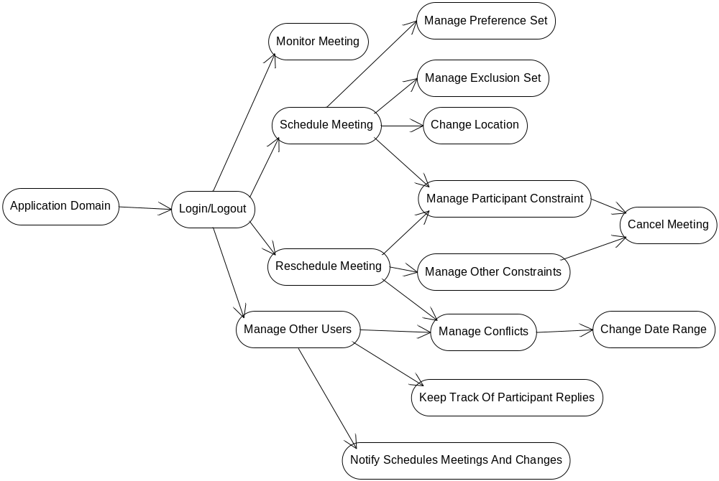

Draft Screen Shots
Login:
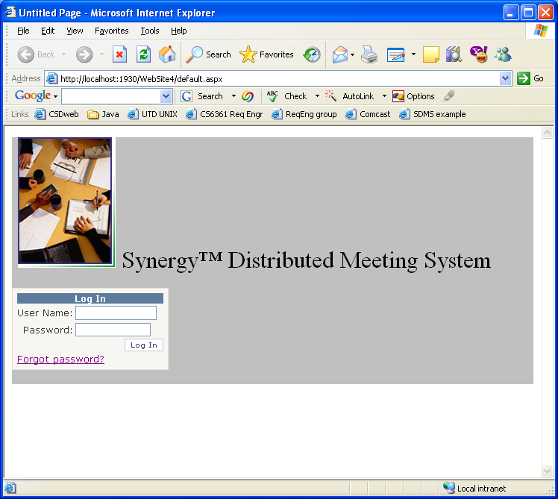

main page
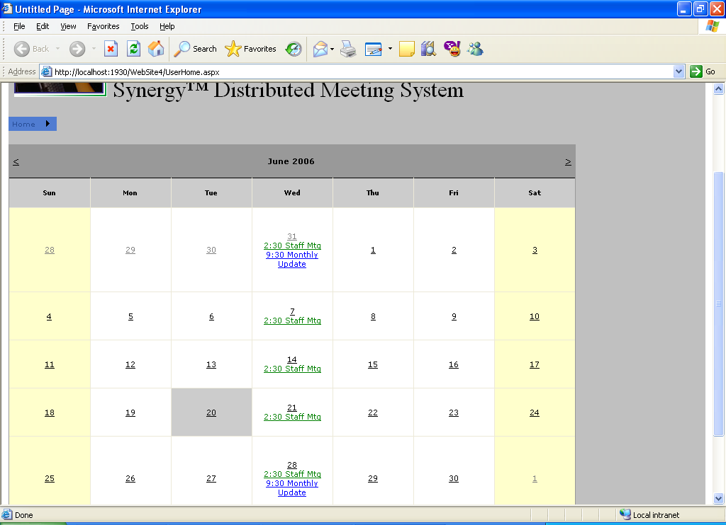
new meeting
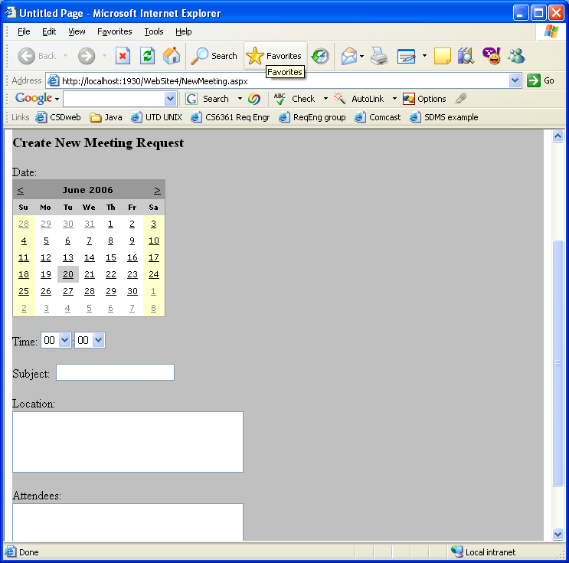
new meeting time query
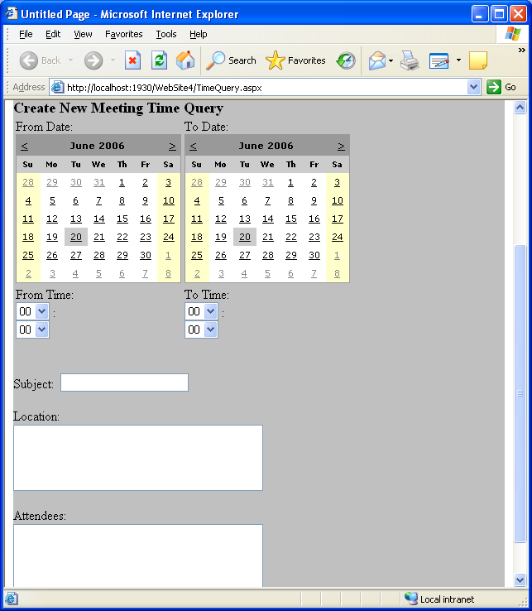
meeting notice (attendee)
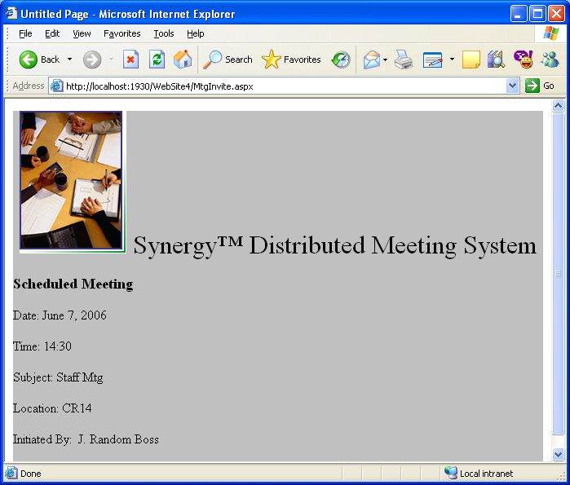

meeting planning (initiator)
