Synergy Distributed Meeting Scheduler System

Project Phase II

Team Members
Geetanjali Sharma
Jeff Koch
Yogita Devarajan

Dr. Lawrence Chung
CS 6361 –Requirements Engineering
University of Texas at Dallas
Summer 2006

Table of Contents

Table of Contents 2
1. Abstract 3
2. Introduction 4
Thus the precise requirements specifications provide the basis for analyzing requirements, validating that they are indeed what stakeholders want, defining what designers have to build, and verifying that they have done so correctly upon delivery. 4
2.1 General Overview 4
2.2 Purpose 4
2.3 Scope 4
2.4 Definitions, Acronyms and Abbreviations 4
2.5 Document References 5
3. Process Description 6
3.1 Stakeholders 6
3.2 Role Description 6
3.3 Team Architecture 7
3.4 Process Specification: 8
3.5 Process Specification (Original SADT) 9
3.5.1 Top Level Diagram 9
3.5.2 Detailed Top Level Diagram 10
Second Level IDEF0 11
3.5.3 Stage 1 11
3.5.4 Stage 2 12
3.5.5 . Stage 3 13
3.6 Modeling the data part - Datagram 14
3.6.1 DataClass Name/pwd with 14
3.6.2 DataClass Meeting parameters with 15
3.6.3 DataClass Meeting response with 15
3.6.4 DataClass Conflict with 16
3.6.5 DataClass Notification with 17
4 Issues Discussed in the Meetings 17
4.1 Incompleteness 17
4.2 Ambiguous: 19
4.3 Misclassified: 21
4.4 Missing 21
4.5 Redundancy 22
5 Product Specification 23
5.1 UML activity diagram + SADT 23
5.2 Entity Class Diagram 25
5.3 NFR Formal Specifications 26
5.3.1 SIG for Process NFR Specification 26
Maintainability 26
Reliability 27
5.4 Product NFR Specification 27
5.4.1 Performance 28
5.4.2 Security 29
6 Prototype 30

1. Abstract

“The hardest single part of building a software system is deciding precisely what to build. No other part of the conceptual work is as difficult as establishing the detail technical requirements, including the entire interface to people, to machines, and to other software systems. No part of the work so cripples the resulting system if done wrong. No other part is more difficult to rectify later.”

[Brooks, 1987]

The success of any system depends upon how well the user’s needs are met. The first step of building a system is identifying what is expected out of it. The requirements Specification Document facilitates this process and helps the project stakeholders reach an agreement on the functionalities of the system and the conditions to which it must conform.

2. Introduction

“ Requirements engineering is the branch of software engineering concerned with the real world goals for, functions of, and constraints on software systems. It is also concerned with the relationship of these factors to precise specifications of software behavior, and to their evolution over time and across software families “

- http://www.doc.ic.ac.uk/~ban/pubs/sotar.re.pdf

Thus the precise requirements specifications provide the basis for analyzing requirements, validating that they are indeed what stakeholders want, defining what designers have to build, and verifying that they have done so correctly upon delivery.

2.1 General Overview

The ‘Synergy Distributed Meeting Scheduling System (SDMS)’ is intended for supporting people schedule their meetings. The SDMS system is intended to accelerate the meeting scheduling communication process, to provide support to the negotiation mechanisms involved, help the scheduler to resolve conflicts and also to support virtual meetings and teleconferencing.

2.2 Purpose

The essential purpose of this document is to transform the requirements specification in UML+ and an NFR specification into UML+ and a more formal NFR specification where some essential NFRs are modeled using a Softgoal Interdependency Graph (SIG)

2.3 Scope

The SDMS system shall support people schedule their meetings. It shall automate the manual meeting scheduling process. The system shall support scheduling meetings and shall book the required location and equipment.The system shall handle conflict resolution. Communication with meeting participants and scheduler shall be performed through the system.

2.4 Definitions, Acronyms and Abbreviations

- Meeting Initiator/Scheduler: Person in charge of setting up the meeting

- Participant: Any individual invited to the meeting

- Date Range: Time interval set by meeting initiator under which meeting shall take place

- Preference Set: A set of dates on which a participant would prefer the meeting to take place

- Exclusion Set: A set of dates on which a participant cannot attend the meeting

- Location: Room where meeting shall take place or virtual place in case of teleconference meetings

- Equipment: Any resource required as part of the meeting, i.e. projector, laptops, workstation, network connection, telephone, etc.

2.5 Document References

Books:
- The Unified Modeling Language User Guide by Booch, Jacobson and Rumbaugh.
- Dr.Lawrence Chung, “Requirements Engineering”, Lecture Notes

Web Resources:
- www.ieee.org
- Previous Projects
- Visual Studio 2005 “Club Web Site” Starter Kit

3. Process Description

“ The primary measure of success of a software system is the degree to which it meets the purpose for which it was intended. Broadly speaking, software systems requirements engineering (RE) is the process of discovering that purpose, by identifying stakeholders and their needs, and documenting these in a form that is amenable to analysis, communication, and subsequent implementation, “

[Source: Bashar Nuseibeh, Steve Easterbrook, “http://www.doc.ic.ac.uk/~ban/pubs/sotar.re.pdf”]

Software process is defined as the set of activities, methods and practices that are used in the development and evolution of software.

3.1 Stakeholders
The following stakeholders were identified in this project:

- Meeting Scheduler / Initiator
- Participants
- Requirements Engineer
- Project Manager
- Developer

3.2 Role Description

- Project Manager: responsible for planning and controlling the engineering activities to meet project goals for cost, schedule and quality. The project manager is also responsible for co-ordinating and integrating activities across multiple functional lines.
- Initiator: responsible for initiating the meeting, setting the date range , inviting participants and resolving conflicts
- Participant: responsible for giving the preference and exclusion date ranges, location and resource requirements and attending the meeting
- Requirements Engineer: responsible for eliciting, specifying and validating requirements and also developing the requirements specification document
- Developer: responsible for making the design prototype operational

3.3 Team Architecture

Each one of us assumed the roles of requirements engineer, developer and customer in our part. Discussions and brainstorming sessions were arranged to discuss the work done by each and suggested changes were incorporated accordingly.
The following table summarizes the team structure:

Team Members | Roles  Played | Primary Concern
Anjali Sharma | Customer World:  End-user/Buyer | - Requirement Analysis  - Document preparation  - Prototype development
Jeff Koch | Consultant World:  Programmer,  Consultant | - Process specification  - Prototype development  - Requirements issues
Yogita Devarajan | Management World:  Project Manager  Product Manager | - Process/Product Specification  - Prototype development

Process Specification:

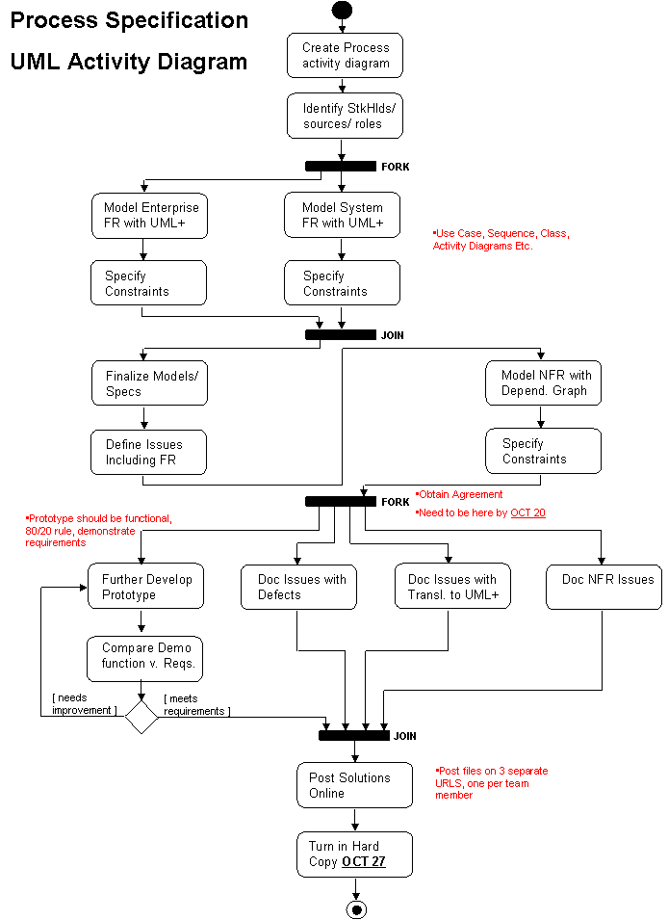
sources
Reqs+Stakeholders
Enterprise Fun Reqs
System Fun Reqs
Model
Depend Graph
NonFunReqs
Give constraints in detail
Req spec + Changed Reqs
Final Model
Issues
FR Issues
Documented issues
UML+
Document NFRs
Stakeholders db
UML+
SADT +

3.5 Process Specification (Original SADT)
3.5.1 Top Level Diagram
C1: Requirements Validation
C2: UML specifications
C3: SADT specifications
C4: SIG specifications
Process Requirements
Preliminary Document
Requirements Engineer
Software Requirements Specification
A0
C1 C2 C3 C4
Process Specification

3.5.2 Detailed Top Level Diagram

Preliminary
Document
Dependency
Diagrams
Functional
Requirements
Specification
SRS
2
3
SIG specifications
Process Specifications
Stage 2
Stage 3
Stage 1
Requirements
Validation
1
A0
Requirements Engineer
UML and SADT specifications

Second Level IDEF0

3.5.3 Stage 1

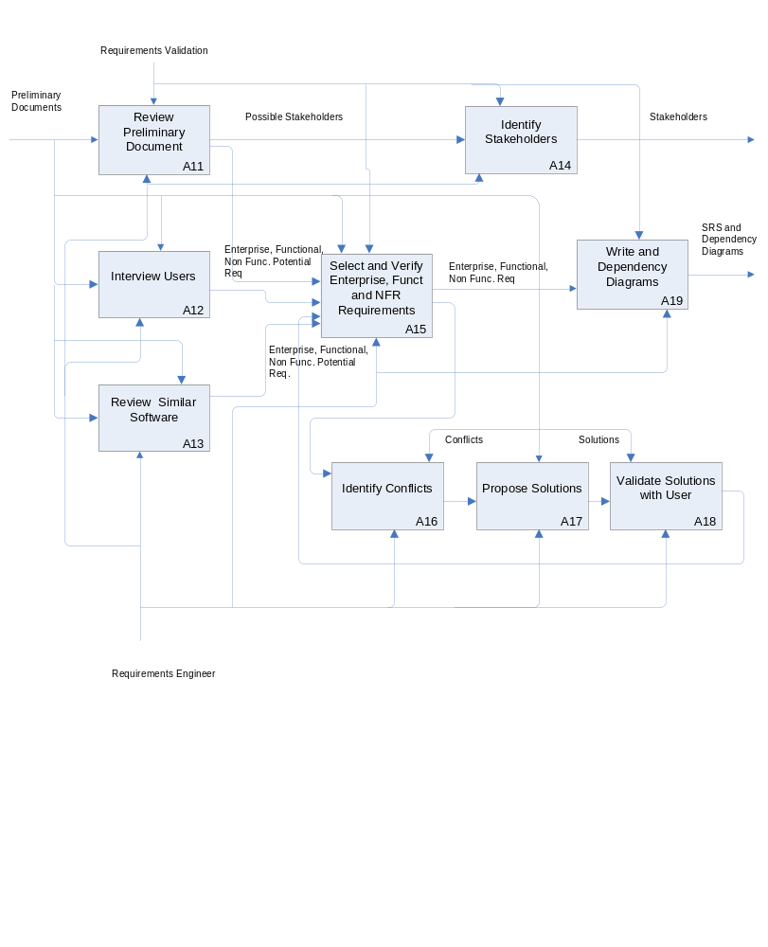
3.5.4 Stage 2

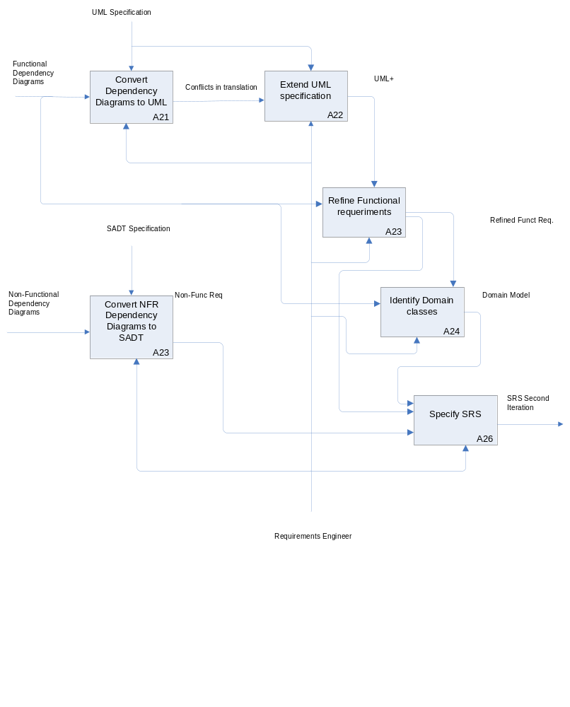

3.5.5 . Stage 3

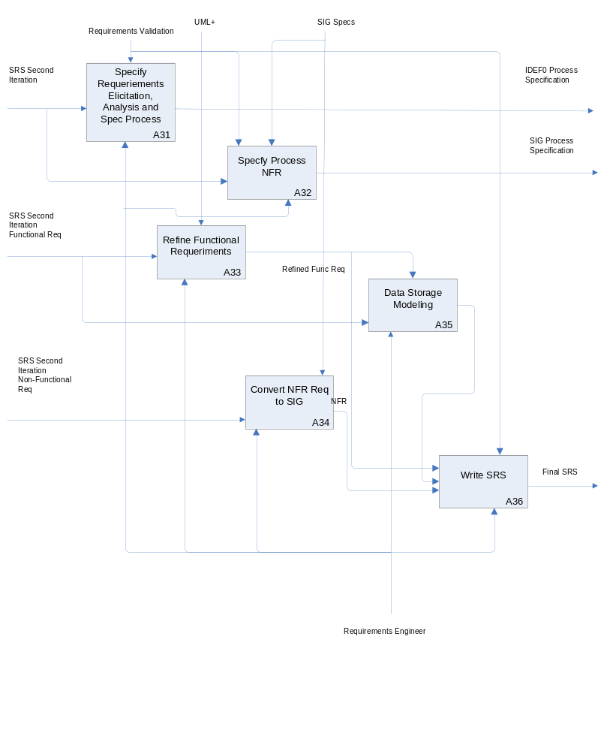

3.6 Modeling the data part - Datagram

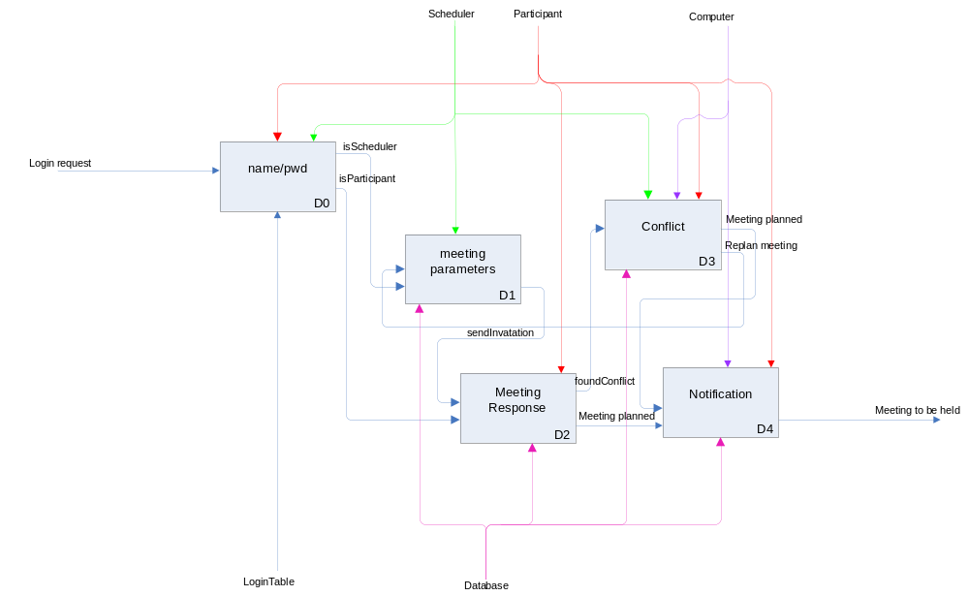

3.6.1 DataClass Name/pwd with
input
login request
control
Scheduler
Participant
mechanism
LoginTable
output
isScheduler
isParticipant
initially
alreadyLoggedIn?: not(exists(session))
isValid?
finally
loggedIn?: create (session)
The user must first login and be validated as a member of the system. The Login table checks to see if the user name/pwd is valid and if he is already logged in. If the user is valid, we check the identity of whether if it’s a participant or scheduler. If his identity is valid and is already logged in, his current session is resumed. If he is not logged in, a new session is created for him.

3.6.2 DataClass Meeting parameters with
input
requestMeeting
control
Scheduler
mechanism
Database
output
sendInvitation
initially
isScheduler?
finally
meetingTypeSet?
meetingPurposeSet?
meetingPrioritySet?
meetingDateRangeSet?
part
meetingConstraint
feasibilityConstraint

After the scheduler is logged in, he can then go ahead request for a new meeting and set all the meeting parameters. Only when all the parameters are set, will the invitation be sent to participant. The meeting parameters will be kept in database and invitations will be sent to all participating participant.

3.6.3 DataClass Meeting response with
input
recieveInvitation
control
Participant
mechanism
database
output
findIntersectionDate
initially
isParticipant?
finally
isRespond?
foundConflict?
meetingPlanned?
part
meetingConstraint

After the meeting invitation is sent, participant can log in and see his own invitation along with all the meeting parameters. He can then decide to respond to a meeting or reject a meeting invitation. His response of preferred date and exclusion date can only be inside the date range which is set be scheduler. After the database receives all the response, the system will then generate intersection date. If we found a conflict, the meeting status will change to “conflict”. If there is no conflict, then the meeting is planned.

3.6.4 DataClass Conflict with
input
foundConflict
control
Scheduler
Participant
Computer
mechanism
database
output
Conflict Resolution
initially
foundConflict?
finally
meetingPlanned?
replanMeeting?
part
meetingConstraint

If a meeting have conflict need to be resolved, the system will try using all the conflict resolution scenarios to resolve it. All the new resolution result will be kept in the database. If the conflict can be successfully resolved, the meeting is planned. If the conflict cannot be resolved, the meeting can be replanned and start from setting new meeting parameters again.

3.6.5 DataClass Notification with
input
notification request
control
computer
participants
mechanism
database
output
sendNotification
initially
meetingPlanned?
finally
meetingToBeHeld?

Once the meeting is planned and no further change to be made, the computer can initiate the notification request and send notification to all participating participant. All the notification will be kept in database. Once the notification is sent, the meeting is waiting to be held.

4 Issues Discussed in the Meetings

4.1 Incompleteness

1.“Various marketing surveys have shown that a product, including SDMS,cannot be sold unless it provides ABSOLUTE SECURITY that is possible currently and will be in the foreseeable future.
Problem: This change to the definition causes a lot of confusion because it dosen’t say what absolute security is.There could be a lot of different interpretations.
Option 1: Define absolute security precisely.
Solution: Option 1. We discussed this issue with our users and focus groups, and received the following answers:
- End users are increasingly concerned about theft of personal information, such as credit card data and Social Security numbers. Although end users don’t believe meeting schedules are as sensitive as Social Security numbers, they are concerned that such scheduling information shouldn’t fall into the wrong hands.
- Corporate leaders were concerned about operational security (OPSEC)—the risk that the competition may be able to discern company plans from seemingly innocent data. They were more concerned about illegal access to schedule data.
- Finally, there were concerns that crackers may be able to intentionally damage the schedule database or make unauthorized changes to schedules.

We therefore decided that for our target audience, security could be handled as follows:
- User IDs and passwords (as specified in the original requirements) would prevent casual access to the records.
- The segregation of meeting information—in other words, restricting meeting information to meeting participants—would further restrict unauthorized use.
- We also decided to implement a separate administrator class in order to restrict the number of users with full access to the system.

2. “It [meeting room] should ideally belong to one of the locations preferred by as many important participants as possible. ”

Problem: The term important participant is not defined else where. There is no concept of a participant being important and other being less important.

Option 1: Choose the locations manually at the time of scheduling the meeting.

Option 2: Always keep a list of preferred locations in the user details. The system shall extract them and display the relevant ones and let the user to choose multiple locations from it.

Solution: Option 2

Reason: Will drastically reduce the work given to the user and also enhance the system performance as the process of choosing the location is automated and the chance of hitting a common location and time quickly is increased.

- “ The amount of interaction among participants should be kept minimal”
Problem: The system non-functional requirement specifies ‘The amount of interaction among participants must be kept minimal’, but the term ‘minimal’ is a very relative term.
Option 1 – Set a value that indicates the minimum.
Option 2 – Let the meeting initiator decide this minimum based on the importance of the meeting.
Option 3- Add a calendar function that allows the meeting initiator to view all participants calendars .This eliminates the interactions involved in collecting preference and exclusion sets.
Solution: - option 2
Reason – If a value is specified for the minimum, it reduces the confusion. It also makes the system more efficient.
- 4“The system extensibility can be enhanced additionally by allowing a participant to attend only part of the meeting”.

Problem

The requirement stated is incomplete. It does not explain how a person just attending a part of the meeting would improve system extensibility.

Option 1: Introduce a new criteria asking the participant what part of the meeting he/she would be able to attend.

Option 2: Consider the requirement to be incomplete and would not enhance the system and just drop the requirement.

Solution: Option 2

Reason: Choosing option 1 would lead to more inconsistencies such as if the meeting is attended by only two participants and if they choose to attend different parts of the meeting would be useless. So the requirement is not required and can be proved that it could not enhance the extensibility of system

4.2 Ambiguous:
1.” A meeting should be accurately monitored, especially when it is held in a virtual place. Here, nomadicity will then be important to consider.”

2U_

Problem
This system non-functional requirement is ambiguous in the sense saying that the meeting scheduler software should also monitor meetings that are held in a virtual place. The term ‘Virtual Place’ is not defined else where.

Option 1: Add a new requirement concerning monitoring and consider coming up with requirements for a separate module for monitoring meetings also.

Option 2: Just consider this requirement as ambiguous and beyond the scope of the software and hence drop it.

Option 3: Allow location information to be entered manually and allow enough space for teleconferencing phone number, pin and server id etc.

Solution: Option 3

Reason: To keep the software and its purpose simple.

2. Difference between potential meeting attendees and participants

Problem: The meeting initiator starts the meeting arrangement by requesting information from the potential meeting attendees. From this point forward all communication is done between the meeting initiator and participants. There appears to be some overlap between these two entity sets. However, there is no distinction is made between the two groups.
Option 1: No change. Add requirement that potential attendees "become" participants when they respond to the initial request of the meeting initiator.
Option 2: Remove the potential attendee entity set. Refer to all person initially requested as participants. One is no longer a participant when he withdraws from the meeting.
Solution: Option 2
Reason: Removes possible areas of ambiguity and confusion.
3.Clarification of criteria for expanding date range. “
Problem: Should the meeting initiator only resort to expanding the date range when there is no possible date when all the important participants can attend, or should this be considered for every participant?
Option 1:Only extend date range only when all important participants can’t attend because having to consider everyone may cause significant delays in resolving conflicts.
Option 2:Extend date range when a larger amount of participants can’t attend then the ones who can attend, regardless of how important they are.
Solution: Option 2
Reason: It is easy and worth to extend date only if there are majority of participants who cannot attend the meeting on desired date.

4.3 Misclassified:
1. “To make them confident about the reliability of the communications”

Problem: The requirement “There shall be a means of making each participant confident in the reliability of the communications” should be classified as a non-functional requirement. Confidence of reliability is a usability issue which is non-functional.

Option 1: Move this to non-functional requirements

Solution: Option 1
Reason: Confidence of reliability is definitely a non-functional requirement

- “Physical constraints should not be broken.”

Problem: The following requirement “Physical constraints shall not be broken. For example, a person can only be in one place at any time, and a meeting room can only accommodate a single meeting at any given time” should be classified as a functional requirement. This requirement describes the possible outputs from a set of inputs and is, therefore, a functional requirement. In addition, I recommend moving “The system shall reflect as closely as possibly the way meetings are typically managed” to “Usability” and removing “Practicality”.

Option 1:The statement concerning physical constraints will be considered a functional requirement

Solution: Option 1
Reason: Checking to make sure physical constraints are not broken is functional, and
the system reflecting the way meetings are typically managed is definitely a usability issue.

4.4 Missing

1.“Missing Login and Logout requirements”

Problem: There is no system functional requirement in text or in the dependency graph that describes logging into the system or out of the system. Is the system open to everyone or should each user have a login ID and password?

Option 1: Assume that the user has logged in upon managing or monitoring meetings
Option 2: Specify that the login process takes place in the system requirements, and create a new item in the dependency graph that represents login having taken place

Solution: Option 2
Reason: User login is a crucial part of the system that determines what the user can and can’t do.

3.”The system dosen’t specify how many participants at the most can be there in a meeting.”

Problem: It is necessary to know the number of participants to book a meeting room
or to arrange a net meeting.

Option 1: Specify the maximum number and the minimum no for a meeting to take place.
Option 2: Assume the number of participants.

Solution : Option 1

Reason: Specifying the number of participants will make it easier to organize and plan the me.

4.5 Redundancy
1. “ Make participants aware of what is going on’ and ‘Keep participants informed about schedules and changes. “
Problem : The functional requirements specify that the scheduling software must ‘Make participants aware of what is going on’ and ‘Keep participants informed about schedules and changes’.
Option 1 – Delete the second statement.
Option 2 – Provide a common way of solving both these issues.
Solution – Option 2
Reason – This is because, the use of a meeting status web page helps all the meeting attendees know about the status of the meeting just by viewing one web page.

5 Product Specification

5.1 UML activity diagram + SADT

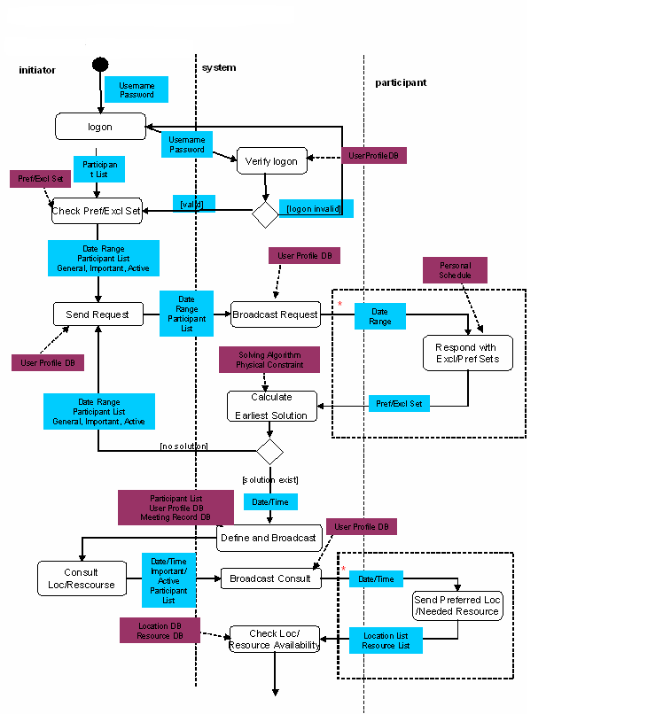

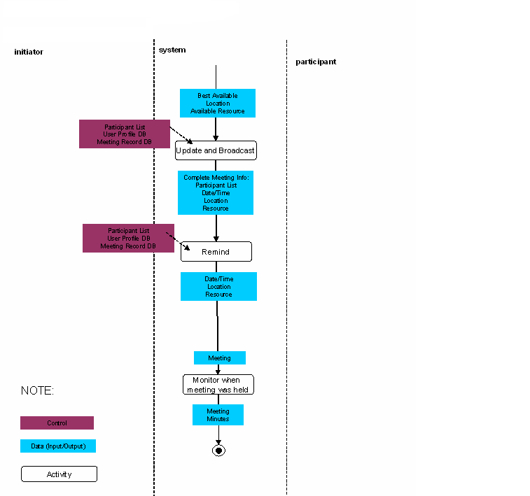

The meaning of boxes is shown above.

5.2 Entity Class Diagram

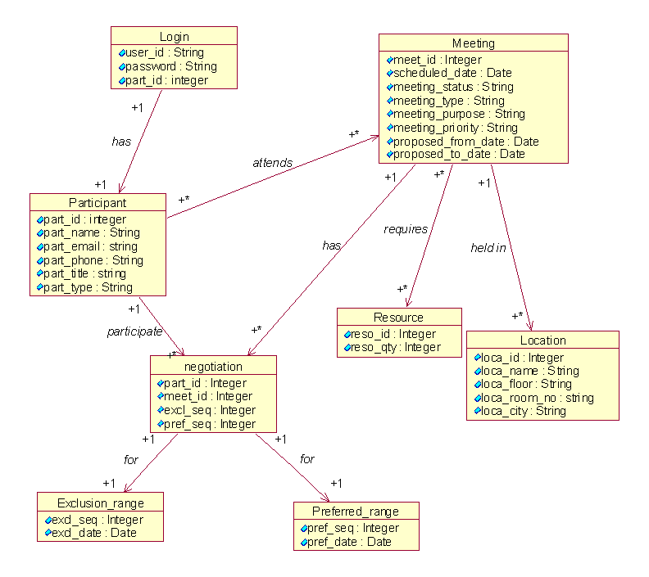

Domain model depicts the domain class entities and their hierarchy

5.3 NFR Formal Specifications
5.3.1 SIG for Process NFR Specification

Maintainability

!
Evolvability
++

Maintainability

Testability
Understandability
Modifiability

Consistency
Structuredness
Augmentability

Extendibility

Design Patterns
++
++

Client-Server
Pipe_and_filter
Object Oriented

Objects
Because of polymorphism and dynamic binding features of the OO style; system is easy to evolve

Since ‘Evolvability ‘ NFR is of high priority; Object Oriented approach is chosen. Also Object Oriented approach is good for ‘Extendibility’. We followed ‘Classification 3 – software quality tree by Boehm 1976 ‘ and customized it so that it fits our application.
Reliability

!
Efficiency
Reliability
++

Availability
Integrity
Accuracy

Consistency
Completeness

++
Database System
Performance

--
System backup
Redundancy check
RDBMS
Relational database management systems can make the system slower and hence degrade the performance a bit

Primary key constraint
Foreign key constraint
Check integrity constraint

Since ‘Efficiency ‘ is of higher priority, data integrity is considered and since RDBMS approach enforces integrity and RDBMS system is considered for the SDMS application.

5.4 Product NFR Specification

Performance

Performance

Time
Space
Responsive

SDMS

Response
Throughput
Manage
Interactions
Plan meeting

Login

++

Indexing is good for response time
Resolve Conflict
Replan meeting
Indexing

Single
level indexing
Multi-
level indexing

Keyword based
Category based

Security
SDMS

Security
!
Ease of use
++
+
+

Integrity
Confidentiality
Password+fingerprint
Makes system complicated
Availability
--

Performance
Authentication

Password
--
Fingerprint
Password + fingerprint

Password+fingerprint
Degrades the performance
++
+

Individual Password
Shared Password

For the product NFR specification, i.e. ‘Performance’ and ‘Security’ we chose the ‘Classification 1 – Roman, IEEE Computer 1985’ style and customized it to fit our application. In case of Security, having data integrity makes the system more secure. Since ‘Ease of use’ is of higher priority, as the system needs to be user friendly, ‘fingerprinting’ approach with ‘individual password’ is used as it helps to make the system ‘easy to use’ than other approaches and yet it contributes towards security.

6 Prototype
Login Screen:
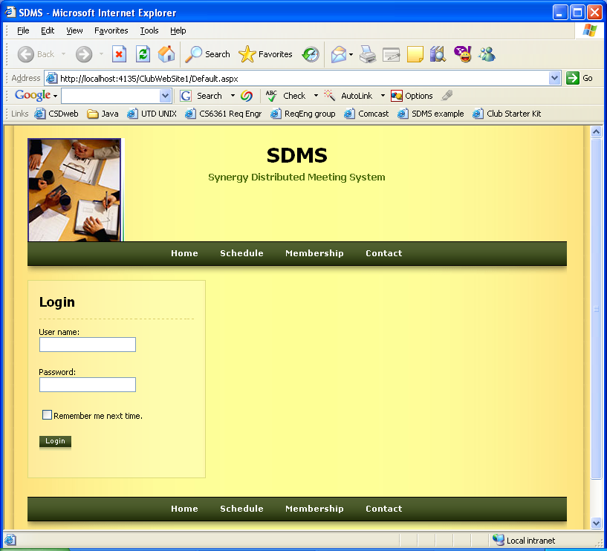

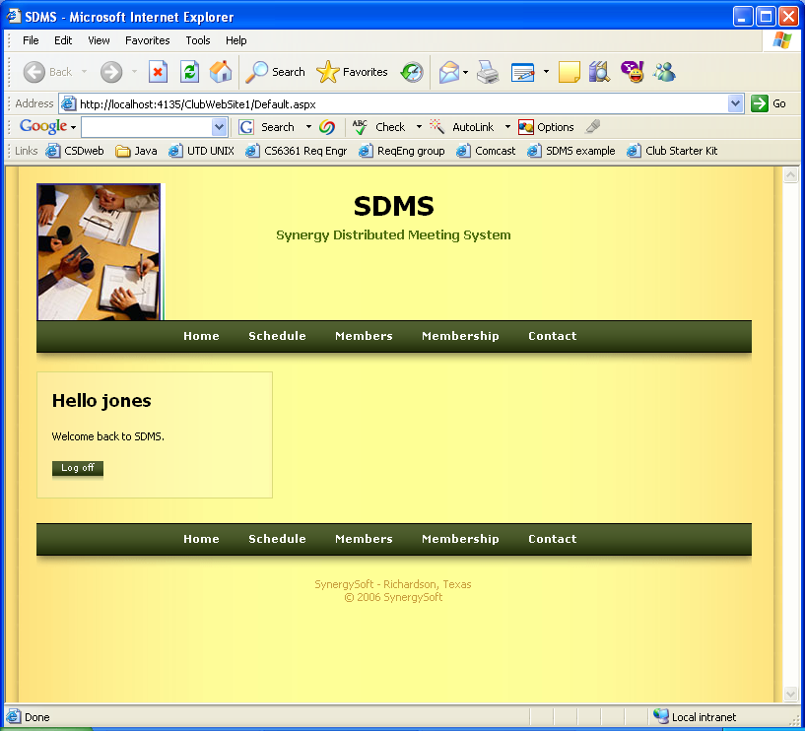

After logging in.
Click "Schedule" to get to:
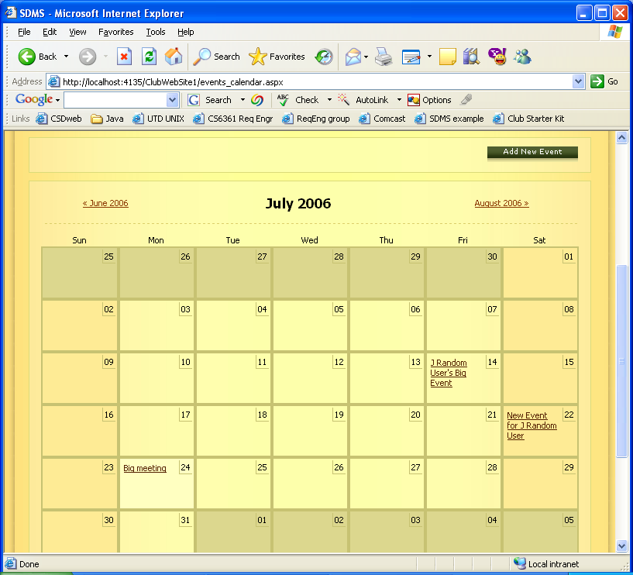

Main calendar page (scrolled down enough to see the calendar)

Click "Add New Event" to go to:
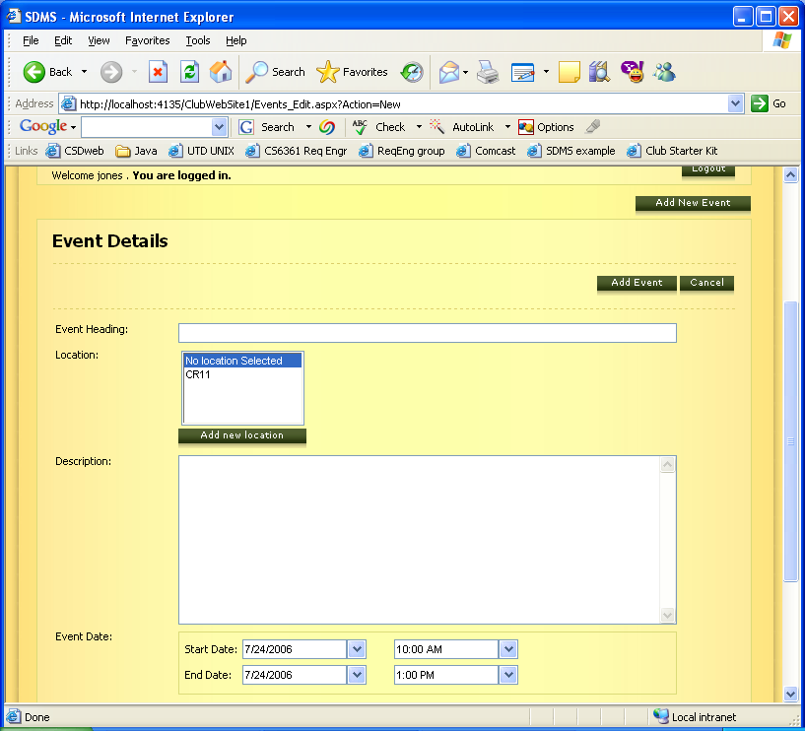

Event Details.. Enter data, then click "Add Event":

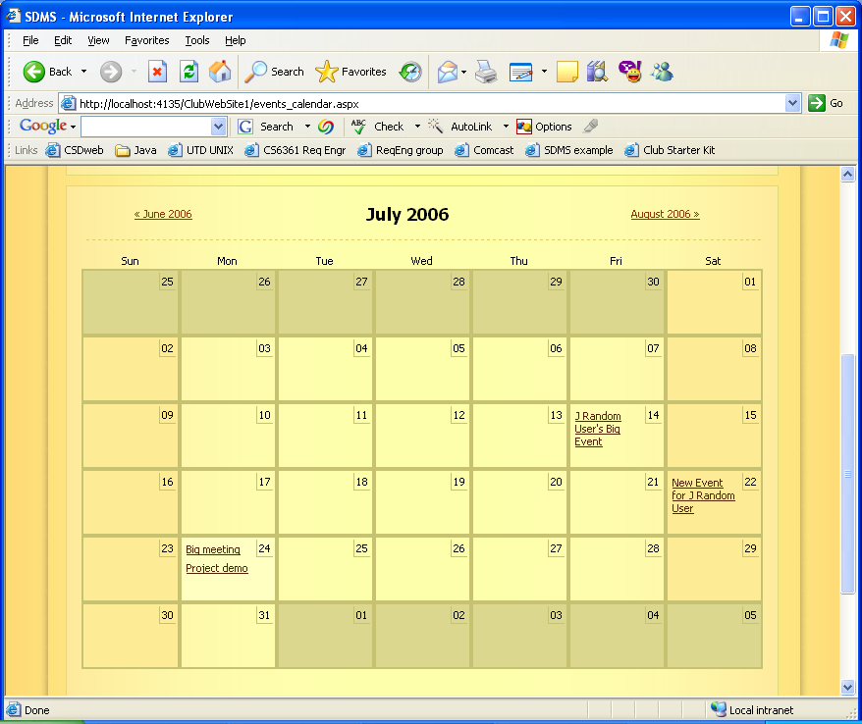

New event ("Project demo") now visible on calendar page. Click on "Project demo"...
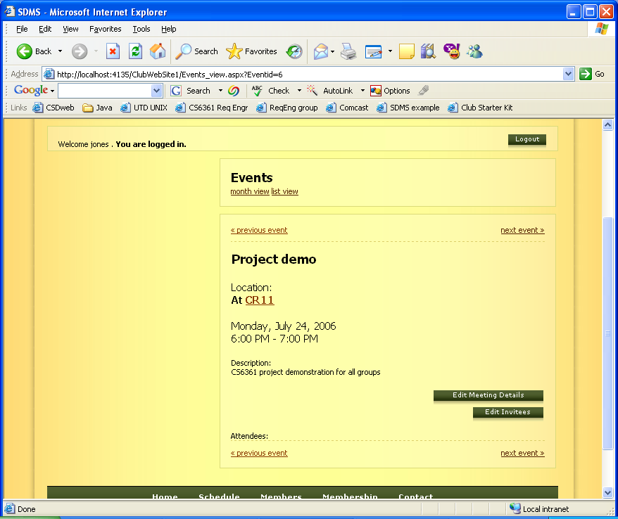

Event details. Click "Edit Invitees"
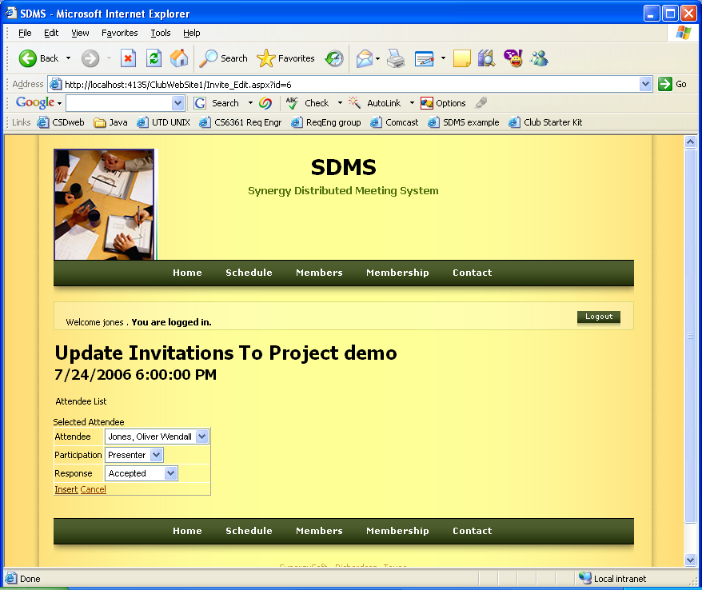

Invitee edit screen—first attendee selected, but entered yet. Press Insert:
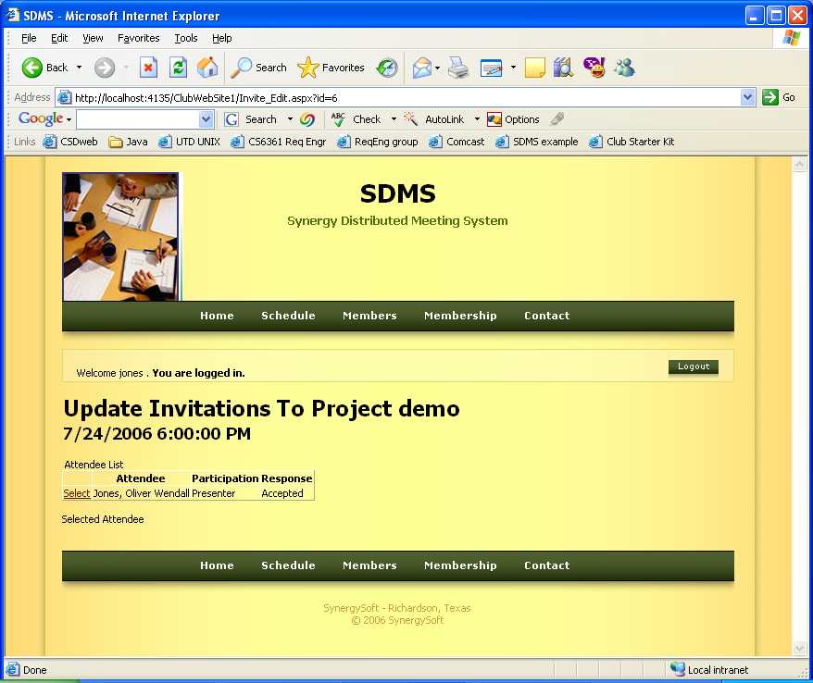

Click Select to bring the edit table back up:
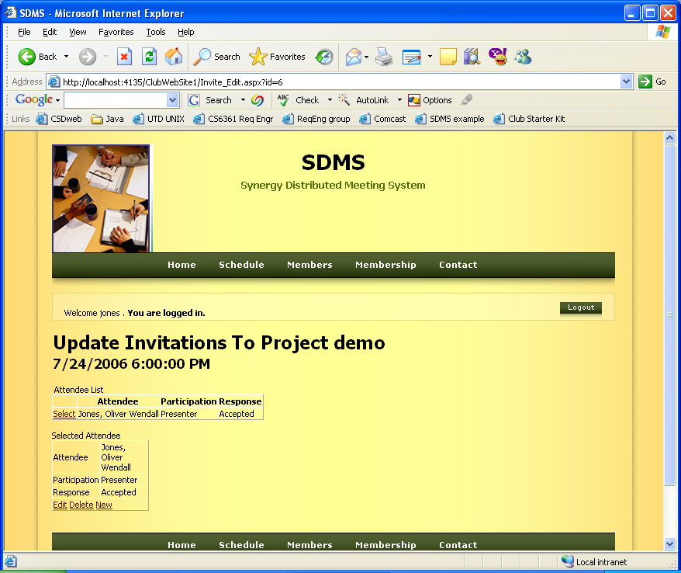

Then "New" to add new person.
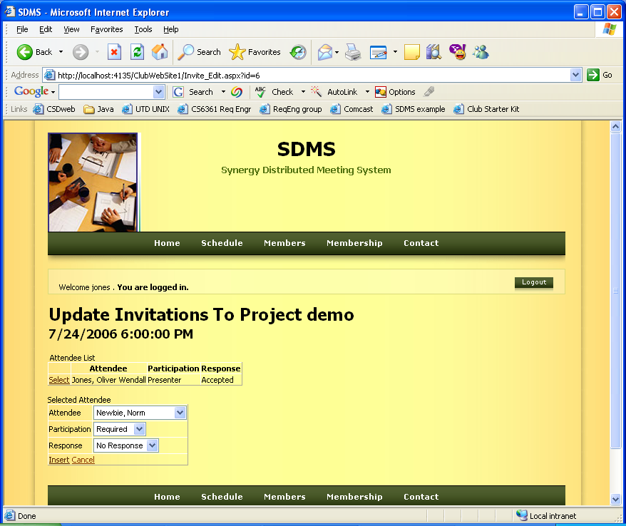

Hit "Insert"
