HOPE System User Manual

Introduction:

Welcome to the Helping Old People Easily (HOPE) system user manual. This manual will serve as a guide to the functionality of the HOPE system.

Table of Contents:

This user manual is organized into the following sections:

- Home Screen
  - Talk
  - Search
  - Favorites
  - Emergency Calls
  - Customization
- Searching
- Communication
  - Predefined Categories
  - New Sentence Generation
  - Listening (Speech-to-Text)
- Calling Contacts

- Emergency Calls
  - Assistive People / Emergency Contacts
  - Nearby Hospitals
  - 911

I. Home Screen

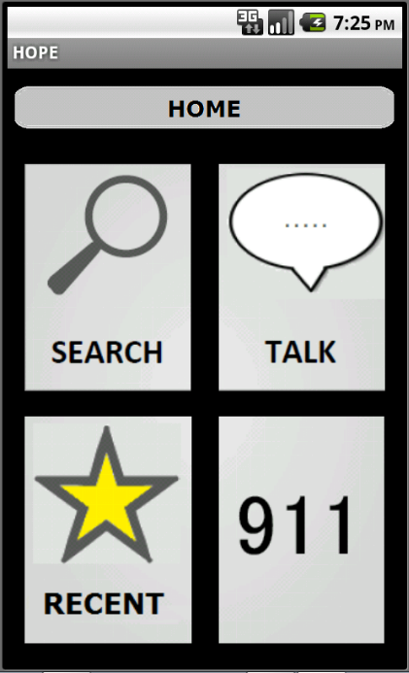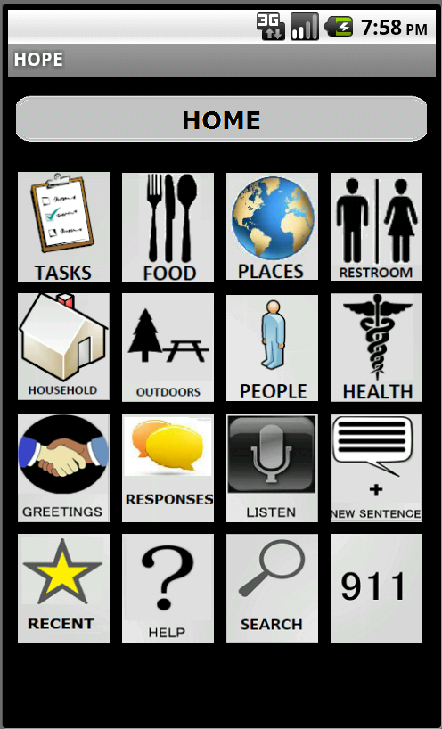

4 Icon View 16 Icon View
The very first screen that the user will see when the application is launched is the home screen. This screen will contain a number of icons that allow access to different features of the system. The HOPE system allows customization of various items that govern the appearance of the menu that is presented to the user, including: icon size, number of icons per screen, and choice of icons on the home screen. However, at a minimum, four icons will appear on the home screen. These icons are labeled: Talk, Search, Favorites, and 911. The following sections describe the features that will be accessed by clicking these icons.

Talk (4 Icon View):

The Talk icon allows the user to access the communication features of the HOPE application. Communication features include speaking user-defined and predefined sentences, creation of new sentences, and speech-to-text functionality. These features are explained under the Communication section in this manual.
Search:

The Search icon allows the user to access the search functionality of the HOPE application. Items that are used for communication, images with meta-data, and menu items can be quickly found by accessing this screen. These features are explained under the Search section in this manual.

Recent:

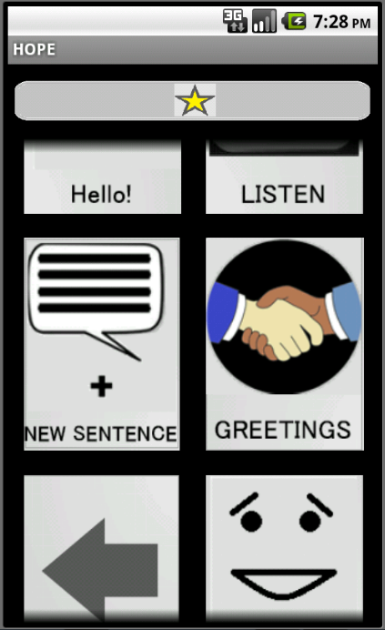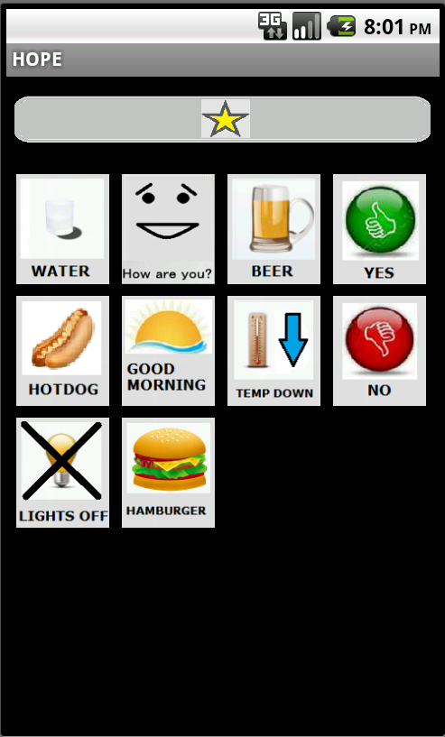

4 Icon View 16 Icon View

The Recent icon allows the user to access to recently used menu items. The HOPE system automatically saves the last ten items that were used.

911:

The 911 icon allows the user to access the emergency features of the HOPE system. The HOPE system will contact assistive persons, nearby hospitals, and the 911 system in the event of an emergency based on the user’s preference. These features are explained under the Emergency Calls section in this manual.

Customization:

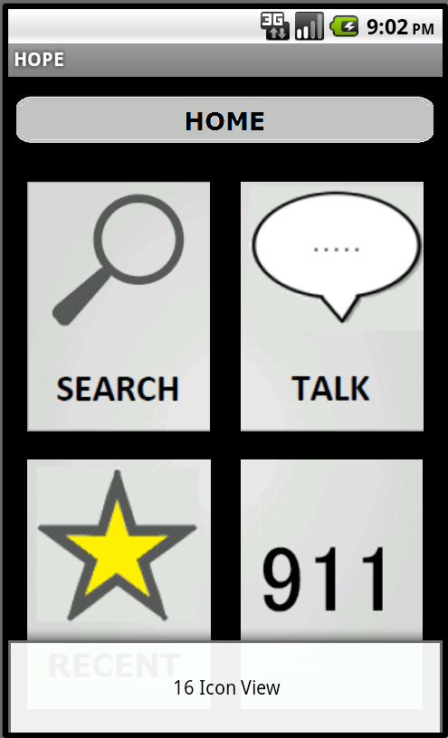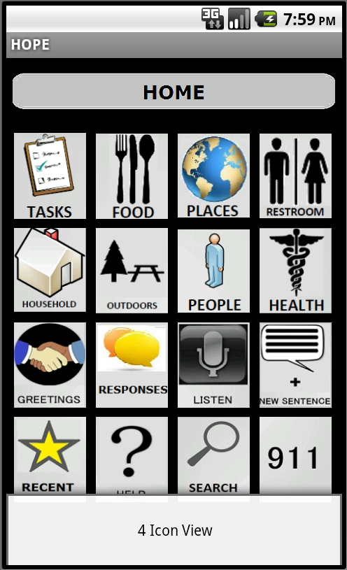

Switch to 16 Icon View Switch to 4 Icon View

The user is able to select the number of icons on their screen to suit their visual needs. To access this option, press the menu button on the Android device. A context menu will appear on the bottom of the screen. Press this menu icon to select the alternative view.

II. Communication
The HOPE system allows users to communicate in various ways. The methods of communication include selecting predefined items by navigating through the menu and communication categories, generating new/user-defined sentences, and utilizing the speech-to-text features of the system.
Predefined Categories:

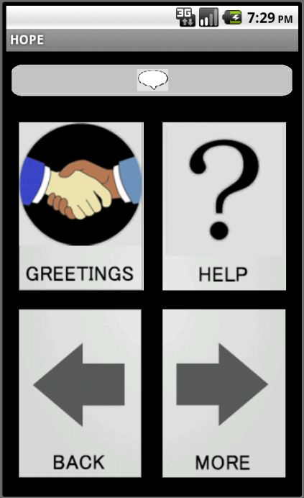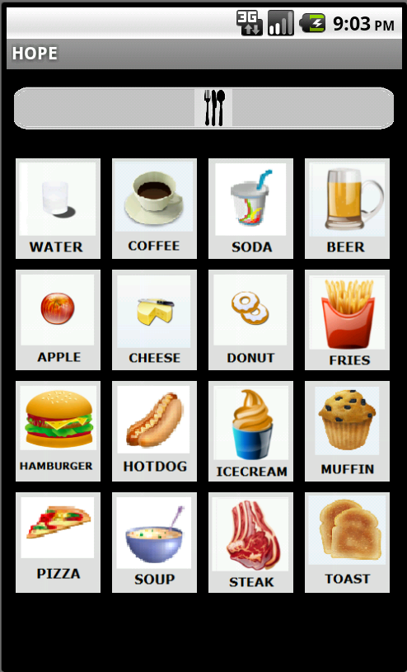

Some Categories: 4 Icon View Food Category: 16 Icon View

The HOPE system includes a selection of common communication items that are divided into related sets and stored under disjoint categories (an item will not be in two categories.) In the 4 icon view, these items are accessed by touching the talk icon on the home screen, then navigating through the various categories which are visually represented by icons. The categories are available directly from the home screen in the 16 icon view. These categories are either activity-based or item-based. Some of the categories include: greetings, decisions, and tasks. For example, to say “hello” to someone, the user would touch the Talk icon on the home screen, then touch the Greetings icon on the following screen, and finally touch the button labeled “Hello” on the screen containing the greetings. Other common communication items are accessed in a similar fashion by navigating to the correct categories.
New Sentence Generation:

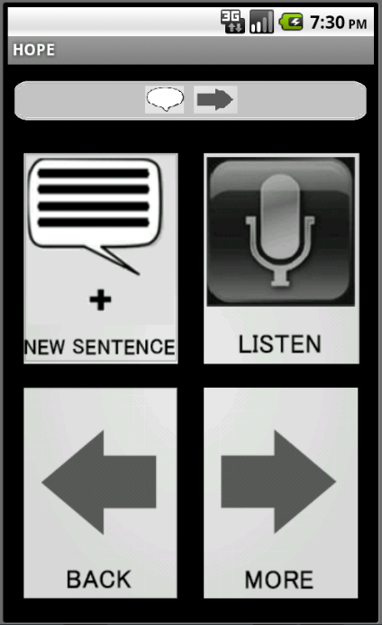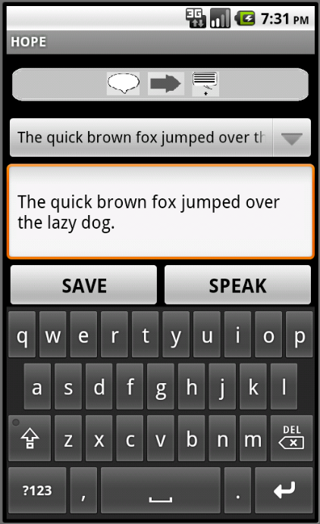

Talk Menu New Sentence Screen

When the user wants to communicate something that is not in the predefined set of communication items, they can generate a new sentence and save it for later use if desired.
The New Sentence screen is accessed by touching the Talk icon on the home screen, then touching the “More” icon, then finally touching the New Sentence icon. This screen consists of a keyboard for user input, a large editable text box, a button labeled “Save”, a button labeled “Speak”, and a drop-down box. The drop down box contains the ten most recently used sentences as a way to save time and prevent generating the same sentences too often. If the user would like to generate a new sentence, the keyboard is used to type the sentence and the output is displayed in the text box. The user can then have the device speak the sentence, using the Text-to-Speech engine, by pressing the Speak button.

Saving a Sentence:

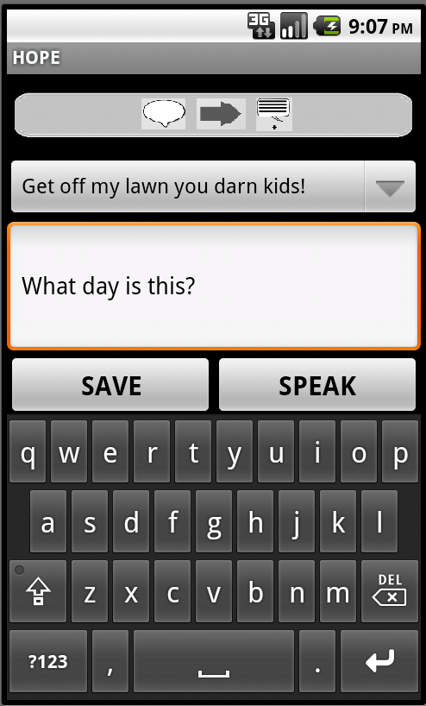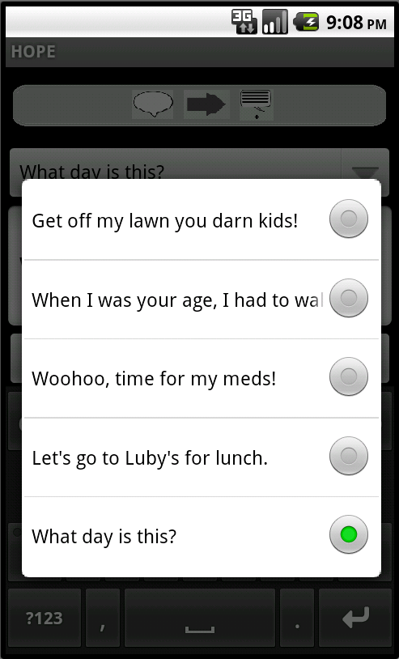

Creating a Sentence Saved Sentences

If the user decides to save the new sentence, they can press the “Save” button and the sentence will be added to the list of sentences and will be available for use later.

Listening:

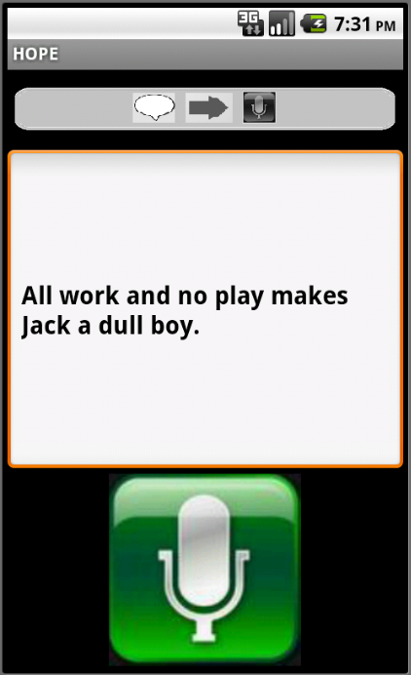

Talk Menu Listen Screen

The Listen feature of the HOPE system utilizes Speech-to-Text to display spoken words. This feature is useful for users that have hearing disabilities.
To access this feature in the 4 icon view, touch the Talk icon on the home screen, then touch the More icon to go to the next screen, and finally, touch the Listen icon. The Listen screen consists of a large text box and a button that has the image of a microphone. To use this feature, the user will press the microphone icon to begin recording. The person who is communicating with the user will then speak and be recorded by the device. Once they are done speaking, the user will press the microphone icon again to stop recording. The device will then convert the speech into text and display what was said in the text box for the user to read.

III. Searching

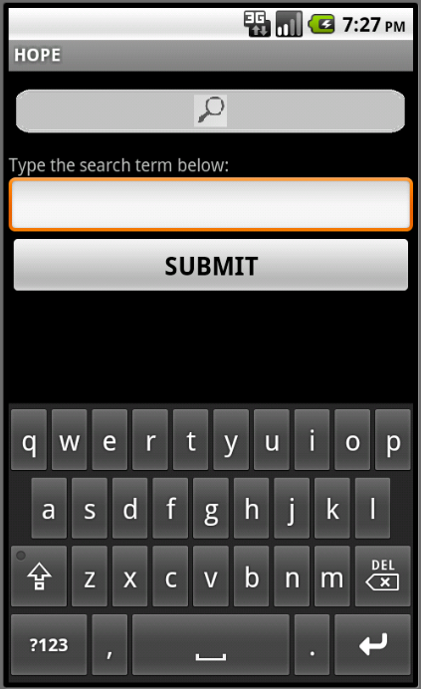

Search Screen
The HOPE system allows the user to search the system for specific features or menu items.
To use this feature, first access it by touching the Search icon on the home screen. The search screen will consist of an editable text box, a button labeled “Submit”, and a touch keyboard for user input. The user will input a search term, which describes the feature for which they are searching, into the text box. Then, they will click the button labeled “Submit” on the search screen. Next, the results of the search will be displayed in a list from which the user can make a selection. Finally, once the user makes a selection, they will be taken to the screen that contains the item.

IV. Calling Contacts

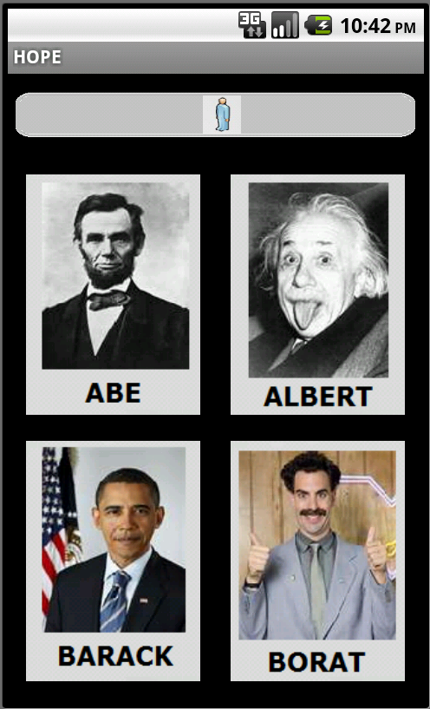

Contacts Screen

The HOPE system allows the user to place calls to their saved contacts. To use this feature, touch the icon labeled “People.” This will open the contacts screen. The user’s contacts will be displayed in a scrollable pane. Each contact is displayed as a picture and labeled with the contacts name, which is chosen by the user. To place a call, the user simply touches the icon that represents the contact that they would like to call.

V. Emergency calls

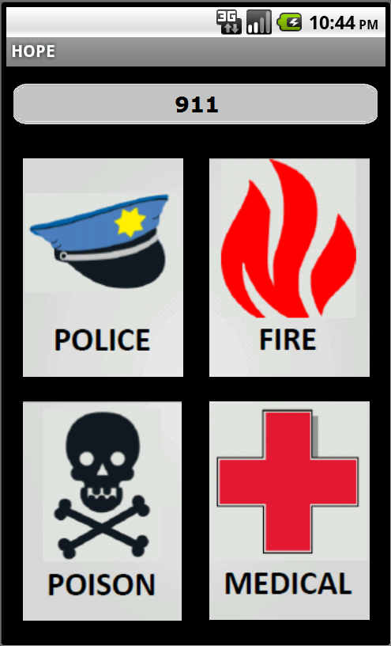

Emergency Call Screen
One of the major focuses of the HOPE system is to allow the user quick and reliable access to emergency care when needed. While the system is placing the emergency call, it will also immediately send an SMS to the contact that is specified by the user. This contact should be someone that is almost always close to the user.
To access the emergency features of the system, the user only has to touch the icon labeled “911” on the home screen. The emergency call menu will be displayed now. To place a call, touch the desired emergency contact button and the call will be placed.

