Alex LundinSE 4367.0U1

HW1

1. Sign up for group discussion board

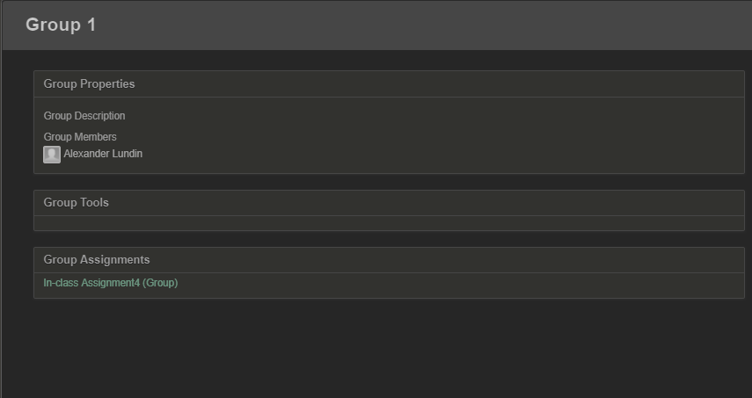



2.) Questions a-e apply to 4 pieces of code

1. Explain what is wrong with the given code. Describe fault precisely by proposing a modification to the code.
2. If possible, give a test case that DOES NOT execute the fault. If not, briefly explain why not.
3. If possible, give a test case that DOES execute fault, but DOES NOT result in an error state. If not, briefly explain why not.
4. If possible, give test case that results in error state, but DOES NOT result in a failure (hint program counters). If not, briefly explain why not.
5. For the given test case, describe the first error state. Be sure to describe it completely.

findLast

1. This piece of code will not be allowed to reach the very first index in the array. Changing the comparison part of the for loop to i >= 0 will fix this.
2. Not possible to skip the faulty loop. All non null arrays reach the faulty loop body.
3. x = [7, 2 ,9]; y = 2; Expected = -1; Actual = -1 🡪 fault executed, but not classified as error state, because there are no matches in the array
4. x = [7, 8,9]; y = 2; Expected = -1; Actual = -1 🡪 error state that did NOT result in failure, because expected and actual results match but, the program has no way of knowing if the first element was a 2. So this is an incorrect internal state only.
5. The first error state for test case d), is when the a 2 does not appear in any position other than the first index. This will not lead to a failure, but it is incorrect. It is wrong because the program can not inspect the first element to be sure that it was not a 2.

lastZero

1. This piece of code returns on the first instance of an integer 0 inside the array x. The function name and comments indicate it should return on the last instance of an integer 0. Keeping the return statement, with a comparison, outside the loop would fix this.
2. Not possible to skip the faulty comparison. All non null arrays reach the faulty comparison.
3. X = [1,1,0]; Expected = 1 ; Actual = 1 🡪 fault executed, because the faulty comparison took place, but not classified as error state, since the faulty comparison is correct, in this case.
4. X = [1,0,1]; Expected = 1 ; Actual = 1 🡪 error state that did NOT result in failure, because expected and actual match.
5. The first error state for test case on d), is when a 0 shows up in any position other than the last index. The return statement breaks out of the loop before completion. So the program has know way of knowing if any items after the first 0, were 0 themselves.

countPositive

1. This piece of code counts zeros as positive numbers. Changing the comparison to x[i] > 0 would fix this
2. Not possible to skip the faulty comparison. All non null arrays reach the faulty comparison.
3. X = [-4,2,1,2]; Expected = 3 ; Actual = 3 🡪 fault executed, but not classified as error state, because there are no 0’s to misclassify as positive numbers.
4. Not possible to execute the fault resulting in an error state without failure because 0’s in the array cause error states, which always result in failures.
5. The first error state for test case d), is when any 0 is in the array, the counter increments, classifying 0 as a positive number.

oddOrPos

1. This piece of code doesn’t account for negative odd numbers. Adding another or statement in the comparison would fix this.
2. Not possible to skip the faulty comparison. All non null arrays reach the faulty comparison.
3. X = [-2,-4,0,1,4]; Expected = 3 ; Actual = 3 🡪 fault executed, but not classified as error state, because there are no negative odd numbers so expected and actual match.
4. Not possible to execute the fault resulting in an error state without failure because negative odd numbers execute the fault, which always results in a incorrect internal state finally leading to a failure.
5. The first error state for test case d), is when the input array has negative positive numbers in it.

3.) Facts zip storage on GitHub

