Alex LundinAli Haider

SE 4367.0U1

HW1_Part2

Notes from Instructor:

All,

I think there was a misunderstanding regarding HW1, part 2. Please submit the HW1 part2 again.

Please redo HW1_Part2, and resubmit it again with your HW2. You can do this as a team now.

You need to follow the following steps:

1- Set up the facts application in your eclipse and run it and make sure it is working

2- Create a public GitHub account

3- Integrate GitHub with eclipse

4- Upload Project on GitHub using Eclipse (local and server repository)

How to Upload Project on GitHub using Eclipse: https://www.youtube.com/watch?v=Huwf0TgWrOw&t=-

6 more videos: https://www.youtube.com/watch?v=OdbBmvfThJY&index=1&list=PLsyeobzWxl7q2eaUkorLZExfd7qko9sZC-

4 more videos: <https://www.youtube.com/watch?v=r63f51ce84A&list=PLGLfVvz_LVvQHO1PfyscjIPkNJjgHsLyH>

Assignment Completion Step by Step

1. Set up the facts application in your eclipse and run it and make sure it is working

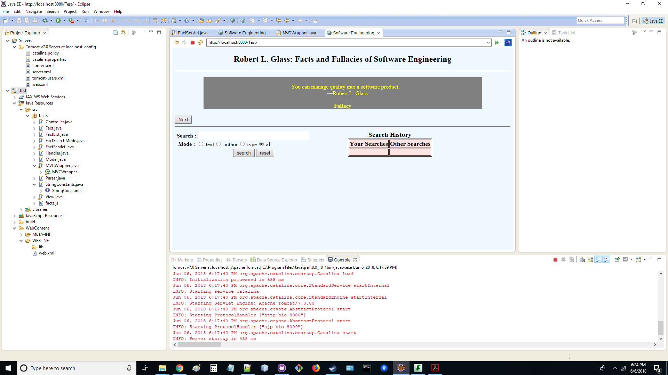

1. Create a public GitHub account

**Accounts:**

AlexLundinEducational

**Repositories:**

<https://github.com/AlexLundinEducational/HW1_Part2>

^ Used for THIS assignment only

<https://github.com/AlexLundinEducational/SE-4367-Testing>

^ Used for entire class assignments

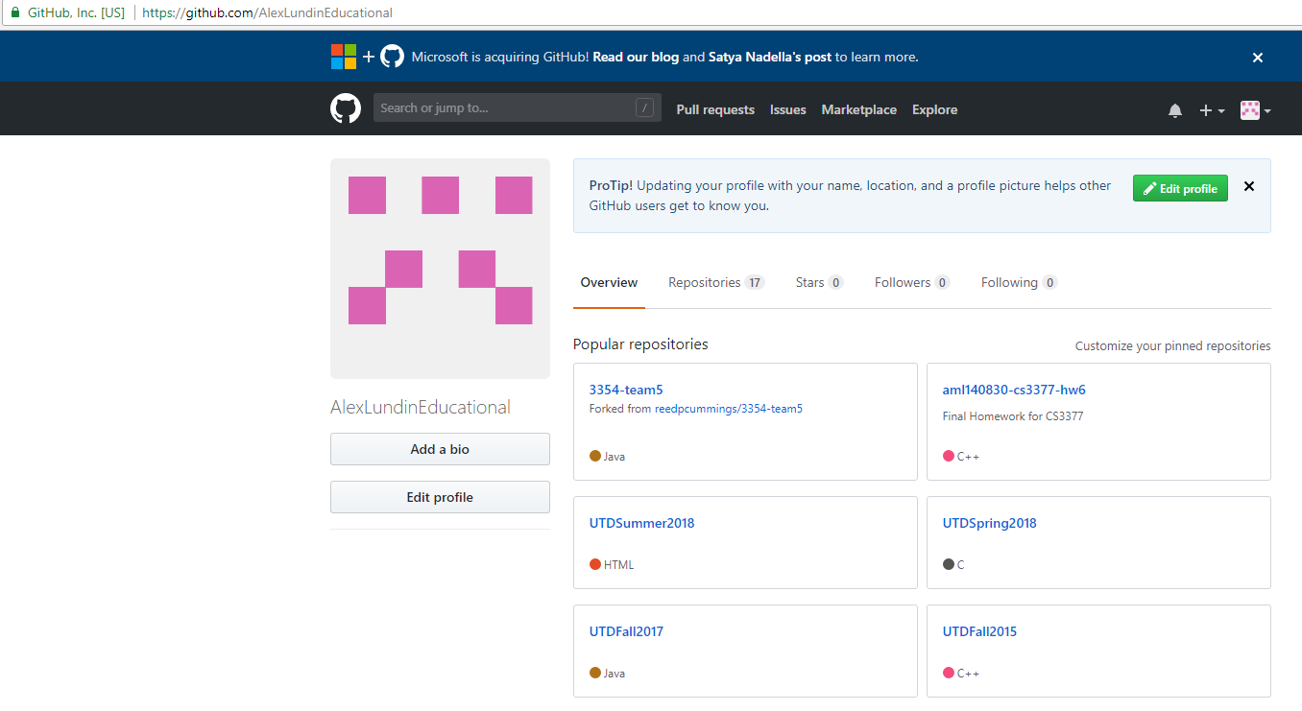

1. Integrate GitHub with eclipse

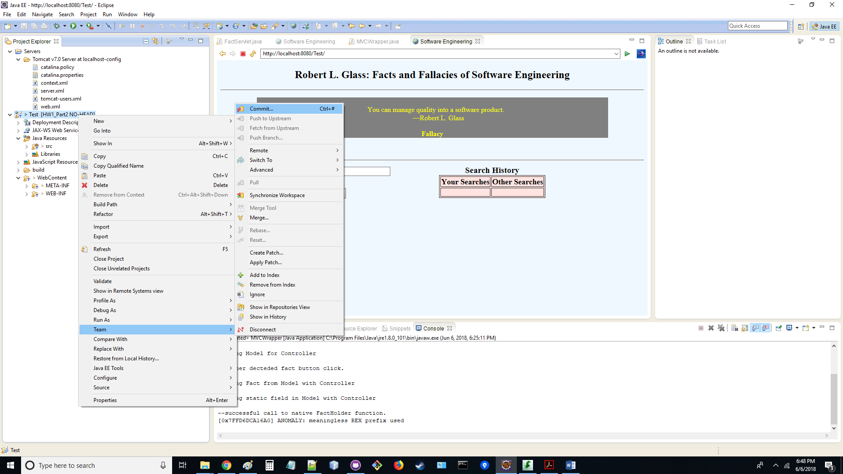

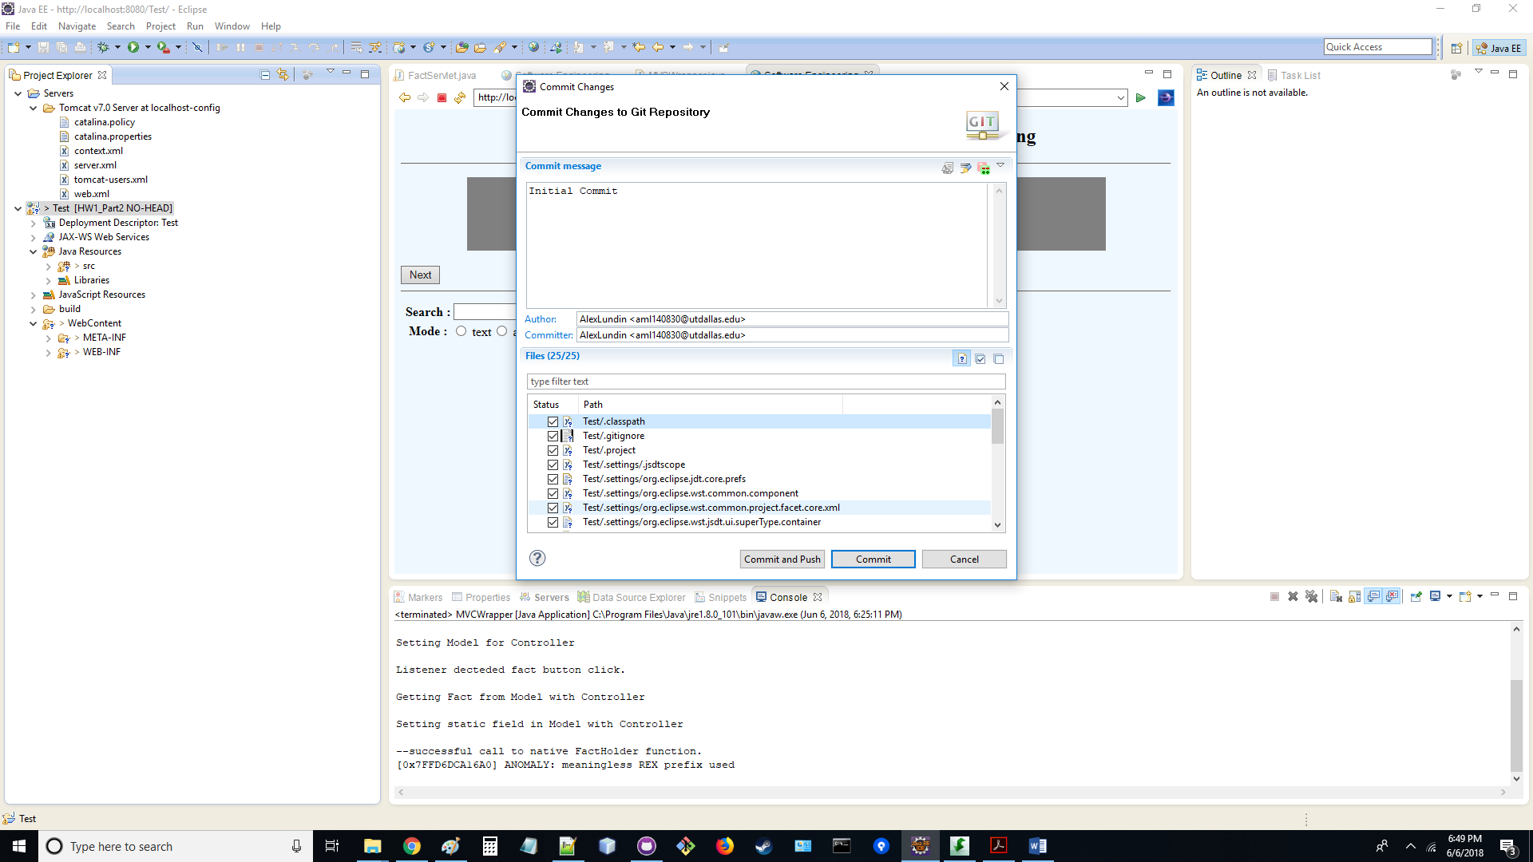

1. Upload Project on GitHub using Eclipse (local and server repository)

