Assignment HW2

**Cover Page**

Prepared for:

Dr. Mehra Borazjany

TA is TBD

Prepared by:

Alex Lundin

Ali Haider

SE-4367.0U1-Testing

**Assignment Choice:**

Simple desktop computer GUI

06 June 6, 2018

**Proof Of Working Software**

Github Link

https://github.com/AlexLundinEducational/SE-4367-Testing

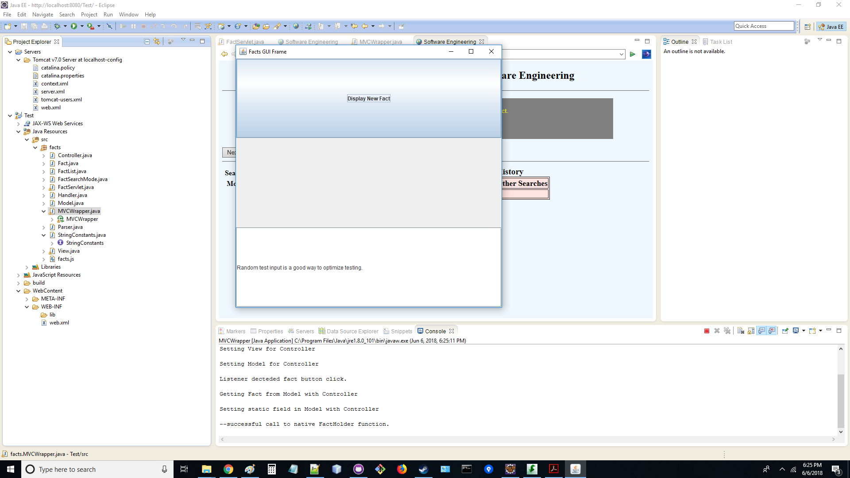

Phase 1 Development

https://knowledge.autodesk.com/community/screencast/9ab30326-5031-45e0-b856-5ff206242024

Phase 2 Development

https://knowledge.autodesk.com/community/screencast/18e387d4-7c61-416a-96d9-26ed922c8539

Phase 3 Development

https://knowledge.autodesk.com/community/screencast/090da05a-5702-41cd-a5ea-1dca3a2862bc

Successful Use Of an active GUI

https://autode.sk/2Je6wml

Proof of Facts Web App Use

https://knowledge.autodesk.com/community/screencast/8d902e29-efae-4a32-a043-e8892cd269b2

Proof of Maintainability Assessment and Fully completed GUI

https://autode.sk/2HoonRK

**Documentation Log**

1. Reductions/removals/modifications
   1. JavaServlet.java

* Refactored the hard-coded string paths into their own file
* this makes the files easier to maintain

1. New Files
   1. StringConstants.java

* this is a refactoring of the strings used in the JavaServlet.java file
  1. MVCWrapper
     + - Holds the main routine
       - Creates the Jframe GUI
       - This class DOES NOT instantiate as an object
       - This allows MVCWrapper to implement (abstractly extend) the ActionListener interface
       - Keeping this class static is a concept is the key to the whole design pattern
       - MVCWrapper's main purpose is to listen to the user clicks
  2. Controller
* Communication between the model and view
  1. Model
* Holds data
  1. View
     + - Displays data in the Jframe GUI
       - This class requests data from the Controller
       - The Controller physically controls the data flow between components

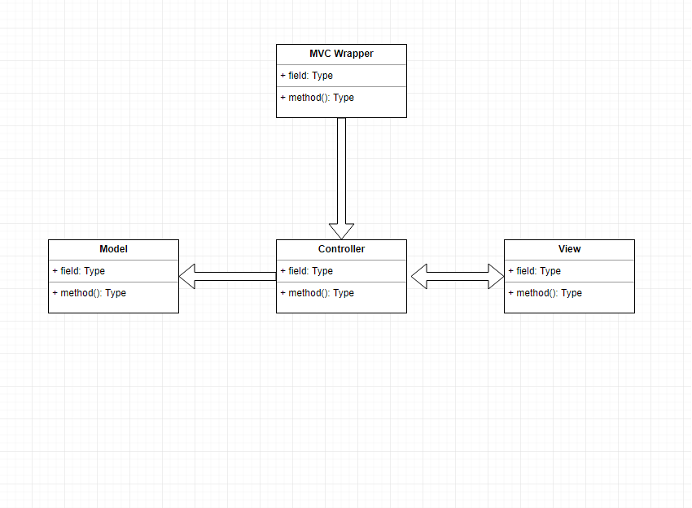

**Maintainability Assessment**

IEEE defines software maintenance as "The ease with which a software system or

component can be modified to correct faults, improve performance or other attributes, or adapt

to a changed environment." Our group decided to implement a GUI interface on our server. We

obtained the original servlet source code from the facts repository and modified the

FactServlet.java source file.

What did the original programmers do that made it hard to change the software?

What made the code difficult to modify was the lack of comments in the original source files. If someone reading the source code is not familiar with web-based java applications, understanding each method can be difficult. As the programmers, we would include a detailed description showing input and output values of each of the functions in the source file.

The overall lack of documentation made the reading demand much higher. We had to read each file to learn how to use the methods that we already in place. Any baseline documentation would have helped. A full UML diagram would have been best. But even a small sequence diagram would speed maintenance up.

What did the original programmers do that made it easy to change the software?

The code was easy to change given the organization of the original source files. Each function followed a universal naming convention.

The string paths were actually very simple to find, they were at the top of the file and they were collected together. So that made it easy to UNDERSTAND HOW to change the string paths if needed. It did not make the paths themselves easy to change because this required immersing ourselves into the project to actually find them.

What would you do differently if you did it again?

We would keep all string constants outside of the designs and in their own file, which we did. This makes updating build paths a breeze because when a programmer wants to tailor to a new location, they don’t even have to open any of the design files to make the project run. This is a design refactoring guideline we learned in Software Project Management. It’s extremely important on large teams and big projects. Building Software must not consume developer or testers time in those large environments.