Assignment HW3

**Cover Page**

Prepared for:

Dr. Mehra Borazjany

Trung Hieu Tran

Prepared by:

Alex Lundin

Ali Haider

SE-4367.0U1-Testing

**Assignment Choice:**

N/A this week

06 June 7, 2018

**Proof of Working Software**

GitHub link:

https://github.com/AlexLundinEducational/SE-4367-Testing

Branch Summary:

master – managed by Alex, only fully completed pulls allowed to make TA’s life easy. Master only contains assignment material once they reach completed status.

working – flexible branch for team, ideally, this material should build without causing technical debt during the project

Commit for grading:

HW3_TEAM1 Complete, Ready for Merge to master and Ready for Grading

Phase 1 Development

Initial Webex Meeting, Alex handles GUI / Ali handles XML writes

Phase 2 Development

https://autode.sk/2l1kJV2 (0:30)

Alex’s side of the project is done

Phase 3 Development

Phase 3 was a cluster of chaos, constant 1 step forward 3 steps backwards. This all stemmed from low quality design decisions. Each one had an escalating effect on the next. We will not deliver any group homework on time if we repeat this. Alex made this clear several times before starting this homework, during the homework and now in the final documentation.

https://autode.sk/2t0NCo2 (1:32)

<https://autode.sk/2t3ii8g> (0:51)

<https://autode.sk/2l7H5o0> (1:00)

Proof of Functional build

Alex stayed up until 5am carrying the team, not the original plan.

<https://autode.sk/2l4AXg9> (1:17)

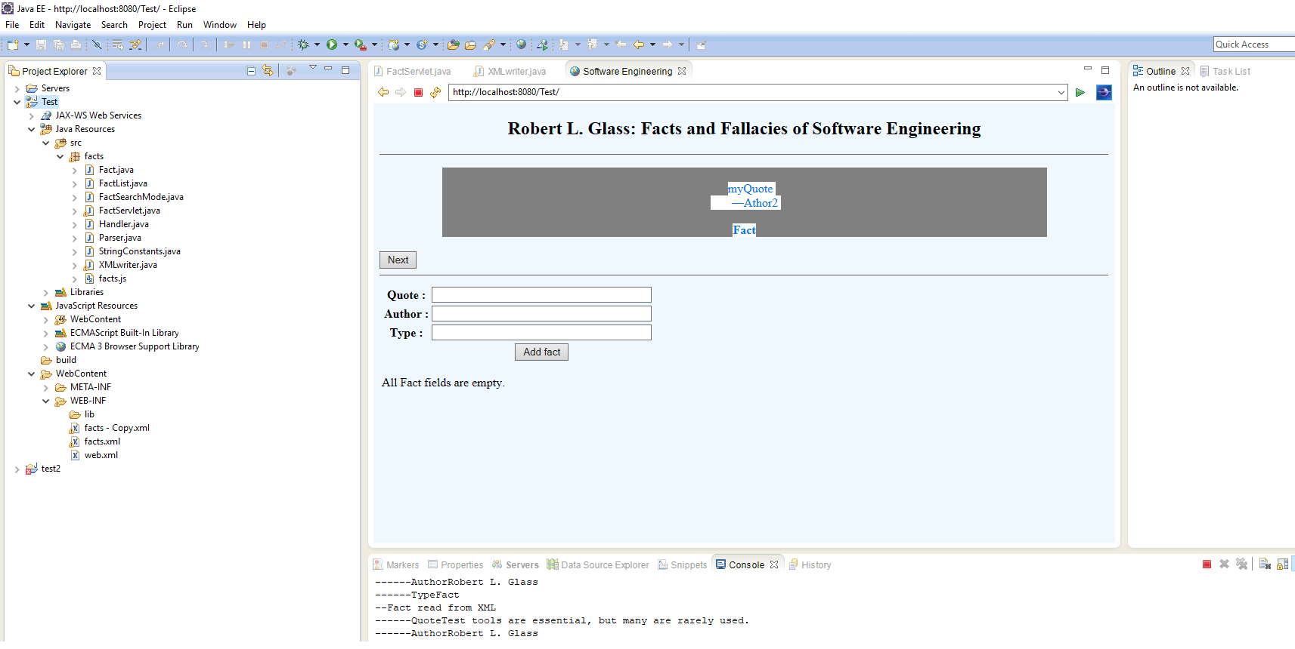**Documentation Log**

I tagged all modifications as follows

HW3 – any edits to the base functionality

Mesh point – control flow between servlet and XMLwriter

*** - all the issues I had to fix before carrying the final 5 hours of work

1. Reductions
   1. FactServlet.java

* Removed search feature

1. Refactors
   1. StringConstants.java

* this is a refactoring of the strings used in the JavaServlet.java file
  1. FactServlet.java
* this is a refactoring of the strings used in the JavaServlet.java file

1. Modifications
   1. Fact.java

* Added several helper methods
  1. FactServlet
* Form table
  + Fields
  + Buttons
* Control flow
  + Request in control flow to pull string from the fields
  + Use addFact method to implement the addButton in the control flow
  + addFact is the mesh point to XMLwriter.java class
* Modified

1. Additions
   1. XMLwriter.java

* Wrapper method combines all necessary control flow for reading existing xml data, adding new data and writing the final combined list

**Data Integrity Checks**

I decided to check that all fields we present, meaning no empty strings allowed in any field. Second I checked that the fact field was either “Fact” or “Fallacy”. The web page has useful messages printed to the page for the user for each condition of the data check.

**Maintainability Assessment**

What did the original programmers do that made it hard to change the software?

The original programmers included too much functionality inside the FactServlet.java class file. This file should have been broken into a few class files. The rule of thumb is 1 method per class file if possible.

What did the original programmers do that made it easy to change the software?

Using XML notation added extremely loose coupling. I didn’t have to edit any existing functions. Since these components were grouped together but not constrained it was a breeze to word around them. Not sticky at all.

What would you do differently if you did it again?

I would modularize the XML reader. As is stands currently, there are hard coded strings inside the reader. It would be better to have a method that accepted the xml tag and then did the reading and parsing.