Project Team Member Evaluation Form

HW3----- SE-4367.0U1-Testing------ Summer 2018------

Group1----

**I’m only evaluating my group, because I have no reference point for the other groups.**

Most team members perform well in a project team. However some members perform extremely well and some very poorly. It is constructive to encourage the outstanding members and inform those who need improvements. This form allows you to convey such information to your team members whenever you deem there is such a need.

 Please give an integer rating of -2 (poor), -1 (below average), 0 (average), +1 (above average), or +2 (excellent) for some of the aspects of the members you want to convey your assessment. Your evaluation might be reproduced to hide your identity and presented to the relevant member(s).

However, the identity of the evaluator will be kept **absolutely** confidential in all cases.

|  |  |  |  |
| --- | --- | --- | --- |
| **Team Member name** | Alex | Ali |  |
| Group meeting attendance | 2 | 2 |  |
| Group discussion | 1 | -2 |  |
| Individual assignment | 2 | -2 |  |
| Technical contribution | 2 | -2 |  |
| Organizational contribution | 2 | -2 |  |
| Total | 9 | -6 |  |

Comments: use additional sheets if needed:

Comments on next page

HW 2, group work

I completed 95% of group homework 2 on my own, giving Ali the benefit of the doubt. I expressed my annoyance with carrying the group through text message.

Here is the correspondence explaining I require him to contribute to HW3, which is due Tuesday. And his lack of contribution on HW2 put me in a difficult situation.

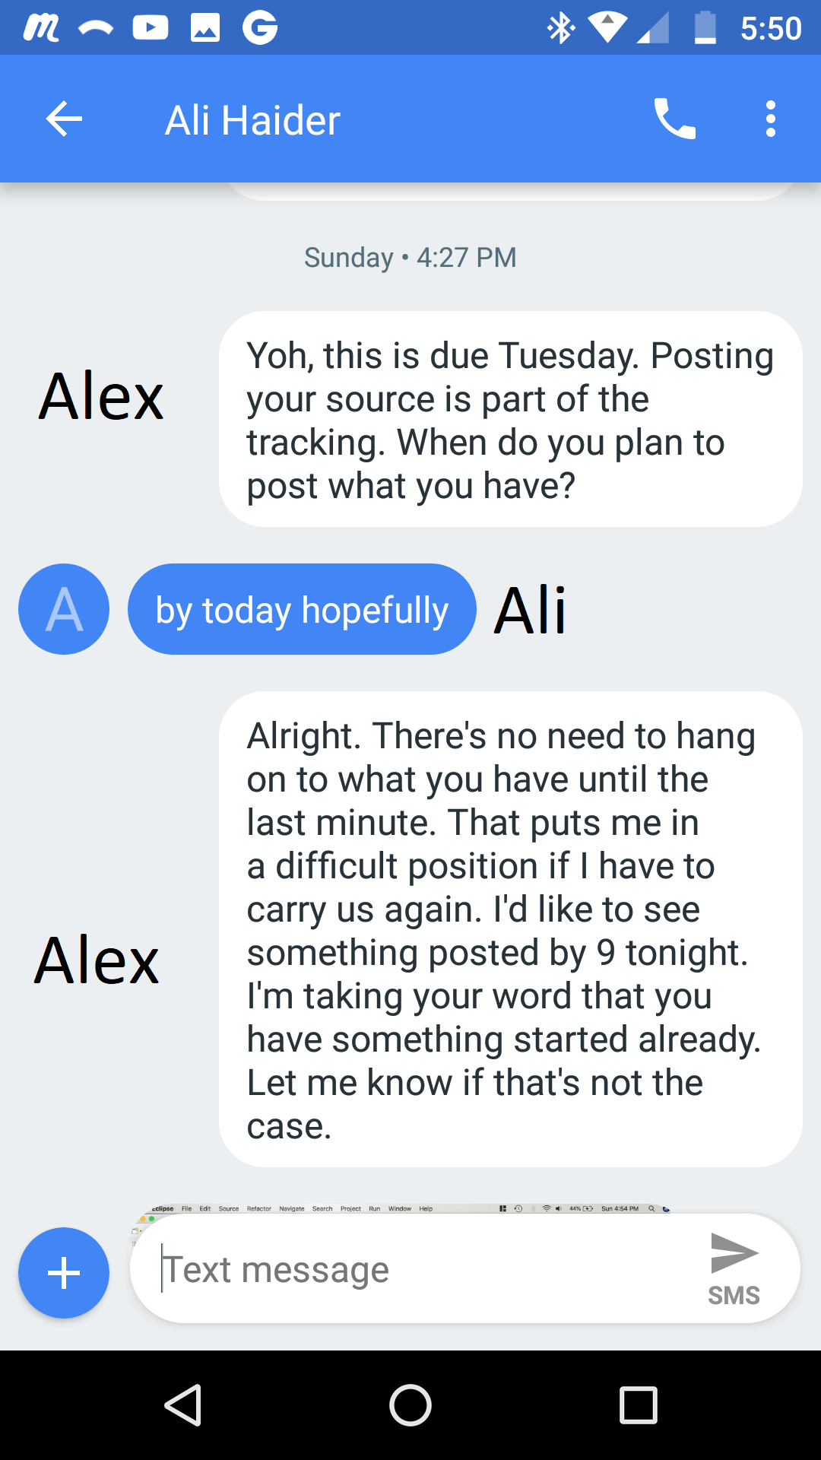

HW 3 group work

I started group homework 3, and I made it clear through text messages that group work requires contribution. Now here we are, he’s contributed this time, but his code has some very careless flaws, like missing parenthesis in method calls and method calls to functions that are not even defined in our project. Syntax errors are mistakes that even novice programmers can fix by sending the code through the compiler. It’s obvious he is posting code without even attempting to compile it. My performance is hindered by him being on the team and hindered again when he contributes because I must fix minor mistakes, on top of design flaws and then actually do the assignment.

There are more errors than syntax, I documented them in the fix that I posted, he is also using incorrect data types. I spent roughly an hour fixing his code before I could continue with the project. I will be working more tonight to produce something that gets a good grade. I’d like to be an effective team and I’ve made multiple efforts to give him another chance and let setbacks go. I’d like this semester to improve quickly.

I contacted him the day after he posted his commit and told him about the flaws. He mentioned he’s too busy to work on them. Here is my attempt to give feedback about his low-quality design. Apparently, Ali thinks he is not capable enough to work on this project.

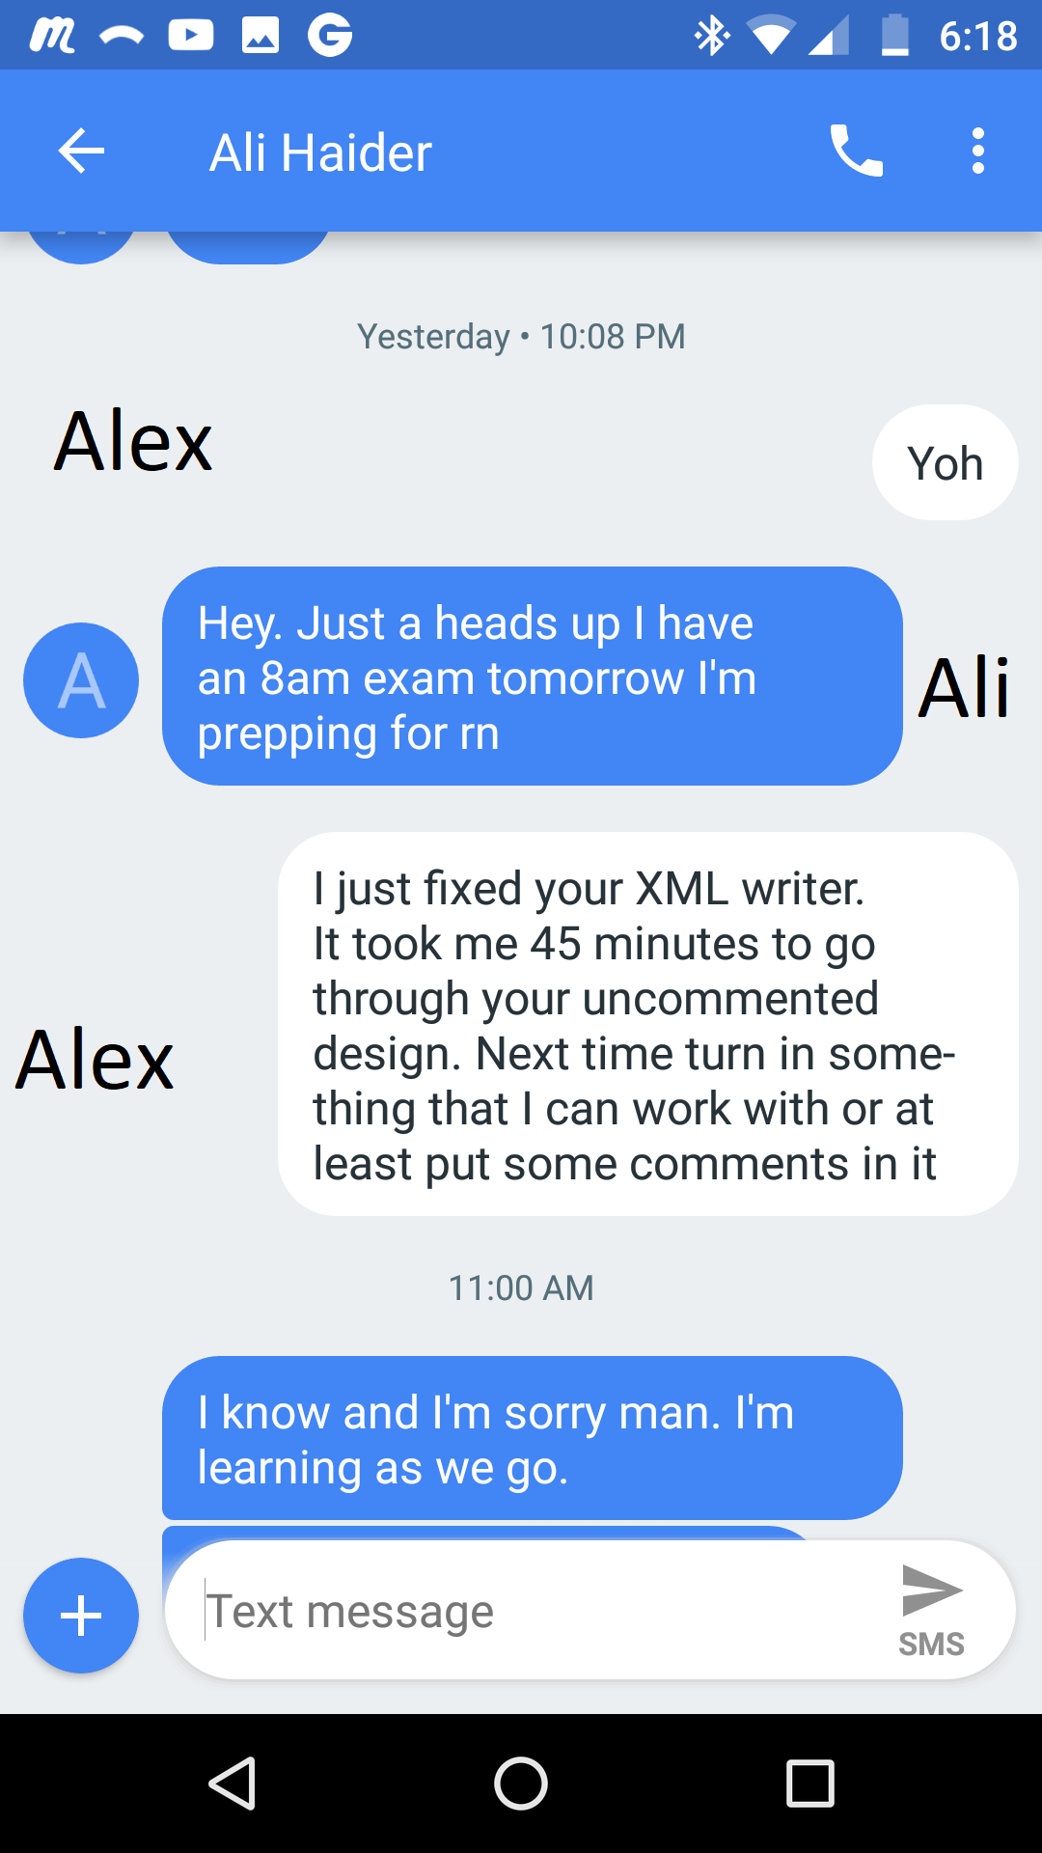

After commit, he’s unavailable to fix his mistakes putting a burden on me

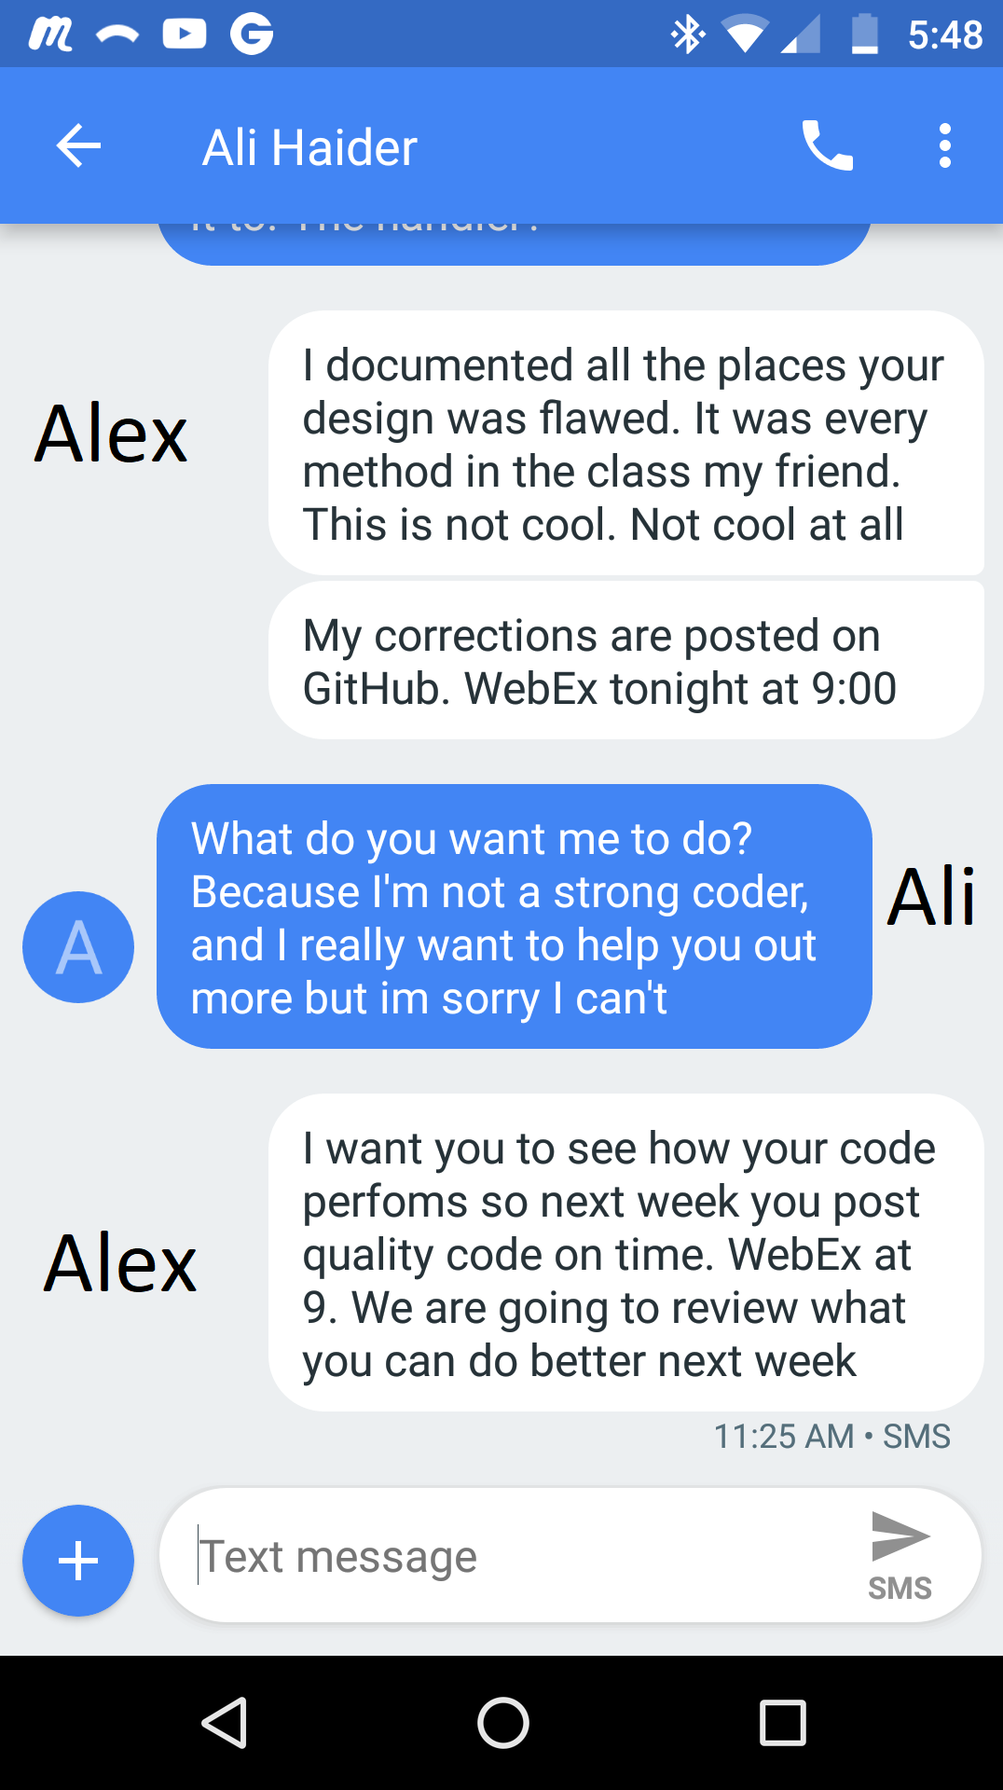

I’m attempting to give feedback, he seems to think he’s incapable

Commit with low-quality source code:

<https://github.com/AlexLundinEducational/SE-4367-Testing/commit/f7c709007d87e93e2a318cbfcabda3cb16843175>

Fixes to commit:

<https://github.com/AlexLundinEducational/SE-4367-Testing/commit/cc38d4a40658f94ff6be25026a97b421df5f9cf5>