Broadcast

- p has a single data item called p.d (non-changing)
- All other q, q≠p, want to learn the value of p.d
- Topology is unknown

Solution:
Every process has a Boolean variable, “rcvd”, initially false.
At p: p sends bcp(p.d) to all its neighbors
p sets p.rcvd to true.

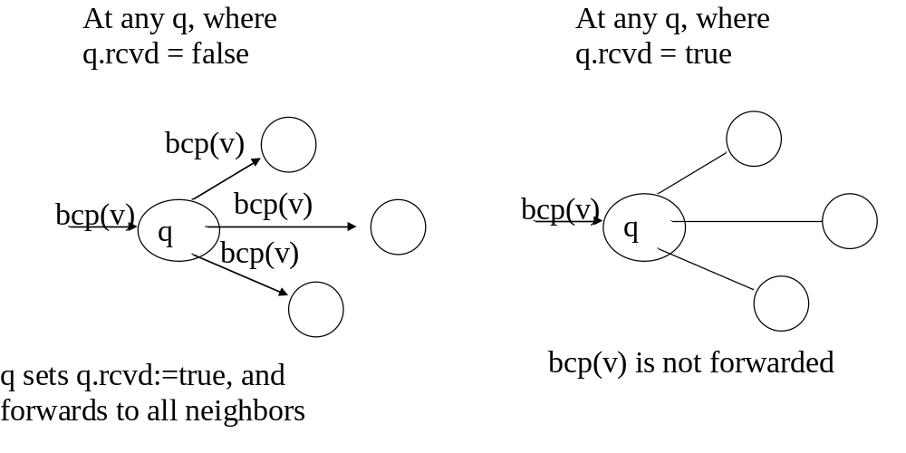

What if p.d changes over time?
- We are interested in learning the latest value of p.d
- Each process has an integer variable ts (replaces rcvd)
- When p updates p.d:
  - p increases its local p.ts value
  - send bcp(p.d, p.ts) to all neighbors of p
- How q updates its q.ts
  - q.ts is initially 0, at all processes q.
  - q.ts stores the largest timestamp from p seen by q.
q
bcp(v,t)
if t ≤ q.ts, throw away (old message, seen it already)
if t > q.ts (new message)
q.ts := t
send a copy of bcp(v,t) to all neighbors of q

E.g.
p

bcp(v,5) bcp(v,5)
q
r
bcp(v,5)
bcp(v,5)
s

- Assume ts = 4 at all nodes.
- p sets p.ts = 5 and sends bcp(p.d, p.ts) (i.e., 5) to its neighbors
- r receives bcp(v,5) from p, sets r.ts = 5 and sends bcp(v,5) to its neighbor q
- q receives bcp(v,5) from p, sets q.ts = 5, and sends bcp(v,5) to its neighbors, r and s
- r receives bcp(v,5) from q, and throws it away
- q receives bcp(v,5) from r and throws it away

Only one copy of bcp(v,5) is forwarded by each node over each link.
(BTW, how many copies of bcp(v,5) messages will exist?)
What if each process has its own independent d value?
- We want to learn the latest d value stored at each process.
- Each process has an array,
  - d: array [PID] of integer
  - p “owns” and modifies p.d[p] in its local array.
  - For all q, p wants to learn the value of q.d[q] at q, and store it in its own p.d[q].
  - I.e., if every process q stops changing its own q.d[q], then all d arrays will become equal to each other.

- We also maintain an array of timestamps at each node:
- at each node,
ts: array [PID] of integer
  - p “owns" p.ts[p], which is the timestamp of p.d[p]

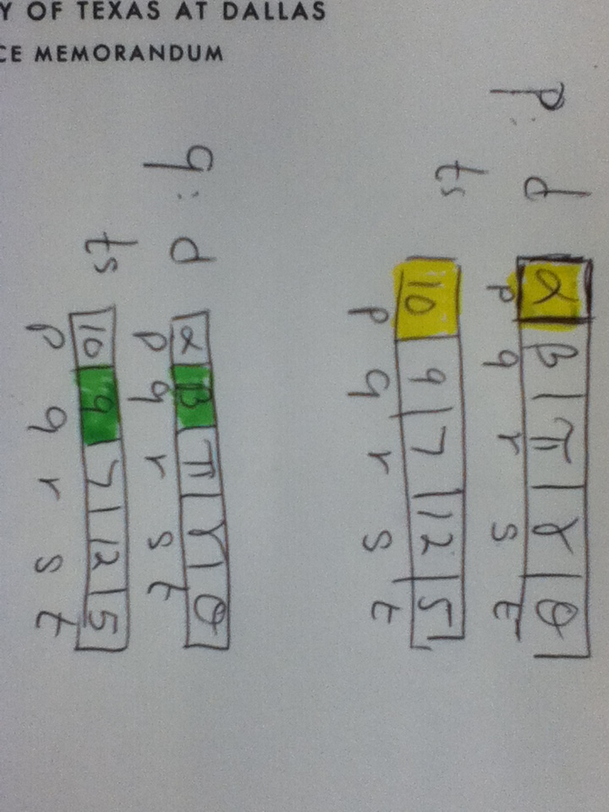

What if p would like to update its value of d[p]?

What are the steps?

Algorithm Overview

- when p updates p.d[p]:
p.ts[p] is increased by 1 at p,
p sends bc(p, p.d[p], p.ts[p]) to every neighbor

- when p receives bc(q, v, t) from some neighbor g:
if t ≤ p.ts[q] then throw away
if t > p.ts[q] then
p.ts[q] := t
p.d[q] := v
send bc(q, v, t) to all its neighbors.

process p
inp
N : set {x | x neighbor of p}
var
d : array [PID] of integer,
ts : array[PID] of integer,
r : N,
q : PID,
t : integer
param
g : element of N (* Neighbor of p *)
begin

event: true
resp: d[p] := any;
ts[p]:= ts[p]+1;
for each g in N do
send bc(p, d[p], ts[p]) to g;
end for

event: receive bc(q, v, t) from r then
resp: if ts[q] < t then
d[q] := v;
ts[q] := t;
for each g in N – {r} do
send bc(q, v, t) to g;
end for
end if

end

