1

Generation & Recognition of Handwritten digits with Generative Adversarial Neural Networks and Convolutional Neural Networks

Alexandru-Ioan Malanca

Faculty of Engineering, Environment and Computing
Coventry University
United Kingdom

Malanca2@uni.coventry.ac.uk

Abstract – Recognition of handwritten digits is an important area for researchers and commercial enterprises alike. It has numerous applications for business purposes and it has become the go to area for new starters in neural networks and machine learning.
For this paper the publicly available dataset MNIST has been used to generate new handwritten digits, which will then be pre-processed and used in conjunction with the original dataset for classification purposes.
For this end, two types of neural networks are used. One Generative Adversarial Model that uses two sub neural network models (one discriminative and one generative) in order to generate new handwritten digits given the MNIST dataset as input sample and another Convolutional Neural Network model for the classification task.
The generation of new handwritten digits is done with the intent to train the CNN model with extra data so that a 99.00% accuracy can be achieved. After initial training of the GAN model 200 new handwritten digits were generated and passed to the CNN model along with the original MNIST digits.
The obtained results of the correct classifications vary between 97% and 99%.
The use of GAN models as a way to generate new or extra training data can potentially have many applications in the computer vision field, especially for image classification tasks, however it requires a lot of computational power therefore for this project it generated only 300 samples instead of thousands.

- INTRODUCTION

Optical Character Recognition systems have been around for a few decades now however recent technologies such as artificial neural networks have developed new OCR systems that can recognise any handwritten character or digit with almost human-like accuracy.
The motivation behind this project is to develop a neural network model can achieve 99% accuracy on the MNIST dataset as well as on new generated digits, representing the variety of handwriting styles an OCR system will encounter in an business application.
The MNIST dataset has been around for over 2 decades and it is one of the most used dataset for machine learning, classiﬁcation and computer vision systems, with impressive results of over 99% accuracy.
While the MNIST dataset is a very balanced dataset, containing digits that have been written by census

bureau employees and high school students in U.S.A, it still doesn’t represent the full scope of handwriting styles an OCR system will encounter in real business applications. [1]
There already are models that can achieve 99% accuracy on the MNIST dataset however the same models will struggle classifying any digits that are written in any other format, rendering the models just an academic exercise without any business applications.
One dataset can only cover and provide data for a specific task therefore the need for a varied suite of benchmark tasks becomes ever more important in allowing a more holistic approaching to testing and analysing the performance of any given system or algorithm.
To make up for the lack of variety in the handwriting styles new digits will be generated from scratch through a Generative Adversarial Neural Network model.
GANs are a form of unsupervised learning that can generate photographs of any input sample given, in this case, the MNIST dataset.
Generative models can generate synthetic inputs x’ and outputs y’ by learning the inherent distribution function of the input data p(x). GANs are usually composed of two models; one model called the Generator that can generate new data similar to the sample input given, and a second model called the Discriminator, whose goal is to analyse and decide if the generated data belongs to the input sample or if it’s fake data.
The interaction between the two models can be seen as a competition in which the generator has to learn how to create new data that is indistinguishable from the original sample and the discriminator has to judge if the generated data is part of the input sample or fake.
The above mentioned GAN model generated 200 new images with handwritten digits. This new data, representing a variety of handwriting styles, will be used to test the classifier model and although it is not enough to represent the full spectrum of styles, an n number could be generated given enough computational power.

The paper is arranged in the following order:

Chapter I – A short introduction

Chapter II - Reviews the literature that documented the GAN & CNN model

Chapter III – A short description of the dataset and methodology used to implement the models.

Chapter IV- Analyses the importance of results and their meaning for upcoming researchers and practitioners.

Chapter V- Discusses the overall project and concludes its outcome.

- RELATED WORK

There is a wide variety of studies in the field of handwritten characters and digit recognition and although there are many different types of neural networks, convolutional neural networks can achieve state-of-the-art results on various task, however CNN excel in computer vision and natural language processing.
The similar challenge of unlimited variation in human handwriting has been overcome by El-Sawy, EL-Bakry, Loey [2] in their 2016 paper “CNN for Handwritten Arabic Digits Recognition Based on LeNet” by using a CNN architecture with impressive results.
The dominance of the CNN model on object recognition task and especially for digit recognition has been confirmed by Jain, Rahul, Khamaru, and Ghosh in their paper “Hand Written Digit Recognition using Convolutional Neural Network (CNN)”[3] in which again their CNN model outperformed any other model.
In 2016, Romanuke achieved a strong 0.27% accuracy on a digit recognition task using a CNN model that has been trained for 74 epochs. [4]
In his 2014 paper titled “Generative Adversarial Nets”, Ian Goodfellow introduced for the first time a neural network architecture in which a generative model G can capture the data distribution, and a discriminative model D estimates the probability that a sample came from the training data rather than G.[5]
One of the many advantages that GANs present is that Markov chain are not even needed, backpropagation is used to obtain gradients, it doesn’t require any inference during learning and it can incorporate a wide variety of functions.
Table 1 presents a comparison of generative adversarial nets with other generative modelling approaches.

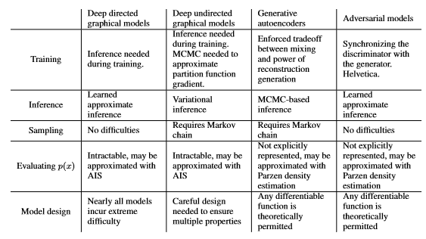
[5]

- DATASET & METHODS

- Dataset

An initial exploratory data analysis has been performed on the MNIST dataset. It contains 10 classes with around 4,000 samples for each class and no missing values.
The data has been first prepared for the CNN model by having the images normalised to grayscale in order to reduce the effect of different lighting and pen colour used. The data comes in a pandas data frame as 1d vector of 784 values and it has been reshaped to 28x28x1 3D matrices.
The labels have been encoded to one hot vectors as the label classes are numbers from 0 to 9.
In order to train & test the CNN model the data has been split in two parts. 10% has been saved as the validation set on which the model will be evaluated and 90% with which the model will be trained.
When it comes to the GAN model, the same dataset has been used as sample input however the data has been processed differently. The input values for each pixel which range from 0 – 255 have been normalised to range from -1 to 1.

- CNN MODEL

Keras Sequential API has been used for the implementation of both models due to its ease of use and features such as adding one layer at a time.
The overall CNN architecture contains two sets of two convolutional layers followed by a MaxPool2D layer and a dropout regularization method, followed by a flatten layer and two fully connected dense layers.
For the first two convolutional (Conv2D) layers 32 filters have been used and 64 filters for last two filters. Each filter, defined by the kernel size, transforms a part of the image.
The MaxPool2D layer acts as a down sampling filter. It takes a pixel, looks at the 2 neighbouring pixels and picks the maximum value among them. This is done with the intention of saving computational cost and to avoid overfitting.
By combining convolutional and pooling layers a CNN model will be able to use local features and learn even more from the global features.
The model uses Dropout as the regularization method, this sets the weights to 0 to a portion of nodes in each training sample so that it forces the network to learn the features in a distributed way by dropping at random some proportions of the network. This technique also helps to improve generalization and to reduce the chance of overfitting.
The Relu rectifier has been chosen as the activation function in order to add non linearity to the network.
A flatten layer was chosen for the conversion of the final features maps into a single 1d vector. This step is necessary so that the model can make use of the fully connected dense layers.
Lastly the two fully-connected (Dense) layers act as the classifier, with the last layer having a softmax activation function which outputs the probability of each class.
The loss function is defined as the error rate between the observed labels and the predicted ones.
Root Mean Square Prop (RMSprop) has been chosen as the optimiser for this model as it’s faster than the normal stochastic gradient descent.
An annealing method of the learning rate has been used in order to make the optimizer converge closer and faster to the global minimum of the loss function.
A decreasing LR during the training can reach the global minimum much more efficiently. The LR is decreased dynamically every X steps (epochs) depending if the accuracy has improved or not.

- GAN MODEL

Two neural networks have been defined for the GAN model. One networks which acts as the discriminator and another one which as the generator.
For the discriminator model, three hidden layers have been used, each followed by a Leaky-Relu rectifier and a Dropout layer. A sigmoid function is then used on the real-valued output in order to obtain values in an open range of 0 -1.
This model will take an already flattened image as input and output the probability of it belonging to a real or synthetic dataset.
The generative model takes a latent value vector as the input and outputs a 784 valued vector which represents a flattened 28 x 28 image. This model will also have three hidden layers, each followed by a Leaky-Relu rectifier and a TanH activation function which correlates the resulting values into a range from -1 to 1, which is the same range in which our pre-processed MNIST images is bounded.
The generators goal is to fool the discriminator by generating realistic digits, this means that the generator’s weights needs to optimise in order to maximize the probability that a fake image will be classified as belonging to the dataset of real images.
This means that the loss function used for this model has to maximize D(G(z)
Additional functionality needs to be added so that random noise will be added. Adding noise to both synthetic and real data during the training process will help overcome the models instability and tendency to degenerate and output weird distributions.
For optimisation the model uses an Adam- method for Stochastic Optimization with a learning rate of 0.0002.

The loss function used for this model is Binary Cross Entopy Loss which will resemble the log-loss for both the discriminator and generator models. It will take the average of the loss calculated for each mini batch.

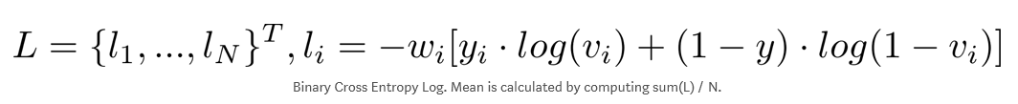

Discriminator Loss Function -
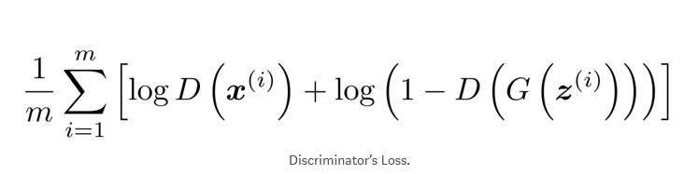
Replace vᵢ = D(xᵢ) and yᵢ=1 ∀ i (for all i) in the BCE-Loss definition,
In order to obtain the loss related to the real-images.
Also set vᵢ = D(G(zᵢ)) and yᵢ=0 ∀ i, to obtain the loss for the fake-images.

Usually the gradient has to be ascended however PyTorch and most other Machine Learning frameworks minimize the functions.

Generator Loss Function –
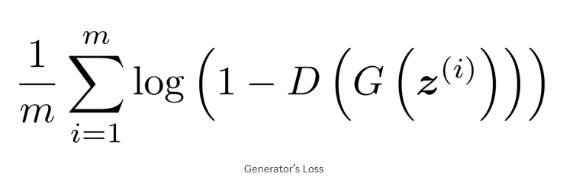Instead of minimizing log (1- D(G(z))), the generator will be trained to maximize log D(G(z)) in order to provide stronger gradients in the early stages of training.
Since the BCE-Loss definition contains a minus sign maximizing log D(G(z)) is equivalent to minimizing it’s negative. Resembling the discriminators loss function, set vᵢ = D(G(zᵢ)) and yᵢ=1 ∀ i, obtain the desired loss to be minimized.

The Discriminator and Generator can be thought of as two agents playing a minimax game with value function V(G,D). In this game the goal for the generator is to maximise the probability of its outputs to be recognised as real while the goal for the discriminator is to minimize the same probability.
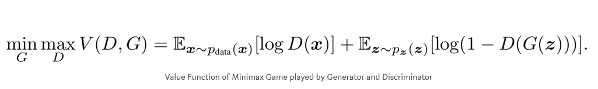

The first step to implementing a GAN model will be to sample a noise & a real dataset, each with size m, followed by the second step which is to train the discriminator model with this data. The third step would be to sample a different noise subset of m and train the generator with this data. Repeat the cycle from step 1 until desired results are achieved.

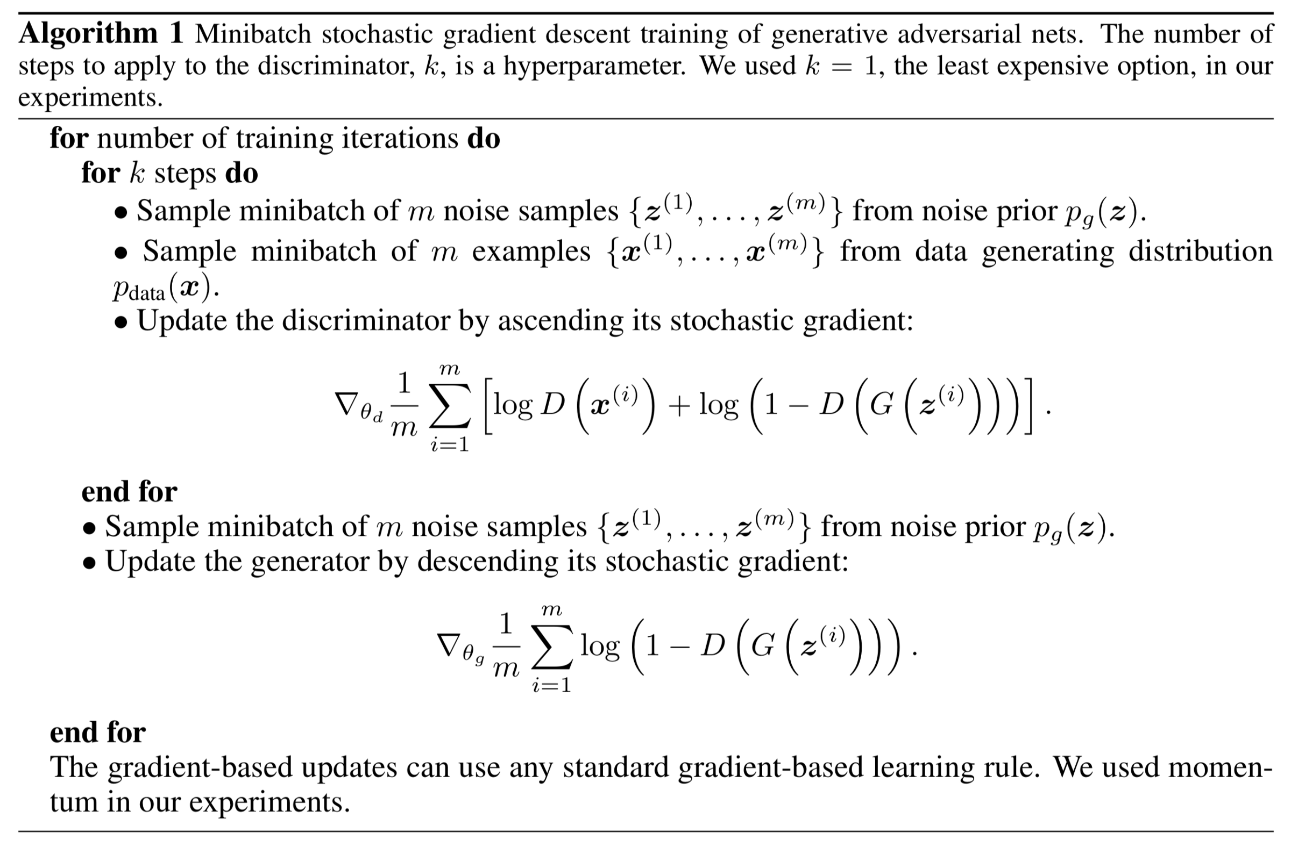

- EVALUATION

Two testing cycles have been conducted in order to evaluate the performance of each model.
The first cycle is testing the CNN model on the normal MNIST data set.
For this, confusion matrices are visualized, they’re a good visualization tool in which the number of correct and incorrect classifications can be observed.

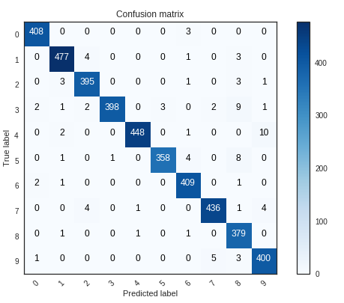

It looks like the CNN model performs well on almost all digits with just a few errors considering the actual size of 4 200 images of the validation set. However it looks like the model might have some issues distinguishing between the 4 and 9, where the 4 is classified as a 9.

Loss and accuracy curves for training and validation

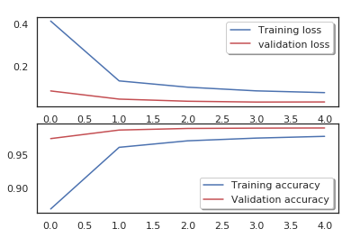

If the loss curve is lower the model is good. Loss is not a percentage but a summation of the errors made for each example. The loss curve also implies how poor or well a model behaves.
The accuracy of a model can be determined after the model learns the parameters. The test samples can then be fed into the model and the number of mistakes it makes are recorded. The wrong classification are then compared to the true targets and the misclassification calculated.

The CNN model performs really well as we can see from the loss & accuracy curves.

To further investigate the performance of the model, we look at the 6 biggest mistakes it did as those errors are usually the most intriguing.

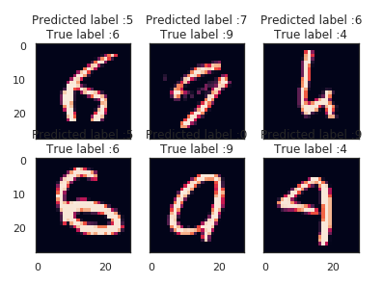

We can see that for the 6th case the model is confused but so would be even a human, especially as the 4 does look like 9.

Lastly, the data generated from the GAN model has been added to the MNIST file and the model tested again. This time it has achieved an accuracy of 99% in just 5 epochs.

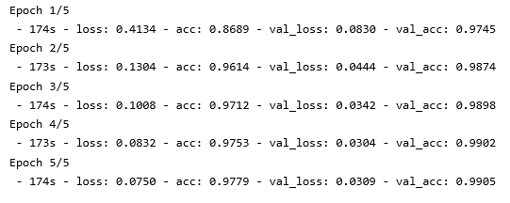

The second cycle is testing the GAN model which took 200 epochs to generate 300 handwritten digits.
At first the images are pure noise; 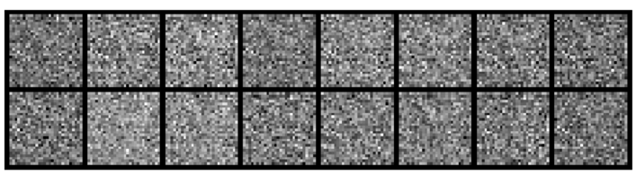
They improve with each epoch, and by epoch 50 we can see the outline of the digits.
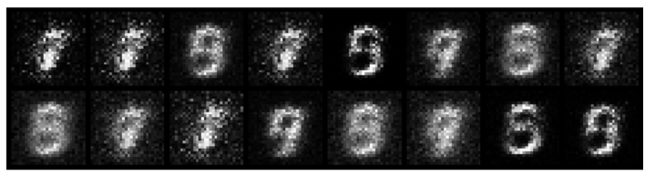
By epoch 200 the digits are completed and look indistinguishable from the real dataset.
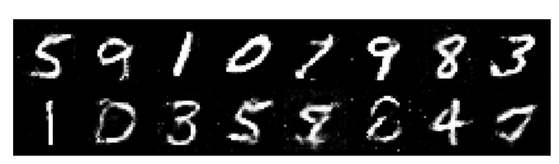

We can also visualise the learning process for the GAN model;

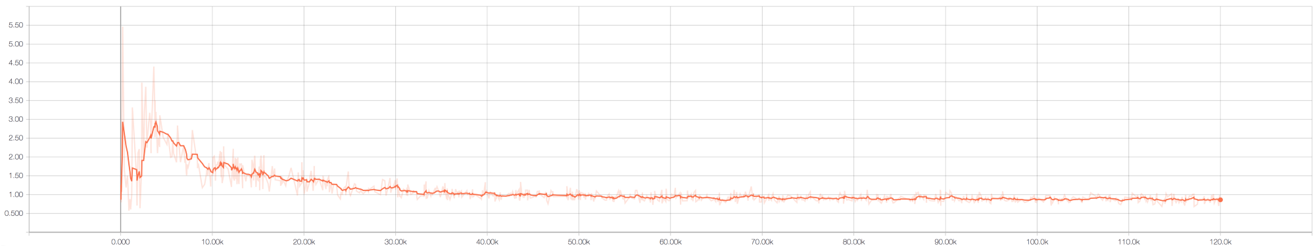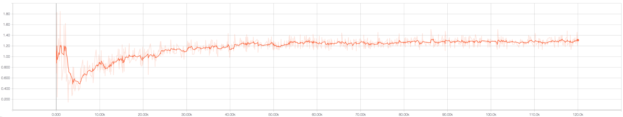

From the above figures we can see that the discriminator errors is quite high in the beginning stages. This is due to the fact that it doesn’t know how to classify the noisy images as true or fake.
As it improvise itself the error rate decrease however the error rate for the generator increases. This proves that the discriminator model can outperform the generator model and that it can correctly classify even the fake samples. As more epoch pass the generator error lowers, which means that the images it generates are getting better and better.

- DISSCUSION & CONCLUSION

This project has demonstrated how a generative adversarial neural network model can used to generate new data that can then be used to train different other models.
This becomes a crucial tool as depending on the specific task, data to train models can sometimes be scarce or even non-existent. This type of neural network allows academic researchers and business professionals to create their own data when needed.
Even if one would have all the data necessary to train and test a model, as we used the MNIST dataset for the CNN model, it would still benefit from a GAN model to generate extra data for testing.
Based on this project the most important application of a GAN model would be to balance unbalanced datasets.
This project also shows that the CNN model is one of the most appropriate models for classifying any handwritten text.
One area for future work in this field with a GANs model would be generation of handwritten sentences that can then be used for segmentation and classifying purposes.

APPENDIX

The folder containing both models can be downloaded from here:https://drive.google.com/open?id=1gkZXghFatfKTN3XcHiVFvV6P4_iyGQ2M

REFERENCES

[1] - LeCun, Y. (2019). MNIST handwritten digit database, Yann LeCun, Corinna Cortes and Chris Burges. [online] Yann.lecun.com. Available at: http://yann.lecun.com/exdb/mnist/ [Accessed 1 Apr. 2019].

[2] - Elsawy, A., M El-Bakry, H. and Loey, M. (2019). CNN for Handwritten Arabic Digits Recognition Based on LeNet-5. Proceedings of the International Conference on Advanced Intelligent Systems and Informatics, dvances in Intelligent Systems and Computing 533(533).

[3] – Jain, N., Rahul, K., Kumar Jha, A. and Ghosh, A. (2017). Hand Written Digit Recognition using Convolutional Neural Network (CNN). International Journal of Innovations & Advancement in Computer Science, 6(5).

[4] – Romanuke, V. (2016) "Parallel Computing Center (Khmelnitskiy, Ukraine) gives a single convolutional neural network performing on MNIST at 0.27 percent error rate". Available at: https://www.drive.google.com/file/d/0B1WkCFOvGHDddElkdkl6bz RLRE0/view [

[5] - Goodfellow, I., Pouget-Abadie, J. and Warde-Farley, D. (2014). Generative Adversarial Nets. D´epartement d’informatique et de recherche op´erationnelle.
[6] - Goodfellow, I. J., Mirza, M., Courville, A., and Bengio, Y. (2013b). Multi-prediction deep Boltzmann machines. In NIPS’2013

[7] - Lecun, Y., Bottou, L., Bengio, Y. and Haffner, P. (1998). Gradient-based learning applied to document recognition. Proceedings of the IEEE, 86(11), pp.2278-2324

[8] - Automatic Recognition of Handwritten Digits Using Multi-Layer Sigmoid Neural Network. (2016). International Journal of Science and Research (IJSR), 5(3), pp.951-955.

