

National College of Ireland
BSHC3A_BSHC3B
Release Date: Monday 11th Oct, 2024
Due Date: Monday 4th Nov, 2024 Dr. Abdul Razzaq

Advanced Programming
Continuous Assessment (CA) Type: Project and Assignment

Goal
Develop a Java TCP protocol‐based Client ‐ Server service that consists of two applications. The main communication protocol for this service is that client and server must alternate between sending and receiving. The client initiates the process by sending the first message and the server replies with a new message. A message with the STOP keyword should be sent by the client when it wishes to close down the connection/communication with the server. When the server receives the STOP message, it will confirm the termination of the communication by sending back a message with the TERMINATE keyword and close its connection to this client.

Brief Terminal Overview

- Start and Select

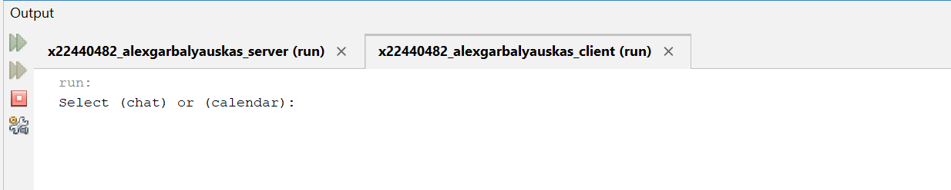

- Chat Selected
User enters their name and messages

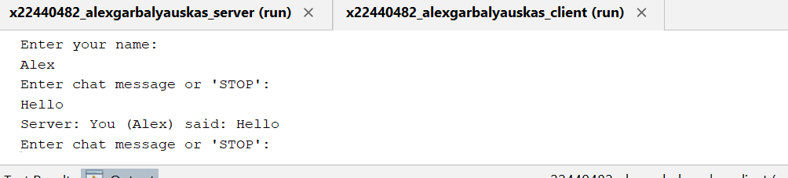

- Server results from chat thread
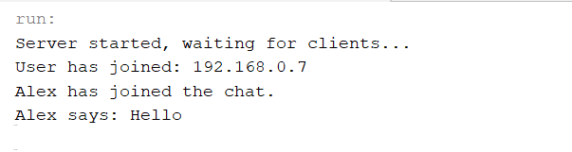

- Exiting from server

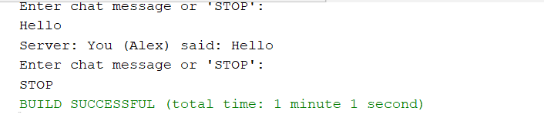

- Calendar is selected
User is able to add and display his events within the list

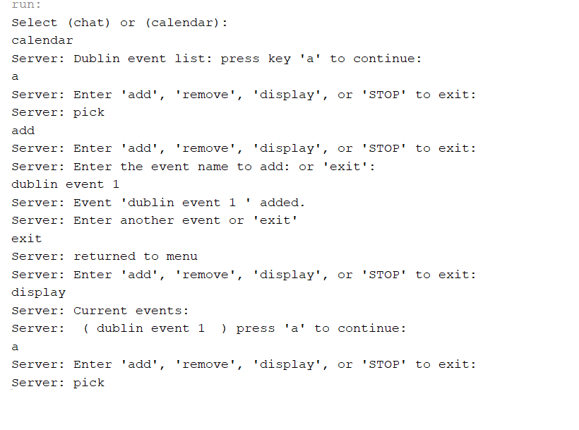
- Server Output

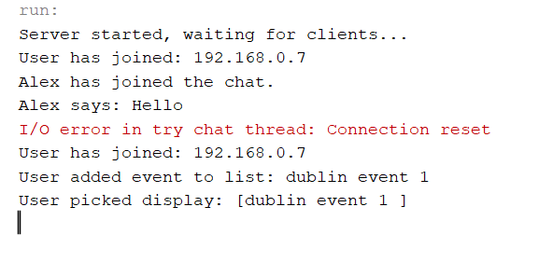

- User removes events from list

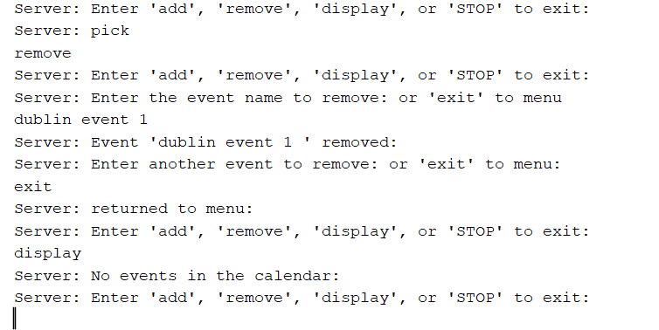

Issues Resolved

1st Issue
- When creating the new mini project, the first issues were to resolve thread linkage, it first began within the server class where it needed to link multiple threads, to resolve this issue I created a selection thread that would be initialized when the user joins the server.

- The selection thread was used to handle user selection as the project required both chat and calendar code implementations to be used which was tricky as how would it be created, for multiple functions so the decision was to separate them into multiple threads that multiple users can select from.

2nd issue
- Exceptions issues, when the project was begun one particular issue, I had with exceptions was the socket exceptions especially when it was initialized at null at the start before being used so that socket exceptions can be handled in the finally catch statements.

3rd issue
- Unorganized output responses from thread classes which was needed to be fixed via synchronization.

4th issue
- Adding and Removing had a logical hole within the code, the major problem was when the user needed to add or remove continuously without it exiting from output and input flow. The solution was to create while loops within these functions so the user would be stuck there able to add or remove as much as he needed before exiting and returning to main selection menu that the calendar thread begins with.

Final Code

- Github
AlexMGarbalyauskas/Java-Client-Server-CA: Java Transmission Control Protocol server project that allows users to chat and adding events via the server

