

ADVANCED PROGRAMMING
National College of Ireland
BSc. in Computing – Year 3 (BSHC3) BSc. in Computing, Evening – Year 3 (BSHCE3)
Dr Abdul Razzaq

Documentation

Student: Alex Garbalyauskas | Number: 22440482

Documentation for Advanced Programming TABA

Introduction
Documentation outlining the Advanced Programming TABA assignment due on January. Part B Practical, 0-4 Online quiz management web service using RESTful API.

How to Use
- Open NetBeans, Open Java package.

- Clean and build.

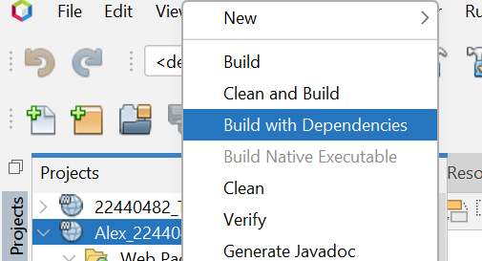

- Run index.html this will bring you to a browser page.

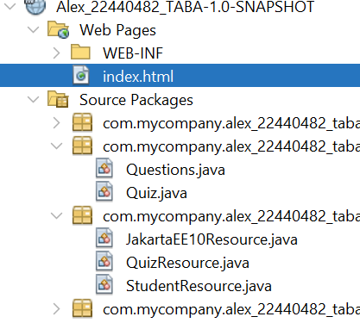

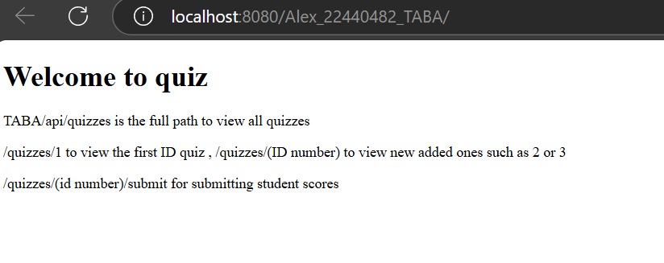
- Enter /api/quizzes to view all quizzes displayed as a JSON.

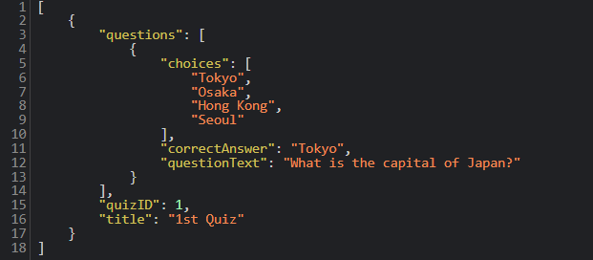

- Open Postman.

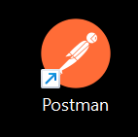

- Create new collection and select, Rest API basics.

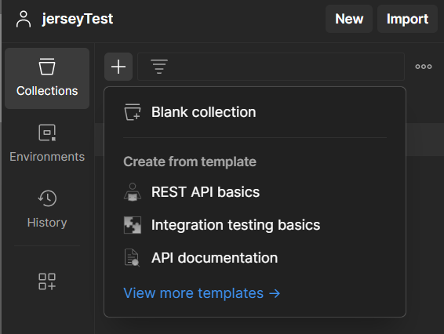
- Select GET method, paste in the URL link from the browser to the GET method and click send. You should receive the JSON quiz result underneath within the body with a 200 OK result.
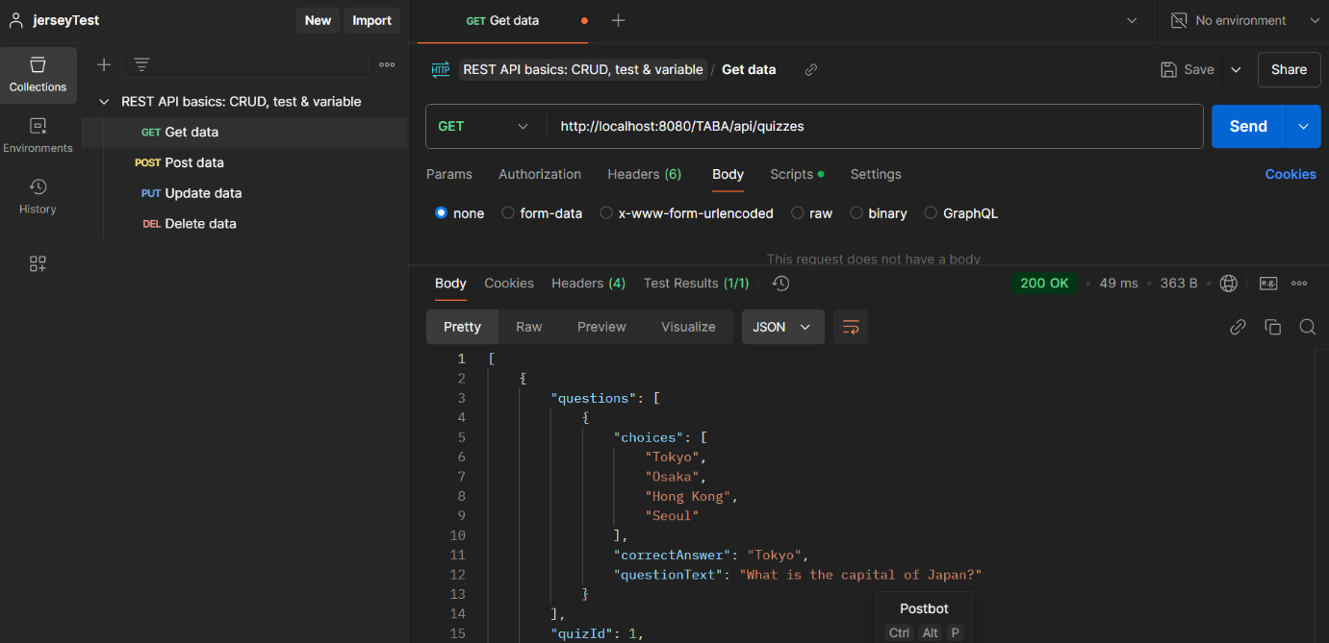

POST

- To test POST, select POST method add in the URL link from the browser. Make sure to include the API key for the teacher in “Headers (6)” as (Key: API-Key, Value: teacher-key), add in your new quiz following the same format, make sure to give it a new ID e.g “2” and click send.

- Utilize a similar example to this format below:

{
"title": "Geography Quiz",
"questions": [
{
"questionText": "What is the largest ocean on Earth?",
"choices": ["Atlantic Ocean", "Indian Ocean", "Pacific Ocean", "Arctic Ocean"],
"correctAnswer": "Pacific Ocean"
},
{
"questionText": "Which country is the largest?",
"choices": ["India", "USA", "China", "Russia"],
"correctAnswer": "Russia"
}
]
}

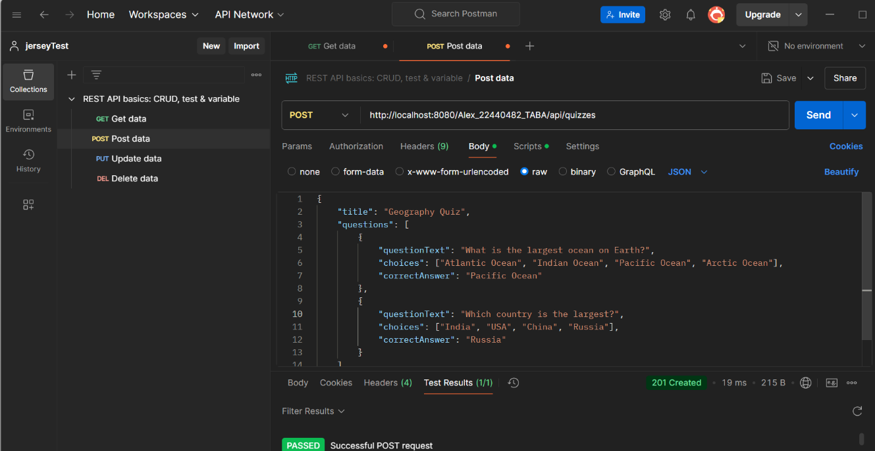

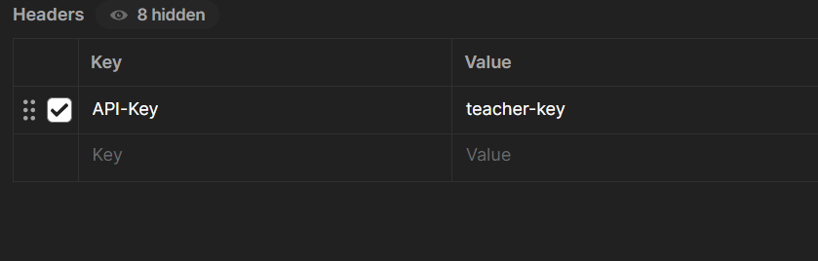

- New posted quiz will appear on the browser.

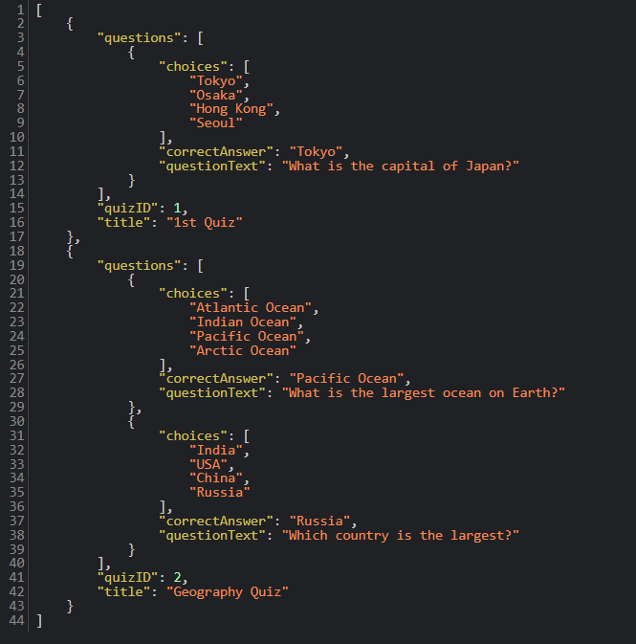

PUT

- To test PUT, select PUT method add in the URL link from the browser but this time after quizzes add /id number to select which one to update. Again, include the teacher API key in headers for it to work.
Utilize a similar example below:
{
"title": "Updated Geography Quiz",
"questions": [
{
"questionText": "What is the largest continent?",
"choices": [
"Africa",
"Asia",
"Europe",
"South America"
],
"correctAnswer": "Asia"
}
]
}

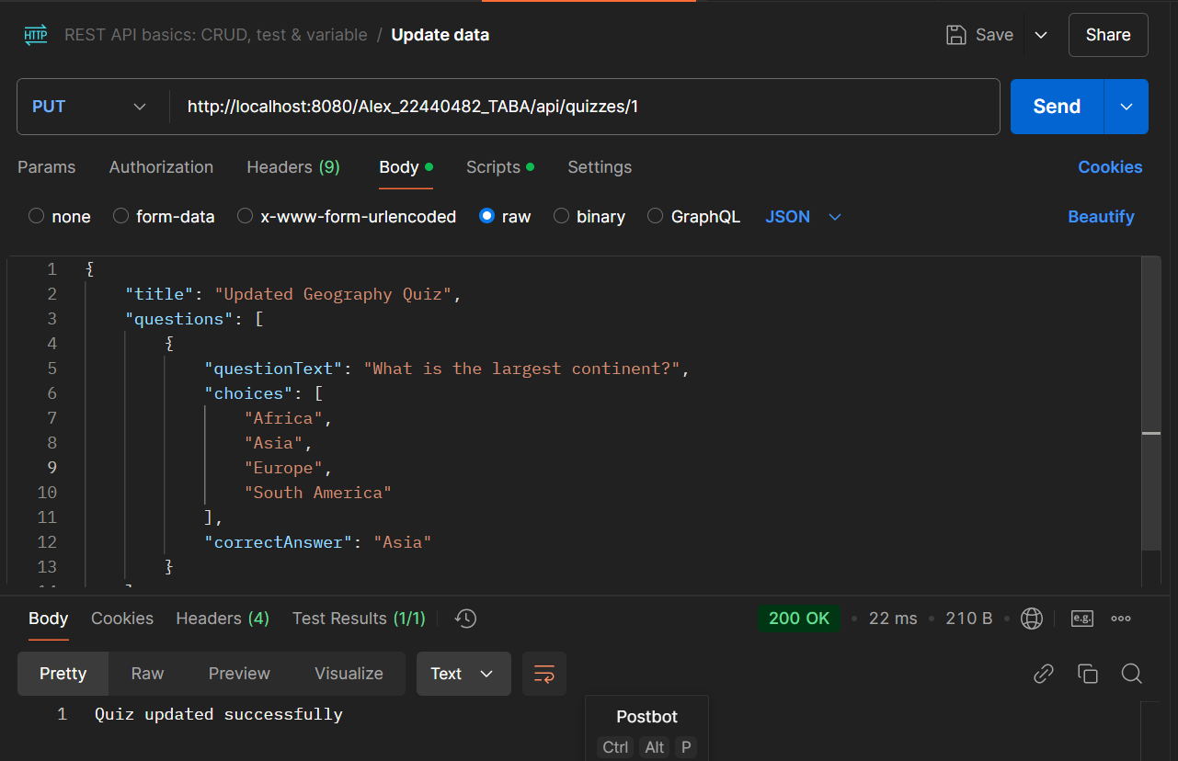

DELETE

- To Delete add in the URL link from the browser, after quizzes add in /(id-number) to select which quiz to delete, add in the API key and click send.
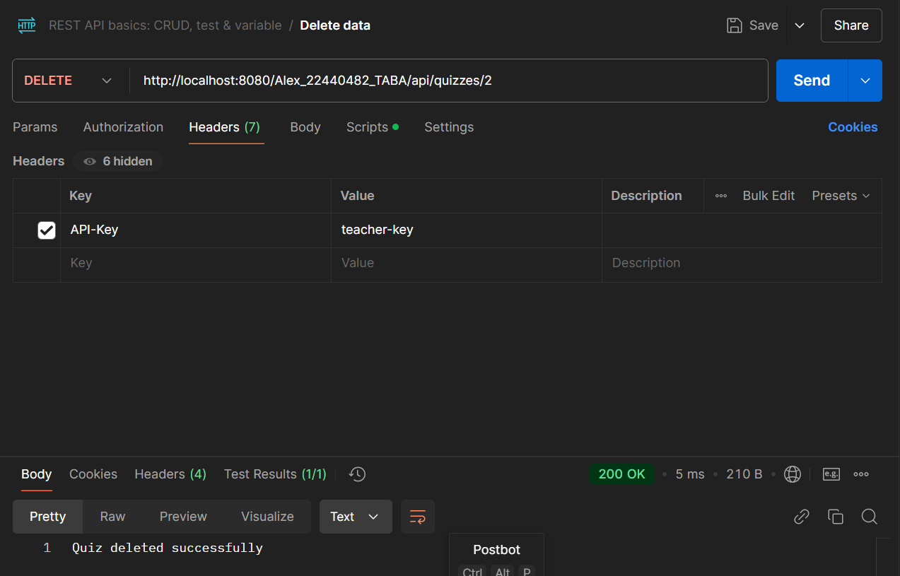

- Quiz will be deleted.

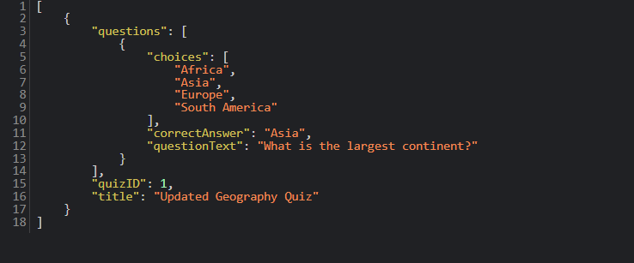

Student Use
- For a student to submit his answers he must also use Postman using this pathway “/quizzes/1/submit” changing ID depending on which quiz they want to use.

- Since the answer is “Tokyo” from the first quiz write down Tokyo inside the body as ( ["Tokyo"]).
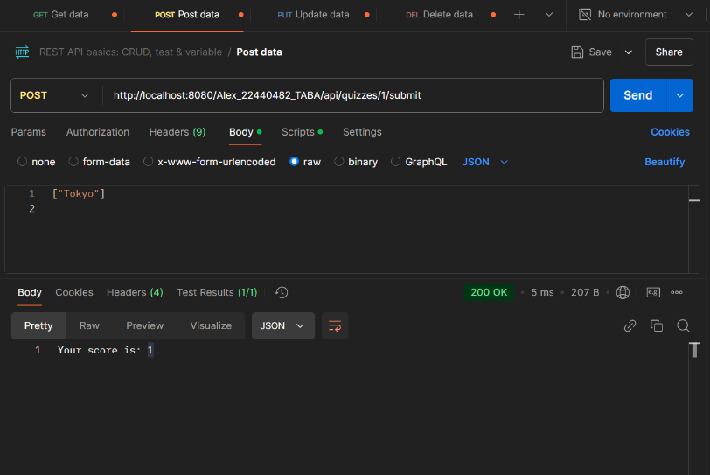
- Within the POST method body type in the answers for the quiz and click send. Afterwards you will receive your results from the quiz.

API Endpoints
HTTP Methods | Endpoint | Description of use
GET | /quizzes | Get all quizzes
GET | /quizzes/(ID number) e.g  /quizzes/1 | Get specific quiz via ID number
POST | /quizzes | Creates new quizes
PUT | /quizzes/(ID number) e.g  Quizzes/1 | Updates a specific quiz via ID, changes previous quizzes
DELETE | /quizzes/(ID number) e.g  /quizzes/1 | Deletes the specific quiz selected via ID from the list

Code
Code outline from each Java package folder.

Web.xml
- Web.xml is used to include the servlet resource and RESTful resource within the Java web services project.
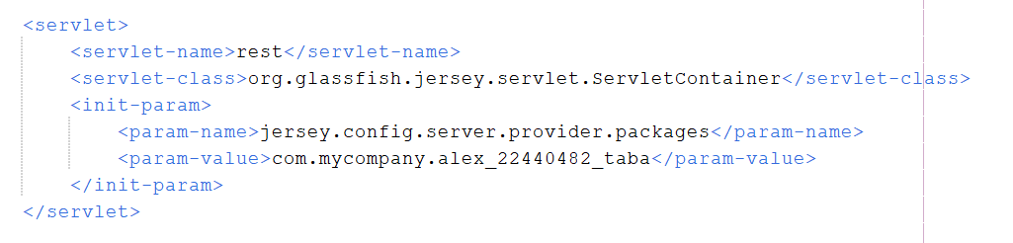
- Servlet mapping includes the pathway slash “api”.
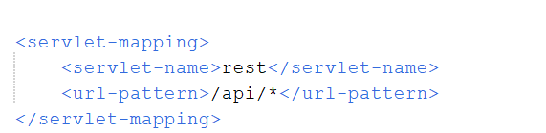

Models
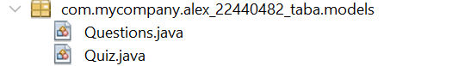
- Quiz Java Class
- Stores the ID number, title of the quiz and the list of questions inside the quiz.

- Question Java Class
- Stores the text questions, the correct answers from the questions, and the list of choices of answers the user can post to find his results.

Resources
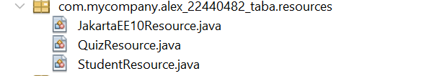
- JakartaEE10Resource
- This resource has the annotation that defines the base URI, when the server receives a request t will route to the correct method.
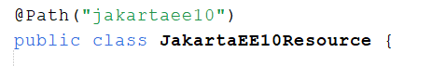
- The ping annotation handles the HTTP requests which helps retrieving information from the server.
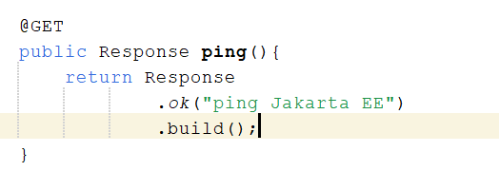
- QuizResource
- Servers as a RESTful endpoint for the API.
- Manages the quizzes POST, PUT and DELETE methods used alongside Postman.
- The Base Path where everything starts.
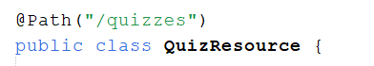
- API key used by the teacher to give them access in posting, updating and deleting quizzes, this increases the security of handling the quiz list.
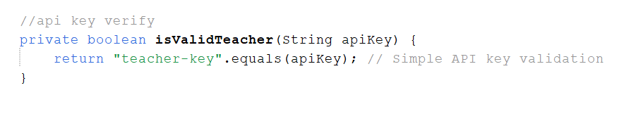
- Getting all the quizzes using the HTTP GET method.
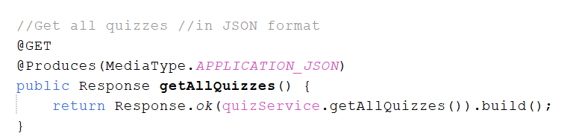
- Getting one quiz from the list via ID number.
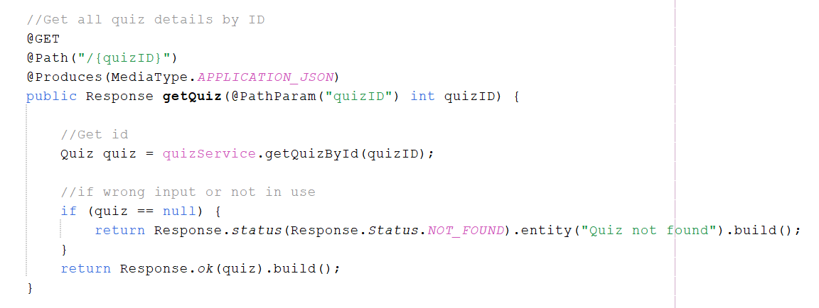
- Creating new quizzes via the POST method.
- Must Have an API key to POST as teachers are only allowed.
- Multiple if statements for error handling.
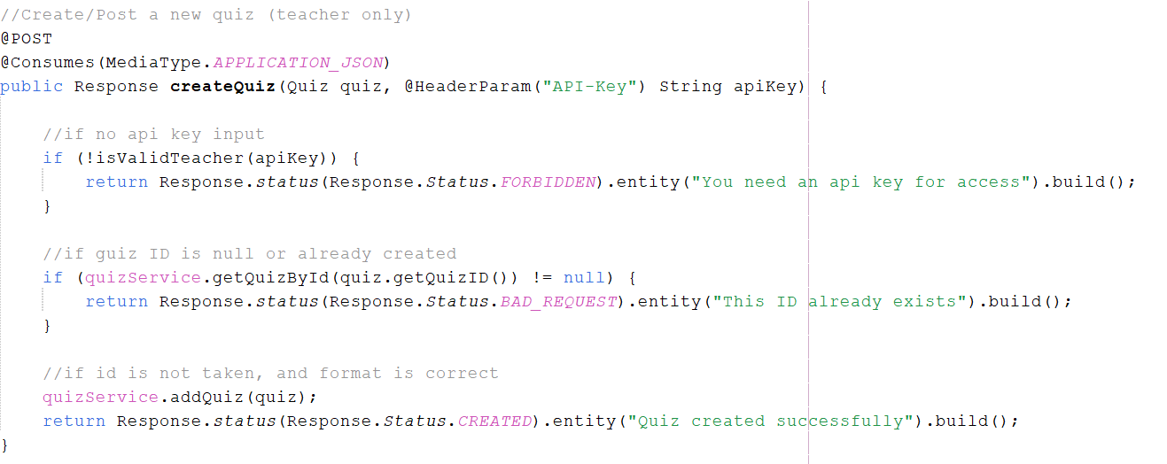
- Updating the list with PUT method.
- Must have an API key.
- Multiple If statements for error handling.
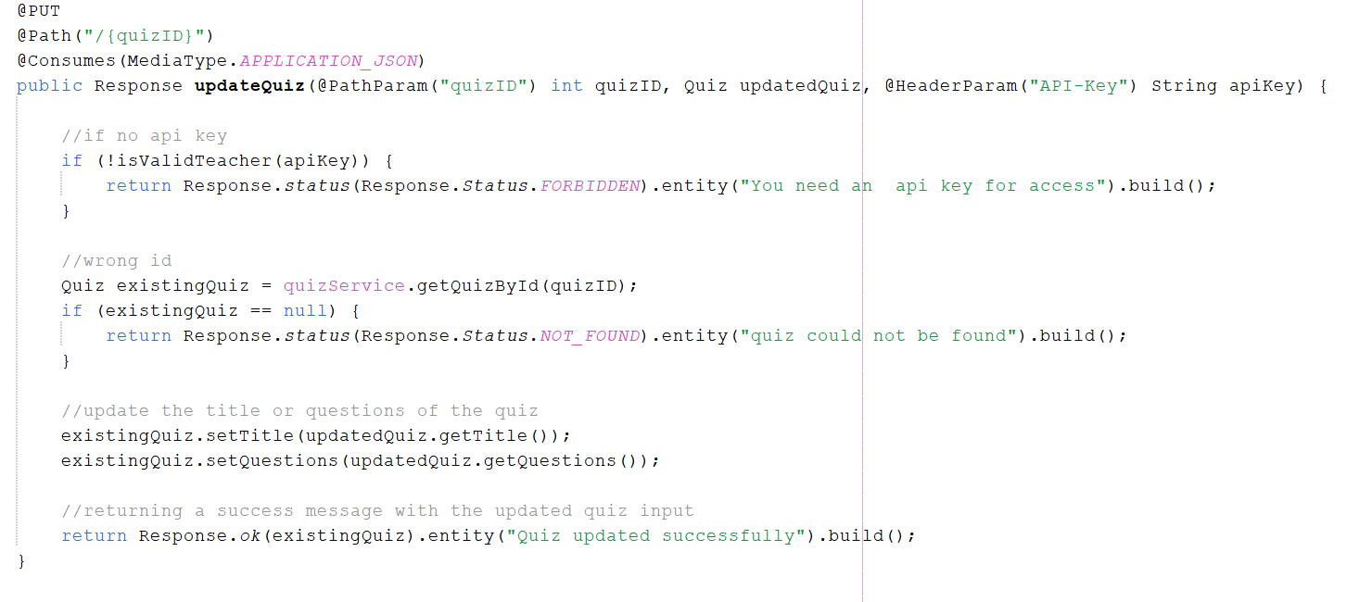
- Deleting the quizzes from the list via the DELETE method.
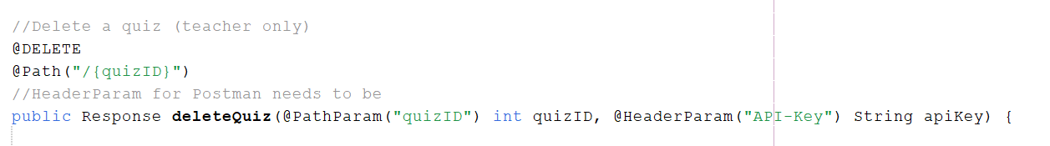
- Student Resource
- Separate Java resource class to handle student answer submissions and score count.
- Student uses POST method to send in his answers using Postman.
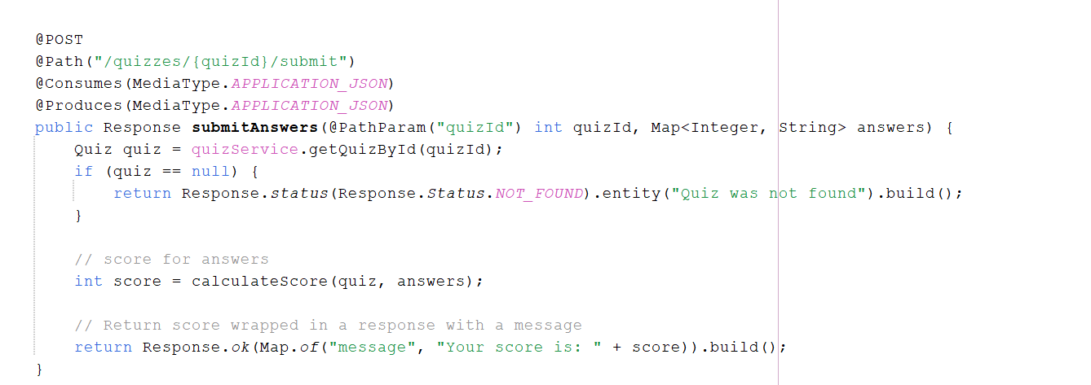
- Score is calculated when submitted.
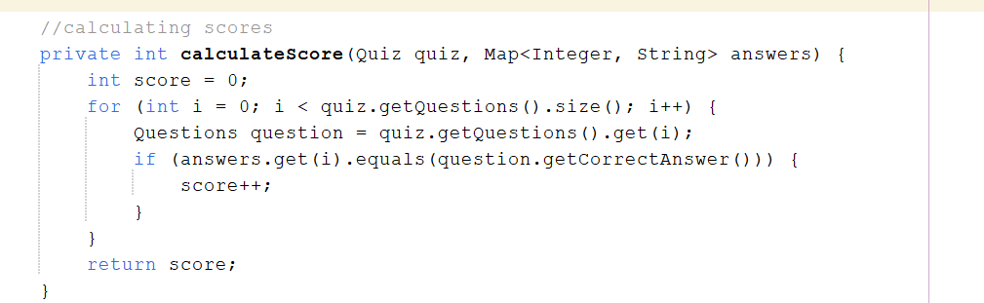

Services
- Quiz Service
- Quiz Service includes an quiz example that teachers can follow to post new quizzes.
- It is linked to the Resource classes for usage.
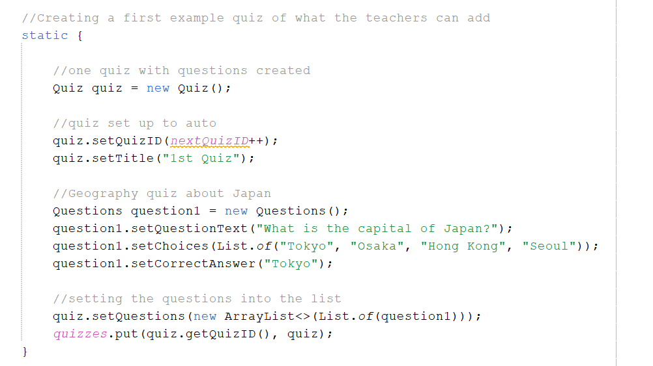
- Likewise, the service class handles the logic of adding, updating and deleting quizzes and questions.
- It uses a map to store the quizzes and remembers it for usage when new quizzes are posted or deleted.
- Quiz management of adding, deleting and updating.
- Score calculation
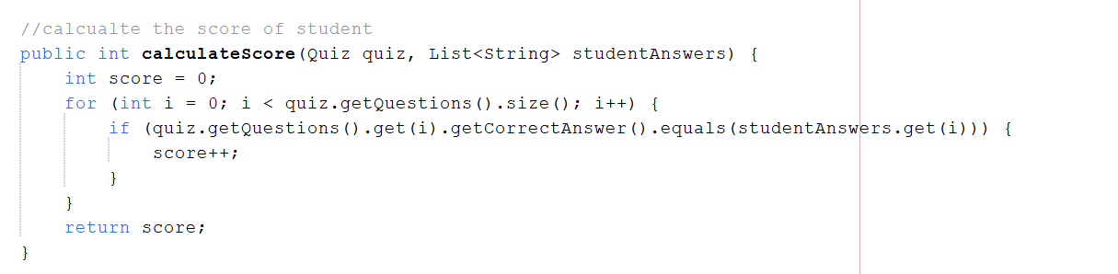

Error Handling

403 Error | 403 Forbidden: API key is invalid or missing.
404 Error | 404 Not Found: Requested quiz does not exist.
400 Error | 400 Bad Request: Request data is malformed.

