Resources for Qt Creator

*Updated for Fall Quarter 2021 by Julie Zelenski, Winter 2022 updates by Neel Kishnani*



Students in the CS106B/courses use **Qt Creator** to write C++ programs. Qt Creator is an *integrated development environment* (IDE) with tools to edit, build, run, and debug programs.

Installing Qt Creator

We have prepared installation guides for each operating system, choose the one for your computer.

* Install [Qt Creator on Mac OS X](https://web.stanford.edu/dept/cs_edu/resources/qt/install-mac)
* Install [Qt Creator on Windows](https://web.stanford.edu/dept/cs_edu/resources/qt/install-windows)
* Install [Qt Creator on Linux](https://web.stanford.edu/dept/cs_edu/resources/qt/install-linux)

This will guide you through downloading and installing Qt and other necessary tools, as well as configuring the CS106-specific package. Please follow the instructions carefully and do not skip steps. In the final step, you will do a build and run cycle on a sample project. If you have successfully done this, your installation is good to go!

If you have a previous version Qt installed

We strongly recommend that you **uninstall any previous version** and make a fresh install following the instructions above. The minimum required version of Qt as of Fall Quarter 2021 is **Qt 6.1.0**.

* To uninstall Qt, run **MaintenanceTool** from your **Qt** folder. Check the box "Uninstall only" on the first pane and follow the instructions.

Using Qt Creator

Here are some guides on using these tools.

* [Quick guide to Qt Creator](https://web.stanford.edu/dept/cs_edu/resources/qt/using-qt)
* This 📦 [blank project](https://web.stanford.edu/dept/cs_edu/resources/qt/BlankProject.zip) is a template for creating a new CS106 project
* [Configuring the Qt debugging helper](https://web.stanford.edu/dept/cs_edu/resources/qt/debugging-helper)
* [Recommended Qt Creator settings](https://web.stanford.edu/dept/cs_edu/resources/qt/recommended-settings)
* [Troubleshooting common Qt Creator project problems](https://web.stanford.edu/dept/cs_edu/resources/qt/troubleshooting)
* [Common build/run/debug issues](https://web.stanford.edu/dept/cs_edu/resources/qt/commonissues.html)
* [Debugger tutorial](https://cs106b.stanford.edu/assignments/0-namehash/DebuggerTutorial.pdf) from CS106B Assignment 0

**以windows为例：**

Install Qt Creator on Windows

<="" style="box-sizing: border-box; position: relative; width: 733.333px; padding-right: 15px; padding-left: 15px; flex: 0 0 83.3333%; max-width: 83.3333%;">

1) Download the Qt installer

Download the Qt installer from its official download site at <https://www.qt.io/download-qt-installer>. The site should detect that your computer is running Windows and recommend "Qt Online Installer for Windows". Click the green **"Download"** button to download the installer.

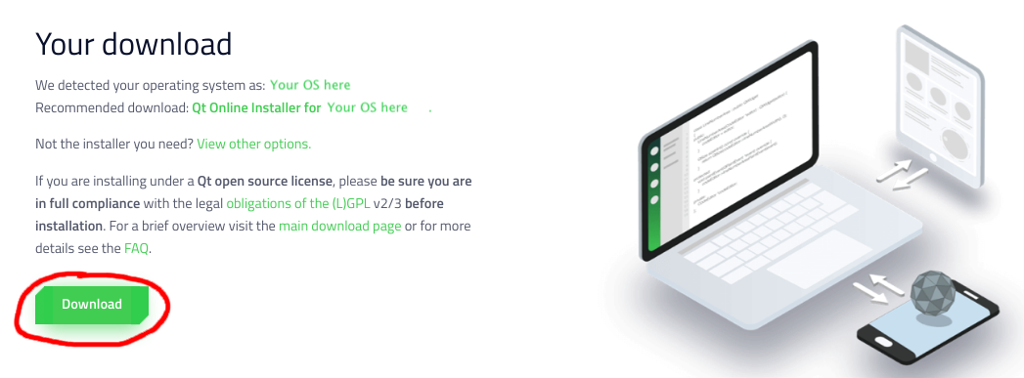

2) Run the Qt installer

The downloaded installer is named something like **qt-unified-windows-version.exe**. Double-click to run it.

The Qt installer will walk you through a set of steps. For most steps, you can use the default settings and simply click **"Next"** or **"Agree"** to move on, with the following exceptions:

* At the **Welcome** step, sign up (or sign in) for your own Qt Account. Go ahead and put in your @stanford.edu email and verify your account via email. When setting up your account, you do not have to put in your phone number or city.
* At the **Installation Folder** step (see screenshot below):
  + Select the option **Qt 6.x for desktop development MinGW toolchain and Qt libraries for MinGW**. Do not change the name or location of the directory where Qt will be installed.

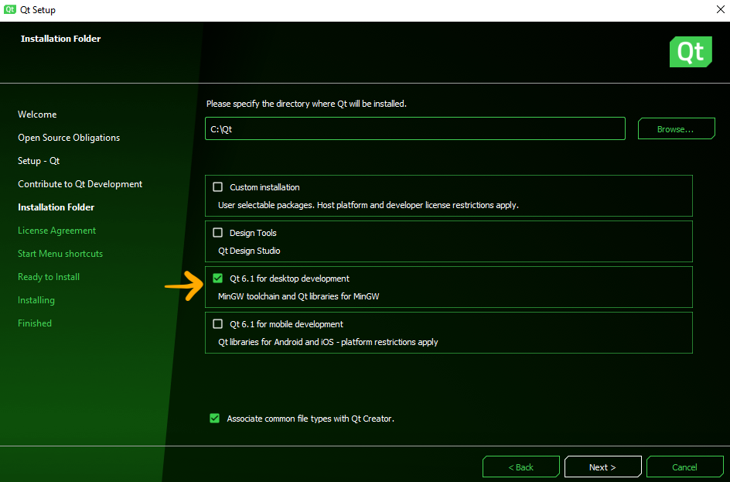

If you don't see **Qt 6.x for desktop development** as an option, click **Custom installation** and then proceed to the next window via "Next." **When you're asked to "Select components" please only click MinGW 9.0.0 64-bit under Qt -> Qt6.2.2**. Once again, you'll click **Qt** and then under **Qt 6.2.2** you'll check the box for **MinGW 9.0.0 64-bit**.

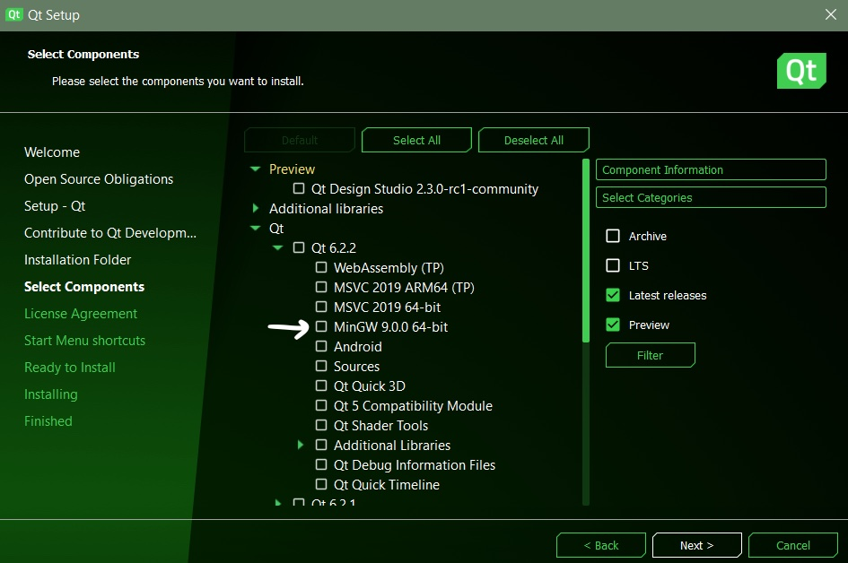

3) Install CS106-specific package

After installing Qt, you must **install the CS106-specific package** and do a **complete build and run cycle** to confirm all is working properly.

Download CS106 package and extract

* Download this archive file: 📦 [CS106.zip](https://web.stanford.edu/dept/cs_edu/resources/qt/CS106.zip)
* Un-zip the download contents (on a Windows computer, click "Extract all") to a location of your choice. You should have a folder named **CS106** with several files and folders inside.

Open and configure CS106 project

A Qt Creator project includes a file named with a **.pro** extension. Double-clicking the **.pro** file opens the project in Qt Creator. When opening a project for the first time, Qt Creator will ask you to configure the project build kit.

* Find the **CS106.pro** file and open it now.
  + If your Windows File Explorer options are set to hide filename extensions, the file **CS106.pro** will display the name **CS106**. You can change whether extensions are displayed in File Explorer by choosing menu item File->Options, select the "View" tab and under “Advanced settings”, uncheck "Hide extensions for known file types". Click "Apply" button.
* The "Configure Project" panel will show the list of available build kits (see screenshot below). The default kit should already be selected; it will match the desktop kit you selected when installing Qt Creator (version **Qt 6.x.x**).
* Accept the default by clicking the "Configure Project" button.

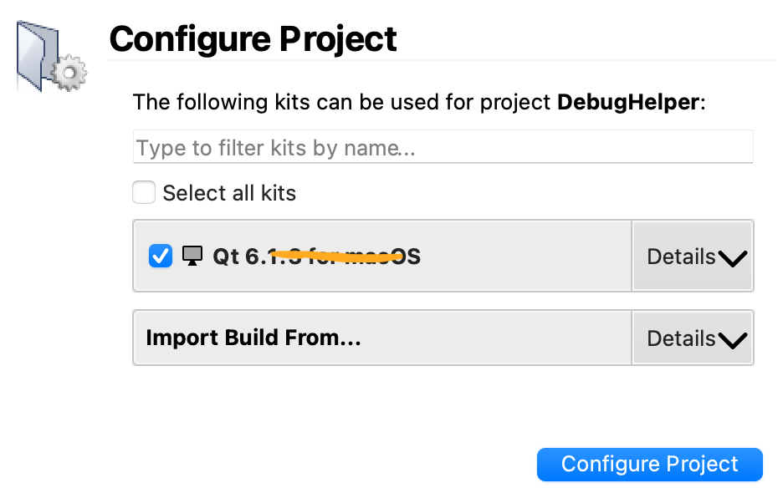

If your Qt Creator shows no kits are available, review the [Qt install instructions](https://web.stanford.edu/dept/cs_edu/resources/qt/index.html). You can repeat the steps to re-install Qt if you missed selecting the correct option.

Build the program

C++ code must be *compiled* or *built* before it is run; this means converting the source code into executable binary code.

* Click the Build icon hammer icon in the lower-left of the Qt Creator window.
* Watch the build progress meter build progress meter in the lower-right. The first time you build a project, it can take a minute or more to compile the library code. When the bar turns green, it indicates the program successfully built.

Run the program

Now that the program is built, you are ready to run it.

* Click the Play/Run icon run icon in lower-left of window.
* As shown in the screenshot below, the welcome program prints a message to the console window and draws the Stanford logo on graphics window.



✔️ Congratulations, **your installation is good to go**! You may now discard the CS106 project, you will not need it again.

4) Configure settings (optional)

For a better experience, we suggest changing some of the default settings, see our [recommended configuration settings](https://web.stanford.edu/dept/cs_edu/resources/qt/recommended-settings).