MySQL Database as the back-end
Use some sort of framework for the UI – Maybe Java FX?
Definitely a flat structure, don’t make the buttons look like physical buttons

MyRecipes
An application that allows you to organise and store your recipes. The fundamental way of doing this is through adding tags to recipes such as “Vegetarian” and “Store cupboard ingredients” and being able to search through these different tags as well as being able to create playlists of your own specially chosen recipes.
A Spotify for recipes.
Its mainly for organising your own recipes. Its basically a base away from all of the clutter and attention grabbing of the internet. Basically taking a physical recipe book and making it digital.

Requirements (these will be taken on and refined later)
- Using the UI be able to perform CRUD operations on the underlying database for both tags and recipes
- Be able to tag recipes with multiple different tags
  - Able to create new tags and delete old tags
  - Recipes can be tagged with as many or as little tags as needed
  - Create a new tag while adding a new Recipe
- Able to create backups that are stored in JSON
- Able to search through the database
  - Filter recipes based on tags or multiple tags
  - Filter by name
  - Set filter for a certain time limit or cost for cooking and it’ll include all all the ones below that time/cost
- Double click on an entry to open it up in its native application

Non-Functional Requirements
- Able to use the application offline
- Edit documents in their native application (so I don’t have to create my own word processor etc)
- Ability to handle multiple recipe formats like PDF, odt, doc, html.

Far Away Requirements
- Able to add recipes from online sources (its converted from a webpage into an entry into MyRecipes seamlessly)
- Android app
- Cloud based (using google drive or some other cloud so I don’t have to do it myself) so that it can be updated and accessed by multiple devices
- Ability to share recipes / your whole recipe collection with people

Database Columns (mainly tags)
- Cost - £ (cheap) → ££££ (very expensive)
- Time (in minutes)
- Cuisine TODO
- Vegetarian/Vegan/Meat
- Freezable
- Store cupboard
- Healthy/Unhealthy/Normal
- Breakfast/Lunch/Dinner/Snack/Starter/Main/Smoothie/Cocktail/Tea etc
- Soup
- Stew
- Bread
- Staple – Potato/Rice/Pasta/Noodles
- Ingredients – TODO
- Work In Progress
- Standard Recipes
- Unique Recipe ID
- Link to the location of recipe in OS (so that when you click on it it goes there)
- User created by ID

Design

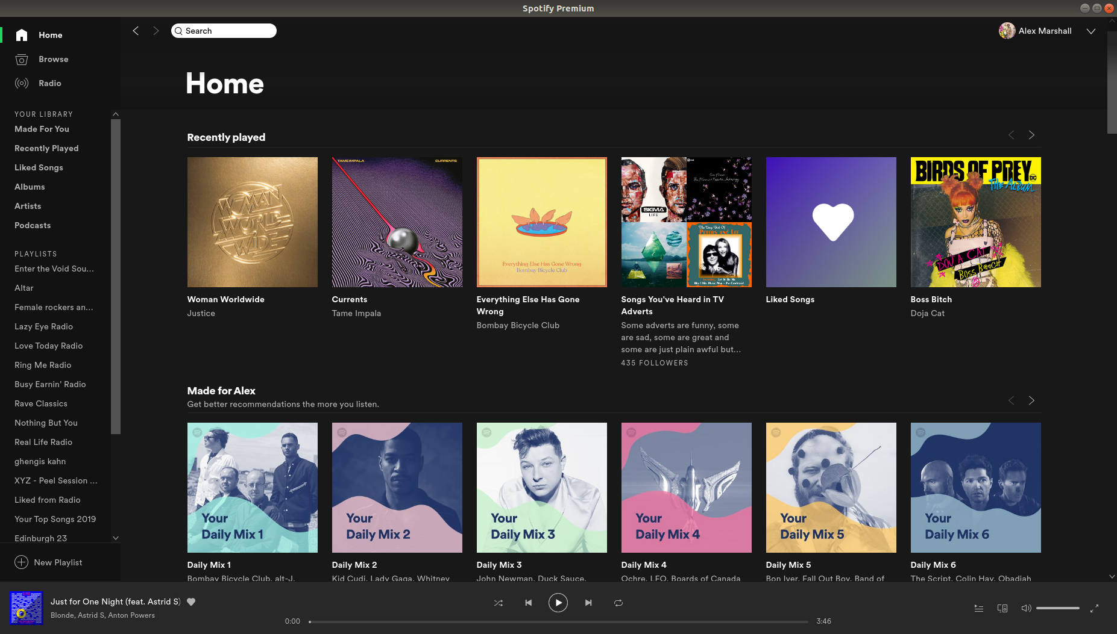Create an App that looks like this
“Home” contains recently accessed recipes, playlist and searches.
On the left hand side you’ve got a list of your playlists along with a list of your saved searches as well as recent searches.
You should be able to open multiple tabs containing your searches and playlists where the home screen is and also be able to have both tabs visible and be able to drag and drop recipes over to different sides.
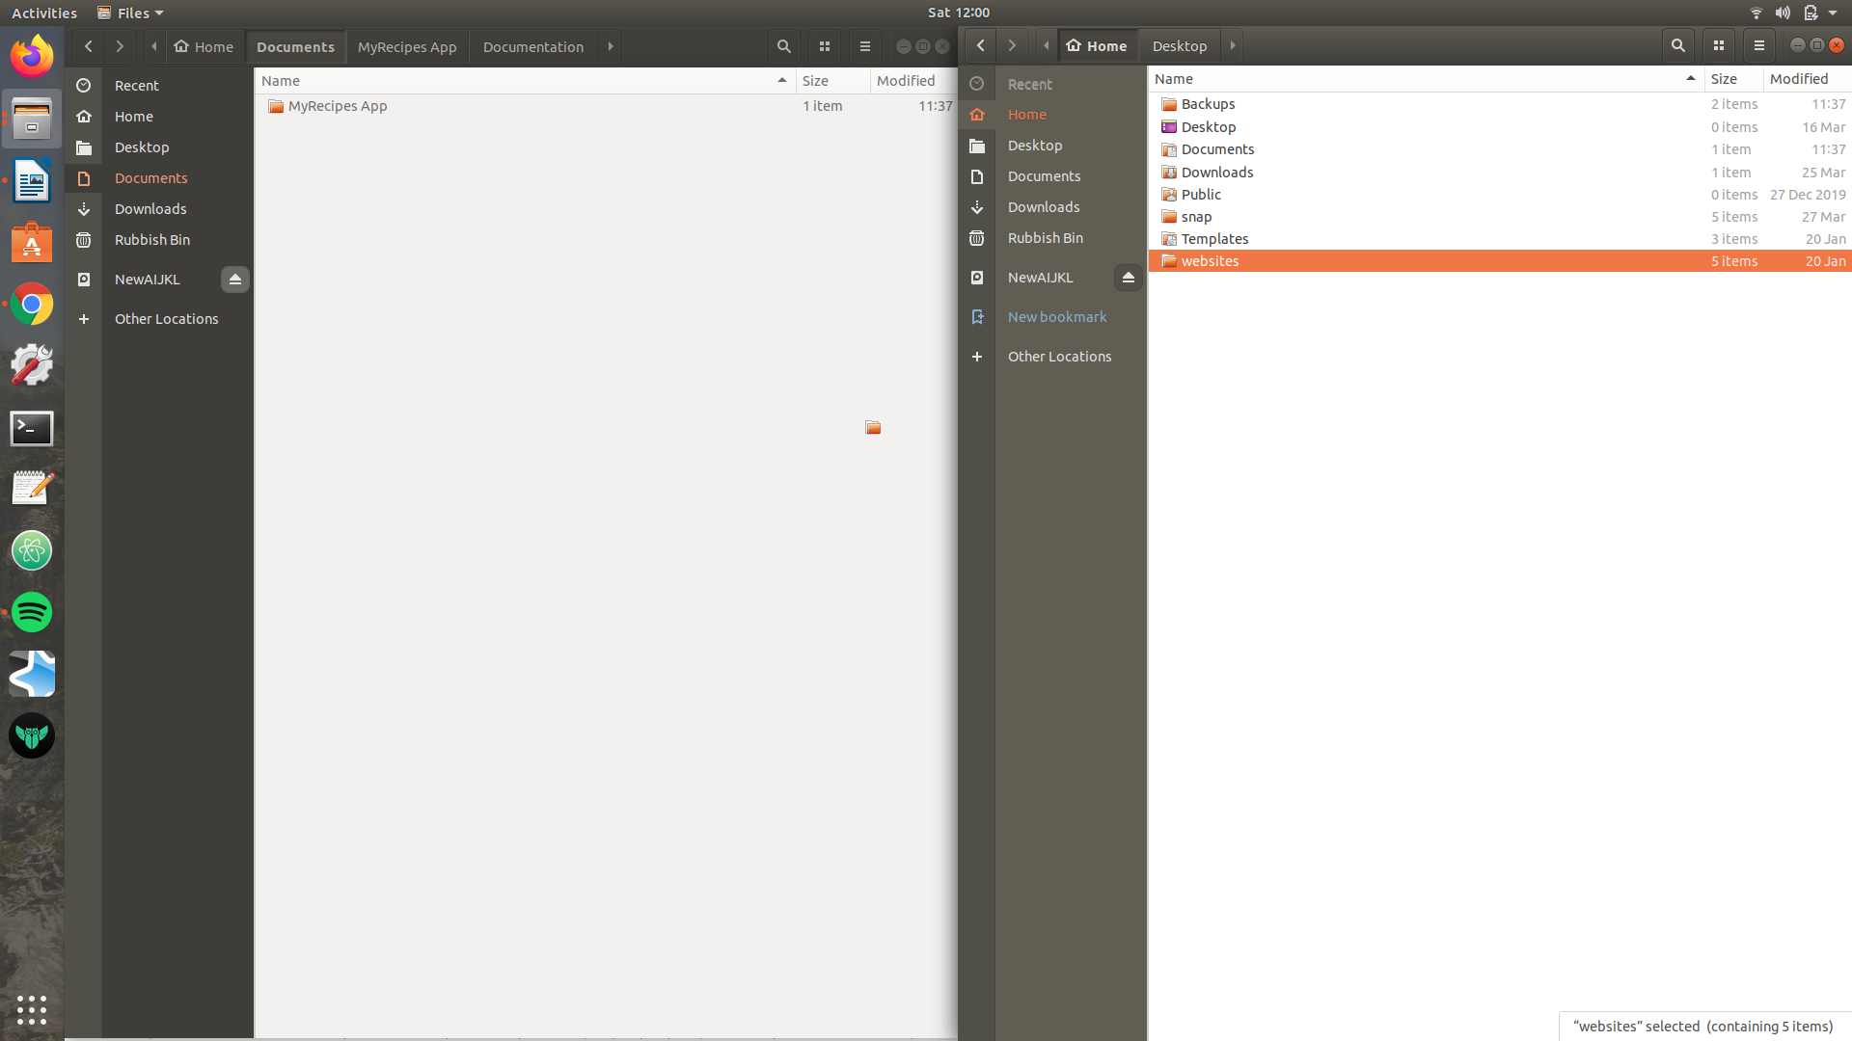Illustration 1: Demonstrating the style of Nautilus File Manager that I can to emulate in the App

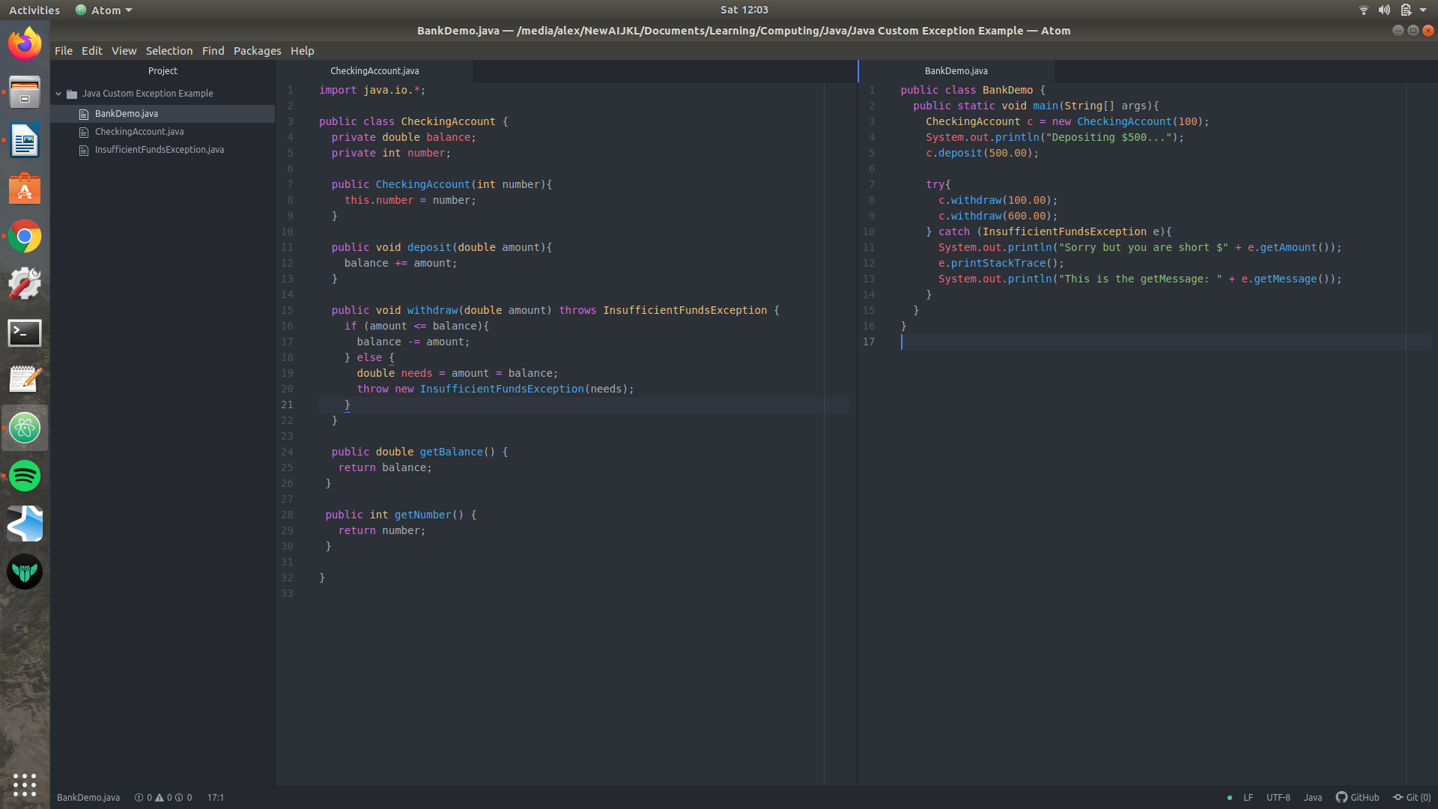Illustration 2: Demonstrating two tabs being open in the same screen

