How to properly calibrate the

PS VR Headset

1-The device.

PS VR Headset is a very well designed piece of hardware, it has it’s flaws, but mostly on the software side, the device’s capabilities are equivalent to the Oculus Rift DK2 in resolution terms but with better lenses, better sensors and better screen.

But as we can see there’s people who still have problems with the device tracking, so, if the device is well designed and manufactured, why people has those problems? Shouldn’t be this a perfectly pleaseant experience?

2-The problem.

Well, Sony had to do some compromises to keep the device as cheap as possible, and one of those is using the PS camera to do the tracking. Other headsets use infrared or laser tracking with two to four receivers, that creates a perfectly controlled area where the device is completely tracked. PS VR uses only one camera, so the data from the camera must be very well calibrated to do a decent tracking. You can argue the camera has two sensors, and it’s true, but with two parallell sensors you can only gain the depth perception, and the perfect scenario should be to achieve triangulation, but for that at least three sensors distributed in a triangle pattern are needed.

Ok, now it doesn’t sounds very good, but Sony did an excellent job combining the info from the accelerometer on the headset with the camera info and got a very good tracking system with only those.

But if the system is so good, why a lot of people suffer of wobbling or even incorrect displacement? (have you felt like if you move to your front the view gets displaced to one side or other? That’s what we’re talking about)

So, why the problems then? Where is the fail?

It can seem a bit ridiculous, but the flawed part in all this system is so basic as the calibration. Yes, you remember when you calibrated your HMD’s lights and the console guides you placing the device in front of the camera in certain positions? That’s the big problem, we as humans that we are can’t controll perfectly the device’s position, we do our best to fit the lights in the screen as they are indicated, but even if we match the light positions the HMD will not have the right orientation and all the process will be messed up.

What I’m going to explain here hope helps you to get a wobbling-less tracking with perfect orientation.

3-The theory.

If you don’t care what is happening and why this can solve it skip this point, but as I always want to understand things I like to explain to others so they can also understand (and yes, I don’t like magic, gimme the explanation, not illusions XD).

First, you must understand your PS4 is like a blind and senseless man, it can’t feel gravity, doesn’t knows where it is and can’t see anything, resuming, it has no idea about the world surrounding it. Now, think you are your PS4, and suddenly you have eyes (the camera) but still have no way to understand what is up, down, left or right as you can’t know how the camera is placed. So the first, you would assume that your eyes are placed in a concrete way that the beginning of the image is the top, the end is the bottom, the camera is looking straight forward and so on. But that’s just an assumption, later we will see the consecuences of this.

Next imagine that you don’t get your equilibrium sense, but you can feel other’s equlibrium… yes, that sounds crazy, but that’s what your PS4 knows, not it’s position nor the camera’s one, but the HMD’s one, and not the full orientation, just the gravity vector.

So, what can you do now with that info? You know the gravity vector and can see the other person, but you still don’t know how that person is placed, so there’s not much you can do… or not? What if that person tells you “Hey!, I’m looking at you perfectly straight!”, then he turns around and tells you “Hey!, mi looking to your left side perfectly straight!”, and so on until you have how that person looks on it’s four sides? Wow! Now you can know exactly where that person is placed and which orientation has! You can interpolate the four views to understand the rotation of the person, you can use the gravity vector to know where is up and down, and you can even know at which distance is placed as you have two eyes and you can caltulate the depth.

Ok, let’s stop imagining things and let’s go to the reality, that what I described is the calibration process for your HMD from the perspective of your PS4. So, if you have paid attention you now know what will happen if the calibration is not well done, your PS4 can’t know exactly where you are or where you are looking at, and also you can understand that each phase of the calibration must be as exact as possible because the process assumes concrete and perfect places, and that’s what screws everything.

If you have experienced wobbling per example, that happens because the picture taken from your HMD and the gravity vector doesn’t match, suppose the camera sees a bit of the lateral lights of the HMD amd you have placed a bit inclined the HMD in your head pointing to the ground, your PS4 can’t find a perfect match between what is seeing and what the sensors are telling it, it tries to approximate to the best placement, but as there’s none it keeps trying and trying, that is one of the sources of wobbling, there are others but I will not cover those in this document.

Other common experience is to have wrong displacement, if you move your head back and forth and you notice the image on the HMD also displaces to the left or right is obvious after understanding the calibration process that happens because the image taken of the front of your HMD wasn’t perfectly parallel to the camera or the placement of the HMD wasn’t correct when the back of the HMD was measured (when you do the back side of the HMD you will notice that the HMD will not be “flat” but you must incline it to match the lights, that’s the way the calibration process detects exactly where the up and front axis is, but this also can introduce a ton of errors if it’s not correctly done).

4-The solution.

So, the solution is “simple”, do a perfect calibration. I’m going to explain how exactly I do the calibration of the headset, but if you understand the principle you can do it as you please with the materials you have.

To do the correct calibration you will need:

1-Perfectly flat and stable surface with an extent of at least 1.5 meters, a table is the perfect tool.

2-A support for your PS VR, the head-like ones. If you don’t have one an EPS (expanded polystyrene) manequinn head is also very good (and cheap, 3-4$), that’s what I use.

3-Camera tripod, or in it’s deffect some stable and regulable support for the PS camera, I used two boxes, but being very careful to get those flat to the table and without any wobbling.

Ok, so, the first is to place correctly the headset on the support. Having the support placed on the table you must get the X axis to be completely parallel to the table. Consider the X axis as the imaginary line going from the middle of the side light on the frontal piece of the headset to the center of the front face. Also the Z axis must be parallel, consider the Z axis as the line going from one of the lateral lights to it’s opposite on the other side.

Now you must place the camera, you need to do the same considerations, X and Z axis must be parallel to the ground.

If you did it right and face the camera to the HMD the front face of the HMD and the front face of the camera must be completelly parallel.

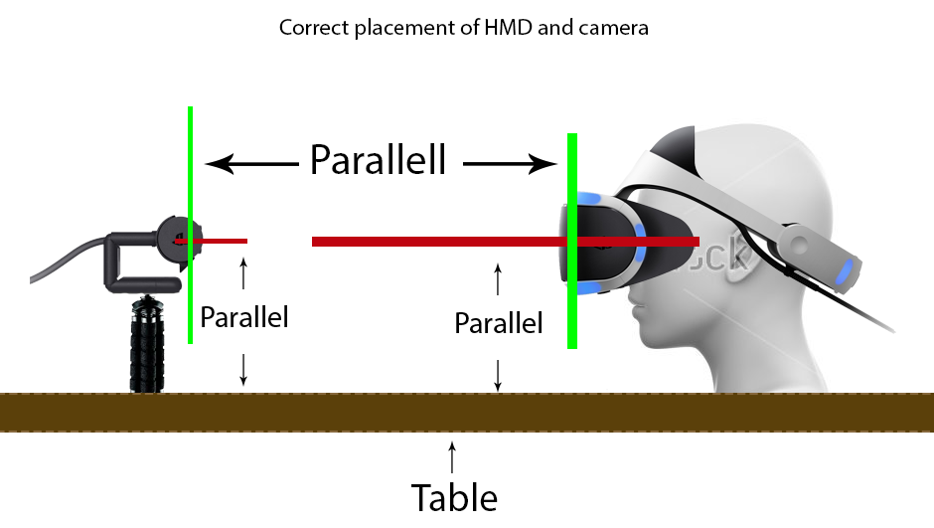Now that you have placed both devices correctly you can start the process. Don’t think it will be done in just a pass, you will need to do it multiples until the height of the camera and the distance between the HMD and the camera is the correct one.

Start the calibration process, but don’t let the camera see the fontal/central LED to be seen, you can place a sticker, that will allow you to move the camera until you get the perfect placement. First the system calibrates the top and center leds, move the HMD until the top lights match horizontally with the led’s shown in the screen. Once it’s centered remove the sticker, if you see that adjusting the height of the camera will leave the center led outside the picture (higher or lower) move forward or backward the HMD until it will match. Once it matches adjust the height until all three leds are recognized and the system proceeds to the next step.

On the second step the system will calibrate the central and bottom lights, this step must perfectly match WITHOUT any intervention, if you need to move the headset or camera to fit, you need to restart the process, you will know when you have the perfect height and orientation when the first and second steps complete without interacting at all with the camera or the HMD. If you need to move the HMD I recommend that you hide one of the led’s to avoid the process to continue until you have placed the HMD in the desired position.

Next are the side leds, for those you must rotate carefully the HMD 90º around it’s center, try to keep the center as static as possible and match the 90º (a quarter of turn) as you need to preserve the distances and angles to do a correct calibration. If you must move the HMD to get the lights match, then like on step 2 you must restart the process, when you get the correct placement, if you rotate the headset the process will pass to the next step without displacing the HMD, just rotating it 90º. Also, try to match as nearly as possible the HMD picture, not only the lights, it will not match perfectly as the support ring will have a different size depending on the head/support size.

After this, the process will ask you to calibrate the rear lights, this part is messy because you need to incline the HMD and keep the ring that holds the HMD to the head flat to the ground, this step is very important as it determines the front and up vectors, the ones used to compute your orientation.  
In this step you will not restart the calibration as you must move the HMD and there’s no perfect way of doing it unless you construct a very complex mechanism :(

Finally the system will calibrate the other side, place the HMD where it originally was, rotate it -90º and calibrate. If you feel you didn’t placed it as it was, restart the process again.

Well, if everything worked you now have a perfectly calibrated device, you can set your camera where you usually place it to play and start using the HMD.

What you have achieved following those steps is to teach the system how the HMD lights look on all it’s sides when they are looking front, back, left and right, so it can interpolate those images and with that interpolation it can match your position. Also you have teached your sistem where is the front vector, the up vector and the gravity vector, these will give the system a precise orientation status, which combined with the position info yields a very good tracking (the underlying process is a lot more complex as it crosses the image data and the accelerometer data, but you get a good idea about how approximately it works).

5-Conclusion.

As you can see the process is not fast nor as easy as Sony wants to make it to seem, there are a ton of flaws on the process as it uses you, the user, as a tool, and we, humans, introduce always a ton of errors in a precisse task like this.

First of all I can’t explain why Sony decided to split the front calibration in two phases, they should aglomerate it in only one, that would remove a lot of the problems as you will need to match the 5 front leds at once and that gives a better calibration of the front face and gravity vector.

And second, I don’t know why they don’t explain this process as detailed as I did here, I’m sure that Sony knew that this process will have problems as nobody -if its not told- will take those considerations to do the calibration.

Hope this info helps you, if you have any update to the process, find a better way to do it, have any info or any doubt you can post a message on my PS VR repository issues and I will try to help you.

The source repository of this document is found at <https://github.com/gusmanb/PSVRFramework>

© 2017, El Dr. Gusman.