Zombie Carnival

|  |  |  |  |
| --- | --- | --- | --- |
| version | name | Changes made | date |
| V 00.1 | Alex | Created document, added to list of ideas. | 19/08/2019 |
|  | Steven | Added to list of ideas. | 19/08/2019 |
|  | Leanne | Added to list of ideas, game flow. | 19/08/2019 |
| V 00.2 | Leanne | Added summary, mood board, assets, UI and HUD | 03/09/2019 |
| V 00.3 | Steven | Added 2 more reference, added ‘2018.3.8f1’ next to the word version. . | 04/09/2019 |
| V 00.4 | Leanne | Added platforms, other software, specifications (VR), constraints,  Input (VR)(PC) , Installer, Deployment Methods. | 10/09/2019 |
|  | Steven | Added specification (PC) | 10/09/2019 |
| V 00.5 | Leanne | Added team logo and formatted document | 10/09/2019 |

# Summary

Zombie Carnival is a First-person shooter, in which the players will need to kill zombies with in an allocated time. Humble studios will be aiming for a low-poly and “cartoony” aesthetic this also applies to gameplay.

# Mood Board

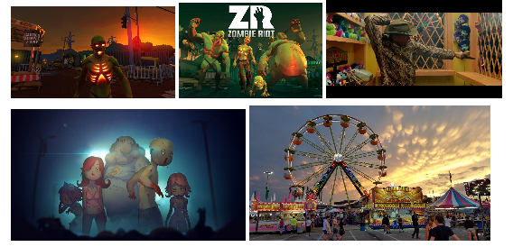

# Language

Humble Studios will be using C# throughout the project. Humble Studios will be using the Unity engine, specifically (version: 2018.3.8f1).

For the installer and uninstaller, we Humble studios will be using Inno Setup. <http://www.jrsoftware.org/isinfo.php>

# Platforms

Humble Studios will be developing this game on two platforms one being on an Oculus Go (VR / Virtual Reality) and PC.

# Deployment Methods

Humble studios would use Steam to deploy Zombie Carnival. To do this we would need to follow the guidelines set out by Steam.

<https://partner.steamgames.com/steamdirect>

# Other software or libraries

* Draw.io (Flow charts)
* Unity asset store (3D models and sound)
* Maya (3D modeling program)
* Gimp (Art program)

# Assets

## 3D assets

* Gun
* Zombies
* Ammo
* Bullets
* Tents (back ground)
* Teddy bear (prizes)

# Game flow

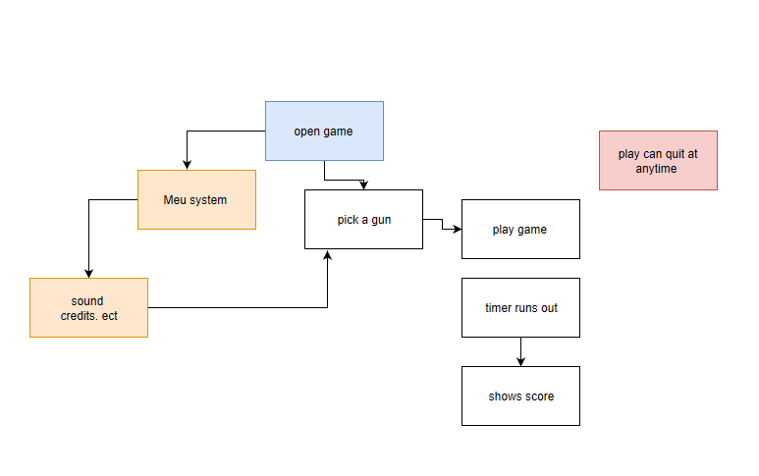

# Specifications

|  |  |
| --- | --- |
| Oculus GO  <https://en.wikipedia.org/wiki/Oculus_Go> | PC |
| Display: 1208 * 1440(per eye) | Display: 1920 * 1080 |
| Memory: 3GB | Memory: 32.0GB |
| Graphics: Adreno  <https://en.wikipedia.org/wiki/Adreno> | Graphics card: NVIDIA GeForce GTX 960  <https://www.geforce.com/hardware/desktop-gpus/geforce-gtx-960/specifications> |

# Constraints

Zombie Carnival will not be able to play the same on the Oculus Go and PC therefore we will have a few constraints between the two platforms.

|  |  |  |  |
| --- | --- | --- | --- |
| Oculus Go (VR) | Possible Solutions | PC | Possible Solutions |
| The Oculus Go only tracks rotation but not position. | The solution would be to make the gameplay not have to track the position of the gun(controller). | The PC is much more powerful than the Oculus Go. so, we can’t have anything to expensive | Bullets will need to have an object pool and we will need to make sure that everything is optimized to the best of our ability. |
| The Oculus Go only has a limited amount of buttons which can mean a limited amount of things the player can do. | The solution would be to have gameplay that only needs a few inputs. | The PC has a wider variety of buttons but to make the gameplay similar is the challenge. | The solution would be to use a similar number of buttons with a similar input. |

# User interface and Heads up display

## Home screen

* Play button
* Instruction button
* Exit button

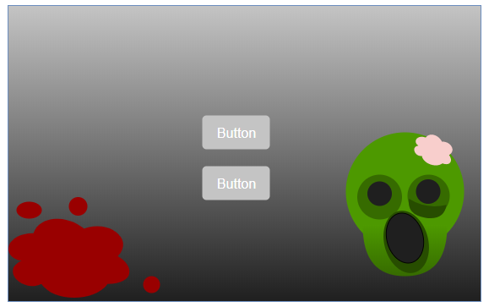

## Instruction screen

* Description of how to play
* Back button
* Exit button

## Game play

* Timer
* Ammo
* Zombies
* A gun
* lives/health

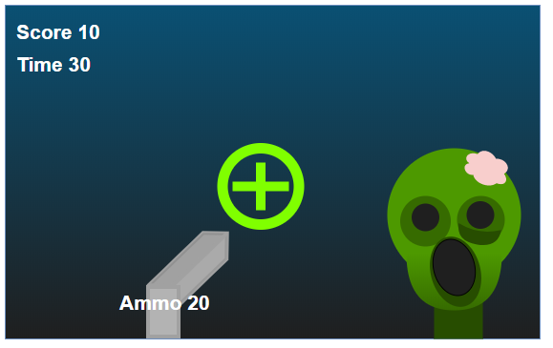

## End game screen

* Score
* Play again button
* Exit button

# Input

## Oculus Go

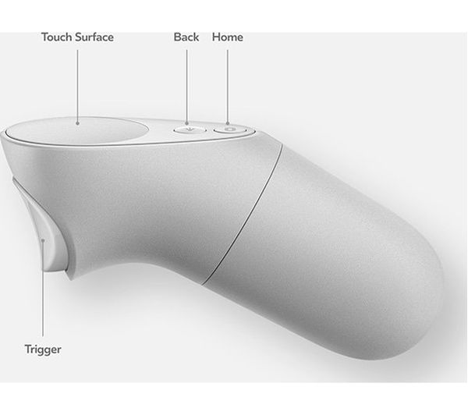

* Trigger will be used to shoot
* Touch surface will be used to move

## PC

* Left mouse button used to shoot and to select buttons
* Mouse used to aim
* Arrows or WASD used to move the players camera

# References

<https://www.vrfitnessinsider.com/best-zombie-vr-games-to-get-heart-pounding-october/>

<http://vrgames.al/en/loja/zombie-riot/>

<https://www.microsoft.com/en-ca/p/dead-ahead-zombie-warfare/bp0d0cxnr435?activetab=pivot:overviewtab>

<https://www.youtube.com/watch?v=ANtuiVojT2U>

<http://a2jaycees.org/events/carnival/>

<https://assetstore.unity.com/>

<https://www.currys.co.uk/gbuk/tv-and-home-entertainment/gaming/virtual-reality/oculus-go-vr-gaming-headset-32-gb-10182141-pdt.html>

<https://assetstore.unity.com/packages/3d/characters/humanoids/character-pack-zombie-sample-131604> - for 3D Zombie models

<https://assetstore.unity.com//packages/3d/environment/lanscapes/lowpoly-environment-pack-99479> - for the environment