**3.6 Describe the differences among short term, medium term, and long-term scheduling.**

* **Short-term Scheduler:** The short-term scheduler usually takes just a few milliseconds to execute a job. Which is mostly to do with I/O bound tasks.
* **Mid-term Scheduler:** The mid-term scheduler manages processes by time. It will pull out a task in mid computation from the CPU and let another process execute and restart that process later on again.
* **Long-term Scheduler:** The long-term scheduler executes processes that take longer than 100 milliseconds to execute or are created minutes apart. These are mostly to do with CPU bound processes.

**3.7 Describe the actions taken by a kernel to context switch between processes.**

The kernel must save the context of the old process from its pcb and load the saved context of the new process to be run.

**3.8 Construct a process tree similar to Figure 3.9.**

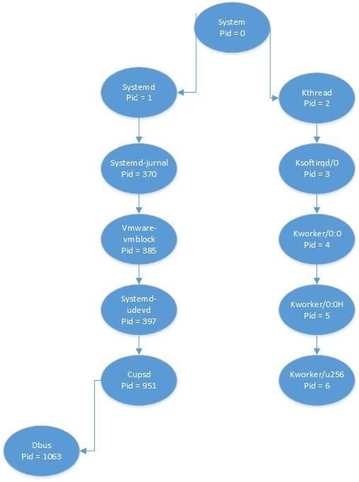

**What are the pid values? Run the following code to prove your guess. Submit the result of the screenshot.**

