Part I: Child calls who and parent waits for child to be done executing.

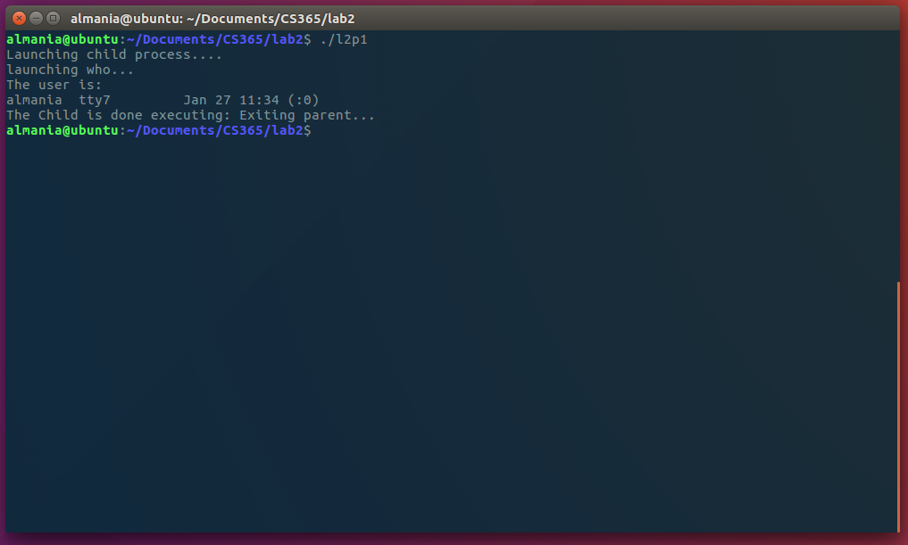

Part II: DateServer and DateClient code output.

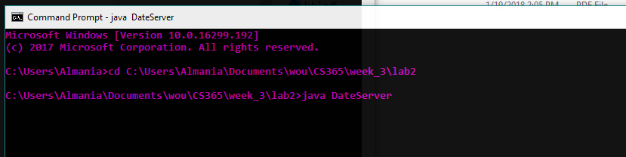Server output:

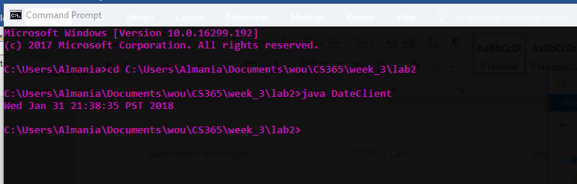Client output:

Part III: A fortune teller client server program.

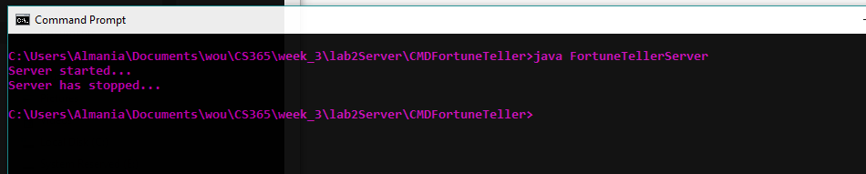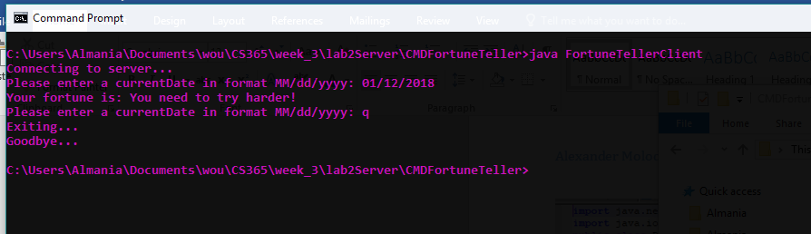

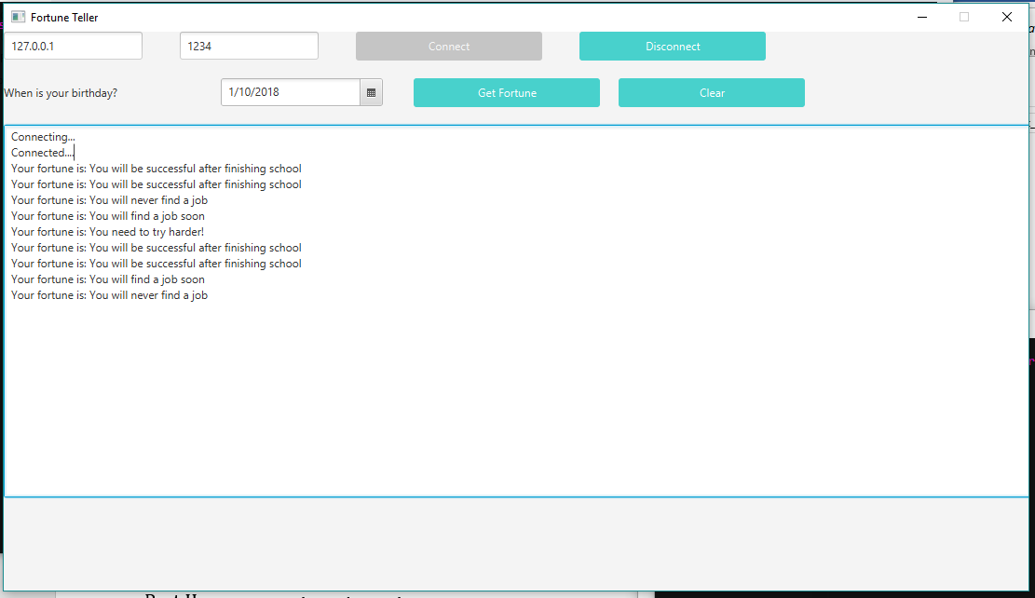Part IV: A fortune teller GUI client server program.

