Report (one paragraph)

Answers to the questions about the overall design.
• What FPGA significant resources are used for the whole SoC?
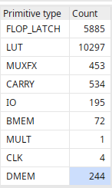
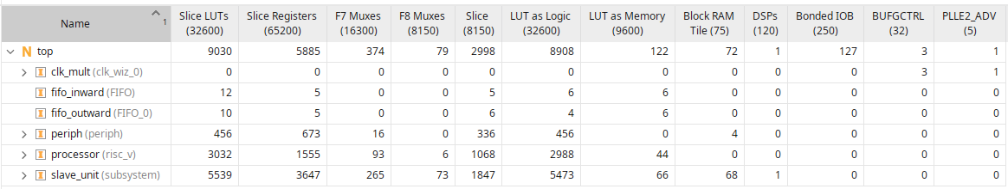

• How ‘full’ is the device?
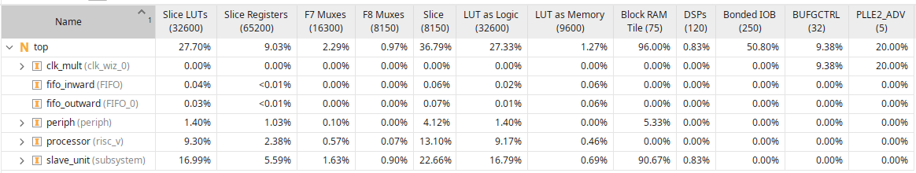

• What resources on the FPGA are used by your block?
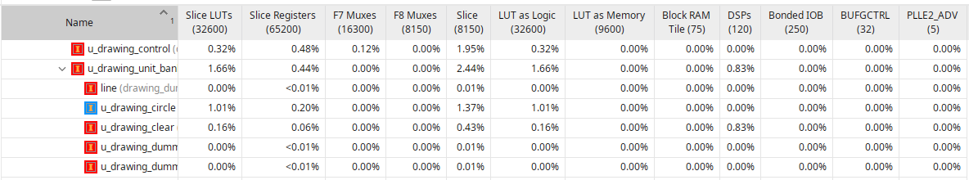
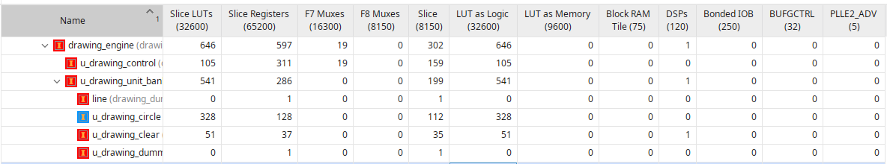

Report parts

• What is the SoC utilisation, including (at least) in terms of Leaf Cells or Look Up Tables (LUTs) and D-type flip-flops (DF**).

• What, in hindsight, was well designed?

• What would you do differently if you were starting again?

• What were the major surprises and lessons learnt?

