

Computer Games Development

Project Report

Year IV

[Alex Mounsey]

[C00183849]

[Date of Submission]

[Declaration form to be attached]

**Contents**

Acknowledgements

Project Abstract

Project Introduction and Research Question

Background

Literature Review

Study

Project Description

Project Milestones

Results and Discussion

Project Review and Conclusions

References

# Acknowledgements

# Project Abstract

The procedural generation of music is has a lot of similarities to other forms of procedural generation, in that you allow the generation inside a strict set of boundaries and rules so as to create assets that are actually useable. I will be using a method of generation called Cell Automaton (CA), with this I will build a music generation system that game developer can use to create emotionally appropriate and adaptive background music for their games. The system will allow for customisation of emotion, tempo and instrument.

# Project Introduction and Research Question

Can procedural generation, cell automaton more specifically, be used effectively to create adaptive and emotive background music for Video Games?

There are some very important and difficult problems in regards to CA and its use in Music generation:

* CAs can create beautiful and intriguing images fairly easily when represented graphically but creating music that is has the same effect aurally requires a much larger effort.
* There is an endless number of CA structures. Finding structures that lead to not only pleasant and interest sounds but also compose an adaptive yet rhythmic musical piece is an incredibly deep and non-trivial task.

Assets creation can be both a massive financial drain on a game's budget and a time-sink for development. There are three main paths a developer can take for acquiring assets, in-house departments creating assets from scratch, bought assets packages from companies like [Kenney](http://kenney.nl/assets) or procedurally generating their assets.

While large development houses can hire professionals to create both audio and art assets, small indie developers are often only left to buy assets or create their own costing precious development time.

The system I create will allow developers the tools to create emotive and pleasant music that will adapt in real-time to what is happening in game without having to create the music themselves or even have anything other than a basic knowledge of music.

# Background

CA is a massively popular algorithmic structure inside both the mathematical and computer science communities and as such has been subject to extensive research. CA’s use in music generation is again such an intriguing topic that many papers have been published on the subject. Procedurally generated music’s use in video games is quite a niche topic and as such its implementation or even papers on the subject are limited. Taking it one step further, adaptive procedural music for games using CA, is a largely under researched topic.

[WolframTones](http://tones.wolfram.com/) uses theories outlined in Stephen Wolfram's book [A New Kind of Science](http://www.wolframscience.com/) and music theory to generate a massive variety of music using CA.

# Literature Review

## What is Cell Automata?

Cell automata is a class of mathematical structures that evolve over time. A basic “cellular automata consisting of a sequence of sites with values 0 or 1 on a line, with each site evolving deterministically in discrete time steps according to definite rules involving the values of its nearest neighbors” [1]

##### Cell Structure

Spacial CA is structured like a chess board, a grid, like shown in *Figure* 1. below. Each cell has neighbours, what cells are classified as neighbours is dependant on the rules set for the structure. The two neighbourhoods mentioned next are the most commonly used but neighbour classification is just another rule set to the preference of the structure’s creator. *Figure* 1. below is classed as a Von Neumann neighbourhood, where only the cells to the North, South, East and West are classed as neighbours, in a Moore’s neighbourhood all 8 surrounding cells are designated neighbours.

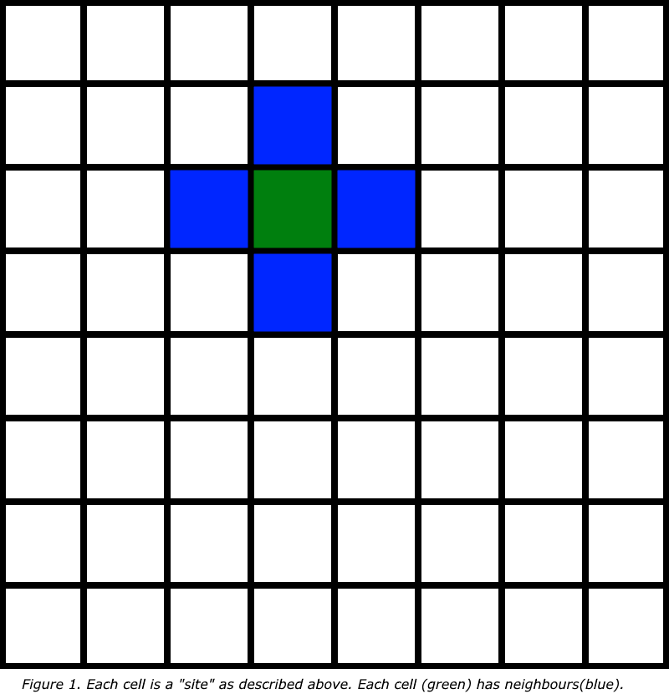

##### Cell Rules

There are two basic principles to understand with CA.

* Cells have a state- in the simplest form, Elementary CA, these state are off(0) and on(1).
* States change- every cell changes state, how it changes depends on its own current state and the current state of its neighbours. Time is discrete in CA, that is to say it, it progresses in steps. So the state of a cell at time(t)+1 is based on it and its neighbours’ states at t.

**Example Rule**

One method used to study CA is to follow its life with an initial state of all 0s except for a single cell with a 1 i.e a starting cell. This is called Single 1 histories.

Rule 28 of single 1 histories



this function generates the sequence of Jacobsthal numbers, and generates a its cells like so

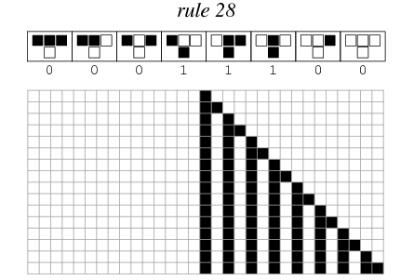

http://mathworld.wolfram.com/Rule28.html

### How can CA be used to create Music?

Once a pattern has been generated the midsection of the pattern is isolated.

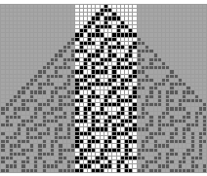

this midsection is then flipped on its side so it reads from left to right

Rule 30 Slice Tipped on Its Side

“Once the cellular automaton pattern has been "tipped on its side" the height of each black square is related to the pitch of a corresponding note. The specific mapping from height to pitch is determined by the musical scale that is used. Each scale picks out certain of the 12 standard tones in an octave.” [2]

# 

# Study

Your study should attempt to answer the research question. Describe the aims, procedure, sample, and measures.

Example: Take three different threshold values, get people to play the game with each value of the threshold. Record the time taken, score achieved, and player rate performance.

# Project Description

Describe your finished product (including screen-shots, where appropriate).

Description of Conformance to Specification and Design – does the submitted product match your specification and design? If it does not, provide reasons and justifications as to why changes were necessary.

Description of Learning – two types: “technical” and “personal”. What are your technical achievements – what did you learn? What are your personal achievements?

# Project Milestones

Key project milestone dates and measurement on schedule, was project schedule adhered to, effectively planned for delivery on-time or ahead of schedule if appropriate.

# Results and Discussion

Describe the results using diagrams such as graphs etc. as appropriate, and discuss what the results mean.

Example: Results indicate that once the threshold gets over a certain point it significantly reduces player performance and player experience

# Project Review and Conclusions

Critical analysis and conclusions written to a highly professional standard including conclusions regarding;

What went right? What went wrong? What (if anything) is still outstanding/missing (i.e., still left to do)? If starting again, how would you approach this project differently? What advice would you have for someone attempting a similar project in the future? Were your technology choices the right or wrong ones? If you chose the wrong technology, provide justifications for why you think this. What were the implications of your technology choices?

Short section summarising findings and indicating what might be some next steps to try (if a student next year was going to undertake a project in this area what might be an interesting thing for him/her to examine?). It is likely that your conclusion will be tentative.

**References**

[1]*Wolfram, Stephen (1983). "Statistical Mechanics of Cellular Automata" . Reviews of Modern Physics. 55 (3): 601–644*

[2]*(WolframTones. HOW IT WORKS. [Online]. (URL http://tones.wolfram.com/about/how-it-works/). (Accessed 14 October 2016).*

# Appendices

Replace this text with Appendices.

This might include ethics application and other relevant material e.g. copy of any questionnaires used.