Markdown DOCX Mermaid Exporter
This sample demonstrates regular markdown, superscripts like 102, and a Mermaid diagram.

Mermaid
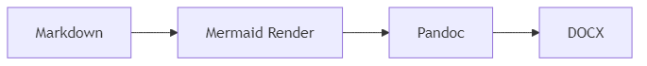

Table
Item | Status
Markdown | Ready
Mermaid | Ready
DOCX | Ready

