We are excited about the opportunities you will have today. Ask plenty of questions & take notes. Fill in the exit ticket using the QR code at the end of your last session.

### Program of Study: Automotive Maintenance and Light Repair, Room: 709

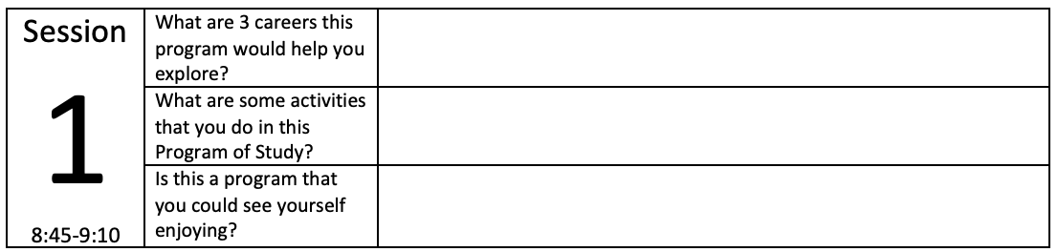

### Program of Study: Therapeutic Services, Room: 704

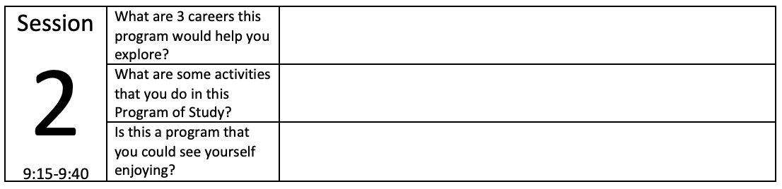

### Program of Study: Culinary Arts, Room: 712

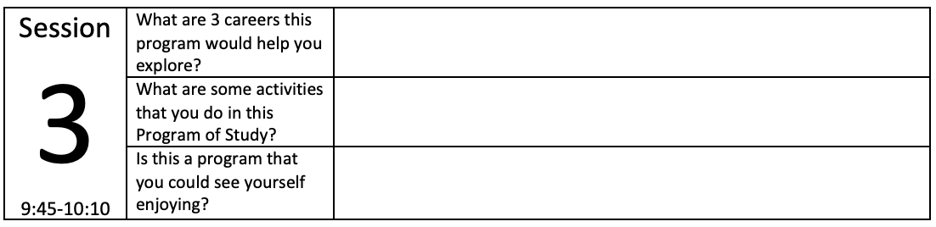

### Program of Study: Leadership in Government, Room: 701

