**Лабораторная работа №2**

**Тема:** Основы технологии Java EE (Сервлеты и JSP)

**Задание**

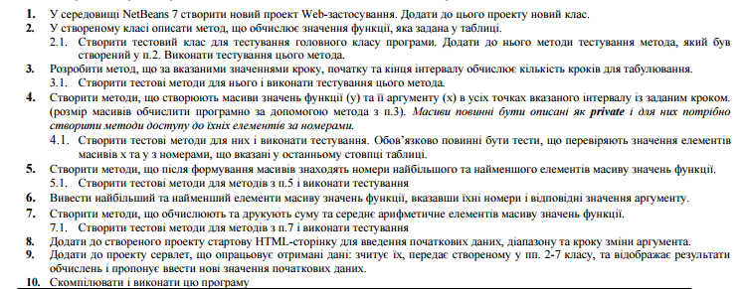

**Вариант 6**

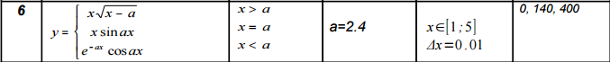

**Ход работы**

Далее будут представлен код исходных пакетов программы. Код представлен листингами 1-3.

**Листинг 1 – «Main.java»**

package lab1;

import java.util.Date;

import static java.lang.Math.*;

import java.util.Scanner;

public class Main {

double x_start,x_finish,delta,a1;

public double ser,sum,arr1_min,arr1_max,arr2_min,arr2_max,y1,y2,y3;

public int i_min,i_max;

public double[] array, array2;

public static void main(String[] args) {

Main prog = new Main();

prog.run();

}

public double form1(double x, double a) {

return x*sqrt(x-a);

}

public double form2(double x, double a) {

return x*sin(a)*x;

}

public double form3(double x, double a) {

return exp(-a*x)*cos(a)*x;

}

private void print(double sum, double ser, int i_min, int i_max) {

System.out.println("y[0] = " + array[0]);

System.out.println("y[140] = " + array[139]);

System.out.println("y[400] = " + array[399]);

System.out.println("y-min = " + array[i_min]+"; x = " + array2[i_min] + "; i = " + i_min);

System.out.println("y-max = " + array[i_max]+"; x = " + array2[i_max] + "; i = " + i_max);

System.out.println("Middle = "+ser);

System.out.println("Sum = "+sum);

}

public void arr(int m){

ser = ser(m);

sum = sum(m);

arr1_min = array[i_min_elem(m)];

arr2_min = array2[i_min_elem(m)];

arr1_max = array[i_max_elem(m)];

arr2_max = array2[i_max_elem(m)];

i_min = i_min_elem(m);

i_max = i_max_elem(m);

y1 = array[0];

y2 = array[139];

y3 = array[399];

}

public void input (){

Scanner in = new Scanner(System.in);

System.out.print("Input x start:");

x_start = in.nextDouble();

System.out.print("Input x finish:");

x_finish = in.nextDouble();

System.out.print("Input delta:");

delta = in.nextDouble();

System.out.print("Input a:");

a1 = in.nextDouble();

}

public double array_len(double a,double b,double h){

return (b-a)/h;

}

public void fill_array(double x, double a, int m, double d){

int k = 0;

double y = 0;

int n = m;

for (int j = 0 ; j < n; j++){

if (x>a) {

y = form1(x,a);

}

if (x==a) {

y = form2(x,a);

}

if (x<a) {

y = form3(x,a);

}

array[j] = y;

array2[j] = x;

x=x+d;

}

}

public int i_min_elem(int m){

int i_min_elem = 0;

double ij = 0;

for (int n = 0; n < m; n++) {

if(ij > array[n]){

i_min_elem = n;

}

}

return i_min_elem;

}

public int i_max_elem(int m){

int i_max_elem = 0;

double ij = 0;

for (int n = 0; n < m-1; n++) {

if(ij < array[n]){

i_max_elem = n;

}

}

return i_max_elem;

}

public double sum(int n){

double suma = 0;

for (int i = 0; i < n; i++) {

suma += array[i] ;

}

return suma;

}

public double ser(int m){

return sum(m)/m;

}

public void init_arr(int len){

int arr_len = len;

array = new double[arr_len];

array2 = new double[arr_len];

}

public void run(){

input();

fill_array(x_start, a1,(int)array_len(x_start,x_finish,delta), delta);

print(sum((int)array_len(x_start,x_finish,delta)), ser((int)array_len(x_start,x_finish,delta)),

i_min_elem((int)array_len(x_start,x_finish,delta)),i_max_elem((int)array_len(x_start,x_finish,delta)));

arr((int)array_len(x_start,x_finish,delta));

Date d = new Date();

System.out.printf( "%tr " , d);

}

}

**Листинг 2 – «MyServlet.java»**

package myweb;

import java.io.IOException;

import java.io.PrintWriter;

import javax.servlet.ServletException;

import javax.servlet.http.HttpServlet;

import javax.servlet.http.HttpServletRequest;

import javax.servlet.http.HttpServletResponse;

import lab1.Main;

public class MyServlet extends HttpServlet {

protected void processRequest(HttpServletRequest request, HttpServletResponse response)

throws ServletException, IOException {

response.setContentType("text/html;charset=UTF-8");

String parameterXstart = request.getParameter("x1");

String parameterXfinish = request.getParameter("x2");

String parameterDelta = request.getParameter("delta");

String parameterA = request.getParameter("a1");

double x1 = Double.valueOf(parameterXstart);

double x2 = Double.valueOf(parameterXfinish);

double delta = Double.valueOf(parameterDelta);

double a1 = Double.valueOf(parameterA);

lab1.Main lab1 = new Main();

lab1.init_arr((int)lab1.array_len(x1,x2,delta));

lab1.fill_array(x1, a1,(int)lab1.array_len(x1,x2,delta), delta);

lab1.arr((int)lab1.array_len(x1,x2,delta));

double sum = lab1.sum((int)lab1.array_len(x1,x2,delta));

double ser = lab1.ser((int)lab1.array_len(x1,x2,delta));

double y1 = lab1.y1;

double y2 = lab1.y2;

double y3 = lab1.y3;

int i_min = lab1.i_min;

int i_max = lab1.i_max;

PrintWriter out = response.getWriter();

try {

out.println("<html>");

out.println("<head>");

out.println("<title>Servlet MyServlet</title>");

out.println("</head>");

out.println("<body>");

out.println("<h1>Lab2 WEB " + request.getContextPath () + "</h1>");

out.println("y[0] = " + y1 + "<br/>");

out.println("y[140] = " + y2 + "<br/>");

out.println("y[400] = " + y3 + "<br/>");

out.println("Sum = "+ sum + "<br/>");

out.println("Middle = "+ ser + "<br/>");

out.println("Y min = " + lab1.array[i_min] + "; x = "+lab1.array2[i_min] + "; i = " + i_min + "<br/>");

out.println("Y max = " + lab1.array[i_max] + "; x = "+lab1.array2[i_max] + "; i = " + i_max);

out.println("</body>");

out.println("</html>");

} finally {

out.close();

}

}

**Листинг 3 – «Index.jsp»**

<%@page contentType="text/html" pageEncoding="UTF-8"%>

<!DOCTYPE html>

<html>

<head>

<meta http-equiv="Content-Type" content="text/html; charset=UTF-8">

<title>JSP Page</title>

</head>

<body>

<h1>Hello World!</h1>

<form name="myform" action="MyServlet" method="POST">

x1 = <input type="text" name="x1" value="1" size="10" /><br/>

x2 = <input type="text" name="x2" value="5" size="10" /><br/>

delta = <input type="text" name="delta" value="0.01" size="10" /><br/>

a = <input type="text" name="a1" value="2.4" size="10" /><br/>

<input type="submit" value="Отправить" />

</form>

</body>

</html>

**Результат**

Результаты работы программы представлены рисунками 1,2.

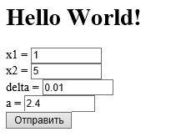

Рисунок 1 – «Ввод данных»

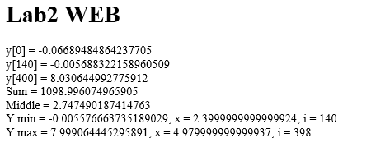

Рисунок 1 – «Вывод данных»

**Вывод**: При выполнении данной лабораторной работы я научился создавать и использовать сервлеты.