

Computer Games Development CW208

GDD and Project Report

Year III

Alex O’Toole

C00216095

|  |  |
| --- | --- |
|  |  |
| 03/05/2020 | |

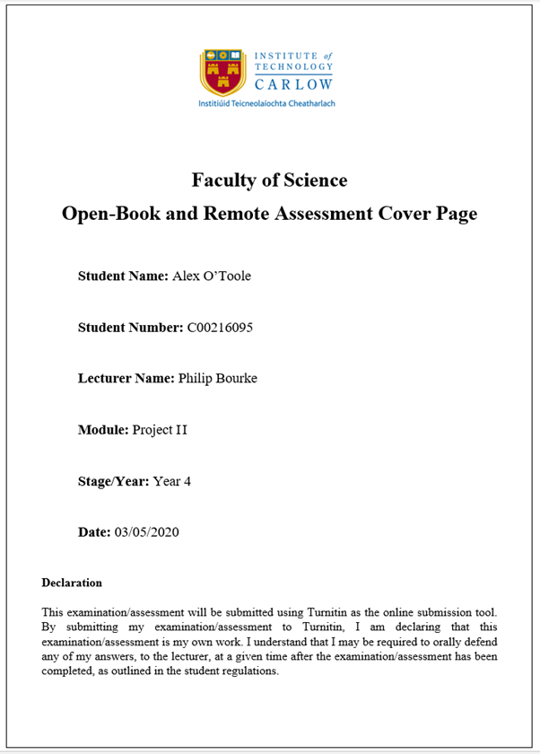

Contents

Acknowledgements **2**

**Project Abstract** **3**

**Project Introduction** **3**

**Background** **3**

**Project Description** **4**

Game Overview **4**

Feature Set **5**

General Features 5

Gameplay 5

Travel 6

Scale 6

Objects 6

**User Interface** **6**

Single-Player Game **7**

Victory Conditions 7

Project Milestones **7**

**Project Review and Conclusions** **8**

# Acknowledgements

I would like to thank the following people who assisted in completing this project including;

Noel O’Hara of The Institute of Technology Carlow who kindly helped me by giving many good ideas and suggestions on levels that would help make this game more enjoyable and challenging.

# Project Abstract

This project is a Virtual Reality puzzle game that requires skill and memory to complete.This game runs on the Oculus Quest. It contains three levels that use various skills like memory, hand eye coordination and multitasking. This research is a quantitative paradigm small scale research. It begins with the foundations of building a game in virtual reality to explore the participants memory and skill. The findings were analysed, discovering that in this instance as you go through the memory levels it affects the participants ability to remember within the game. This game is challenging and rewarding. On the final level the success rate after the first try is 40%, however on the second attempt there is a 20% increase in the success rate making it 60%.

# Project Introduction

This project is a Virtual Reality puzzle game that runs the Oculus Quest and Oculus Rift S. The game consists of three levels that tests the user's memory and also requires a little skill. The first level is a memory puzzle , the second level is a skill game. These two levels are kind of a warm up for the third level which combines skill and memory.

I chose this project because I wanted to expand on my knowledge and learn how to develop in virtual reality and because the uses for virtual; reality are ever growing in the industry. For the topic of the game I took inspiration from carnival style games where you can win small prizes like goldfish. These carnivals usually have puzzle / skill games which are similar to the levels I designed.

The audience for this game ranges from young children to adults as it can be played on your own or even in a room with others as a party style game, to try and compete with friends.

# Background

Over the past ten years virtual reality has grown exponentially in popularity due to improvements in hardware over that time. Not only has it grown in popularity in the games industry but it has also grown in popularity in other industries such as the healthcare sector and education sector. This is due to virtual realities wide range and diversity, the possibilities are endless due to how good and cheap virtual reality has become over these past ten years. Virtual reality is still growing to this day and its potential is evergrowing.

I took inspiration from carnival style games where you can win small prizes like goldfish. These carnivals usually have puzzle / skill games which are similar to the levels I designed. This includes carnivals and theme parks that I have been to and also games like *Carnival Games VR.*

# Project Description

The game consists of three levels that tests the user's memory and also requires a little skill. The first level is a memory puzzle that contains three coloured boxes red, green and blue and six coloured cubes on a table in a random order. The user is then given ten seconds to memorize what order the cubes are presented in, after the time is completed all the cubes lose their colour and a list containing the correct order the cubes should be placed in the boxes that match the cubes colour will be presented. For example, the cubes could be presented on the table in the following order from left to right red, green, green, blue, red, blue. When the time is up and all the cubes lose their colour, the sequence list is presented for example, blue, red, green, blue, red. If the user does not put the cubes in the correct coloured boxes in the correct sequence they fail.

The second level is a skill game based on the basketball arcade/carnival game. The aim of this is to throw basketballs into the hoop. Each time a basketball goes in the users score is increased. The goal is to get the highest score in the given time limit.

The first two levels are kind of a warm up for the third level which combines skill and memory. The third level takes place in a dark room. The user spawns in front of a table, the table has a box on it and a flashlight . When the user presses the start button a list of six coloured shapes will appear in a certain order. For example red cube, green cylinder, cyan sphere and so on. The user has ten seconds to remember this list in order, after this time period the user will then have to use the flashlight to navigate the dark room and find and bring each shape back to the table and place them in the box in the correct order.

# Game Overview

# Feature Set

## General Features

VR

Interactable objects.

Basketball.

Flashlight.

large room to walk around in.

Dark level.

## Gameplay

*Level One -* This level is a memory puzzle that contains three coloured boxes red, green and blue and six coloured cubes on a table in a random order. The user is then given ten seconds to memorize what order the cubes are presented in, after the time is completed all the cubes lose their colour and a list containing the correct order the cubes should be placed in the boxes that match the cubes colour will be presented. For example, the cubes could be presented on the table in the following order from left to right red, green, green, blue, red, blue. When the time is up and all the cubes lose their colour, the sequence list is presented for example, blue, red, green, blue, red. If the user does not put the cubes in the correct coloured boxes in the correct sequence they fail.

*Level Two -* This level is a skill game based on the basketball arcade/carnival game. The aim of this is to throw basketballs into the hoop. Each time a basketball goes in the users score is increased. The goal is to get the highest score in the given time limit. When the ball hits the floor of the level a new ball will spawn back on the table to ensure the user does not lose time trying to retrieve the ball.

*Level Three -* The third level takes place in a dark room. The user spawns in front of a table, the table has a box on it and a flashlight . When the user presses the start button a list of six coloured shapes will appear in a certain order. For example red cube, green cylinder, cyan sphere and so on. The user has ten seconds to remember this list in order, after this time period the user will then have to use the flashlight to navigate the dark room and find and bring each shape back to the table and place them in the box in the correct order.

**The Game World**

### Travel

The user can walk around the whole room(provided they have the space in the real world).

### Scale

The room that these levels take place is 25m^2 in the real world.

### Objects

*Level One -* Three coloured boxes, Six coloured cubes, Table, Two buttons.

*Level Two -* Basketball, Basketball hoop,Table, Two buttons.

*Level Three -* Flashlight, Six random shapes that are randomly coloured,Table, Two buttons

***Collision Detection***

Unity’s collision system and colliders are used in this project.

**The World Layout**

*Level One -* This level takes place in a large room. Positioned in front of the user is a table that contains three coloured boxes and six cubes. On the back of the table there is a backboard that contains a list of level instructions. To the left of the user is a start button and to the right of the user there is a quit button.

*Level Two -* This level also takes place in a large room. Positioned in front of the user is a table that contains a ball. In front of the table there is a basketball hoop. On the backboard of the hoop there is a timer and a score counter. To the left of the user is a start button and to the right of the user there is a quit button.

*Level Three -* This level takes place in a very dark room. Positioned in front of the user is a table that contains one box and a flashlight. Above the table there is a dim ceiling light. Randomly positioned around the room are six randomly coloured random shapes. The shapes can be either Cyan, Yellow, Pink, Orange or Purple and they can either be a Cube, Sphere, Cylinder or Capsule. These shapes spawn randomly on the floor or on the shelfs that are attached to the room walls. On the back of the table there is a board with a list of instructions. To the left of the user is a start button and to the right of the user there is a quit button.

# User Interface

The user face for this project is quite straightforward and easy for the user to learn quickly. The user face consists of text and a button model. This button model is used throughout the entire game and the buttons are colour coded. On the main menu there are four buttons in front of a wall and on the wall there are four pieces of text, “Level 1”, “Level 2”, “Level 3”, “Quit”. Each piece of text is coloured the same as its matching button. For example, “Level 1” is written in green and the button to start level one is also green.

In each level there are two of these button models, one on each side of the user. One is used to start the level after the user has read the level instructions. The other is used to quit the level and return to the main menu.

To use these button models all the user has to do is point their finger and push the button.

# Single-Player Game

### Victory Conditions

*Level One -* In this level victory conditions are met when the user successfully remembers the order of the cubes on the table and places them in the correct coloured box in the correct order.

*Level Two* - In this level there aren't really any victory conditions. The goal of this level is to score as many baskets as possible in the given time period.

*Level Three -* In this level the victory conditions are met when the user successfully remembers the list of coloured shapes and then can successfully find them in the dark room using the flashlight and then place them in the box in the correct order.

# Project Milestones

Throughout this project there were many important milestones. One of the first milestones was when the local avatar with custom hands was integrated successfully using the Oculus toolkit provided by Oculus on the Unity asset store. Once this was working it allowed for the user to actually walk around the scene. Which then meant the work on the levels and interactable objects could begin. The next big milestone for the project was when the first level had working scripts and multiple interactable objects. This meant that the first level of the game could be played. Another milestone was hit when level transitions were needed to move from the main menu to each level. This meant that some sort of button was needed. A button model was then created in Unity using 3D cube objects to create a tall stand for the button, Then a spring joint at the top and another 3D cube object at the top to act as the pushable button. Once the script was then added to the spring joint it meant the button model was fully working and could be used throughout the whole project anywhere a button was needed.The next big milestone was creating the lighting for level three. The scene needed to be as dark as possible for the flashlight to actually be needed and a light above the main table in the level needed to be dim enough so that it only illuminated the table and nothing else. Then for the flashlight a script was added to turn the flashlight on and off when it was in the user's hand and they pull the trigger(switch). Finally the last milestone was when the random spawn point system was made for level three. This needed to work well because otherwise the objects would always be in the same spots and the user wouldn't actually have to look for them. Once this was working it was then also integrated into level one in order to make the cubes spawn in a different order every time which added more difficulty. Overall the biggest milestone/technical achievement was actually learning how to develop in virtual reality with Oculus.

# Project Review and Conclusions

Based on the data gathered in this research, in this instance it does appear that multitasking does in fact have an affect on the users memory. However there was one big limitation to the research and that was time. If the research was to be carried out again a larger user group would be used and more than the first two tries would be recorded for example, the first four tries would be recorded.